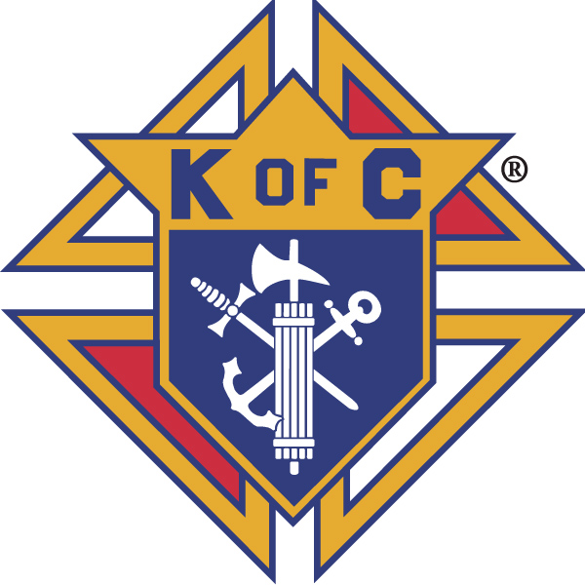
Knights of Columbus

In Service to One, In Service to All
Rev. Robert F. Houlihan, S.J., Council 10937
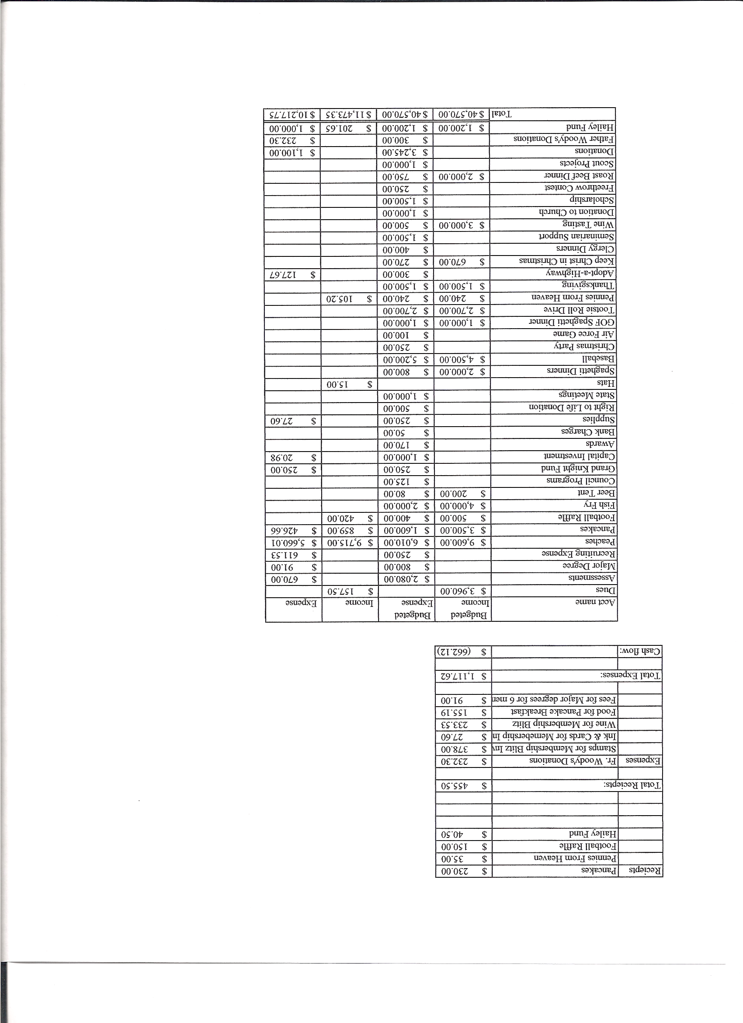
Business Meeting Minutes – February 8, 2014

I. General
- The Council was called to order at 8:08 AM by Grand Knight, Joe Musso.
- Opening Prayer was offered by Gary Mayfield. The role of officers was called and noted as follows (P = Present; A = Absence; E = excused)

Title | Status | Title | Status | Title | Status
Chaplain | P | Financial Secretary | P | Inside Guard | P
Grand Knight | P | Treasurer | P | Outside Guard | P
Dep. Grand Knight | P | Lecturer | P | Trustee 3rd Year | P
Chancellor | P | Advocate | P | Trustee 2nd Year | P
Recorder | P | Warden | P | Trustee 1st Year | E

The January 9, 2014 business-meeting minutes were approved as read and published.

II. Applications for Approval – Roger
None

III. Grand Knight Report – Joe
Pennies from Heaven
Knight of the Month – Art Myers
Family of the Month – Alan Brown Family
There is a change in February’s planning meeting. It will be Tuesday February 25th instead of Monday February 24th.
The Joshua Tracy Memorial Golf Tournament is April 3rd at Applewood. Entry fee is $80.
The State Convention is the weekend of April 25th at Keystone Co.
Correspondence:
The Arc – Intellectual Disabilities - Thank you note
Joe Regnery – State Family of the Month
Colorado Springs St. Patrick Day Parade – March 15
Joshua Tracy Memorial Golf Tournament – April 3
KnightstoChrist.org for the Kindle reader
Women’s Crisis Center – Thank you note - (We donated 20 Thanksgiving baskets to the Center.)

IV. Chaplain’s Report - Father Jim
Father Jim asked for prayers both for Father Brian and himself during this transition in leadership. Pray that we will be able to discern the will of God. Father Brian remains our KofC chaplain and Father Jim is our faithful friar.
Father Jim’s priority is to form disciples who encounter Christ through prayer. Every parish has a person with a deep prayer life who experience Christ through prayer. This is the most important person in the Parish. Spiritual reading is very important in building a life of prayer. We need input through reading to form, expand, and build our prayer life. Father Jim encouraged all to do more spiritual reading. Contemplative prayer should also play an important part in everyone’s prayer life. Our goal is to pray that we may discern the will of God and thereby live our lives in the way of God.

V. Treasurer’s Report – Dennis Cullen
Report handed out at meeting.
Bank Balance - $ 12,669.29 Available Funds - $ 9,631.69

VI. Financial Secretary’s Report – Dennis Thumann
Report handed out at meeting
Receipts - $ 3,153.78 Expenses - $ 1,215.77 Bank Balance - $ 12,669.29
We received a letter from Carl Anderson, from Supreme, expressing gratitude for the Thanksgiving Basket Drive with an enclosed check for $500 to help with our costs.

VII. Chancellor’s Update – Matt Yeagle
We receive $150 back from Supreme for each seminarian that we sponsor.
The prayer for vocations was said.

VIII. Committee Reports – Gary Mayfield

a. Membership – Roger Guidici
There are major degrees at St. Joan of Arc on March 29th and a 4th degree on March 30th at St. Joan of Arc.

b. Church Director Report – Jay Calvarese
The Lady Knights will be sponsoring donuts on February 9th.
On Easter, donuts will be available outside, if weather permits.
Help is still needed for Casino Night on Saturday March 1st. Only about half of the volunteer positions are filled.

c. Community Report - Bob Luckner
40 Cans of Lent Schedule:
February 17 – The bulletin announcement regarding 40 Cans for Lent will be submitted to Joanne in the Parish office.
February 23 thru April 6th - 40 Cans for Lent announcements appear in Parish Bulletin.
March 8 thru April 6th - Knights collect donations after mass. Volunteers are needed to help with signups.
March/April - Knights collect donations at each Knights Fish Fry.
March 29 - 30, April 5 - 6 - Announcements regarding food drive will be made during Sunday masses.
April 12th - Parishioners Deliver food to church & Knights ship food to Denver Rescue Mission.
April 20th - Easter
Bob could use some help planning and coordinating activities. Please let him know if you would be willing to give him a hand in this community ministry.

d. Council Activity Report – Nereus Lobo/Paul Sciera
February pancake breakfast will be on Sunday, February 23rd.
February’s Family Social will be February 21 at the home of Mike and Denise McGinnis at 6 PM.

The address is:
1005 Snow Lily Ct
City of Castle Pines
(Directions by e-mail later)
The Mooyah Burgers, Fries and Shakes fundraiser is all weekend of February 21st to 23rd. Enjoy a good meal and help out the Knights!
Our Lenten fish fries will be March 7 and March 28. Brennan Mendus will coordinate. There will be games during dinner.
e. Family Report – Bill Hensen
Thanks for making the spaghetti dinner a success.
There will be another spaghetti dinner the Saturday before Mother’s Day.
A family sledding party activity is being considered. More later.
An outdoor activity and pork dinner is being considered after the 5:00 o’clock Mass for the coming summer. Details later.

f. Right to Life report - Mike McGinnis
40 Days For Life begins March 5th. Devotionals will be sent out. Please take a few minutes each day to pray for life from womb to tomb. Also, we can support 40 Days For Life on Sundays from 6am to 6pm between March 5 and April 13 by having at least 2 Knights in a prayer vigil in front of Planned Parenthood. Signup for times at: http://www.signupgenius.com/go/10C094AA4A72EA2FB6-40days
Also, for those available on Friday mornings, Father Carmody says Mass in front of Planned Parenthood at 8 AM .
g. Youth Report – Tim Pimmel/Ben Stancati
There were only three participants in the free throw contest this year.
Cody Pimmel in the eleven-year old division.
Simon May in the thirteen-year old division
Austen Yarosh in the fourteen-year old division.
Simon and Austen will participate in the district contest at Ave Maria.
Scholarship selection has been pushed back to April 12th. Applications are due by April 5th. Five Knights are asked to stay after the meeting on April 12th to select the scholarship recipient. See Tim to volunteer.

h. Newsletter – Herb Engler
No report.

IX. Advocate’s Report – Dave Petteys
KofC dues cannot be deducted on income tax because we are not a 501C3 organization but a 501C8. For large donations use the KofC State Charities which is a 501C3.

X. Auditors and Trustees – Chris Kennedy
The audit will be completed today after the 4th Degree meeting in the Parish office.

XI. Lecturer – Ben Stancati
No report.

XII. Unfinished Business -
None.

XIII. New Business
State convention: Jon Herskovits
Friday night is the dinner.
Because it’s an off year, there is no one running against any seated state officer as of now. However, anyone can run.
Help is needed to run the hospitality center.
Program reports are turned in.
State officers are trusties for the Colorado State Charities which has a 501C3. thus, when you donate to state, you may take an income tax deduction.
Delegates for the State Convention were elected. Delegates are the Grand Knight and Past Grand Knight with alternates Deputy Grand Knight and Financial Secretary.
On April 5th, Danny Harris, from Supreme, will be giving a membership-recruiting workshop at Queen of Peace between 9 and 11 AM. The membership director, the Grand Knight and the Deputy Grand Knight should attend.

XIV. 4th Degree Report – Chris Kennedy
There will be an Assembly meeting in the Parish office immediately following the Council meeting.

XV. Field Agent Report – Lou Lesser
No report.

XVI. District Deputy Report – John Lynn
No report.

XVII. Good of the Order
Jim DeRose, Monique Conley and the Conley family, Sherri Suddarth, Bridget Mosley, Loren Hansen, Ken Bertrand, Charles Brady, Anne Thumann, Michelle Cullen

XVIII. Chaplain’s Summation – Fr. Jim

XIX. Closing Prayer
Read by Gary Mayfield.

MEETING WAS ADJOURNED AT

9:08 am

- minutes recorded and reported by Mike McGinnis

