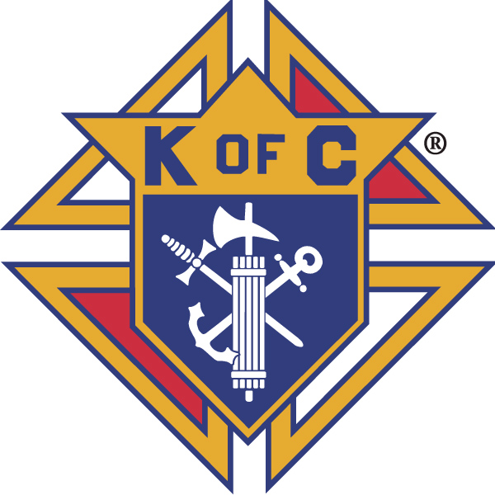
Knights of Columbus

In Service to One, In Service to All
Rev. Robert F. Houlihan, S.J., Council 10937
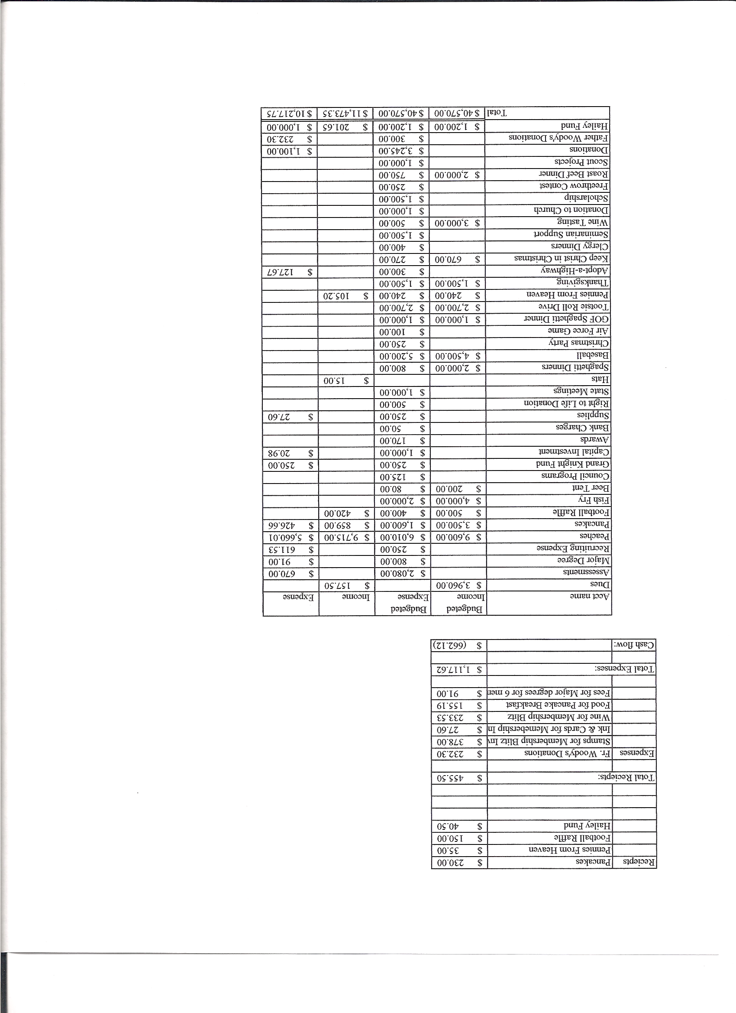
Business Meeting – December 14, 2013

I. General
- The Council was called to order at 7:20 AM by First Degree Team Grand Knight, Tom Whyte. Two applications for membership were read and approved unanimously. The meeting was then suspended for the 1st degree exemplification. After the 1st degree ceremony, the meeting was re-convened by Grand Knight Joe Musso.
- Congratulations to our two new 1st degree knights, Wilbur Tan and David Tidaback.
- Opening prayer was offered by Gary Mayfield. The role of officers was called and noted as follows (P = Present; A = Absence; E = excused)

Title | Status | Title | Status | Title | Status
Chaplain | P | Financial Secretary | P | Inside Guard | P
Grand Knight | P | Treasurer | P | Outside Guard | P
Dep. Grand Knight | P | Lecturer | P | Trustee 3rd Year | P
Chancellor | P | Advocate | P | Trustee 2nd Year | P
Recorder | P | Warden | P | Trustee 1st Year | E

The November 9, 2013 meeting minutes were approved as read and published.

II. Applications for Approval – Roger
No new applications read.

III. Grand Knight Report – Joe
Pennies from Heaven
Knight of the Month – John Hilton
Family of the Month – Joe Regnery Family
Correspondence: Knights of Columbus Colorado State Council, convention guidelines.
Father Woody’s announcement of the passing of Brother Jay Gould, a founder of Father Woody’s
Knights of Columbus Military Chaplain Scholarship Fund
Knights of Columbus – Numbers Make a Difference
Thank You from Steven Nucci, a college scholarship recipient.
Knightsgear.com to purchase Knight related gear and clothing.
Note reminding us to fill out the yearly fraternal activity survey.
Joe reminded everyone of the January business meeting change from January 11th to Thursday, January 9th at 7:00 PM.
Joe recognized Bob Luckner with the Knight of the year award and the Jay Calvarese family with the family of the year award. (Each award was presented last night at the Christmas party.)
Gary thanked all who submitted reports and those who filled out the fraternal survey.

IV. Chaplain’s Report - Father Brian
Father Brian thanked the Knights for their work on the Thanksgiving basket drive and for all the charitable work we do.
There will be a Parish financial overview statement in Sunday’s bulletin. Sunday offerings are currently down about 6.8%. Our deficit from July to November is $99,000. Check out the bulletin.
All that we have is a gift from God and we need to give back.
Haiti: The poverty in Haiti is extreme. Tent cities, no running water, no electricity, not enough to eat, yet people display a joy one wouldn’t expect to see. The chapel has no windows, no doors and no floor. People offer fruit and produce at the offertory during mass and, as poor as they are, they wear their best clothes to mass. Forty-five kids meet for school each day. It is important to support these kids. This experience has been very humbling. We still have no committee. The question is, do we want to continue this ministry or shift our efforts elsewhere. We will assess this at the end of the year.

V. Treasurer’s Report – Dennis Cullen
Report handed out at meeting.
Bank Balance - $ 28,206.60 Available Funds - $ 10,147.17

VI. Financial Secretary’s Report – Dennis Thumann
Report handed out at meeting
Receipts - $ 12,729.96 Expenses - $ 16,552.96 Bank Balance - $ 28,206.60
There will soon be an e-mail notification of this year’s dues. ($36)

VII. Chancellor’s Update – Matt Yeagle
An invitation to attend our annual Christmas party was sent to Bishop Sheridan and all three seminarians but was all four declined.
Matt invited all Knights to sign the Christmas cards for the seminarians, which will then be sent to each seminarian along with $500 for support.
VIII. Committee Reports – Gary Mayfield

a. Membership – Roger Guidici
Roger welcomed the new 1st degree members and encouraged all of us to invite men who are not Knights to join the Knights.
At the end of March in Northglenn, there will be a 1st degree exemplification on Thursday, a 2nd and 3rd degree on Saturday and a 4th degree on Sunday.
February 8th there is a 4th degree in Northglenn. The entire hierarchy of the 4th degree is expected to be present.
See Roger if you are willing to help with membership and exemplifications.

b. Church Director Report – Jay Calvarese
Donuts are ongoing. Thus far the Knights have made $1200 for the year.
The Reconciliation dinner is December 19th.
Help is needed with parking before and after the 4:00 PM Christmas Mass and to usher at Christmas Masses. Sign up at:
http://www2.mysignup.com/cgi-bin/view.cgi?datafile=christmass_ushers_2013
Todd thanked everyone for ushering. More ushers are needed and welcome.
c. Community Report - Bob Luckner
412 Thanksgiving baskets were put together and donated. $12,000 in money was contributed. 50% of remaining donations was given to Father Woody’s and 50% to Alternatives Pregnancy Center.
The December 14th Adopt-a-Highway cleanup was cancelled due to snow and ice along the highway.
Thanks to Tony an article about the Thanksgiving basket drive will appear starting January 1st on the Nightline online addition. Herb will send the website out .

d. Council Activity Report – Paul Sciera
Our next breakfast will be January 26th.
Please try to participate in the monthly Council social events.

e. Family Report – Bill Hensen
Thanks to Gary and Ben and all others who help on Christmas dinner last night.
The spaghetti dinner is February 1st.
Bill would like Knights who have ideas for family activities to contact him.

f. Right to Life report - Mike McGinnis
Over 400 babies were born this past year to those who found Alternatives Pregnancy Center and chose life for their babies. Great News!!

g. Youth Report – Tim Pimmel
No report

h. Newsletter – Herb Engler
Our Christmas party will be featured in the next newsletter.
Herb requested each program director to send him a summary of activities that his committee held this past year.
Pictures of officers and program directors will be taken after today’s meeting.

IX. Advocate’s Report – Dave Petteys
Dave found that the Knights cannot acquire a radio station. There is a Catholic radio station in Loveland.

X. Auditors and Trustees – Chris Kennedy
No report.
The audit will be done in January or February.

XI. Lecturer – Ben Stancoti
The Rev Robert F. Houlihan, S.J. Educators Series, number 8.0
“The Magis”
Taken from the Regis University brochure on Ignatian
spirituality, teaching, and learning; by Father Bart Geger, S.J.
Magis is Latin for “more” or greater. Jesuits and their associates use it as an abbreviation for their organization’s motto, which is Ad Majorem Dei Gloriam, meaning, “For the Greater Glory of God.” In terms of just who and what are the Jesuits, it is considered a religious order or “fraternity” of Roman Catholic men, most of whom are priests. They were founded in 1540 by St. Ignatius of Loyola, along with nine other men, one of most famous being St. Francis Xavier. The goal, focus, and purpose of this group, was to serve God and other people in a very distinctive manner.
Their chosen path, or way of proceeding as the Jesuits like to call it, is this: Since there are so many pressing tasks in both the church and the world, and it is impossible to do everything, the key then is to focus on those that have a greater or wider impact. In Ignatian language, the order should focus on “the more universal good.” And this type of approach centers on teaching, learning, and educating. A proverb says, Give a man a fish, and you feed him for a day; teach him to fish, and you feed him for a lifetime.” Both approaches work, and each is essentially both necessary and holy. Nevertheless, the second has a much wider impact. The man can return to the village and teach others, while the teacher is now free to teach the rest of the world. In addition, the villager now has a new dignity, since he and his family no longer have to rely on charity. For these reasons, tempered by the weight and extent of circumstances, the Jesuits focus on teaching.
Turning to the principle of “charism,” this is a distinctive emphasis that people bring to their service of God and neighbor. For example, Monks give witness through silence and prayer. Dominicans focus on preaching the word. Other orders do other things, like Mother Teresa’s sisters of mercy. Many laypeople, married couples, and ministries, like the Knights, have created their own approaches and emphases. All, however, give glory to God by fulfilling a particular role in salvation history, a role that gives all of them a special identity or “nature.” This variety of charisms gives glory to God by revealing His great diversity and providential love.
St Ignatius originally conceived the Jesuits to be a highly mobile group, going at a moment’s notice wherever the needs of the church were the greatest. Therefore, such a lifestyle by its very nature would require Jesuits to make all kinds of “command decisions” in unique circumstances about the best way to serve the Society, the people, and our God. To have such flexibility, coupled with a unifying charism, Ignatius urged his men to make “the more universal good” the criterion for their decisions.
Consequently then, “the more universal good” is why education and social justice are both key Jesuit ministries. The Society created the first systemic network of schools in the world, which had an incalculable impact on the course of intellectual history. From an Ignatian perspective, social justice, in its most basic form, means having a vision beyond just direct service to the poor. While helping the poor is important, the more important approach, however, is to dedicate ones energy toward studying and addressing the social and economic factors that are causing the poverty in the first place.
Examining, analyzing, questioning, and applying the majis whenever choices need to be made, no matter how personal or private they might be, is a powerful reminder that every action taken has both intended and unintended consequences and implications for others. When it comes to asking a number of what, when, where, how and why questions about life, the “more universal good” will not always be clear. Yet Ignatius would say that at least the right path is being followed because the right questions are being asked. He might also say that habitually asking such questions would in time create a special identity, one of a profoundly holy person.

XII. Unfinished Business -
None

XIII. New Business
None

XIV. 4th Degree Report – Chris Kennedy
Corporate Mass will be the January19th.
A form 4 will be attended to after the January 9th meeting.

XV. Field Agent Report –
No report.

XVI. District Deputy Report – John Lynn
No report.

XVII. Good of the Order
Jim DeRose, Sherri Suddarth, Bridget Mosely, Michelle Cullen, Herb Engler, Al and Antoinette Valenti, Joe and Jackie Regnery, Lauren Hensen, Pat Wyght.

XVIII. Chaplain’s Summation – Fr. Brian
None

XIX. Closing Prayer
Read by Gary Mayfield.

MEETING WAS ADJOURNED AT

9:45 am

- minutes recorded and reported by Mike McGinnis

----- Correspondence -----

