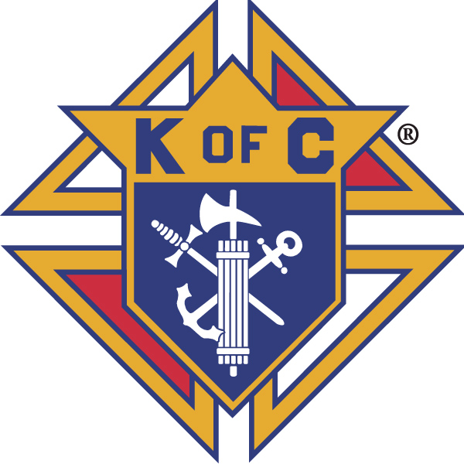
Knights of Columbus

In Service to One, In Service to All
Rev. Robert F. Houlihan, S.J., Council 10937
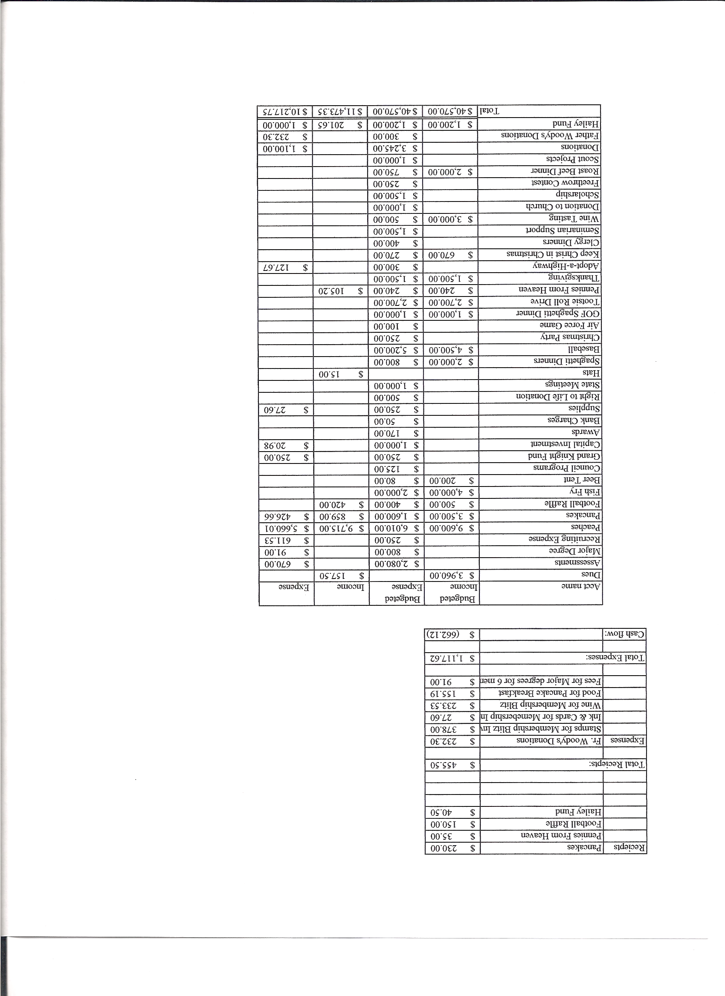
Business Meeting – March 8, 2014

I. General
- The Council was called to order at 8:07 AM by Grand Knight, Joe Musso.
- Opening Prayer was offered by Gary Mayfield. The role of officers was called and noted as follows (P = Present; A = Absence; E = excused)

Title | Status | Title | Status | Title | Status
Chaplain | P | Financial Secretary | P | Inside Guard | P
Grand Knight | P | Treasurer | P | Outside Guard | E
Dep. Grand Knight | P | Lecturer | P | Trustee 3rd Year | P
Chancellor | P | Advocate | E | Trustee 2nd Year | P
Recorder | P | Warden | P | Trustee 1st Year | E

The February 8, 2014 business meeting minutes were approved as read and published.

II. Applications for Approval – Roger
Luke Davis was re-admitted to Council 10937 by unanimous approval.

III. Grand Knight Report – Joe
Pennies from Heaven
Knight of the Month – Leonard Leyba
Family of the Month – Larry Call Family
Correspondence:
Thank you notes from our seminarians Roy and Justin.
Eagle project outline from Jack Vasquez
Appreciation letter from Special Olympics Colorado
Thank you note from St. Mary’s Pantry for food baskets received.
Due to Confirmation class, next month’s business meeting will be at 7 PM on April 10th and there will be a 1st Degree exemplification at the meeting.
Joe expressed thanks to those who ate at Mooyah.
Joe reminded those attending the state convention to complete their registrations. (meals, registration, hotel)
Joe reminded everyone of the Josh Tracy Memorial Golf Tournament on April 3 and encouraged the Knights to form a foursome.
Tony Yarosh received his Shining Star Award. Congratulations, Tony!
Joe passed around the article in the Carroll College newspaper about Josh Tracy.
Joe pointed out that Bob Luckner was Steward of the Month at Pax Christi.

IV. Chaplain’s Report - Father Jim (Faithful Friar)
The phrase “non multa, sed multum”, "not many but much" in Latin, provides motivation for the 40 days of lent. Christian ideal is to be proficient in one thing. Not quantity but quality should be our objective. We are called by God to do one important thing through our vocation in life. Put your energy in what God deems important. Christian vocation is a strong way to see how this saying is applied. Jesus’ task “much not many” on earth was to do the will of the Father. We can focus on the deeply profound areas of our lives by stripping away distractions during lent to concentrate on the mysteries of the cross.

V. Treasurer’s Report – Dennis Cullen
Report handed out at meeting.
Bank Balance - $ 14,928.07 Available Funds - $ 12,153.02

VI. Financial Secretary’s Report – Dennis Thumann
Report handed out at meeting
Receipts - $ 5,367.98 Expenses - $ 2,634.75 Bank Balance - $ 14,928.07

VII. Chancellor’s Update – Matt Yeagle
Roy’s Deacon ordination will be May 24th. All are invited to attend.
Both our seminarians, Roy and Justin, sent thank you letters for our support.
Roy sent a prayer card with his thank you letter from which Matt read the prayer.

VIII. Committee Reports – Gary Mayfield

a. Membership – Roger Guidici (Gary)
There will be two major degrees at St. Joan of Arc in Arvada. March 29th is a 3rd Degree and March 30th is a 4th Degree. Please let Roger or Joe know if you would like to participate in either.
Joe welcomed Luke Davis back to our Council and Luke spoke a little about himself.

b. Church Director Report – Jay Calvarese (Gary)
Lady Knights will sponsor donuts on March 30th.
The reconciliation dinner is March 25th.
On Easter donuts will be outside, weather permitting.
Parking help is needed on Easter.

c. Community Report - Bob Luckner/Ford Fay
Bob complimented those volunteers who worked the fish fry for doing such an excellent job.
Knights will collect donations after masses and at the fish fries through April 6th for the 40 Cans For Lent project. We want as much participation from parishioners as possible. Signups begin this weekend. On April 12th parishioners will deliver food to the Church and the Knights will then deliver the food to the Denver Rescue Center. At this time last year the Denver Rescue Center was very low on food. Sams Club has offered a 25% discount on cans of food purchased there. It was decided to commit $2,500 of donations to buying cans there.
Many kids have been helping at Knight activities. Bob thought that they should be given recognition, possibly at the Christmas party. It was suggested that we should start a Council Squires group here. Chris will send an e-mail containing information about starting Squires.

d. Council Activity Report – Nereus Lobo/Paul Sciera
There will be no family social this month due to the many scheduled activities.
The new date for the next pancake breakfast is March 23rd.
The next fish fry is March 28th.

e. Family Report – Bill Hensen
The Mother’s Day spaghetti dinner is scheduled for May 10th. We will ask for donations at the dinner.
Bill would like to schedule the annual Rockies baseball game around June 8th, which is Father’s Day. He will check into the “Faith Day” sponsored by the Rockies to see if that would work.

f. Right to Life report - Mike McGinnis
40 Days For Life devotionals are e-mailed daily. Please take a little time to participate.
Prayer vigils at Planned Parenthood, 3480 Centennial Blvd., Colorado Springs are being held daily. Knights are participating on Sundays through April 13th. If you are able to participate for two hours of prayer, please sign up at:
http://www.signupgenius.com/go/10C094AA4A72EA2FB6-40days

g. Youth Report – Tim Pimmel/Ben Stancati
At least 5, (preferably 7), volunteers are needed on the scholarship committee. We will meet at Tim’s house April 12th for lunch to choose a recipient.
Jack Vasquez came to the February 25th planning meeting and presented his Eagle Scout Project. When he gets more details worked out, a motion to donate up to $250 will be made.
h. Newsletter – Herb Engler
none
IX. Advocate’s Report – Dave Petteys
none

X. Auditors and Trustees – Chris Kennedy
The audit has been completed and submitted.

XI. Lecturer – Ben Stancati
In December 2013, Time magazine named Pope Francis I, “Person of The Year.” The two articles written went into pretty good detail concerning his life as a priest, Cardinal Priest, Archbishop, and now pope. While the secular medias fascination with the new pontiff is intriguing and somewhat refreshing, they seemed to have missed the mark a bit on whom and what kind of pope Cardinal Bergoglio really is. Fundamentally speaking, he is not going to roll back time and he is not going to abandon the sacraments. Bishop Sheridan of the Diocese of Colorado Springs wrote an editorial in the January 2014 edition of the Catholic Herald trying to explain who Pope Francis really is and what he is trying to achieve. The bottom line is that being of Jesuit and Ignatian spiritual tradition, the pope is trying to teach us a new way to look at the gospel teachings as they apply to the plight of the poor. While the pope may be speaking about a new way to approach highly charged social issues, such as homosexual behavior, gay marriage, contraception, and abortion, he has no intention of abandoning the sacrament, and dishonoring his predecessors and the office. Pope Francis has, however, outlined his vision for the way head in Evangeli Guadium no. 27, that speaks to us about a missionary option that is focused on the evangelization of the world. Therefore, whom and what is Pope Francis, he is a man of our time.

XII. Unfinished Business -
none

XIII. New Business
Father Jim has requested that we replace two flagpoles. Dave Martz can possibly get them through the American Legion at a discounted price. Also, some updating of AED equipment is needed.

XIV. 4th Degree Report – Chris Kennedy
March 30th is the 4th Degree Exemplification at St. Joan of Arc.
The next corporate Mass will be April 13th with lunch following at White Fence Farm at 1:30 PM.
The Assembly will need to elect new officers.

XV. Field Agent Report –
none.

XVI. District Deputy Report – John Lynn
Our audit and survey have been cleared.
We stand presently at 2 out of the quota of 5 on insurance.

XVII. Good of the Order
Jim DeRose, Bridget Mosley, Loren Hansen, Michelle Cullen, Anne Thumann, Carol Calvarese

XVIII. Chaplain’s Summation – Fr. Jim

XIX. Closing Prayer
Read by Gary Mayfield.

MEETING WAS ADJOURNED AT

9:10 AM
- minutes recorded and reported by Mike McGinnis
