KNIGHTS OF COLUMBUS COUNCIL #10937

Pax Christi Church
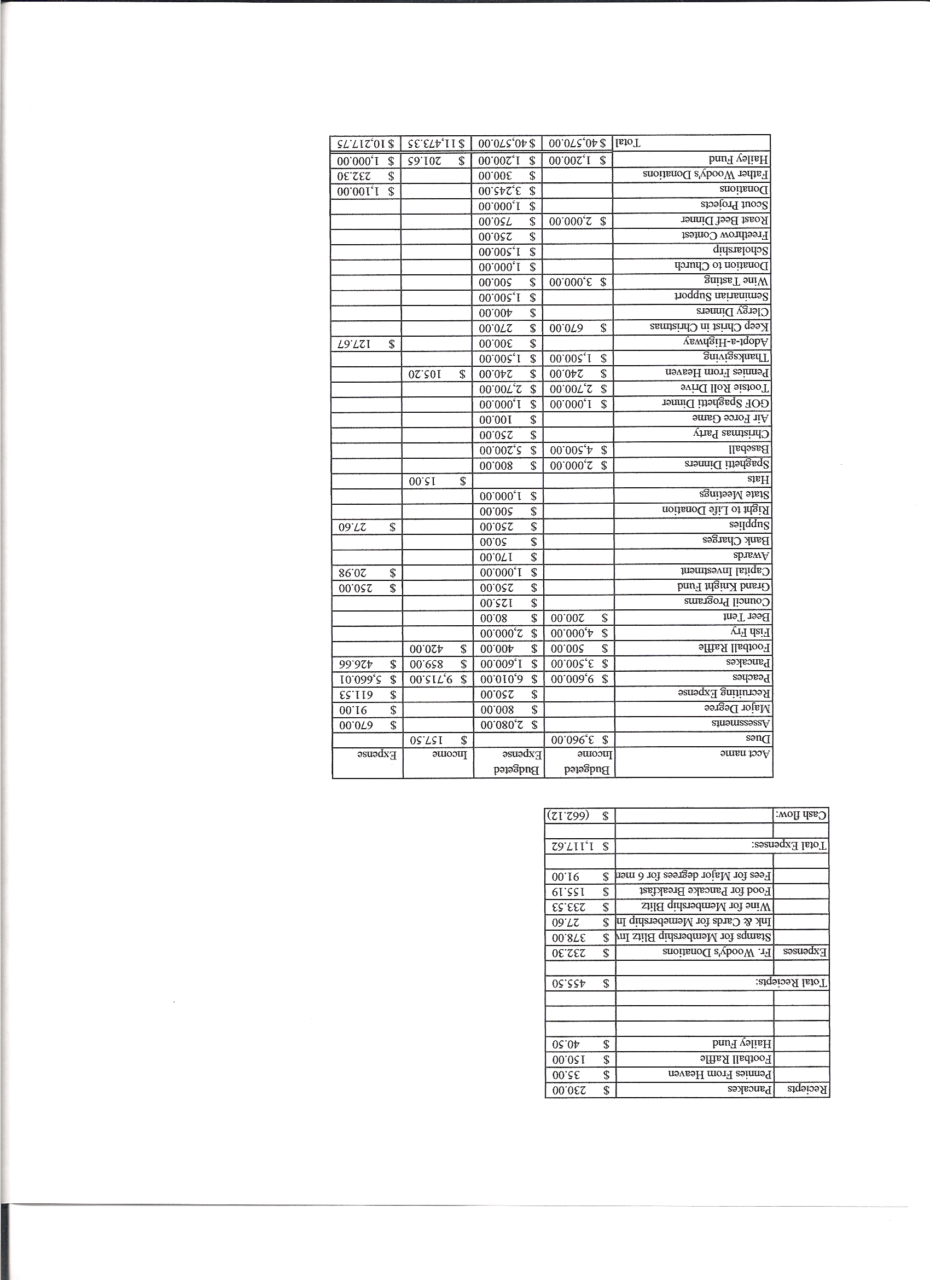
Business Meeting Minutes

February 12, 2011
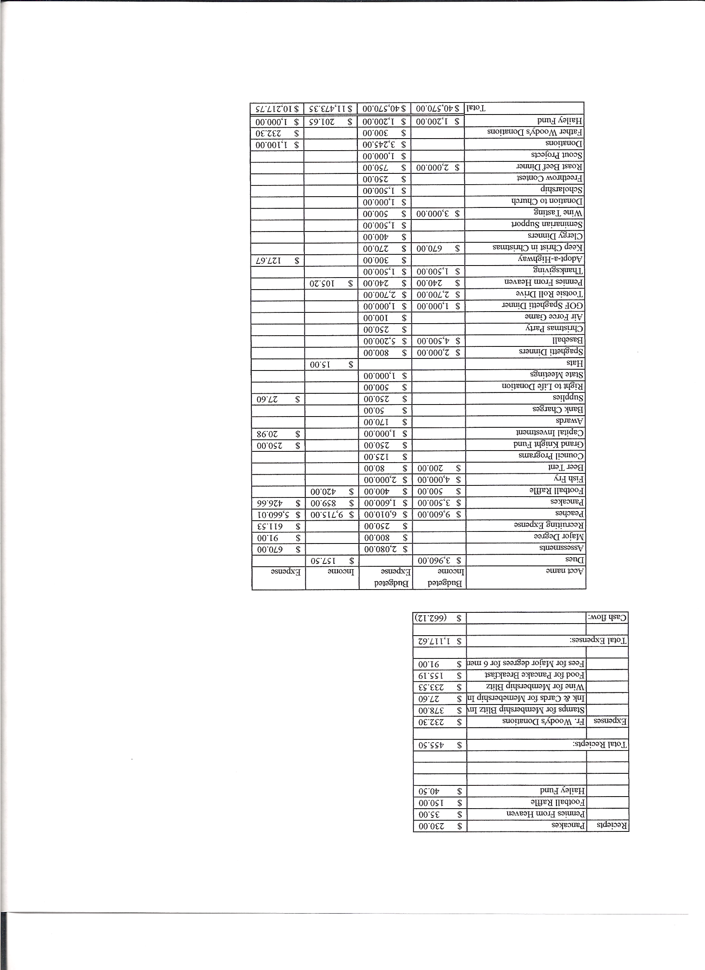

I. General
- The Council was called to order at 8:20 by Grand Knight Chris Kennedy
- Opening Prayer was offered by Paul Sciera The role of officers was called and noted as follows (P = Present; A = Absence; E = excused)

Title | Status | Title | Status | Title | Status
Chaplain | P | Financial Secretary | P | Inside Guard | P
Grand Knight | P | Treasurer | P | Outside Guard | P
Dep. Grand Knight | P | Lecturer | A | Trustee 3rd Year | P
Chancellor | P | Advocate | E | Trustee 2nd Year | A
Recorder | P | Warden | P | Trustee 1st Year | P

- The January meeting minutes were approved as read and published

II. Applications for Approval – Roger

Joshua Tracy and Keith Lobis both were approved and will have 1st degree Feb. 18th before happy hour.

III. Grand Knight Report – Chris
- Pennies from Heaven
- Knight of the Month – Mike McGinnis
- Family of the Month –John Kennedy family
- State convention coming up in April 28th – May 1st
- Start thinking about elections for next fraternal year. Need a recorder and Warden.
- Warden is first step, traditionally, on the track to Grand Knight.
- Program chair meetings to be held between 8:30 and 10 masses. Check emails for each committee.
- IV. Chaplain’s Report

- Fr. Ken reported the following: Quote “People make up the church, not the building by itself”
  - Thanks to Knights for all we do by being involved in church activities.
  - Thanks to Sir Knight Gary Mayfield and Serv Pro for their work on the lower level of Christi Center repairing damage from frozen pipe.
  - Kenny Kaehler a Knight for 56 years, passed away this week. Monday is the funeral.
  - CHRP coming in March 26th-27th .
  - V. Treasurer’s Report - Barney
- Balance as of Feb 1= $14,549.05 Available funds = $11,885.71
VI. Financial Secretary’s Report – Roger
Report handed out at meeting
Receipts = $2,368.75 Expenses = $1,500.89 cash flow of 867.86
VII. Committee Reports – Paul S

Auditor – None

Chancellor’s Update –
Vocations night ( meet and greet with seminarians and sisters) June 14th
Monday 21st mass at Redemptorous Martyr for Vocations

Family Report – Sean
May is Mothers day spaghetti dinner time
Council Activity Report – Leonard Leyba/

Happy hour is Feb 18th at the 1st degree at 6 p.m.

Church Director Report – Harisha B
Lenten reconciliation dinner is March 24th.
Guy will be looking for help with donuts this month. He will be out of town.

Community Report Jonathan Feifarek

Bicycle drive in May and adopt-a-highway coming soon.

Youth Report –Dennis Thumann
Basketball free throw contest with 5 participants going to districts next Saturday.
Scholarship contest ends Feb 28th and anyone wanting to assist with reading reports contact Dennis.
Altar servers’ recognition dinner coming after first of year as well.
Financial planning meeting for high school youth coming June 7th.

Right to Life report- Chris Mosely / Mike McGinnis
Write to congressmen about no tax money to be used for abortions. Planned parenthood is funded in part by tax dollars. Over $363,000,000 last year.
40 days for Life demonstrations are being put together and we are being asked for prayers and fasting

VIII. Unfinished Business =
None

IX. New Business
Convention delegates were voted on and Chris Kennedy and Ron Rietsch won in a land slide. Roger Guidici and Ben Stancati are alternates.
Seeds of Hope are looking for interest to help inner city Catholic schools with delivery of food from food bank to schools. Brought to us by Tom Odle.

^{4th} Degree Report – Roger
Corporate Mass is Feb 26^{th at St Marks}
March 27th is White Fence Farm outing. Save the date.
New Sir Knights Gary Mayfield, Joe Musso, Tim Pimmel, and John Alfeld

XI. Field Agent Report – Brian Brunette

No report

District Deputy Report – Mark Solome

We have 12 out of 11 for membership and 3 out of 4 for ins.
State convention advertising opportunities are available. 10937 has a half page in the State convention handout.
Our audit and fraternal survey was turned in.
10 Commandments plaque for sale with portion on profits going to State ultrasound initiative.

XIII. Good of the Order

Jim DeRose, Gary Ewing, Keith Kaehler

XIV Chaplain’s Summation – Fr. Ken

XIV. Closing Prayer
- Read by Paul Sciera

MEETING WAS ADJOUNRED AT

9:00 am

- minutes recorded and reported by Ron Rietsch

