KNIGHTS OF COLUMBUS COUNCIL #10937

Pax Christi Church
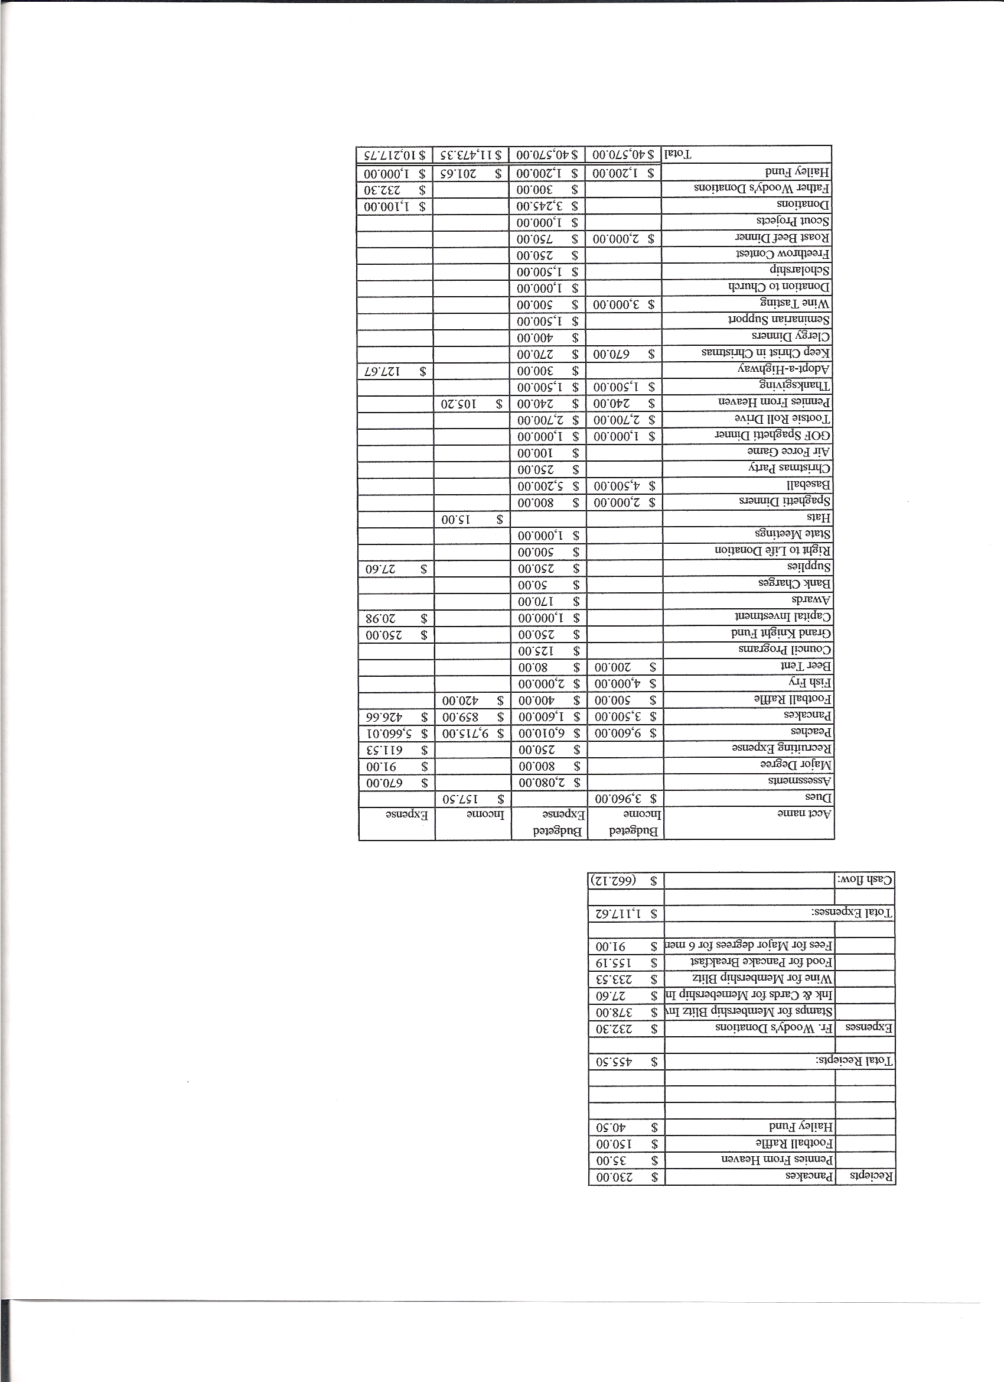
Business Meeting Minutes

October11, 2008
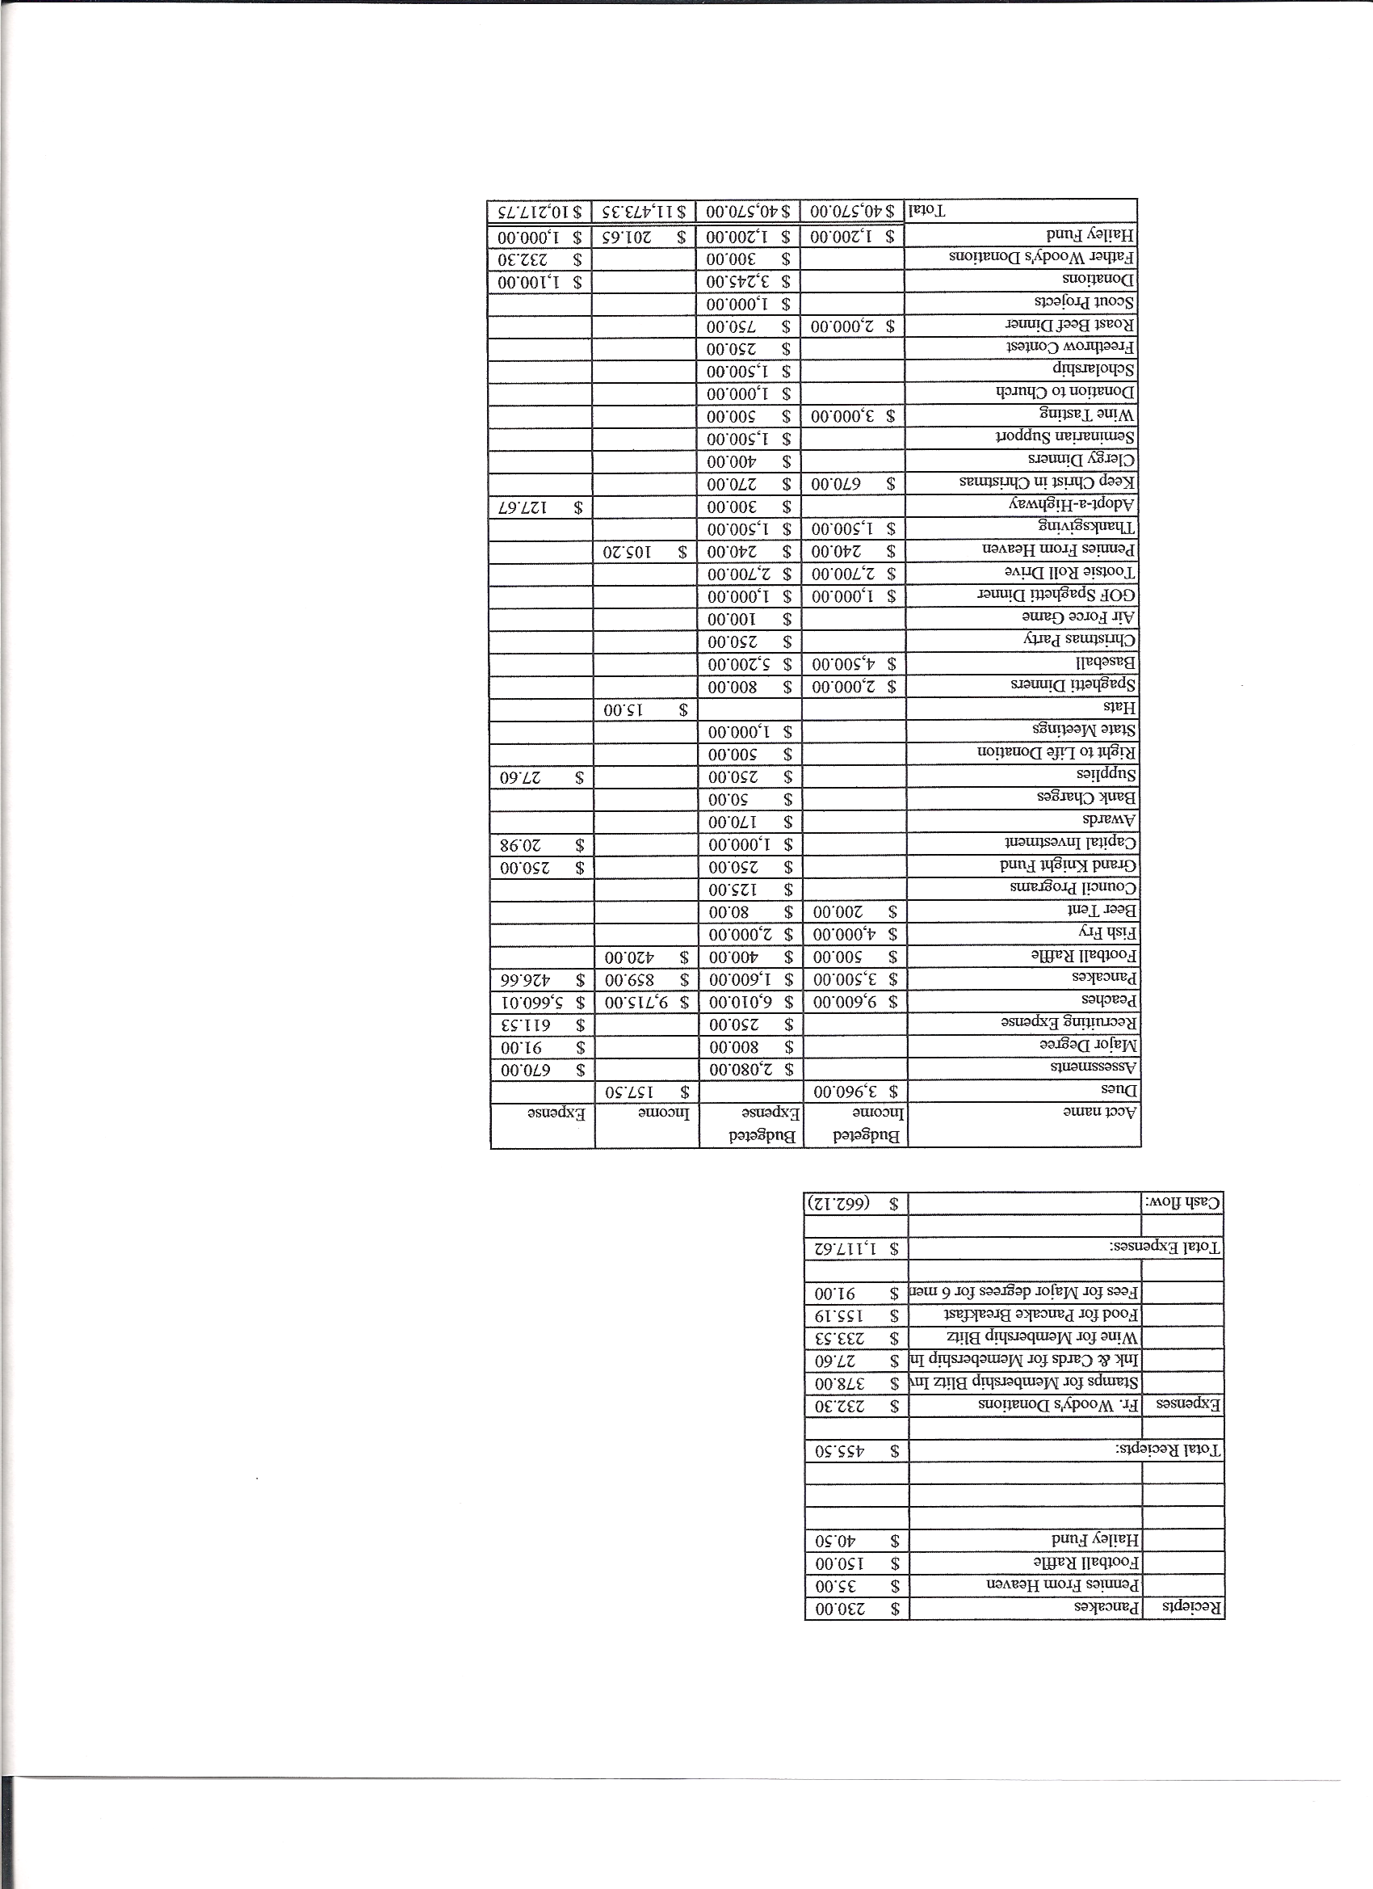

I. General
- The Council was called to order at 7:37am by Grand Knight Ron Rietsch
- Opening Prayer was offered by Chris Kennedy The role of officers was called and noted as follows (P = Present; A = Absence; E = excused)

Title | Status | Title | Status | Title | Status
Chaplain | P | Financial Secretary | P | Inside Guard | E
Grand Knight | P | Treasurer | P | Outside Guard | A
Dep. Grand Knight | P | Lecturer | A | Trustee 3rd Year | A
Chancellor | A | Advocate | A | Trustee 2nd Year | P
Recorder | E | Warden | E | Trustee 1st Year | E

- The September meeting minutes are approved as read and published

II. Applications for Approval – Chris K

- 1 new applications received
- Reading of applications for:
Jessie ( )

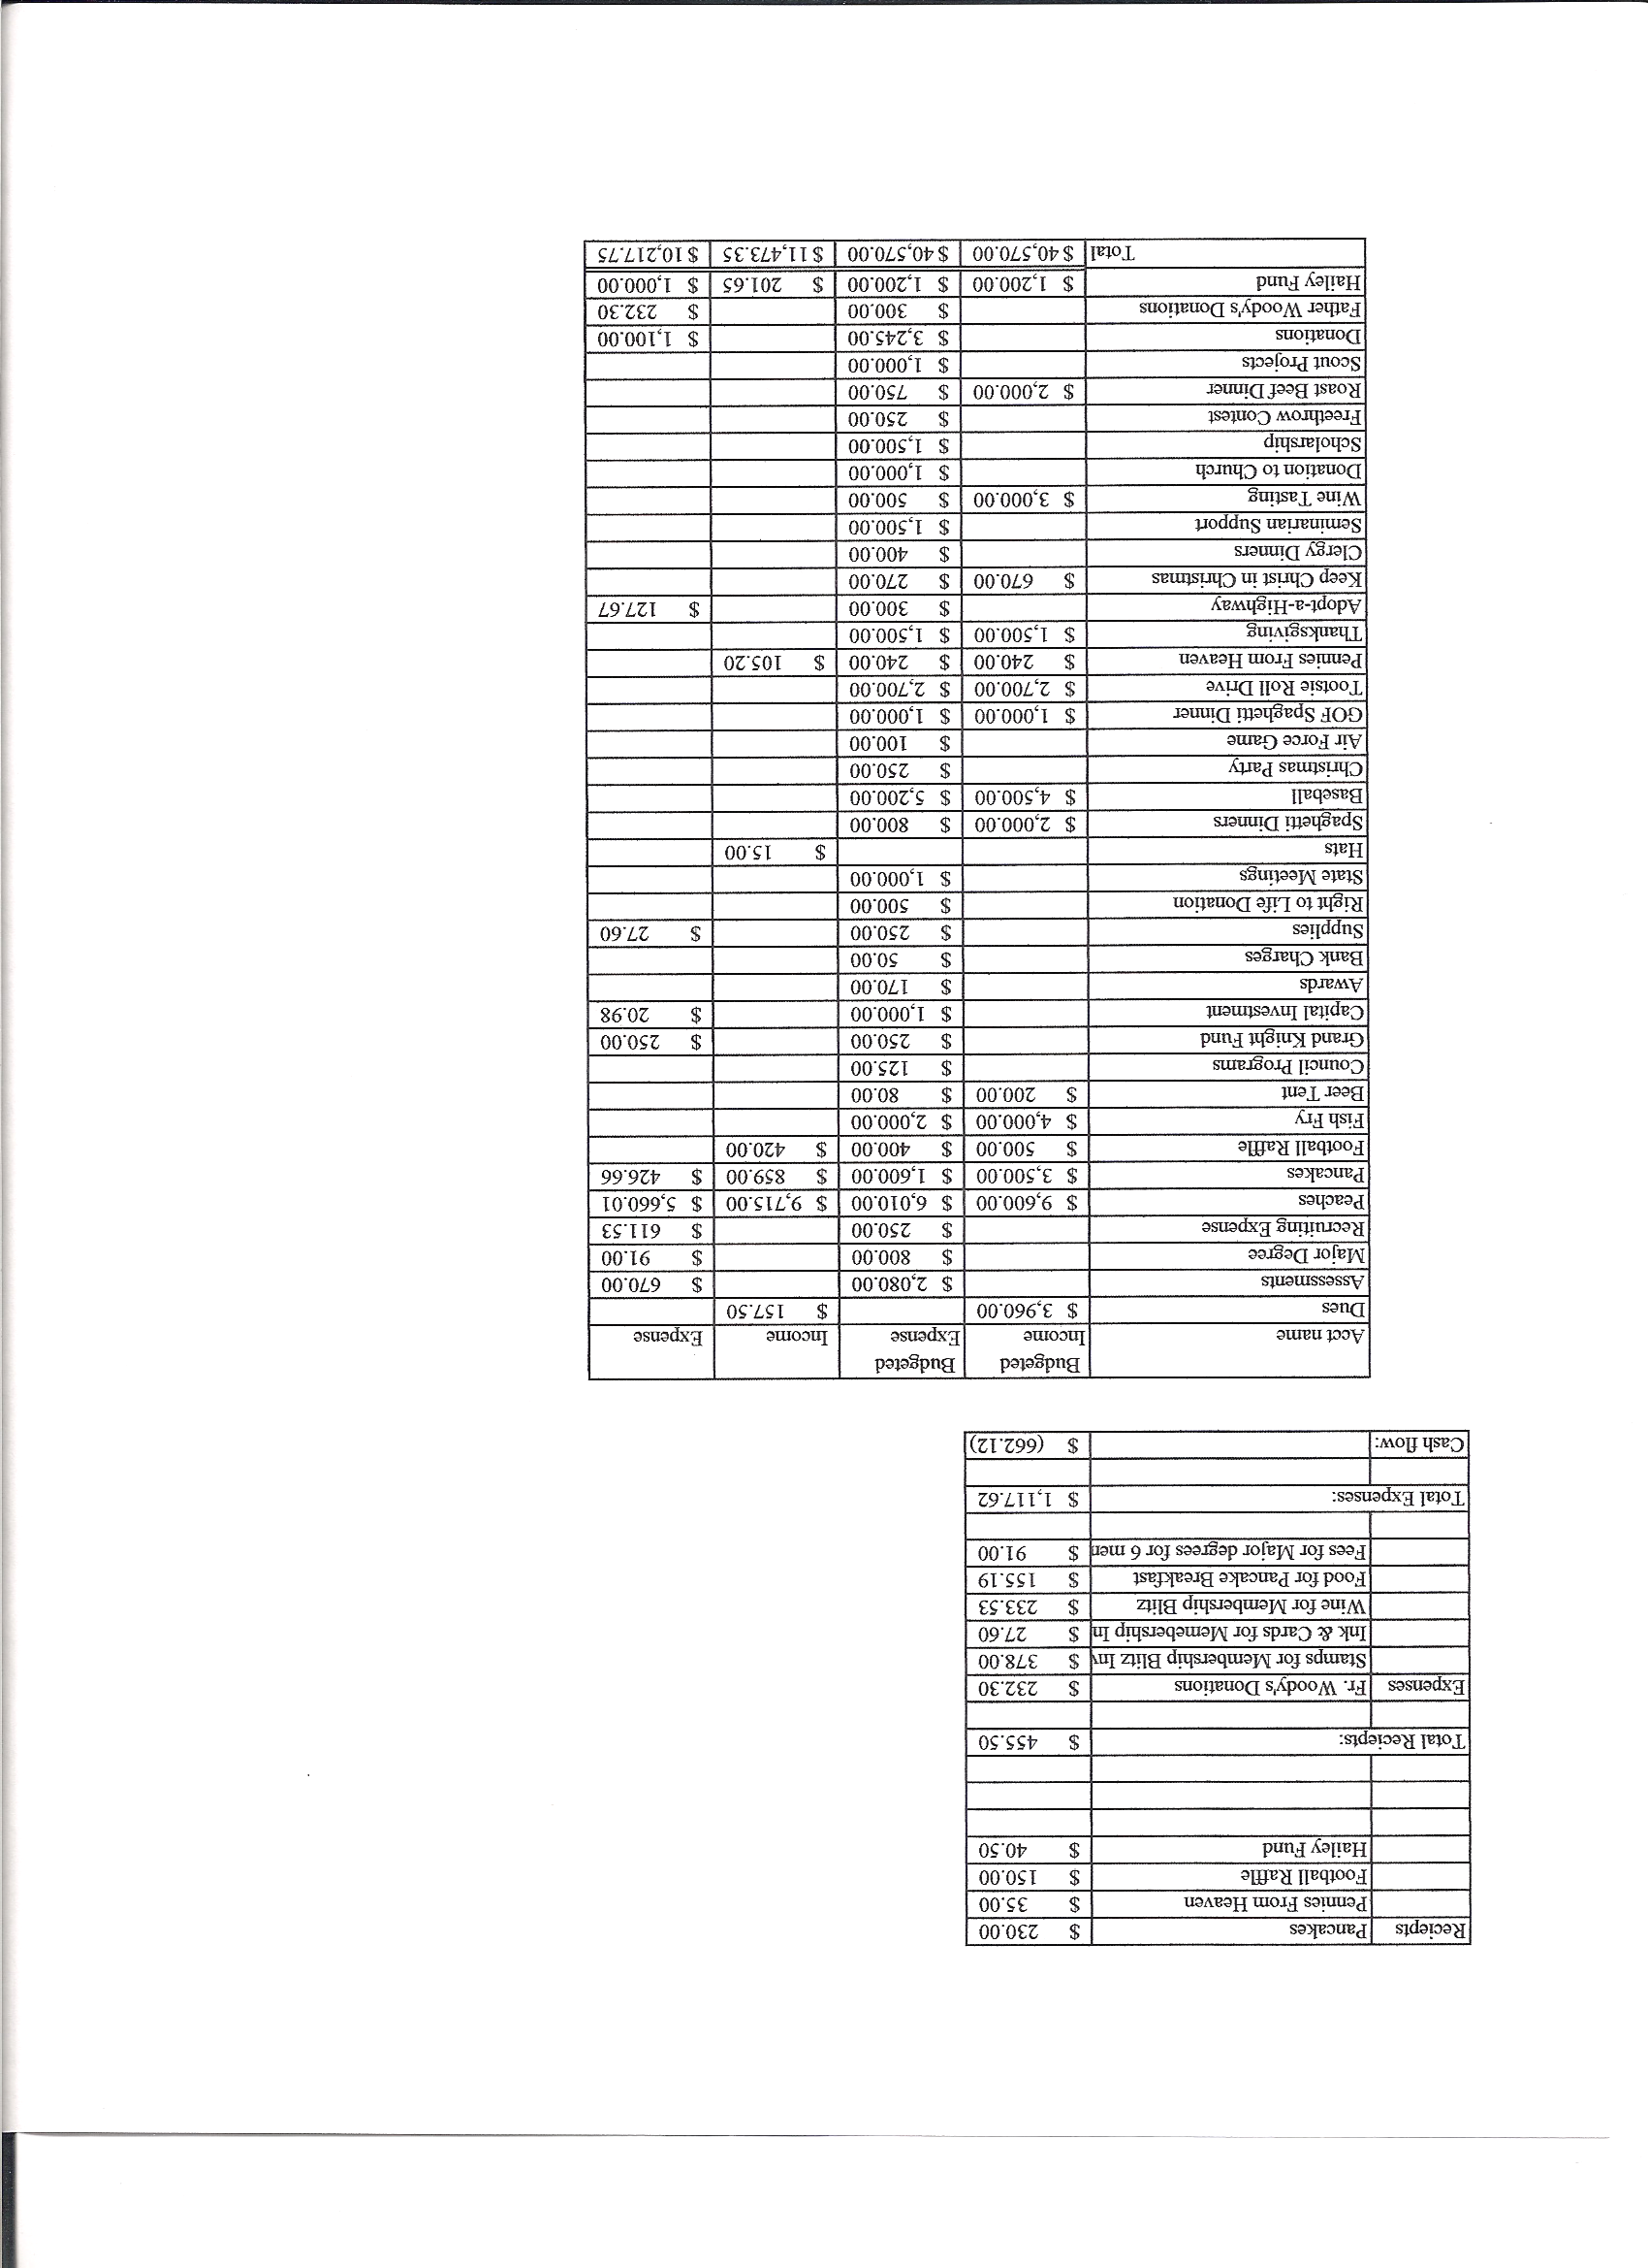

III. Grand Knight Report – Ron
- Thanked Brother Knights for their continuing support of Wife Andrea.
- Pennies from Heaven
- Thank yous read
  - From Joe Searlines’ Father in law for Haley fund gift
  - Special thanks from Ann Thumann for scholarship support
- From Tom Riley for check for Relay For Life
- Knight of the Month –Roger Guidici
- Family of the Month – Tim Pimmel

IV. Chaplain’s Report

- Fr. Ken reported the following:
  - Chillin and Grillin coming up
    - To be held with Oct 19
  - Pancake Breakfast
    - Nov 1 and 2 will be Third World sales
    - Nov 16th Generations of Faith info night 4:30-6:00
Nov 14th St Francis Cabrini prayer service for those serving in the Military and those who have died and Veterans

V. Treasurer’s Report - Barney
- Financial report passed out, showing all activities for rest of year
- See attachment for minutes
VI. Financial Secretary’s Report – Roger

VII. Committee Reports – Chris K

Auditor – None

Chancellor’s Update – None

Family Report – Tim
- Oct 18th Spaghetti Dinner coming up
  - Help will be needed in a variety of areas for Oct event
  - Please be on look out for email with more details
  - Air Force game was well attended (45)
  - Dec 19th is Christmas dinner for Knights and their families
  - Need someone to head up planning for Generations of faith program
Council Activity Report – Chris
Informational meeting on Oct 21st
KofC buttons to be worn at church
First Friday Mass downtown Denver sponsored by Chris Mosley

Church Director Report – Dan Cahill
Starting Christmas card sales soon after Masses
Looking to sponsor new Seminarian from Colorado Springs
Community Report – John Alfeld
- Tootsie roll drive this month

Thanksgiving dinner baskets to be assembled on Nov 21st
Money for Fr. Woodys was received and a thank you was read.
Money was used to purchase tooth paste and brushes as well as other personal hygene
Products.

Youth Report – Chris K for Don

Planning a roast beef dinner to aid in funding programs for the youth.
Tom Whyte and Roger Guidici assisting with Youth retreat.

VIII. Unfinished Business = NONE
Tim Pimmel made a motion to give all spaghetti dinner net proceeds to the Generation of Faith program. Was seconded and approved.

IX. New Business

NONE

4th Degree Report – Roger
October 19th at White fence farm to meet for dinner.

XI. Field Agent Report – Ken

Money with the Knights Insurance plans is safe. The past and present stock market falls and uneasiness haven’t affected the Knights. We are still an A Best rated company.

District Deputy Report – Tom O

Congratulated us for all our hard work!
Introduced Mark Solome as his District Warden and to be the new D.D. next term in June.
52 new 3rd degrees at last weeks degree.

All 1st degrees are in honor of Fr. Richard Ryan

XII. Good of the Order - Ron

XIII. Chaplain’s Summation – Fr. Ken

XIV. Closing Prayer
- Read by Chris Kennedy

XV. Closing Ode
- Read by Chris Kennedy

MEETING WAS ADJOUNRED AT

9:12am
- minutes recorded and reported by Don Z.

