KNIGHTS OF COLUMBUS COUNCIL #10937

Pax Christi Church
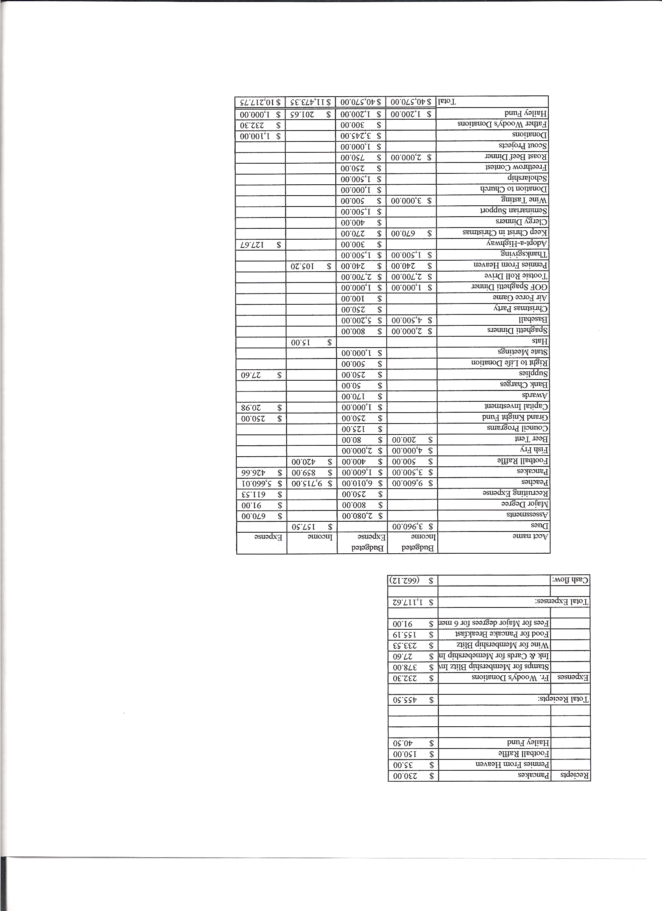
Business Meeting Minutes

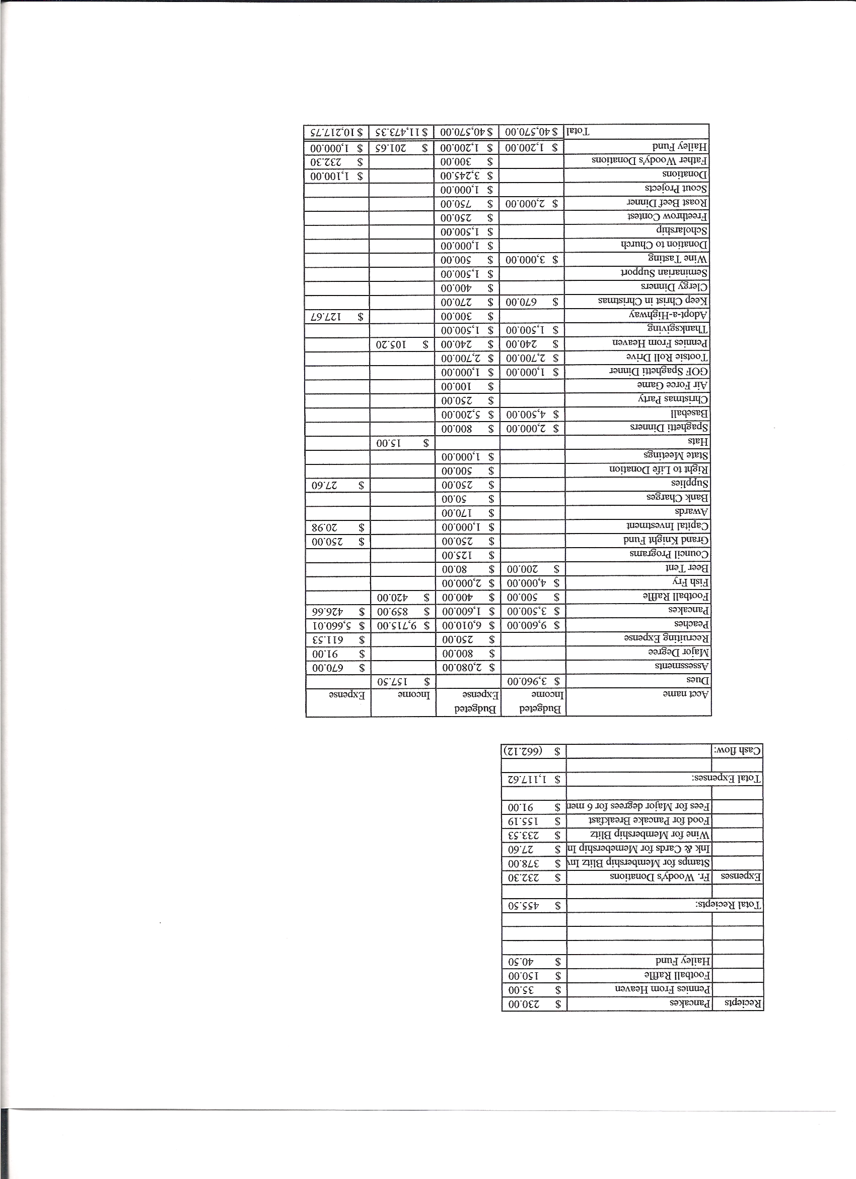

I. General
- The Council was called to order at 8:03 AM by Grand Knight Chris Kennedy
- Opening Prayer was offered by Paul Sciera The role of officers was called and noted as follows (P = Present; A = Absence; E = excused)

Title | Status | Title | Status | Title | Status
Chaplain | P | Financial Secretary | P | Inside Guard | E
Grand Knight | P | Treasurer | P | Outside Guard | NA
Dep. Grand Knight | P | Lecturer | A | Trustee 3rd Year | A
Chancellor | P | Advocate | E | Trustee 2nd Year | A
Recorder | A | Warden | P | Trustee 1st Year | A

- The May meeting minutes were approved as read and published

II. Applications for Approval – Roger

none

III. Grand Knight Report – Chris Kennedy
- Pennies from Heaven
- Knight of the Month – Dave Martz
- Family of the Month – Chris Kennedy Family

- IV. Chaplain’s Report
- Thanks to Chris.
$23000 sent to Haiti - Will start building chapel. Some $$ possibly used for a school.
Second trip to Haiti possible around Oct. or Nov.
Beer and Brats tonight.
Rediscover Catholicism book discussion Wed. 6/15/11.
Women’s and men’s renewal in Oct.
Possibility of starting a “That Man Is You” spiritual foundation group at Pax Christi.

  - V. Treasurer’s Report - Barney

Bank Balance $16,632.58

Available Funds $14,357.57

VI. Financial Secretary’s Report – Roger
Report handed out at meeting

VII. Committee Reports – Paul S

Community-Highway cleanup was successful.
Council-Fri.,17th happy hour.
- June 26th next breakfast. (Finish left over burritos. No more burritos until Aug.
Youth -Thanks to Steve Lucas and Chris Kennedy for coordinating the Finance Workshop.
-Relay for Life July 29th.14 hours; ½ mile track; walk as long as you like. Knights will cook at Redstone Park at 6:00 PM Friday for the walk.
-Dennis needs someone to take over the scholarship program next year. He will train.
Right to Life.- Father Ken, and, Chris, Michelle and Christian Kennedy , Barney and Barbi Meyers, and, Mike and Denise McGinnis all participated in the Walk for Alternatives along with about 850 others who are equally concerned about the unborn.
Property next to the church (tax relief) .Possible trail of reflection for Stations of the Cross.
Eagle Scout project ?? (Build benches along the trail etc.)
Need to check on what exactly will constitute tax relief.
Guy on “That Man Is You” –Meets early once a week. – Discuss spiritual questions posed on a DVD. – Has been very successful in large parishes drawing 100 to 200 men in attendance at weekly meetings.
Need core team of about 6 to 8 men to plan fall start.
Election of Officers: Slate of officers – no new nominations.
Grand Knight – Paul Sciera
Deputy Grand Knight - Joe Musso
Chancellor – Gary Mayfield
Warden – Matt Yeagle
Inside Guard – Ben Stancati
Outside Guard – Dennis Cullen
Recorder – Mike McGinnis
Treasurer – Barney Meyer
Advocate – Dave Petteys
Trustee 3 year – Chris Kennedy
Trustee 2 year – Ron Rietsch
Trustee 1 year – Chris Mosley

Unanimously Approved as read.

Motion by Paul Sciera to approve increases in donations as recommended by Roger:
Raise from $800 to $ 950 donation to US tragedy relief (tornados etc.)
Raise from #900 to $1000 donation to Catholic Relief Services.
Prayer books to troops $300.
Motion seconded by Jim Egan and approved.

Auditor – None

Chancellor’s Update –

Barbeque for Redemptorists last week.
Vocation Night on Tuesday this week.
Prayer for Vocations said.

VIII. Unfinished Business =

None brought up.

IX. New Business

Paul Sciera would like a committee to send out cards for birthdays, anniversaries etc. Will need a coordinator and a data base update.

X. 4th Degree Report – Roger

9:15 Ordination Mass at St. Dominics in Security June 18tth.
White Fence Farms dinner for 3rd and 4th degree - $25 / adult ; $12 / child
H.R. July 4th parade. Meet at Target at 9:00 AM. Info later.

Field Agent Report –

XI District Deputy Report – Mark Solome (Chris)
Down one on insurance. Paper work in progress.

XIII. Good of the Order
Jim DeRose

Roger presented a metal to Chris Kennedy for Grand Knight service for the past two years.

THANKS , CHRIS , FROM ALL OF US, !!

XIV Chaplain’s Summation – Fr. Ken

XIV. Closing Prayer
- Read by Paul Sciera

MEETING WAS ADJOUNRED AT 9:05 am

- minutes recorded and reported by Mike McGinnis

