KNIGHTS OF COLUMBUS COUNCIL #10937

Pax Christi Church
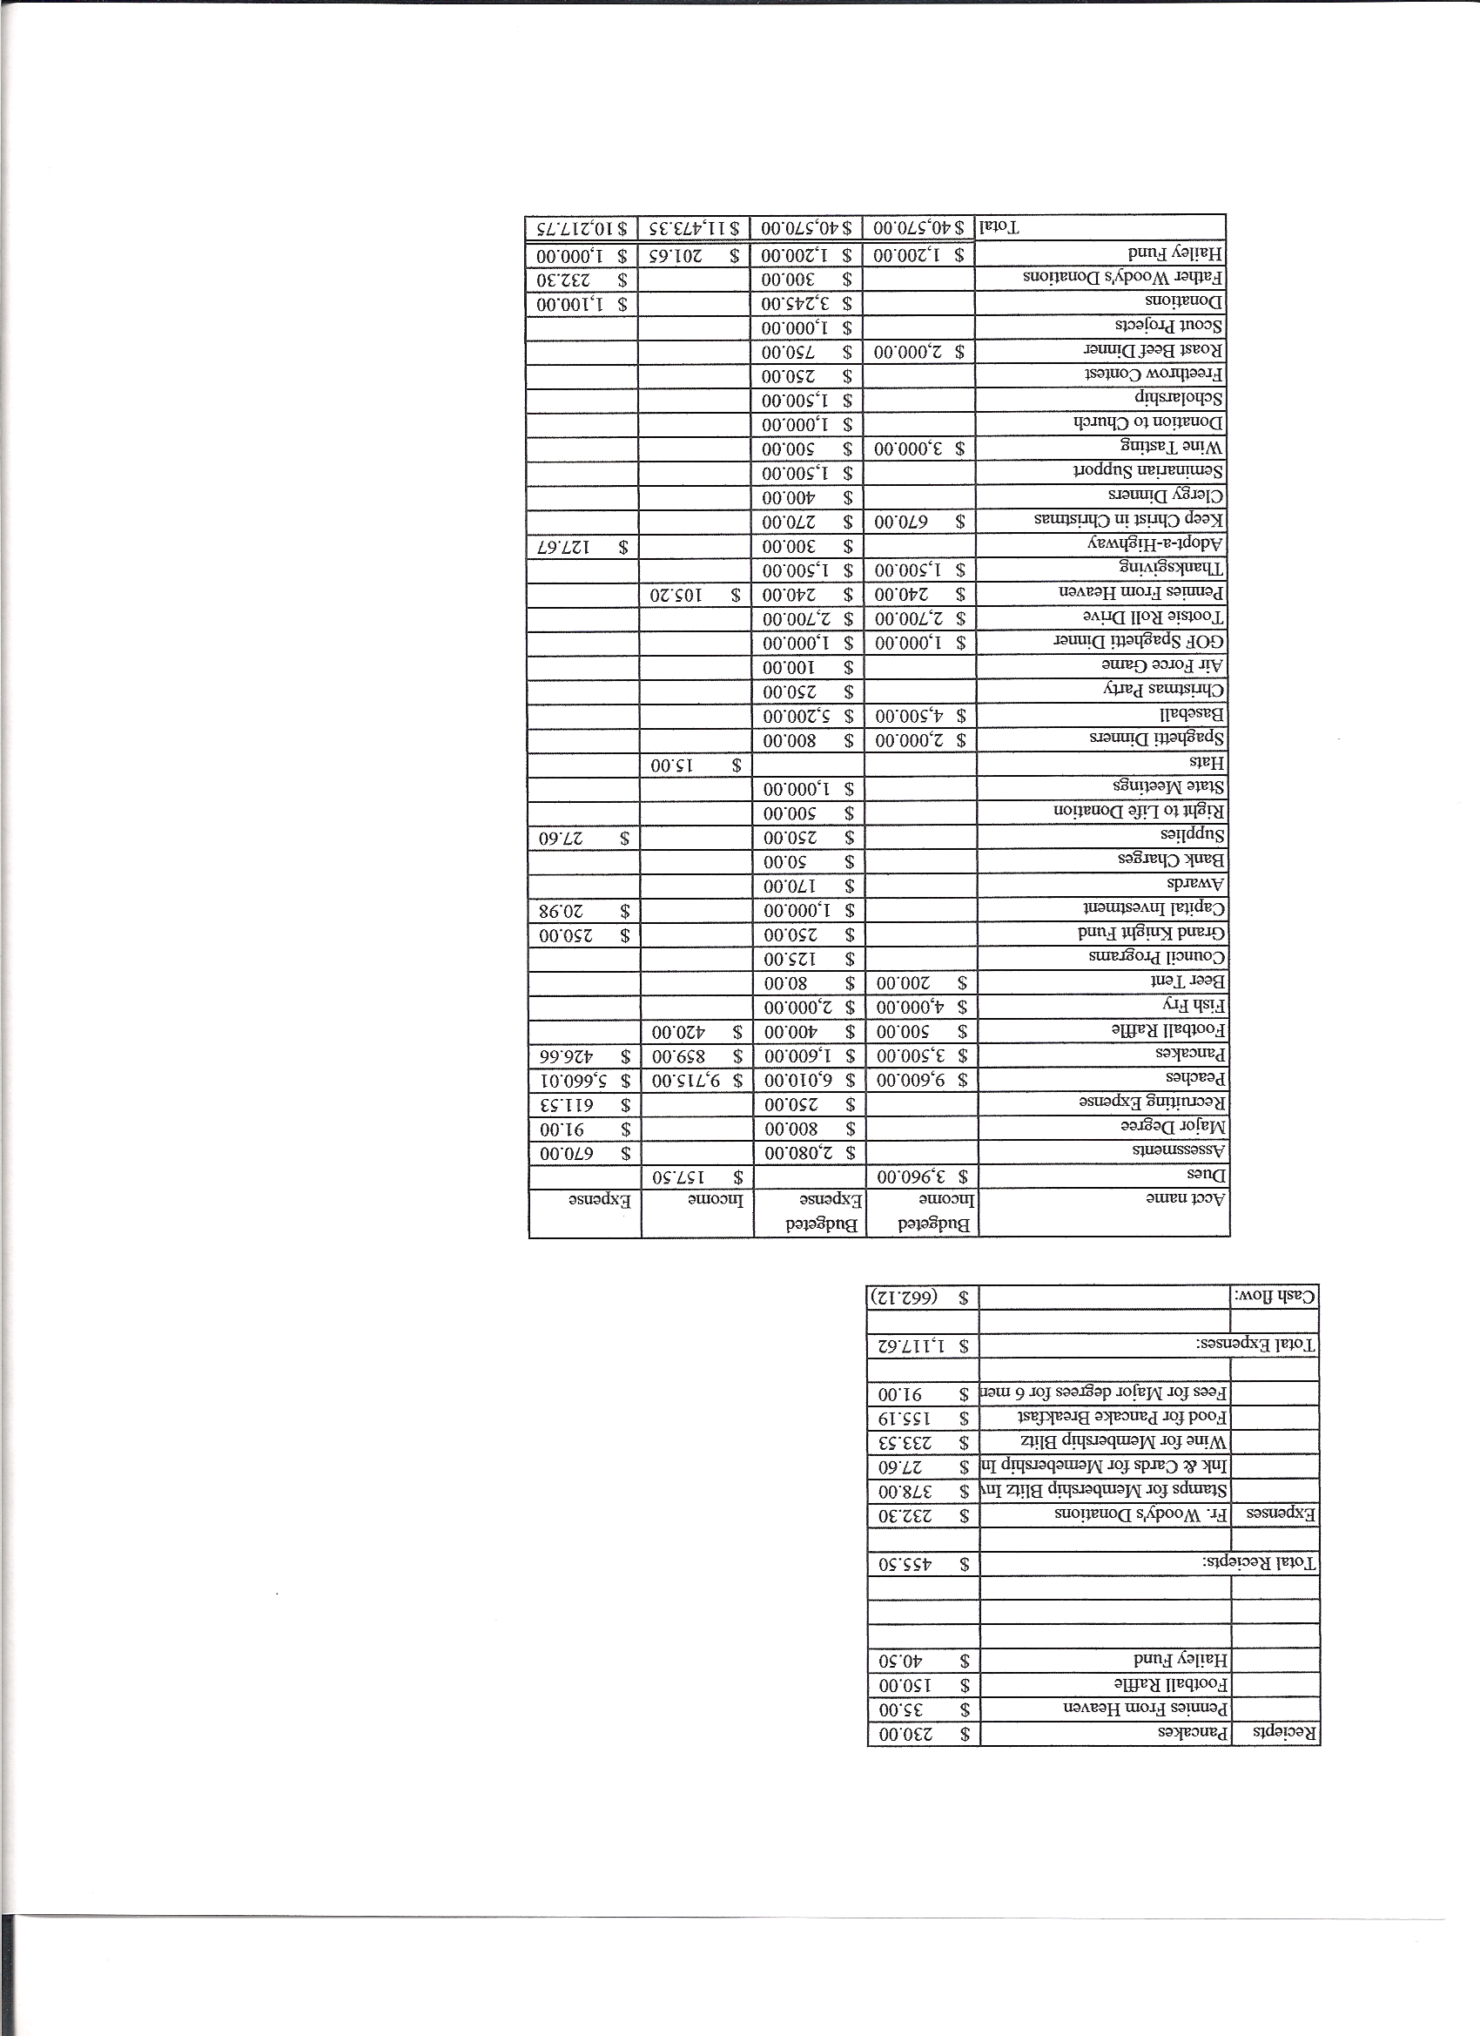
Business Meeting Minutes
July 9, 2011

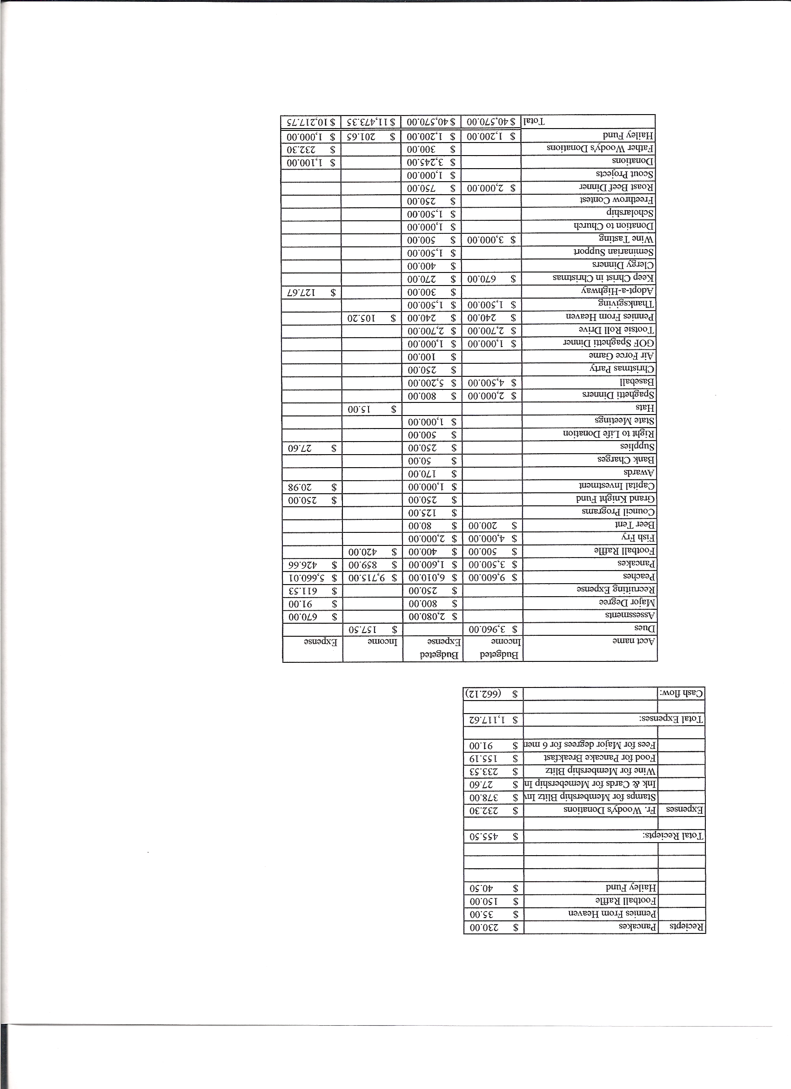

I. General
- The Council was called to order at 8;05 by Grand Knight Paul Sciera.
- Opening Prayer was offered by Joe Musso. The role of officers was called and noted as follows (P = Present; A = Absence; E = excused)

Title | Status | Title | Status | Title | Status
Chaplain | P | Financial Secretary | P | Inside Guard | P
Grand Knight | P | Treasurer | P | Outside Guard | P
Dep. Grand Knight | P | Lecturer | none | Trustee 3rd Year | A
Chancellor | E | Advocate | P | Trustee 2nd Year | P
Recorder | P | Warden | E | Trustee 1st Year | E

- The June meeting minutes were approved as read and published.

II. Applications for Approval – Roger

Application transfer John Hertzkavitz.- Unanimously accepted.

III. Grand Knight Report – Paul
- Pennies from Heaven
- Knight of the Month – John Starke
- Family of the Month – The Family of Victor Ogunmodede.

- IV. Chaplain’s Report

- Property next to Church.
-Much work was done cleaning up area and barn.
- Taxes of $42,000 for unused property.
- Plans for a pavilion and has asked the Diocese for $10,000 toward improvements.
- More help needed for cleanup.
-Pamphlets in great hall for 5 wishes for terminal patients.
-Discussed plans for “This Man Is You” for this fall.
-Talked about prayer as in letter from Knight’s Chaplain. Adoration, petition, intercession and thanksgiving covered in the article. We never pray alone but as part of the entire Church.
-Thanked the Knights for their service.

  - V. Treasurer’s Report - Barney

Report handed out:
As of July 1, 2011.
Bank balance $ 15,686.14
Available funds $ 11,846.83.

VI. Financial Secretary’s Report – Roger

Report handed out at meeting

VII. Committee Reports – Joe Musso

Vocations Vocations Night – Two seminarians , six youth and six adults were present.
There are some dinners and barbeques which raise money to support and send seminarians to Youth Day.

Family Report – Shawn

-Shawn needs help for family activities in August.

Council Activity Report

-Knight of the month and family of the month could also be state knight of the month and family of the month .
- Keep notes of all hours spent working on KofC activities for report.
-Program reports need pictures, records, etc.
-Beer and brats tonight.
-More on property by the Church.
Uses- Pavilion and parking lot. Will tear down the barn. Will get estimates on cement etc. (Trying to make a facility for parish events.) Will hire a general contractor to plan. Will need help from 10:00 to 12:00 today to finish teardown.
-Rockies tickets. 43 out of 50 tickets have been sold.

State Meeting Theme

-Get state members more involved.
-Retention committee Chair. John Starke volunteered.
-Book and reports will be different. Focus on quality not quantity.
-Push for one new member per month. Incentive- Do 1st degree right away.
-Star Council changed.- Must do four 1st degrees.
Order of meetings will be changed by Supreme.- Chaplain’s reflection will be placed at the beginning of the meeting.
-Knight’s Call will publish knights and families of the month.
-Suggestion: Try to attend at least one mass at the convention. First day mass is ideal.
-Shining Knights. Get 1st year Knights involved immediately. Could be recognized at state convention.

Youth Report –Dennis Thumann

-John Kennedy will be taking over H.S. scholarships.
-Youth group going to Busby Montana to repair homes.
-8 going to Mescalaro Apache Reservation in New Mexico.
-7 going to a team retreat.
-July 16th bingo night to raise money for youth group.
-Our seminarian, Jason Keys has worked with youth.
-Relay for Life coming up. 55 registered on Team Pax Christi.

Right to Life report- Chris Mosely / Mike McGinnis

-8 states have now rejected renewal of tax payer monies to Planned Parenthood. New Hampshire is the latest to do so.
-A new 40 Days for Life campaign is beginning Sept. 28th. Mike would ask limited
participation in the way of daily prayers. Mike will try to e-mail the reflection and prayer each day of the campaign. Please think about the reflection and then say the prayer.
-Raising money for the Ultra Sound.?- Possibly a dance? Suggestions are welcome.

VIII. Unfinished Business

-Dave Pettis volunteered to be Advocate.
-Seconds are needed for program chairs. Please step up.
-Paul reminded everyone to attend the planning meeting if you want something on the business meeting agenda.

IX 4th Degree Report – Roger

-18 Knights attended the 4th of July parade.
-Social at White Fence .
-30 Knights at Pax are 4th degree.

X. New Business

-none

XI Field Agent Report – Brian Brunette

-none

District Deputy Report – Mark Solome
.
-none

XIII. Good of the Order

-Pray for Brother Jim DeRose and Gina.

XIV Chaplain’s Summation – Fr. Ken

-Father Ken shocked us with news of his transfer to St.Francis of Assisi in Colorado Springs on September 1, 2011.
-Brian Mohan will be the new pastor at Pax Christi.

XIV. Closing Prayer
- Read by Joe Musso

MEETING WAS ADJOUNRED AT

9:13 am

- minutes recorded and reported by Mike McGinnis

