KNIGHTS OF COLUMBUS COUNCIL #10937

Pax Christi Church
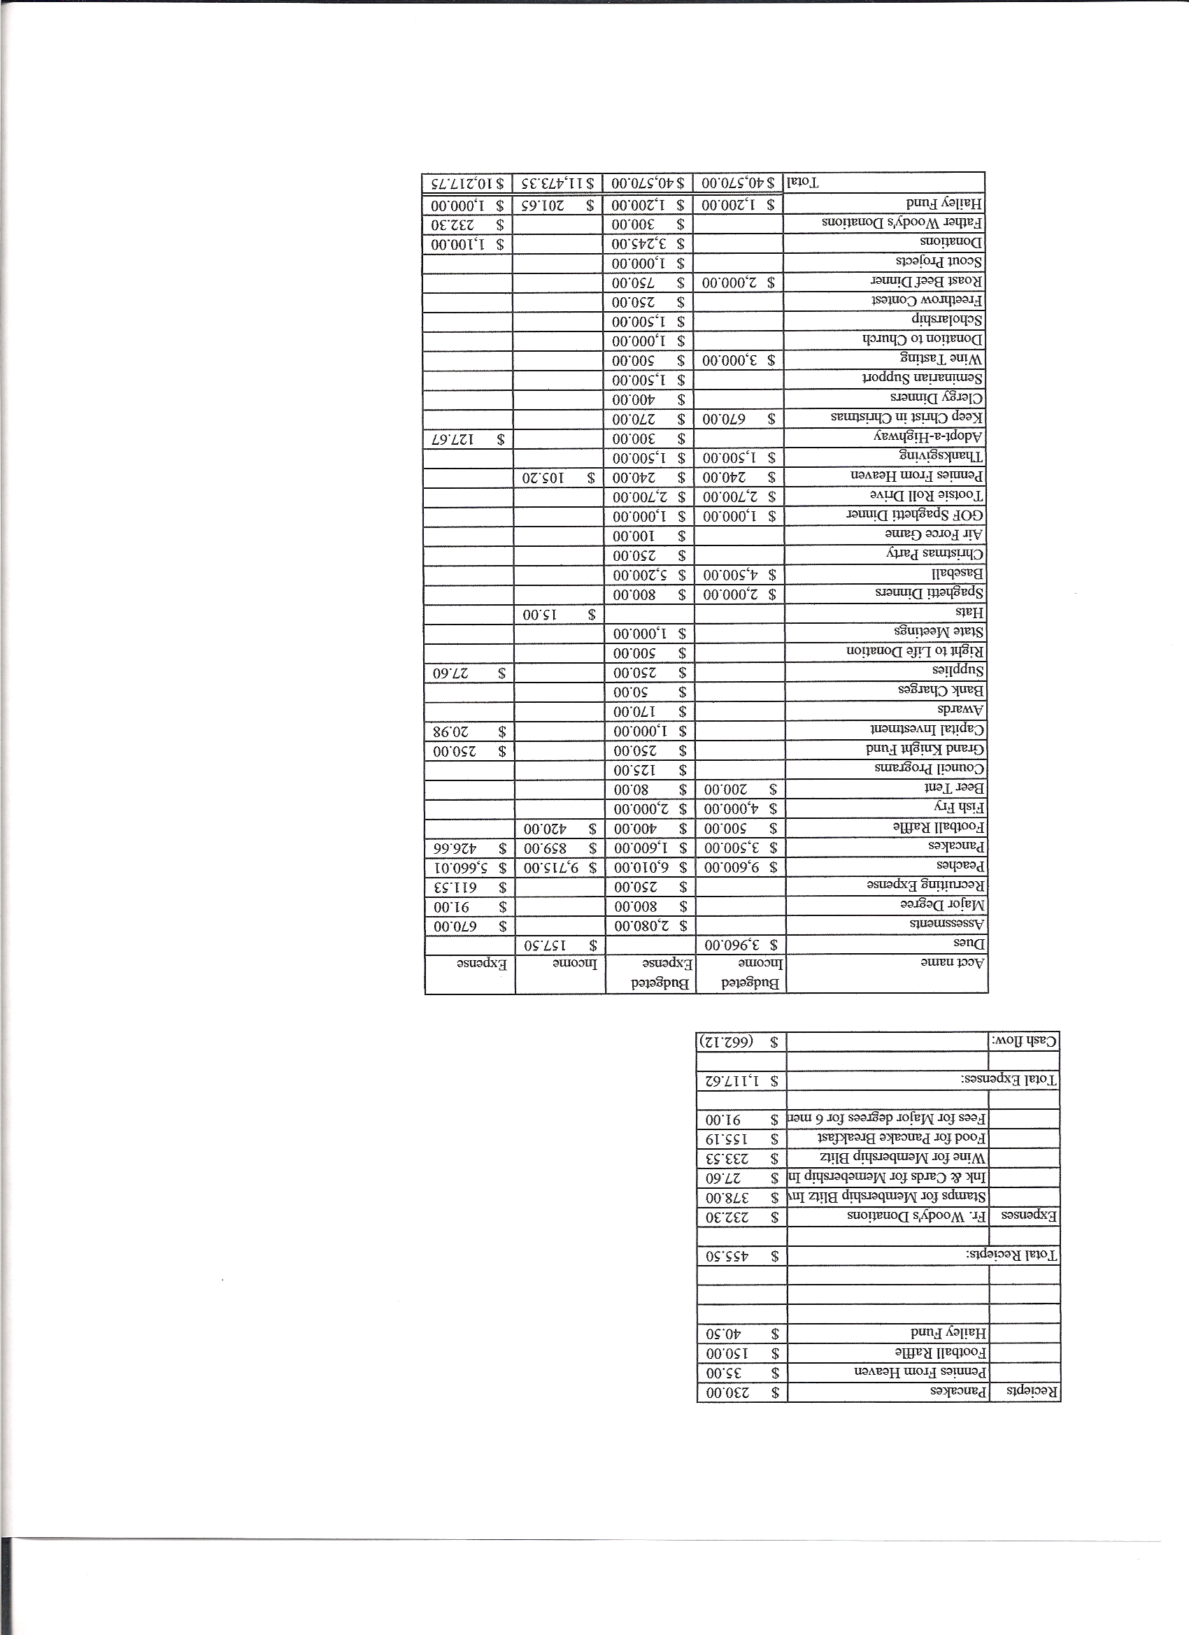
Business Meeting Minutes

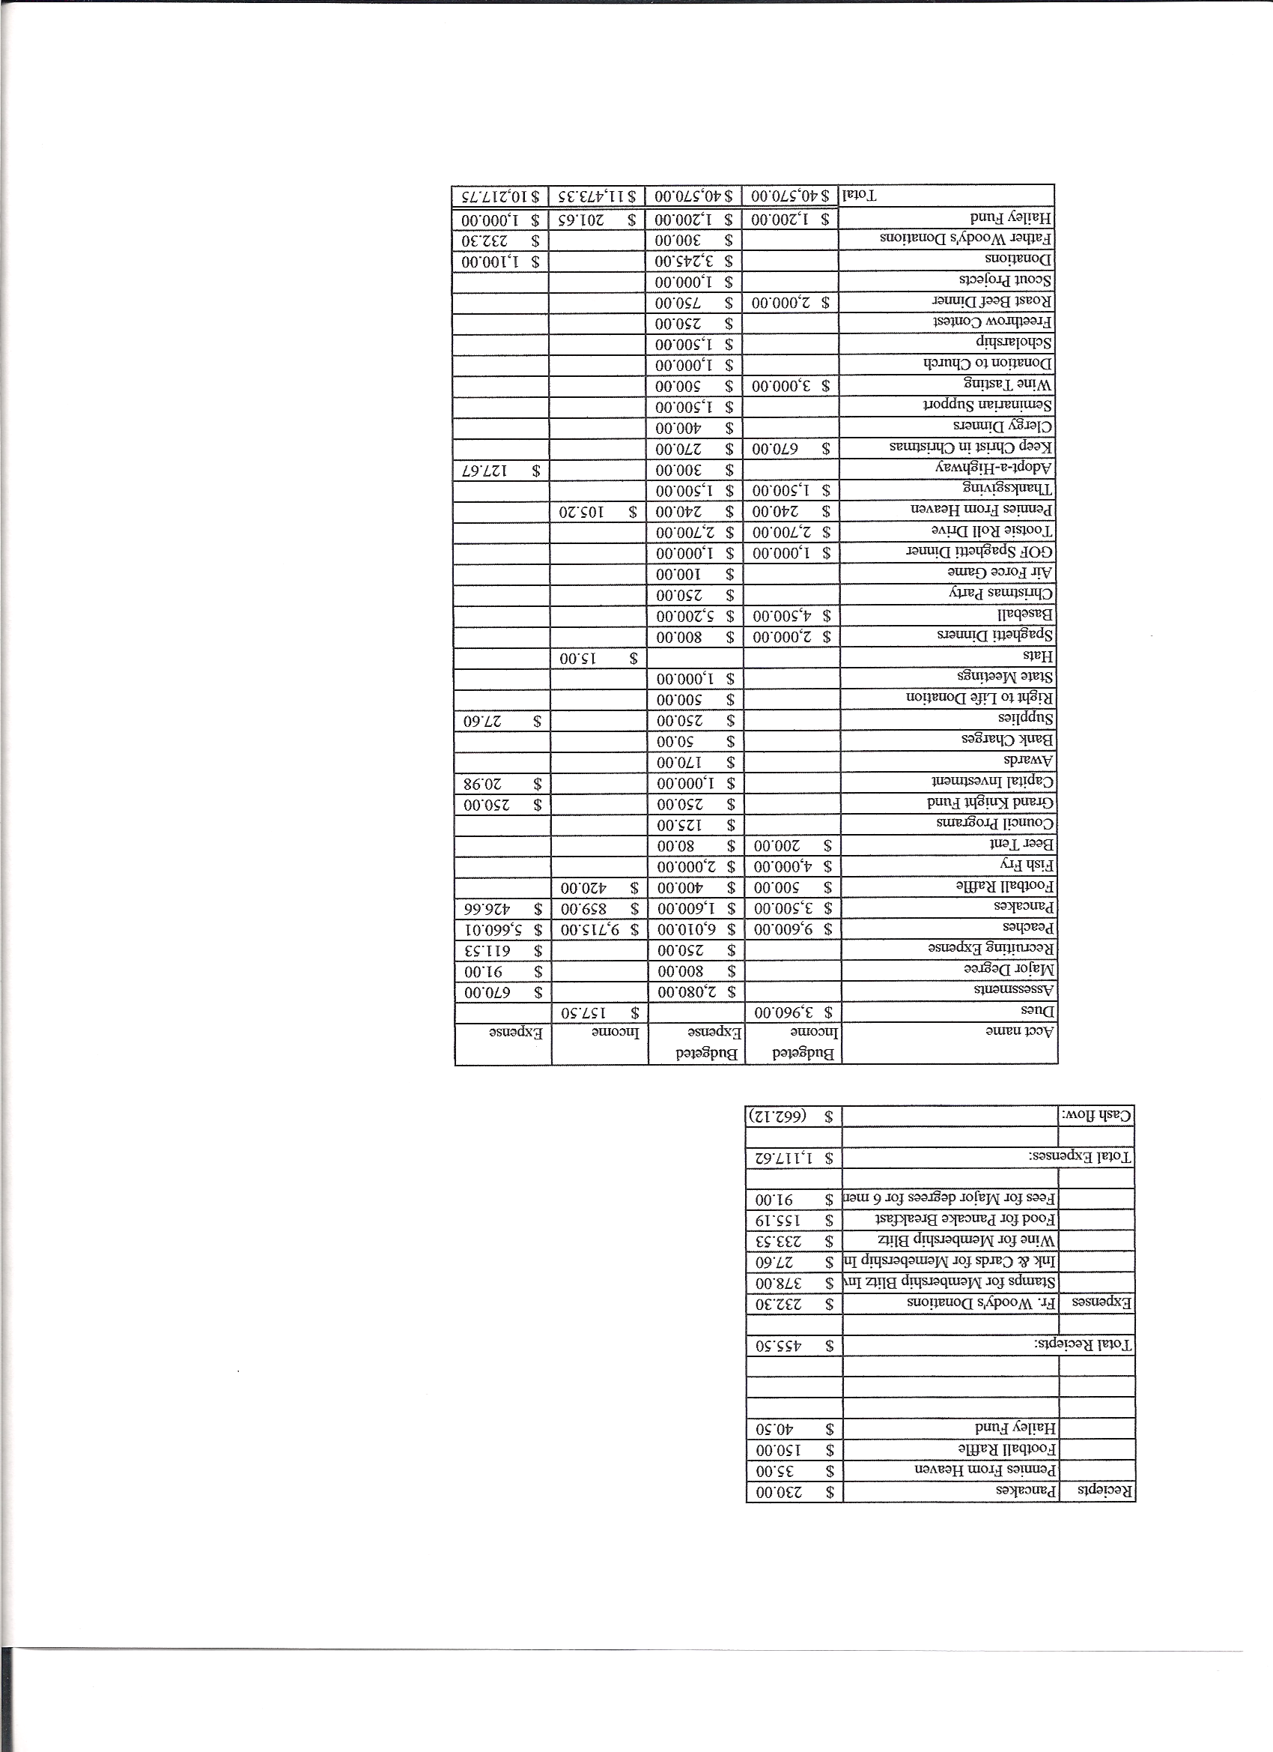

I. General
- The Council was called to order at 8:29 AM by Grand Knight Paul Sciera.
- Opening Prayer was offered by Paul Sciera The role of officers was called and noted as follows (P = Present; A = Absence; E = excused)

Title | Status | Title | Status | Title | Status
Chaplain | P | Financial Secretary | P | Inside Guard | P
Grand Knight | P | Treasurer | P | Outside Guard | P
Dep. Grand Knight | P | Lecturer | NA | Trustee 3rd Year | P
Chancellor | P | Advocate | P | Trustee 2nd Year | P
Recorder | P | Warden | P | Trustee 1st Year | A

- The July 2011 meeting minutes were approved as read and published

II. Applications for Approval – Roger
No new applications presently but some potentially showed interest from Ministry Fair.

One transfer application for Kevin Kincaid. Transferring from Castle Rock. Voted on and accepted.

III. Grand Knight Report – Paul
Supreme Dinner was inspiring.
Need an updated list for birthdays, anniversaries etc. If you haven’t sent this information in please do so ASAP. Lady Knights will handle the details.
Thanks to those who helped notify people regarding delay in peach pickup.
Need volunteers to help with distribution of peaches.
Need help tearing down barn.
- Pennies from Heaven
- Knight of the Month – Father Ken
- Family of the Month – Jim Egan Family
Recruitment Effort Award – Max Gramly
- IV. Chaplain’s Report
- Commented on Supreme Bishop’s article on prayer. Emphasized habits of prayer. Should have a time to pray. There are different types of prayer. – confessing faith, thanksgiving, vocal, meditation, contemplation. Important to be focused on time for prayer. Try praying while doing other things. Pray for others.
- Father Ken thanked those who worked tearing down the barn. He explained that County regulations require a restroom within 500 ft. of structures. A smaller pavilion closer to the Chapel might be the answer. Also a road to and around the property and a prayer path are possibilities.
- Father thanked the Knights for their support and stated that he has been a member of three councils and Pax Christi has been the most active.
  - V. Treasurer’s Report - Barney
Bank Balance - $ 14,054 Outstanding Checks- $2,000
Hailey Funds- $1,827.55 Lady Knights- $33.17
Available Funds- $10,194.11
Current CD #1 $2,082.99 Current CD #2 $1,659.39
(Report was handed out at meeting.)
VI. Financial Secretary’s Report – Roger
(Report handed out at meeting.)
Receipts = $9,396.07 Expenses = $5429.30 Cash Flow = $3,966.77
VII. Committee Reports – Joe Musso
Prayer for vocations was read. Joe expressed the need for a Church Director. Ron Reitsch graciously volunteered.
Matt has been corresponding with Father in Haiti. The Chapel is about 1/3 complete. There is a 50-50 chance of going to Haiti in October.
Beer and Brats tonight. Help needed and appreciated.
Thanksgiving and Tootsie Roll (2 weekends) drives coming up.
Jonathan Feifarek will work with communications committee. October is fall hwy. pickup.
Happy Hour is at Ron and Andrea Reitsch’s this month.
Shawn- Talked about the fishing event Aug. 21 at Lake Lehow near Chatfield Resevoir from 8AM to 4 PM. Oct. 1st is the Air Force game.
Max on membership- mouth to mouth is the best way to recruit. Please take advantage of any recruiting opportunities.
Youth- Soccer a join effort of Pax and St. Mark. Will be in Oct. at Redstone Park.
Advocate- New bi-laws will be presented next month. A few things need to be added.

Auditor – None
Right to Life report- Chris Mosely / Mike McGinnis

Mike will try to send out prayers to Knights for 40 Days for Life. Please say the daily prayer for the success of the campaign.

VIII. Unfinished Business - None

IX. New Business - None

4th Degree Report – Roger – Roger recruits for 4th degree from 3rd degree knights.
4th degree is about patriotism and is the visible arm of the order. Bishop Sheridan’s visit and the installment of Father Brian will be an opportunity for the 4th degree.
There will be a 4th degree assembly at Pax next year. St Mark’s and Pax are splitting.

Field Agent Report – Brian Brunette Most insurance companies have been downgraded because of the government rating downgrade. Knights insurance is still highest rated company. Annuity guaranteed 3% growth. Invested only in companies demonstrating Catholic values. Our council has full quota.

District Deputy Report – Mark Solome - none
.

XIII. Good of the Order - Jim DeRosa, Marya Snearline, (Joe’s mother), Dennis Thumann’s brother, and Marge Nestel (Bob Nestel’s wife).

XIV Chaplain’s Summation – Fr. Ken

XIV. Closing Prayer
- Read by Joe Musso MEETING WAS ADJOURNED AT 9:37 AM minutes recorded and reported by Mike and McGinnis

