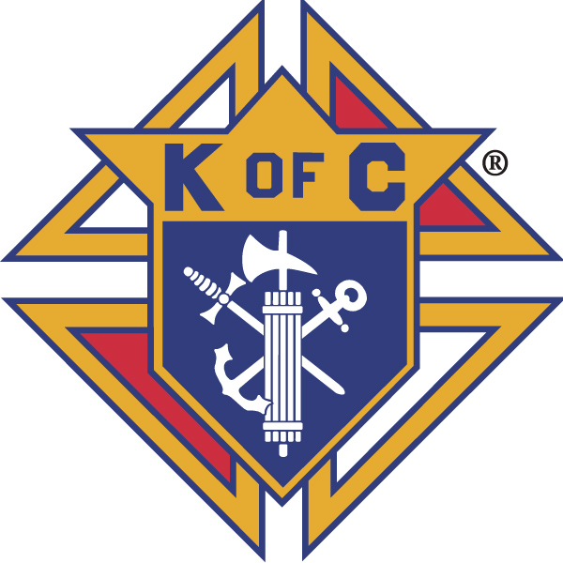
Knights of Columbus

In Service to One, In Service to All
Rev. Robert F. Houlihan, S.J., Council 10937

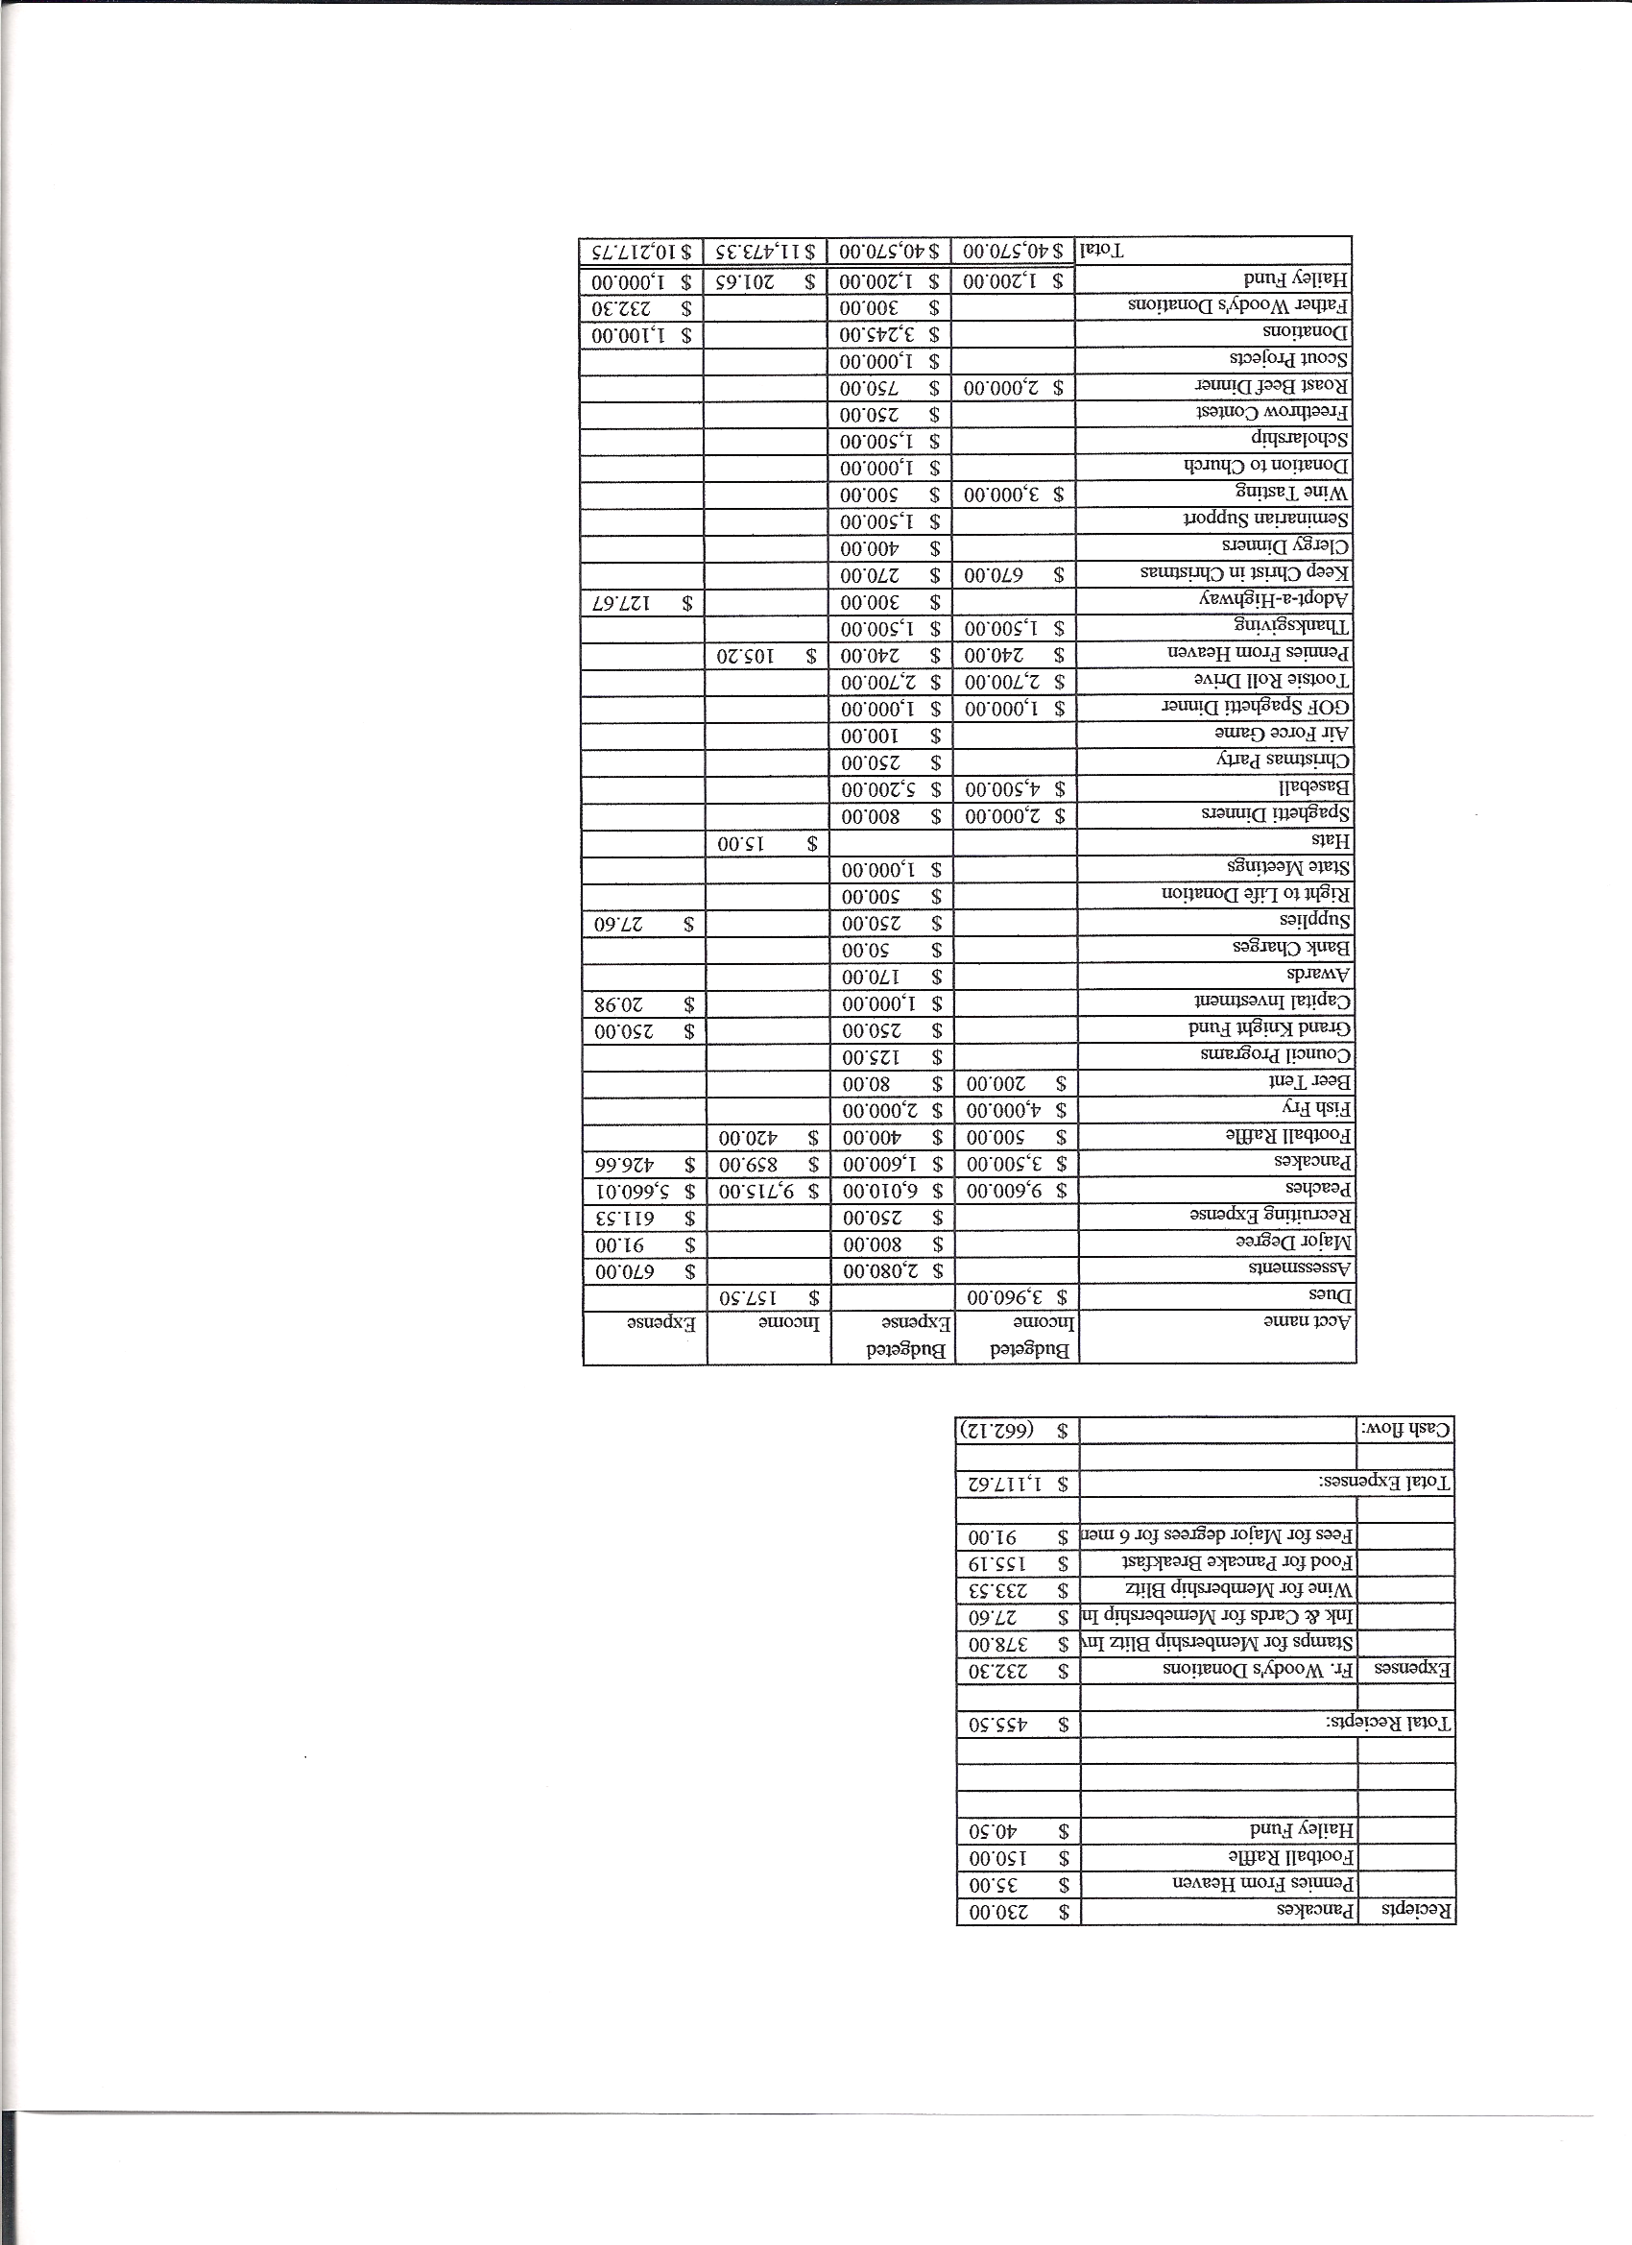
Business Meeting Minutes
October 8 , 2011

General

The Council was called to order at 8:03 AM by Grand Knight Paul Sciera.
Opening Prayer was offered by Joe Musso. The role of officers was called and noted as follows (P = Present; A = Absence; E = excused).

Title | Status | Title | Status | Title | Status
Chaplain | P | Financial Secretary | P | Inside Guard | P
Grand Knight | P | Treasurer | P | Outside Guard | P
Dep. Grand Knight | P | Lecturer | - | Trustee 3rd Year | A
Chancellor | E | Advocate | P | Trustee 2nd Year | P
Recorder | P | Warden | P | Trustee 1st Year | E

- The Sept. 10, 2011 meeting minutes were approved as read and published.

II. Applications for Approval – Roger
- No Applications.

III. Chaplain’s Reflection – Father Brian
- Urged the Knights to consider saying the rosary before meetings rather than having Mass.
- Would like to have donuts served on a regular basis after Sunday Masses.
- Introduced Deacon Tim Walsh as a 4th degree knight and thanked him for being here.

IV. Grand Knight Report – Paul
- Pennies from Heaven
- Knight of the Month – Ron Reitsch
- Family of the Month – Richard Storick Family
- Read thank you letter from Joe Snearline.
- We will support Coats for Kids here on the local level. The blue bin in the Christi center is available for donations.
- Voted to support the Carl Anderson Event and donate $200.

V. Treasurer’s Report - Barney
- Report handed out at meeting.
- Bank balance - $ 16,223.25 Available funds - $ 14,030.36
(See handout.)

VI. Financial Secretary’s Report – Roger
- Report handed out at meeting
- Receipts - $ 1,377.47 Expenses - $ 954.51
- Bank balance - $ 18,245.49 Difference between financial reports - $1,765.96
- The difference was reconciled and reported by Roger on October 9, 2011.
(See reports.)

VII. Committee Reports – Joe Musso
- Membership – Max - Knights were encouraged to recruit at spaghetti dinner.
- Church – Ron - We had a very successful donut Sunday Oct. 2nd. If we go back to donuts following all Sunday Masses, make sure to check for conflicts. Also, responsibility should be spread among different ministries.
- Community – Jonathon - Sept. highway cleanup went well.
- John Kennedy - Tootsie Roll drive for intellectual disabilities is in full swing. Help is still needed the 21st and 22nd. Sign up on line.
- Thanksgiving baskets – Gary Mayfield volunteered to be Day of Event Coordinator.
- We will go back to baskets. There will be an assembly line at Pax.
- Parishioners can donate a basket or money.
- Council Activity Report – Leonard - Family social hour is the 14th at Pax.
- Breakfast will be the 23rd not 30th.
- Nov. social hour will be at the Leyba’s. Leonard’s famous chili will be featured.
- Don’t forget the Air Force game on Nov. 5th. Contact Tim Pimmel.
- Pro Life - Chris and Mike – October is Respect for Life month. Remember the dignity of life. All lives are equal in value.
- Please continue praying for the success of the 40 Days For Life campaign. Prayers will continue to be e-mailed.
- Youth – Dennis – Soccer challenge (with St. Mark) will be held Oct. 23 at Redstone Park at 1:00 PM. State will follow on Nov. 19th at Trade Winds Park in Thornton from 11:00 AM to 1:00 PM.
- Free throw challenge will be on January 15th.

- Family Report – Shawn – Spaghetti dinner tonight (Oct.8th). Seminarians have been invited. Lady knights will sell deserts.
- State vocations matches councils in support of new seminarians.

VIII. 4th Degree – Roger – Assembly meeting on Monday the 10th. It is a business meeting.
- Corporate Mass will be Nov.13 at 8:30 at Pax.
- Roger has a list of 4th degree exemplifications if anyone is interested.

IX. District Deputy Report – Mark Solome – The dedication of St Francis of Assisi in Castle Rock was very successful and beautiful.
-Retreat October 23rd and 24th at Sedalia Retreat House.
Donation - $180.
- Don’t forget Shining Knights.(3 events, 3 meetings, 3 degrees).
- October and March is Supreme drive for membership.

X. Unfinished Business – Dave - Update of Council By-laws approved.
(memorial committee and needy council members relief fund)
- $ 500 will be moved from budget to special relief fund.
- Just One Day donations – None received as yet. Please have checks ready to give to Roger by next business meeting.

XI. New Business - Dave Martz offered a volunteer opportunity to help the elderly and disabled file their income tax reports. Dave has found this to be very rewarding. Training will be held the 3rd week in January. See Dave for information.

XII. Good of the Order Jim DeRose, Larry Thomasson, Shawn Conley

XIV. Chaplain’s Summation – Fr. Brian - There has been some resistance to change here at Pax. Father is working with Phil to implement these changes. Father Brian is the Pastor and, hence, the administrator of the parish. He asked for our support, help and prayers for a smooth and cohesive change.
- Father needs help in recruiting altar boys.

XIV. Closing Prayer
- Read by Father Brian.

MEETING WAS ADJOURNED AT

9:09 AM

minutes recorded and reported by Mike McGinnis

.

