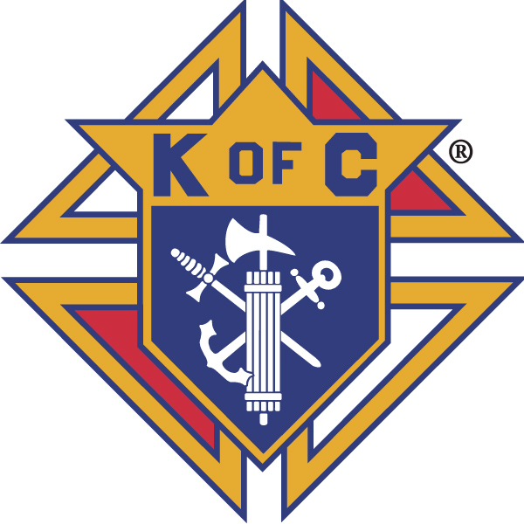
Knights of Columbus

In Service to One, In Service to All
Rev. Robert F. Houlihan, S.J., Council 10937
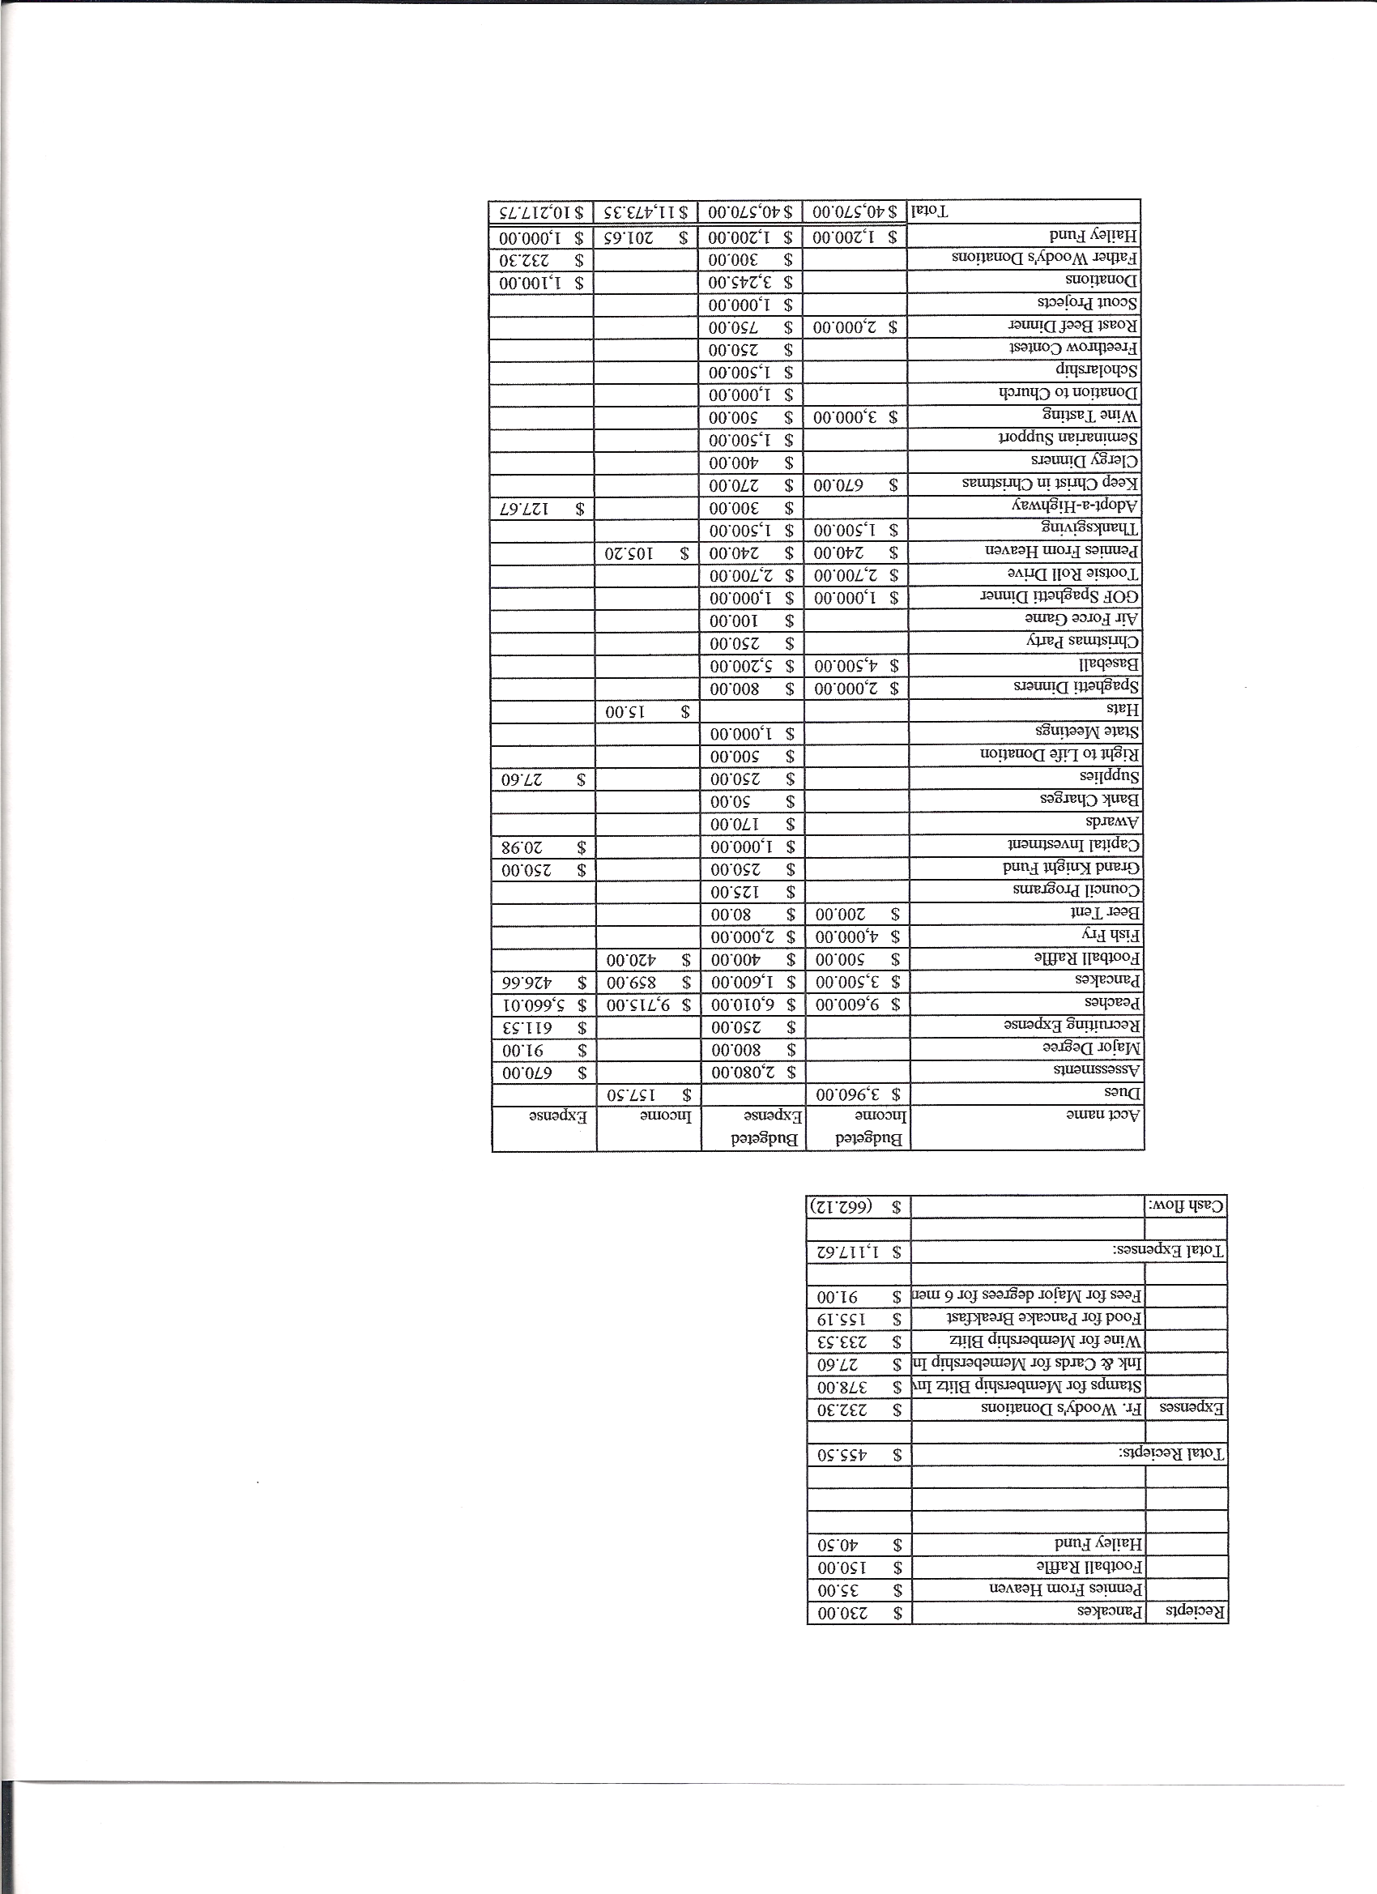
Business Meeting - November 12, 2011

I. General
- The Council was called to order at 8:03 AM by Grand Knight, Paul Sciera.
- Opening Prayer was offered by Joe Musso. The role of officers was called and noted as follows (P = Present; A = Absence; E = excused)

Title | Status | Title | Status | Title | Status
Chaplain | E | Financial Secretary | P | Inside Guard | E
Grand Knight | P | Treasurer | P | Outside Guard | P
Dep. Grand Knight | P | Lecturer | A | Trustee 3rd Year | P
Chancellor | P | Advocate | P | Trustee 2nd Year | P
Recorder | P | Warden | P | Trustee 1st Year | A

- The October 2011 meeting minutes were approved as read and published.

II. Applications for Approval – Roger
No Applications.

III. Grand Knight Report – Paul
- Pennies from Heaven-
- Knight of the Month – John Kennedy
- Family of the Month – Ed Nowak Family
- State Convention in Loveland at Embassy Suites 4/26/12 – 4/29/12
- Arrupe Jesuit H.S. dinner (fundraiser for scholarships) is February 25, 2012.
- Revision of Bylaws have been approved.
- Thank you letters received from: Bishop Gomez for donations.
Books for soldiers.
Gerkins for Thanksgiving baskets.

IV. Chaplain’s Report
- Deacon Tim Walsh talked about the power and persistence of prayer. All the apparitions of the Blessed Virgin Mary over the years speak of prayer. This year the theme of the GOF is prayer.

V. Treasurer’s Report - Barney
- Report handed out at meeting.
- Bank balance - $19,453.67 Available funds - $ 16,746.86
(See handout)

VI. Financial Secretary’s Report – Roger
Report handed out at meeting
Receipts - $ 7,521.27 Expenses - $ 1,086.41 Bank balance - $ 19,453.67
(See handout)

VII. Auditor – None

VIII. Chancellor’s Report on Vocations – None

IX. Committee Reports – Joe Musso
Membership – Max talked about the distribution of Thanksgiving baskets as an excellent time to recruit Knights.
- We are at 50% membership and 150% insurance.

Church Director Report – Ron - The travelling Marian Icon will be here in December. Deacon Tim Walsh will organize a prayer service at the Christmas party.

-The dinner for priests participating in the reconciliation service is on December 15th. Help needed for preparation.

- Next breakfast is Dec. 4. Donuts served 11/27, 12/11, 12/18.
- Help will be needed for Christmas Mass parking.

Community Report - Jonathan Feifarek – Coat collection drive was very successful.
- Tootsie Roll Drive very successful. $2,700 raised.
- Help is needed this Friday afternoon to pick up food for Saturday’s Thanksgiving basket project. Knights and others will come at 7:30 Saturday to unload food and assemble baskets. Hope to have people on the road delivering by 9:00 AM.
- Just One Day matching fund is at approximately $700 thus far.
- Tax Aid Help volunteer opportunities will be advertised in the bulletin this weekend. See Dave Martz for details.

Council Activity Report – Leonard Leyba – Leonard will host this months family social hour at his house, November 18th. (10648 Jewelberry Cr., Highlands Ranch), at 5:00 PM (or when you can get there).

Family Report – Shawn – The Air Force game was fun and exciting.
- The Christmas party will be held on Dec. 16th here at the Church.

Right to Life report- Chris Mosely / Mike McGinnis – The 40 Days For Life campaign was a success. Thanks to all who participated.
- Right to Life meeting in Colorado Springs with Father Bill Carmody: (1) Baby Bus Project – All Councils in the Diocese have been asked to contribute an annual donation as a budget item each year to help support mobile pregnancy center (“Baby Bus”). A motion will be prepared for the next business meeting. (2) Also, someone will talk with the Youth Group about possibly sponsoring youth to attend the March on Washington (1/22/12). Knights would pay half the cost ($300).
(3) Finally, consideration will be given for a donation to the Chastity Rally in the fall.

Youth Report –Dennis Thumann - Soccer challenge had very few participants. Possibly not advertised well enough. State finals will be held Nov. 19, 2011.

X. Unfinished Business - None

XI. New Business - None

XII. 4th Degree Report – Roger – Meeting Monday Nov.14th concerning logistics in the separation between St. Marks and Pax Christi. Rosary at 6:30, meeting begins at 7:00 PM.
- Corporate Mass at St. Marks on Sunday, Nov. 13th, followed by a social.

XII. Field Agent Report – None

XIII. District Deputy Report – Mark Solome - None

XIV. Good of the Order – Jim Egan, Ben Stancati , Father Brian, Jim DeRose (just turned 73), Leonard Leyba, Dave Petteys, Fr. Bill Volmer, Dan DeVulk.

XV. Closing Prayer - Read by Joe Musso

MEETING WAS ADJOURNED AT 9:00 AM

Minutes recorded and reported by Mike McGinnis

