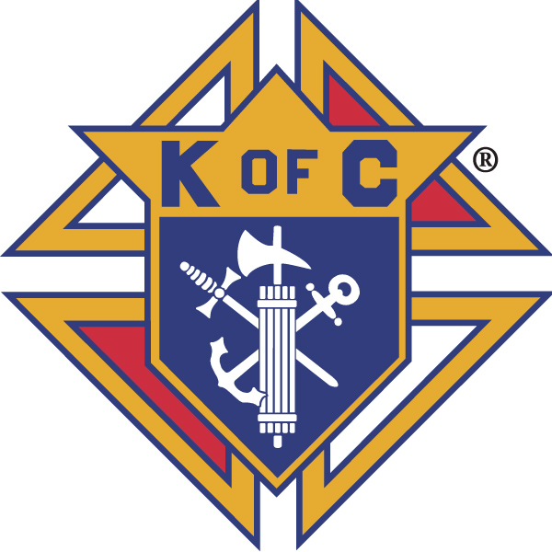
Knights of Columbus

In Service to One, In Service to All
Rev. Robert F. Houlihan, S.J., Council 10937
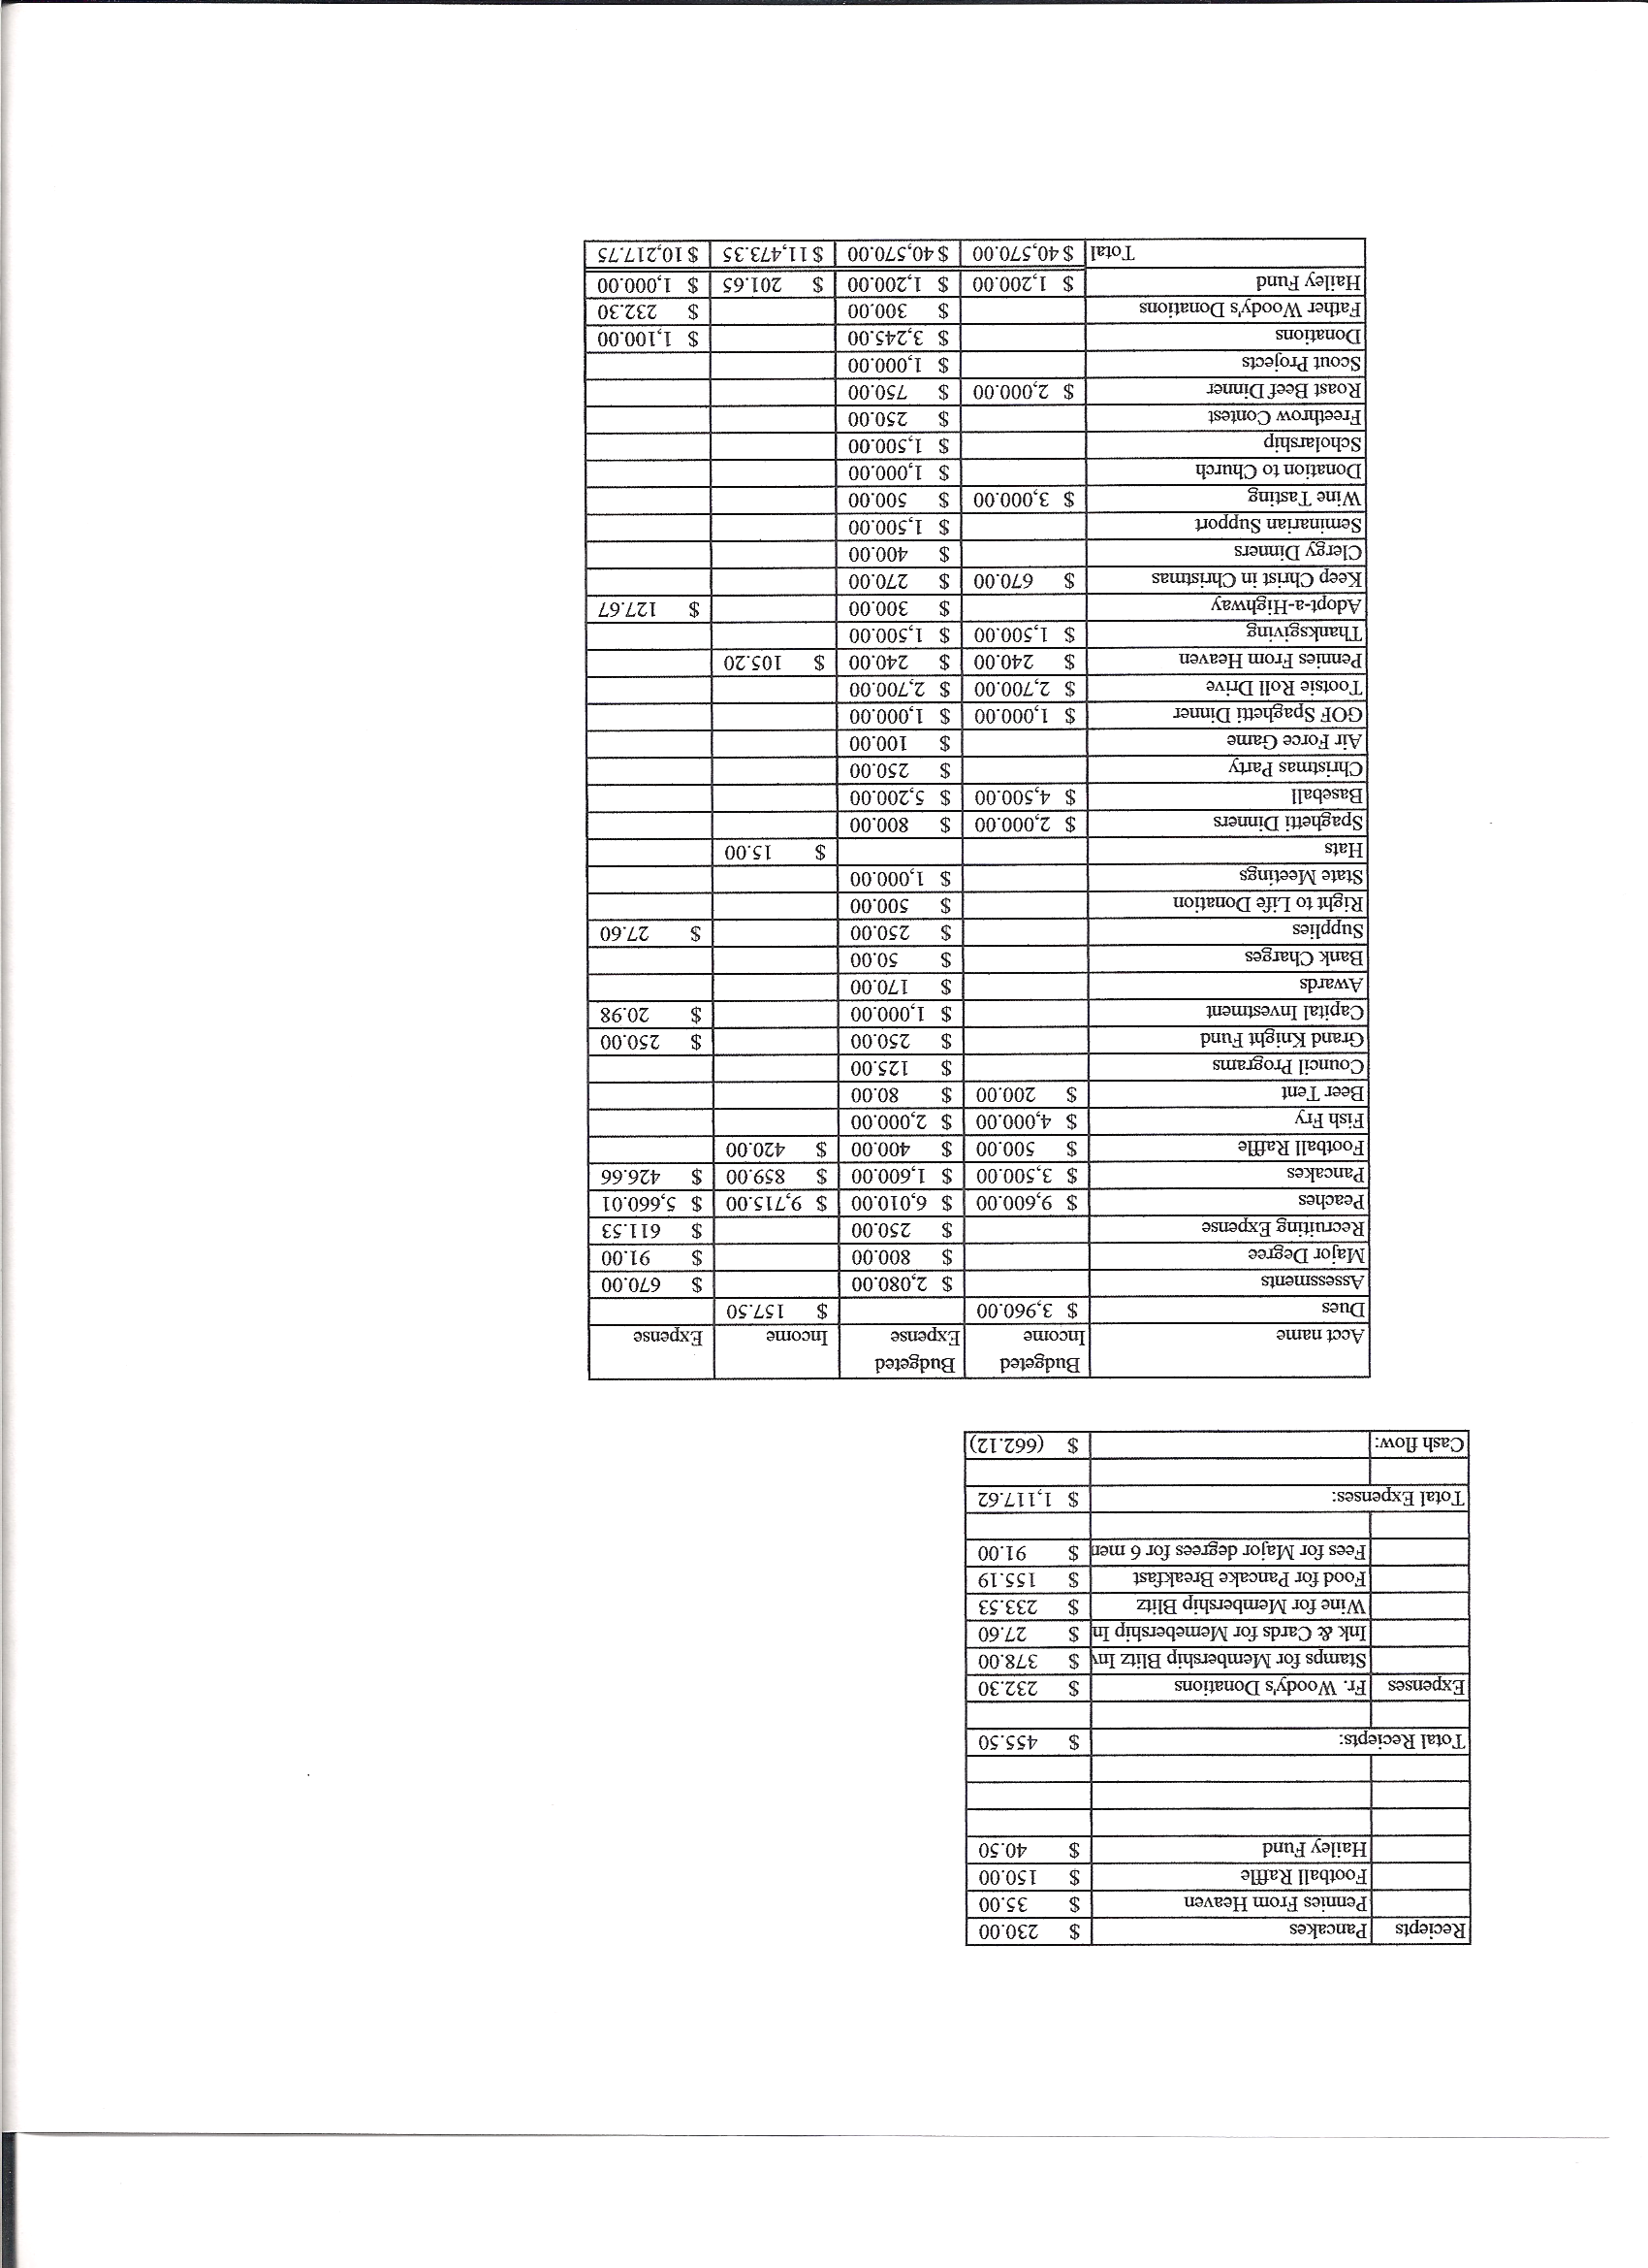
Business Meeting Minutes– January 14, 2012

I. General
The Council was called to order at 8:14 AM by Grand Knight, Paul Sciera.
Opening Prayer was offered by Joe Musso. The role of officers was called and noted as follows (P = Present; A = Absence; E = excused)

Title | Status | Title | Status | Title | Status
Chaplain | P | Financial Secretary | P | Inside Guard | P
Grand Knight | P | Treasurer | P | Outside Guard | P
Dep. Grand Knight | P | Lecturer | A | Trustee 3rd Year | E
Chancellor | P | Advocate | E | Trustee 2nd Year | P
Recorder | P | Warden | E | Trustee 1st Year | A

The December 2011 meeting minutes were approved as published with correction of date to Jan. 5th for Jonathon Allen’s 1st degree.

II. Applications for Approval – Roger
No applications.

III. Grand Knight Report – Paul
State mid-year meeting – We had a good representation. We shared our membership recruitment strategies.
January planning meeting will be at Roger’s new house on January 31. (602 Bristolwood Lane, Castle Pines,Co., 80108)
Those having keys to the Church should read the lockup procedures as sent out by the Church.
Received thank you from Parker Task Force.
Idea! (Paul) Knights volunteer once per quarter as ushers. Roger suggested the 5th Sunday of the months that have 5 Sundays. Background checks are necessary for those dealing with money. Someone will check this out with Todd.
Pennies from Heaven
Knight of the Month – Joseph Regnery
Family of the Month – Gary Mayfield Family

IV. Chaplain’s Report – Father Brian
The vocation of the knights is to help support the priest.
Father Brian will be doing catechesis on new changes in the Mass.
Phil Strong is no longer on staff. Staff has been reduced by four.
We need more sacristans.
Financially the church is not doing well. 70% of the parish give nothing to support the parish. Also, 20% give 80% of the offertory. Returning God’s gifts will also be starting shortly.
Youth activity at Pax is very important.
There is a flyer in the bulletin from Catholic Bishops regarding civil unions. There will be cards in the back of the church for parishioners to sign urging Colorado senators and representatives to vote no on civil unions. Father Brian reminded everyone that sensitivity is very important to people who have homosexual tendencies.

V. Treasurer’s Report - Barney
Report handed out at meeting
Bank balance - $18,098.95 Available Funds - $9,462.13
(See report)

VI. Financial Secretary’s Report – Roger
Report handed out at meeting
Receipts - $2,480.00 Expenses - $5,488.49 Bank Balance - $18,098.95
(See report)

VII Chancellor’s Report – Gary Mayfield
Vocations– Checks were sent to seminarians. ($500 each year.)
Received a nice card from Jason Keys and e-mails from two seminarians.
Ordination will be in Security. Knights are invited to attend.

VIII Committee Reports – Joe Musso Thanks for reports. All are in. 7500 hours of service.

Membership – Max Gramly – Recruitment strategies shared at State meeting.
Second and third degrees coming up at St.Mark.
First degree at St.Mary’s on Feb.25th. (2 people)
We are eleven out of twelve toward membership quota.
We are 200% of insurance quota.

Church Director Report – Ron Rietsch – Knight’s breakfast on Jan.15th.
Casino Night on Feb. 18th. Need dealers and other help.
Fish fries coming up. E-mails coming with details soon.

Community Report – Jonathan Feifarek has stepped down. A chairman is needed. Please volunteer.
AARP Tax Aid training is in January for volunteers to aid seniors. Volunteers work from Feb.1 to April 15 on taxes for senior citizens. Four Knights have volunteered and two parishioners have volunteered.

Council Activity Report – Leonard Leyba – Family Social Hour is Jan. 20th hosted by Glen and Sherry Suddarth. (556 Fox Hunt Cr. in Highlands Ranch.)

Family Report – Shawn Conley – Council Christmas Party – The party was well attended. A good time was had by all.

Right to Life report- Chris Mosely / Mike McGinnis – There will be a rosary said Sunday, January 22, in the Church between the 8:30 and 10:30 masses. The 22nd is the 39th anniversary of Roe vs Wade. All Knights and parishioners are encouraged to attend. Knights please wear your shirts.
Baby Bus Project – 3rd refurbished RV in US, purchased for $57,000.

Youth Report – Dennis Thumann – Free throw contest Jan.15 at Rocky Heights.
Financial workshop for youth will be on March 6.
Meet our Seminarians on June 12.

“Tailgate Party” for youth on Super Bowl Sunday. Bring an extra can of soup to donate to the Food Bank of the Rockies.
Would like Knights to step up and help with youth activities as much as possible.

Our Knights are always mentioned in a positive light by our youth.

IX. Advocate’s Report – We need to post bi-laws on website.

Membership vote must follow bi-laws.
Working on a single provider for liability insurance.

X. Auditor – No report at this time. Report is due February 15th. A meeting February 11th.

XI. Unfinished Business - none

XII. New Business - Marc Solome – Our State Chaplin found a used monstrance in a pawnshop and donated it to state. It has been evaluated between ten and twelve thousand dollars. It needs refurbishing. They are asking each council to donate to donate $200. There was a motion made to donate $200 for refurbishing. It was first and seconded and approved unanimously.

XIII. 4th Degree Report – Roger – All 3rd and 4th degree members received an e-vite to attend a February 9th meeting to discuss 4th degree possibilities for service within the parish and the split from St. Mark. The fourth degree is the visible arm of the order and there are 35 fourth degree members in our council.
Our fourth degree will be chartered in July 2012, the birthday of our council.

XIV. Field Agent Report – We will have a new insurance agent, Jayme Sanford, for our council.
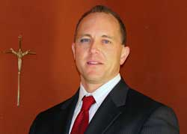
Jayme Sanford (Karol)
23071 Cleveland Dr. Parker, CO 80138 Mobile: 720 384 6090 Jayme.Sanford@kofc.org

As previously mentioned, our council is at 200% of its quota for insurance. Excellent!

XV. District Deputy Report – Mark Solome – 4th degree on Jan. 28th in Ft. Lupton.
District meeting Feb. 4th.
Major degree at St.Mark on March 31.
Colorado State convention April 26th to 29th. Need to know delegates and anyone in any Knight’s family that passed on during the year. Names will be read.
Reports are all turned in.
Membership count – Blessed John Paul II awards a medallion to Chaplain of council for 6 new members.

XVI. Good of the Order – Jim DeRose

XVII. Closing Prayer - Read by Joe Musso

MEETING WAS ADJOURNED AT 9:34 am
Minutes recorded and reported by Mike McGinnis.

