KNIGHTS OF COLUMBUS COUNCIL #10937

Pax Christi Church
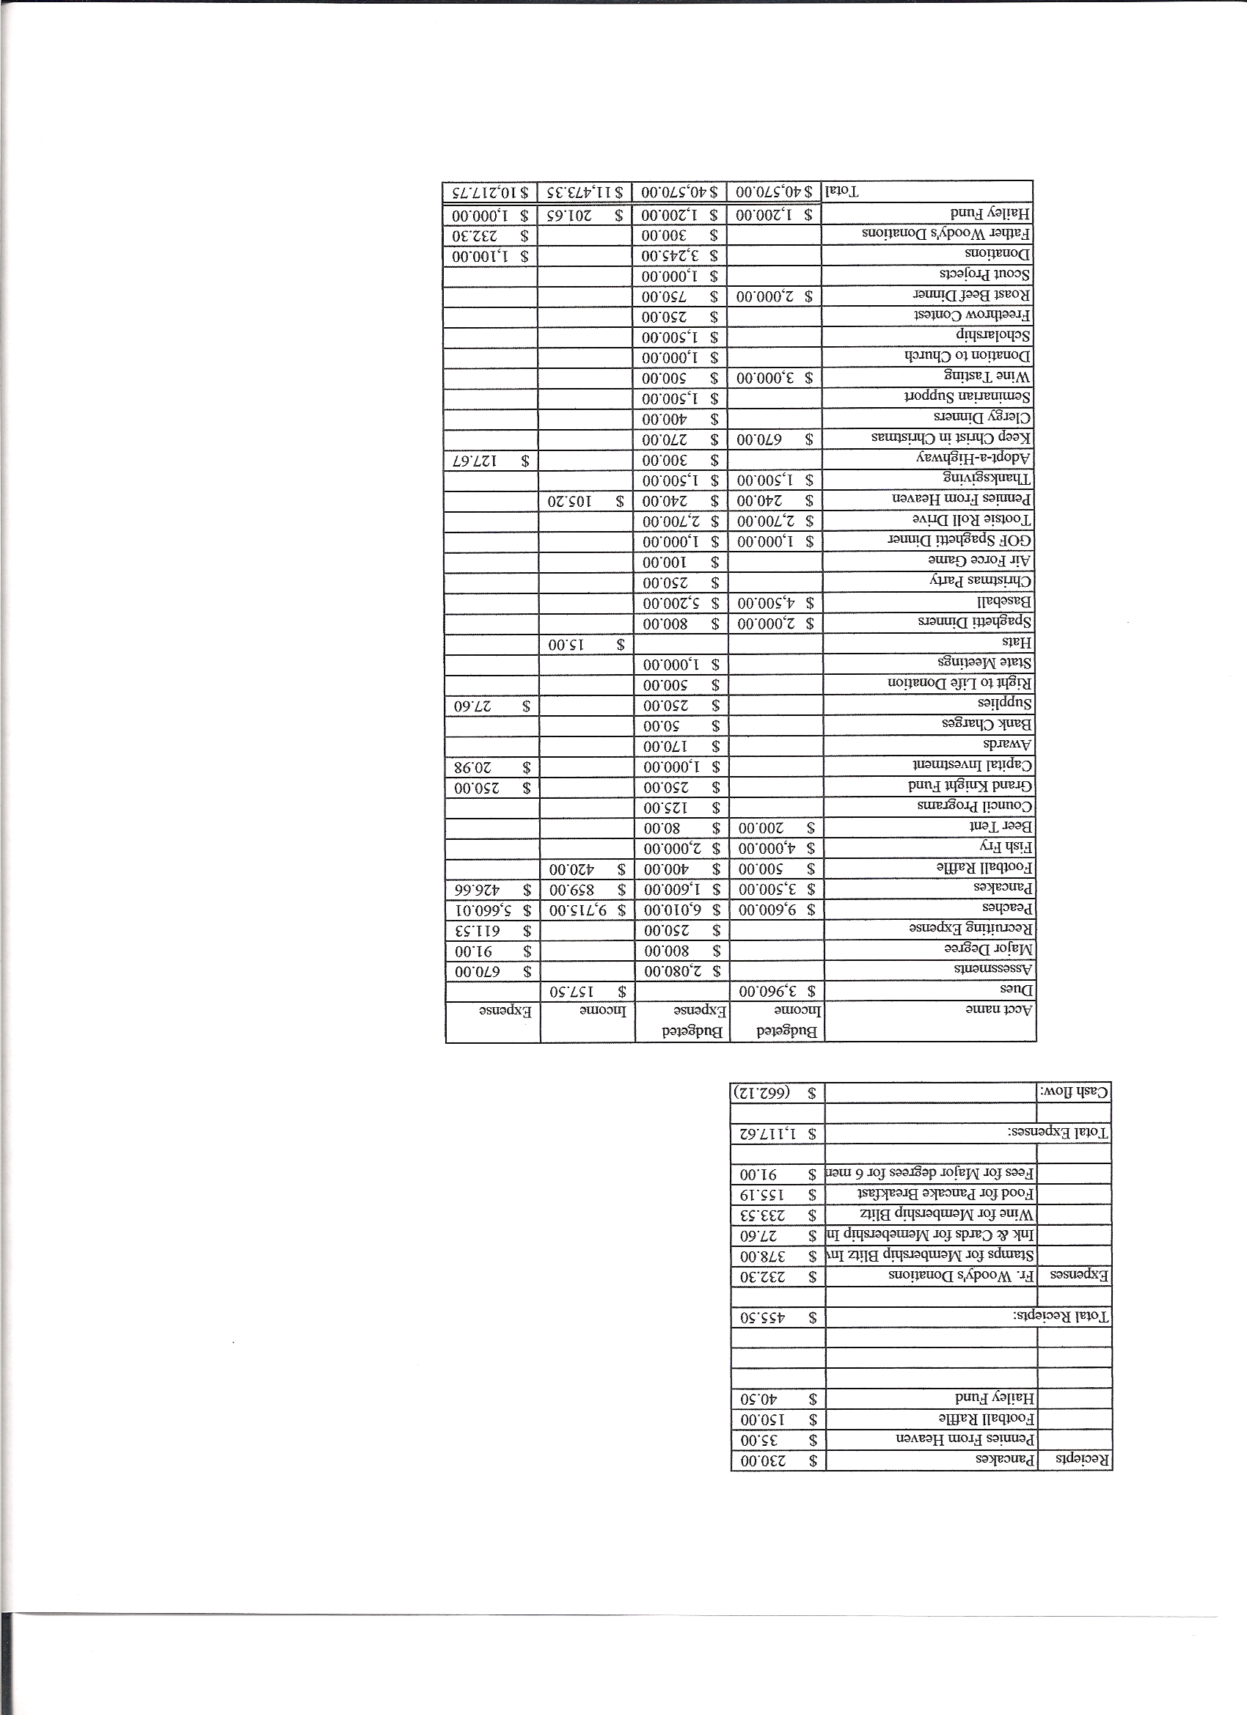
Business Meeting Minutes

January15, 2011
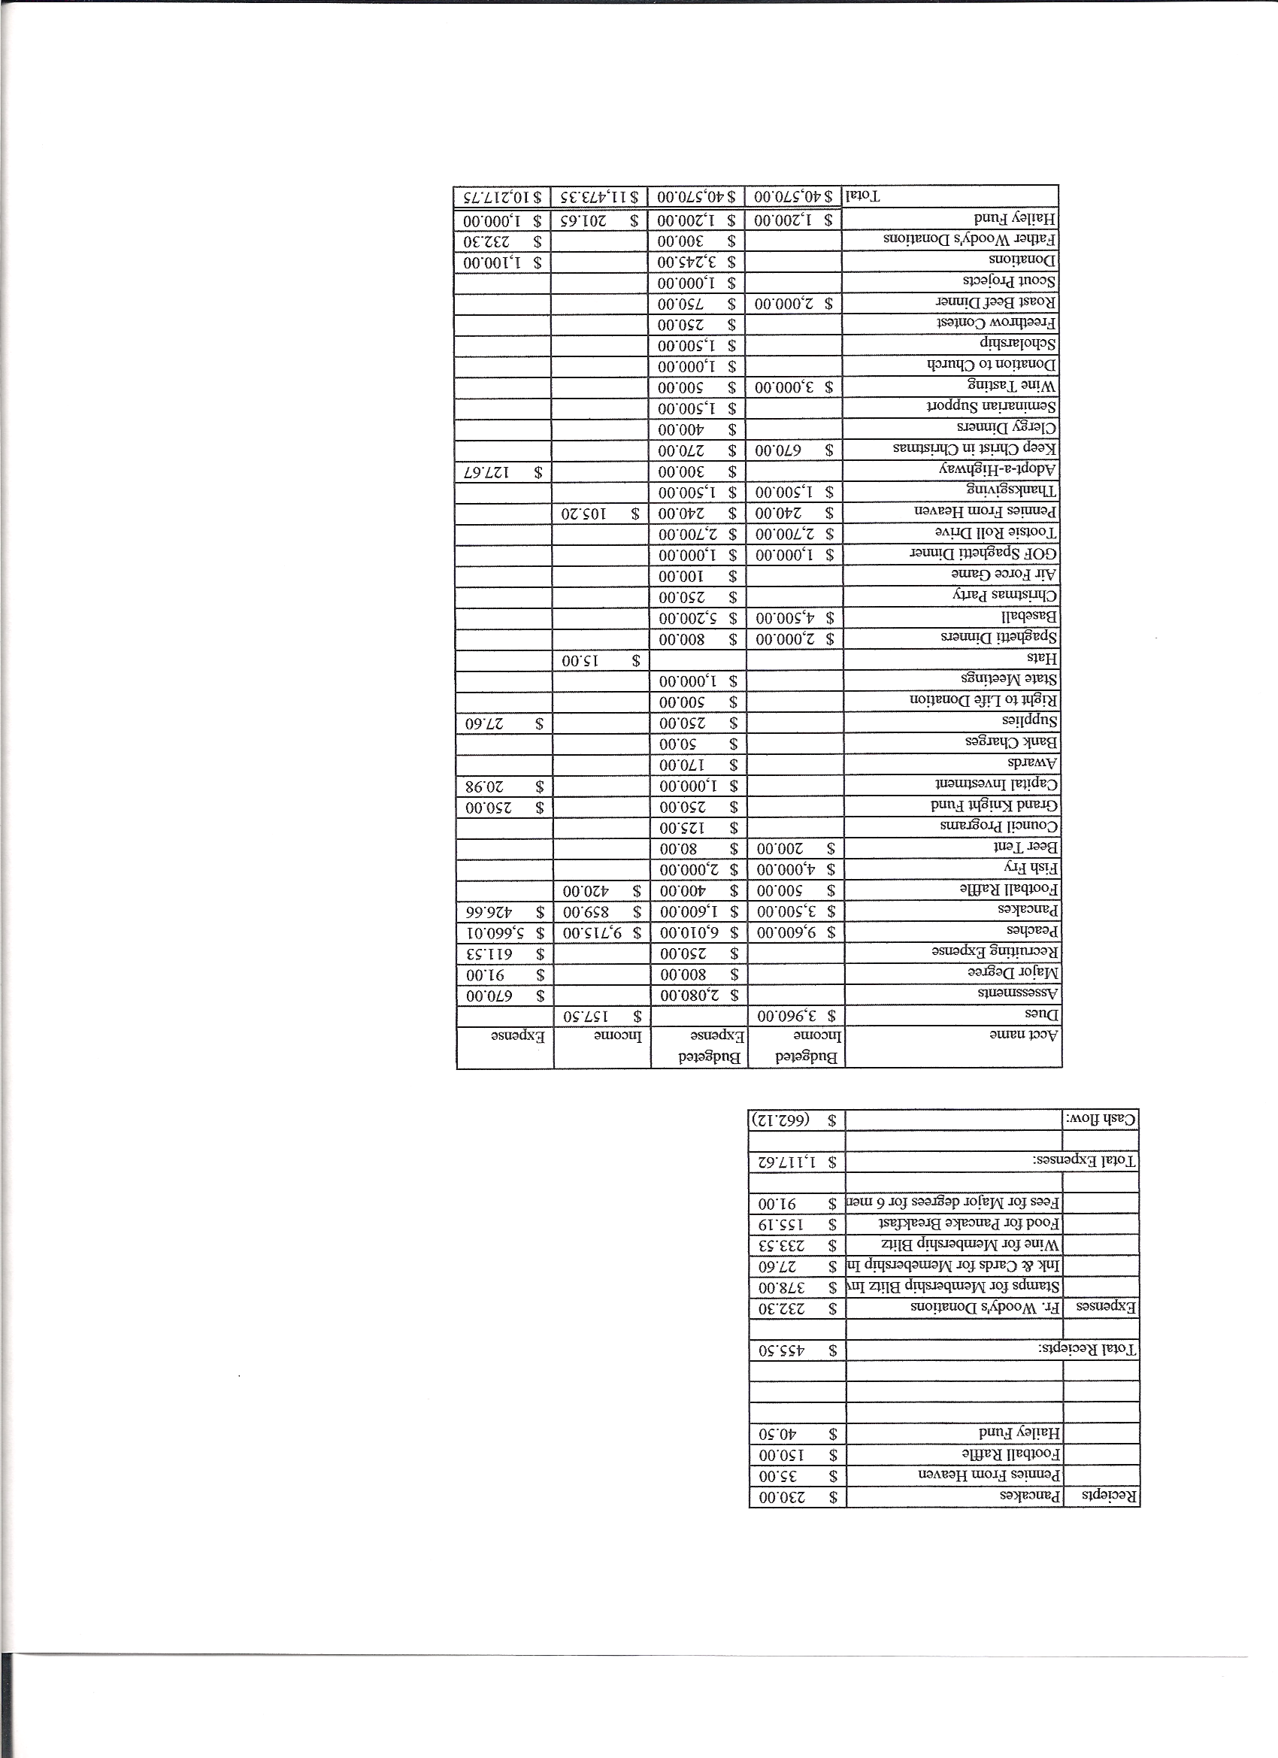

I. General
- The Council was called to order at 8:01 by Grand Knight Chris Kennedy
- Opening Prayer was offered by Ron Gerber The role of officers was called and noted as follows (P = Present; A = Absence; E = excused)

Title | Status | Title | Status | Title | Status
Chaplain | P | Financial Secretary | P | Inside Guard | P
Grand Knight | P | Treasurer | P | Outside Guard | A
Dep. Grand Knight | E | Lecturer | A | Trustee 3rd Year | P
Chancellor | E | Advocate | P | Trustee 2nd Year | P
Recorder | P | Warden | P | Trustee 1st Year | P

- The December meeting minutes were approved as read and published

II. Applications for Approval – Roger

William McLoughlin approved. Joe Becker (transfer) approved. George Byrne (Bernie) transfer approved.

III. Grand Knight Report – Chris
- Pennies from Heaven
- Knight of the Month – Ron Gerber
- Family of the Month –Guy Hopkins family
- Thank you note received from Task force for $750.00 check.
- Leonard and Lena Leyba receiced Supreme Family of the month.
- IV. Chaplain’s Report

- Fr. Ken reported the following:
  - Knightline reported on Christian volunteerism. Knights become good volunteers. Membership in the Knights keeps us active Catholics.
  - CHRP coming in March 26-27 for men and April 30 and May1st for women.

V. Treasurer’s Report - Barney
- Financial report passed out. Balance as of Jan. 1, 2011=Balance $15,068.36 outstanding checks= $1,701.84 Hailey fund= $1,673.30 Lady Knights= 320.51 Available funds = $11,372.761
VI. Financial Secretary’s Report – Roger
Report handed out at meeting
Receipts = $2,971.13 Expenses = $988.78 cash flow of ($1,982.35)
VII. Committee Reports – Paul S

Auditor – Audit will be signed and turned in.

Chancellor’s Update –
2 seminarians were at Christmas party.
June 14th parish youth to meet with Seminarians to learn what it means to become a Seminarian.

Family Report – Bob Luckner a new family chairperson is needed. Bob and Tim will be traveling more with their jobs.

Council Activity Report – Leonard Leyba/

Happy hour was at Ben and Carolyn’s house, a great time was had by all.
1st degree next month and happy hour will be had at that tme. Wives and family members are encouraged to come and get started with happy hour while we have 1st degree.
Fish fry start March11.

Church Director Report – Harisha B

Thanks for help with Christmas parking.
Donuts are Feb 20th Guy will be out of town and looking for help.
Community Report – John Alfeld/ Jonathan Feifarek

No report.

Youth Report –Dennis Thumann
Basketball free throw contest coming on Sunday January 23rd From 12:30 to about 3:00
Scholarship contest is underway. Deadline for turning in is Feb 28th.

---Right to Life report- Chris Mosely / Mike McGinnis
A rosary will be held at the chapel on January 20th Thursday night 7 p.m. for anniversary of Roe V. Wade
Abortion prohibitive act is coming to ballot (no tax payers money to be used for abortions)
Contact Senators and House Reps. to bring interest to this cause.
Looking for possible fund raising event for ultrasound machine.

VIII. Unfinished Business =
More ideas were brought up for fund raising through Roses for Life.

IX. New Business

A fly fishing trip for youth and parents was brought up.

4th Degree Report – Roger

March 27th is White Fence Farm outing. Save the date.
Sunday January 22nd is a 4th degree exemplification. Any 3rd degree members wanting to participate should speak to Roger Guidici.
Assembly meeting 2nd Monday of the month at St. Marks 7 P.M.

XI. Field Agent Report – Brian Brunette

No report

District Deputy Report – Mark Solome

No report

XIII. Good of the Order

Jim DeRose and family Joe Musso had eye surgery Anne Thumman Uncle passed

XIII. Chaplain’s Summation – Fr. Ken

XIV. Closing Prayer
- Read by Ron Gerber

MEETING WAS ADJOUNRED AT

8:53 am

- minutes recorded and reported by Ron Rietsch

