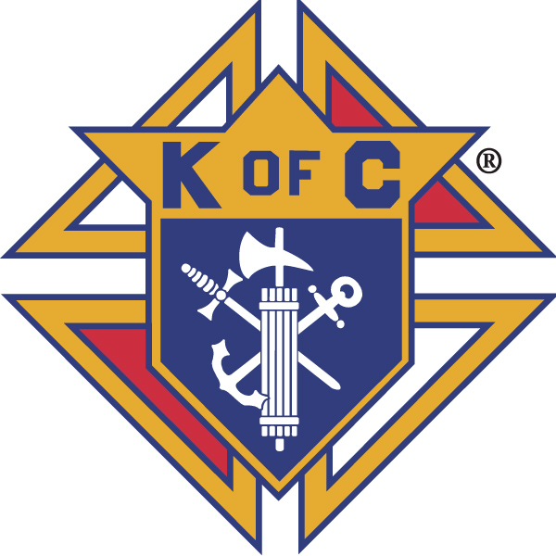
Knights of Columbus

In Service to One, In Service to All
Rev. Robert F. Houlihan, S.J., Council 10937
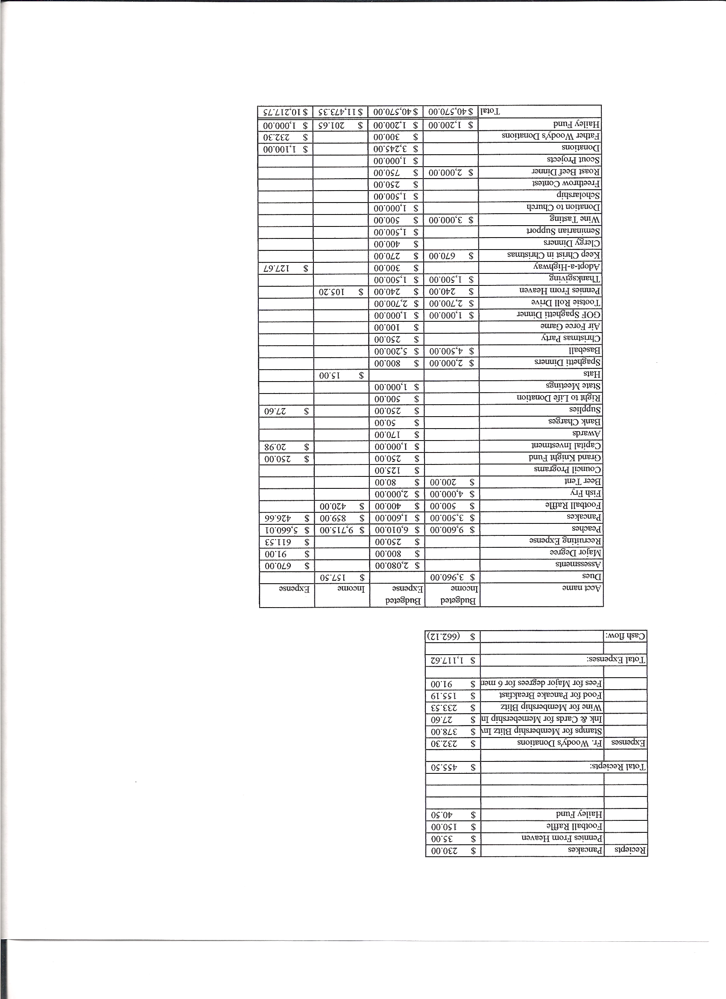
Business Meeting – June 9, 2012

I. General
- The Council was called to order at 7:35 AM by First Degree Team Grand Knight, Tom Whyte.
Meeting was suspended at this point for first degree exemplification.
Congratulations to Nate Pray, our new first degree Knight.

Meeting resumed at 8:33.
- Opening Prayer was offered by Joe Musso. The role of officers was called and noted as follows (P = Present; A = Absence; E = excused)

Title | Status | Title | Status | Title | Status
Chaplain | E | Financial Secretary | P | Inside Guard | P
Grand Knight | P | Treasurer | P | Outside Guard | P
Dep. Grand Knight | P | Lecturer | P | Trustee 3rd Year | P
Chancellor | P | Advocate | P | Trustee 2nd Year | A
Recorder | P | Warden | P | Trustee 1st Year | A

The May 12, 2012 meeting minutes were approved as read and published.

II. Applications for Approval – Roger
Application for Ronald Lovall, a transfer from California, was read. Motion for acceptance was made and seconded. Approval was unanimous.

III. Grand Knight Report – Paul
Pennies from Heaven
Knight of the Month – James Grady
Family of the Month – Mike Callahan Family
Presentation of home Mass kit to Father Brian was postponed.

IV. Chaplain’s Report - Father Brian was not present to give his report.

V. Treasurer’s Report - Barney
Report handed out at meeting.
Bank balance - $16,570.25 Available funds - $13,188.13
(See report)

VI. Financial Secretary’s Report – Roger
Report handed out at meeting
Receipts - $3,457.85 Expenses - $4,985.02 Bank balance - $16,570.25
(See report)

VII. Chancellor’s Update – Gary Mayfield
Vocation’s night – Meet the seminarians and sisters after the 5;00 Mass.
Now Deacon, Jason Keas, expects to be there. He will be ordained in a year.
The prayer for vocations was said.

VIII. Committee Reports – Joe Musso

a. Membership - Max
For the fiscal year we will have 15 new members. Our quota is 12.
We are still at 225% of our insurance quota. Out of 192 members, 68 have purchased insurance.
All Knights are encouraged to keep a list of people who are good prospects to join our council. One way to encourage men to join is to invite them to participate in Knight activities such as breakfasts so that they can experience the camaraderie and friendship among Knights.
There is a second and third degree exemplification at Our Lady of Loretto next Saturday.

b. Church Director Report – Ron Rietsch
Ron was absent. Chris Kennedy gave the report. - The Church picnic is tomorrow (June 10th, 12-3PM). Help is needed and appreciated (cooking, serving and cleanup). Setup starts about 9:30AM, after the 8:30AM Mass.
The Rosary Walk is nearly finished and looking good. Signs will be coming Monday.
The Catholic School Task Force sent out a survey about building a school. Please consider participating, especially if you have young children. Chris will send out a second e-mail. Call Chris if you have questions.

c. Community Report - Bob Luckner
The highway cleanup date will be rescheduled. The date will be announced.

d. Council Activity Report – Leonard Leyba
There will be no family social this month or July.
Council anniversary is July 28th with installation of officers.
Leonard recommended seeing For The Greater Glory. Said it was outstanding.

e. Family Report – We still are in need of a director.
The Rockies baseball game is June 29th.

f. Right to Life report- Chris Mosely / Mike McGinnis
Our Rosary for Right to Life will be in the Chapel the second Sunday of each month right after the 8:30 Mass. Please consider participating. The attendance has been very small.
A $500 donation will be presented to The Alternative Pregnancy Center for their “Promise Yourself campaign”.
Dave Petteys talked about the wonderful experience that attendance at Father Bill’s Right To Life Mass in front of Planned Parenthood was. Please consider going some Saturday morning. (8:00 AM)

g. Youth Report – Dennis Thumann
Thirty to forty youth have signed up for Vocational Night, June 10th.

IX. Lecturer – Ben Stancati
Ben’s talks will be taken from the Columbian Magazine which Knights receive each month. The series of talks will be named The Rev. Robert F. Houlihan Educator Series. This month Ben talked about the violent revolution in Mexico starting in 1910 which resulted in a new constitution in 1917 with anticlerical laws which then set the stage for terrible persecution and banishment of the Church and the resulting atrocities experienced by all Catholics and especially the Knights whose first council was established in Mexico only 5 years (1905) before the beginning of the this revolution.

X. Trustee Report - No report.

VIII. Unfinished Business -
The motion to reimburse officer hotel expenses from the state convention was voted on and approved unanimously.
The motion to pay the approximately $562 for a Mass kit for Father Brian was reopened and voted on. The motion carried unanimously. The Knights would like to engrave the case when Father becomes a 3rd degree Knight. The Mass kit was displayed and will be presented to him at the Parish picnic.

IX. New Business
A copy of the budget will be sent out and voted on next month. Also the calendar of events will be sent.
Guy set up a calendar of events on google calendar. He asks that as much information as possible, including times, dates locations etc. about upcoming events be sent to him so that he can include that info on the calendar.
Vote for officers – The slate of officers was read and new nominations requested. No new nominations were submitted and a move to vote by acclamation was unanimous. Slate of officers carried as read.

A motion that the Knights set up a one time matching fund for Church needs including a monstrance and furnishings for the rectory. Paul said that Ray Gerkins has a monstrance needing restoration. ($2000-$2300) The Knights will match up to $5000 raised by the parish. The motion was seconded and discussion ensued. The motion will be written out detailing the wording and the source of the funding. The motion was tabled until our next meeting.

X. 4th Degree Report – Roger
Three Knights are going through the Fourth Degree Exemplification at St. Francis Cabrini after the meeting.
There will be a fourth degree meeting immediately following this meeting. Officers will be elected and by-laws formed.
The July 28th celebration will include installation of the assembly and officers will be installed.

XI. Field Agent Report – No Report

XII. District Deputy Report – Mark Solome – No Report

XIII. Good of the Order
Jim DeRose, John Starke (Shoulder surgery), Dennis Cullen (Will have surgery this week.), Colleen Herskovit ( bike accident-broken arm).

XIV Chaplain’s Summation – Fr. Brian – ( Reading was read by Grand Knight Paul Sciera )

XIV. Closing Prayer
Read by Joe Musso

MEETING WAS ADJOURNED AT

9:36 am

- minutes recorded and reported by Mike McGinnis

