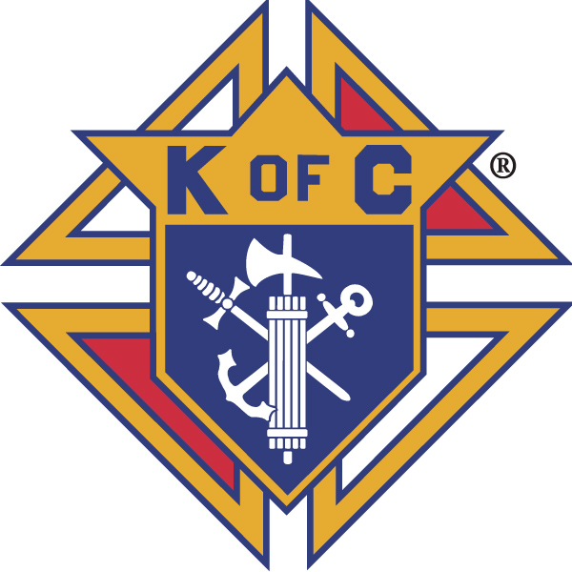
Knights of Columbus

In Service to One, In Service to All
Rev. Robert F. Houlihan, S.J., Council 10937
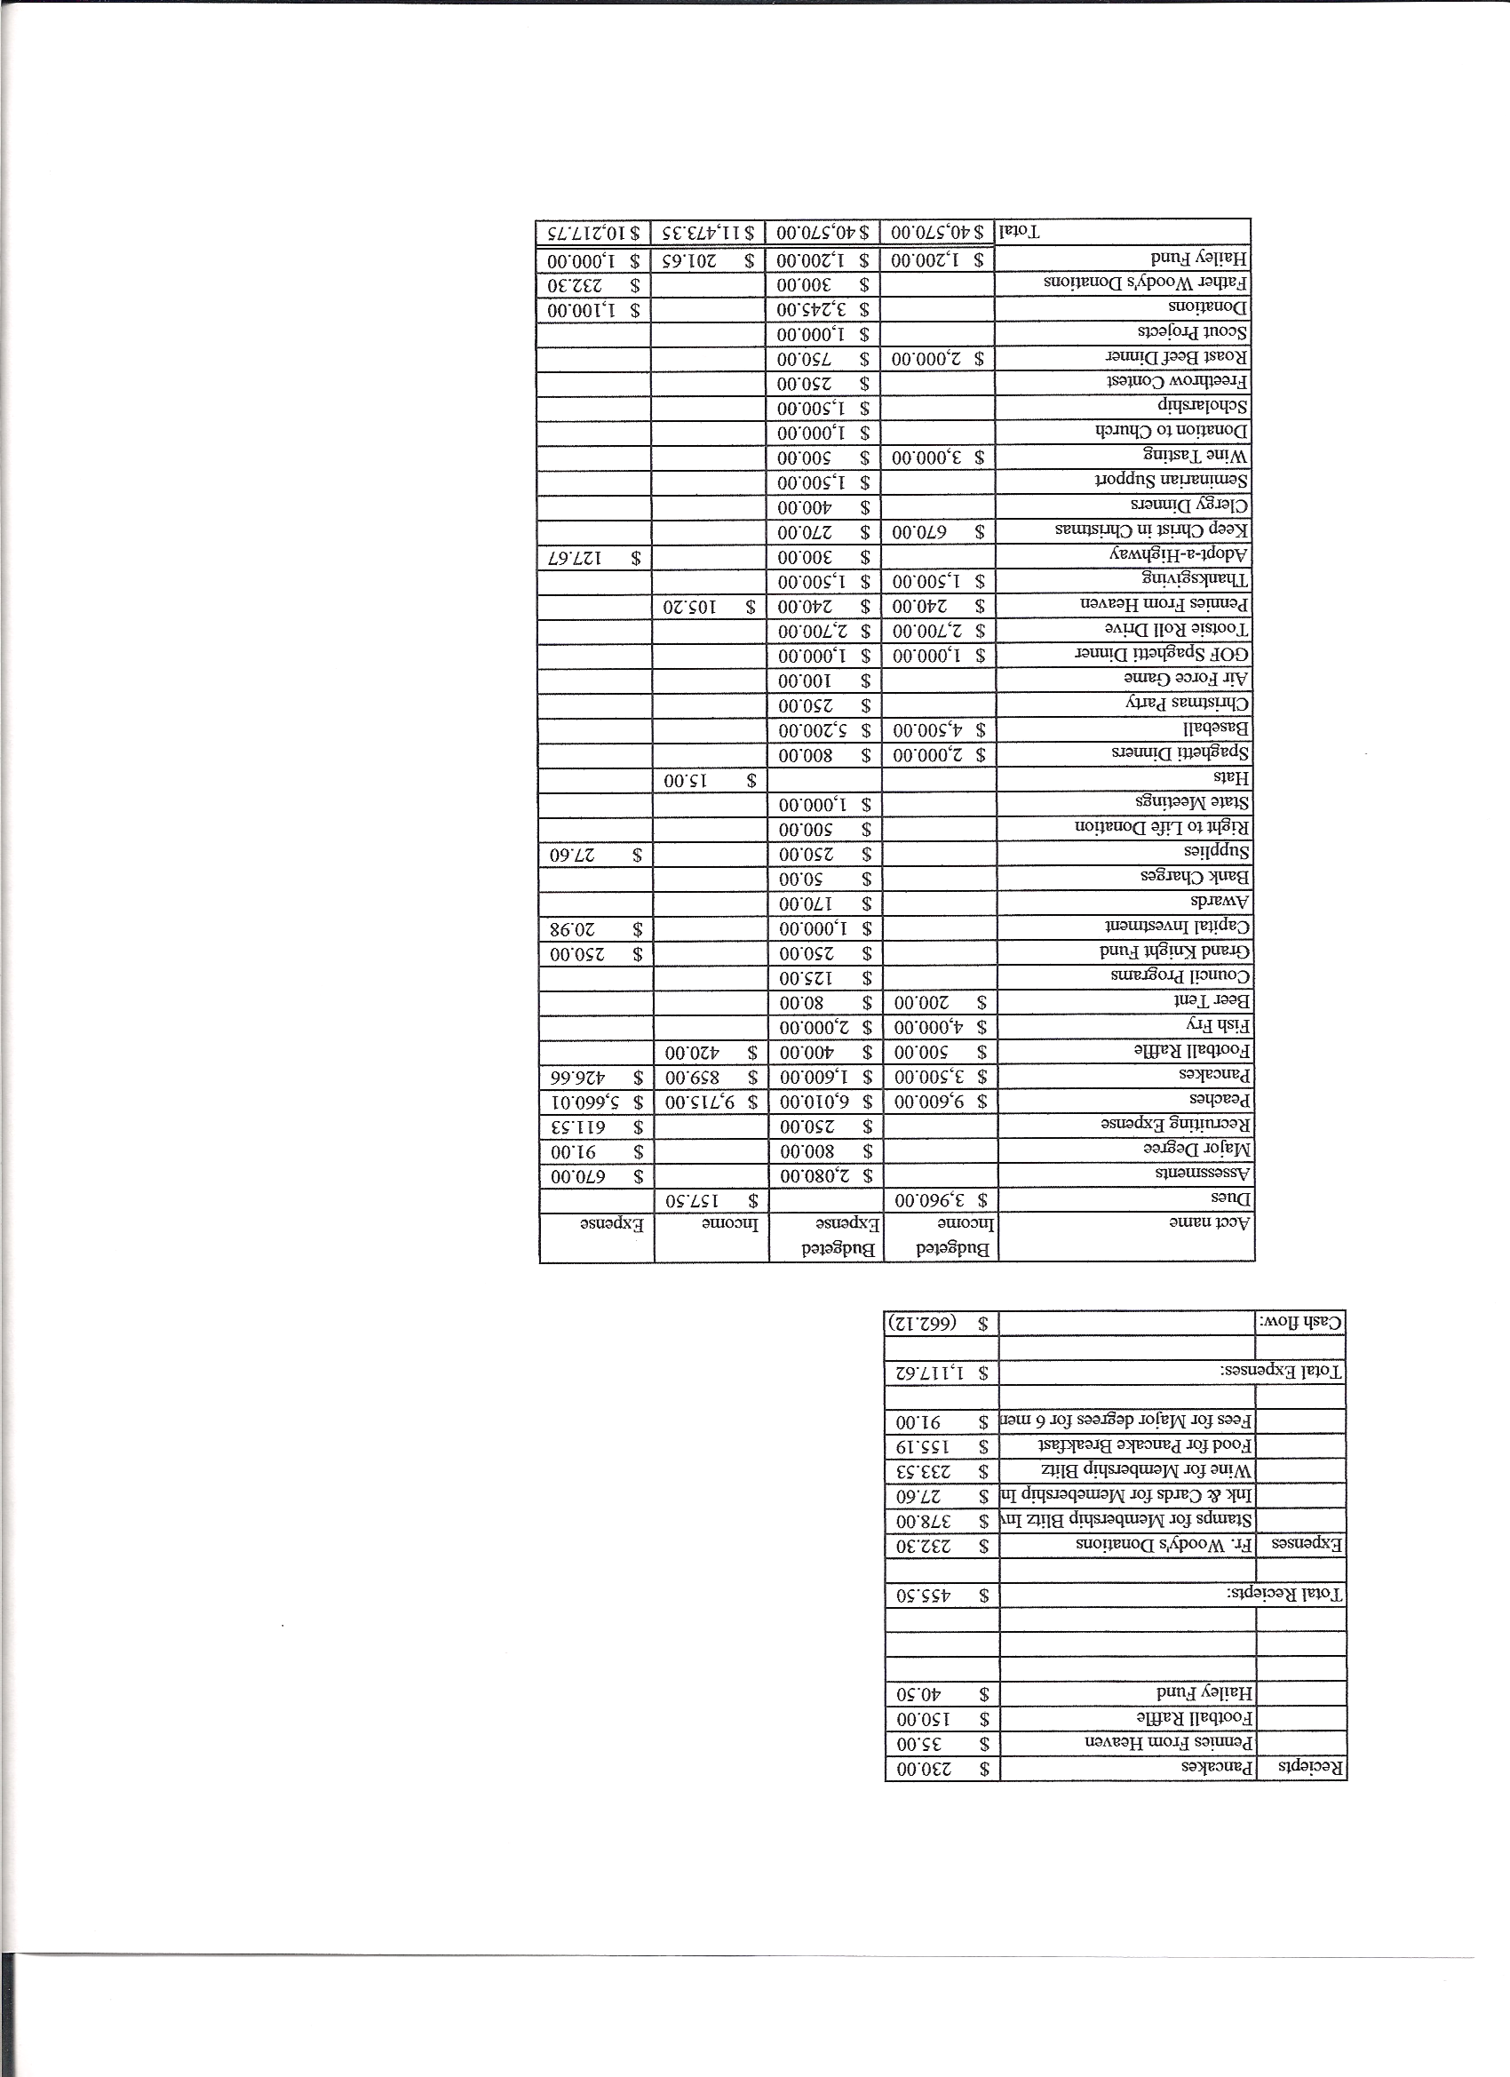
Business Meeting – September 8, 2012

I. General
- The Council was called to order at 8:03 AM by Deputy Grand Knight, Joe Musso.
- The Opening Prayer was offered by Gary Mayfield. The role of officers was called and noted as follows (P = Present; A = Absence; E = excused)

Title | Status | Title | Status | Title | Status
Chaplain | P | Financial Secretary | E | Inside Guard | P
Grand Knight | E | Treasurer | E | Outside Guard | E
Dep. Grand Knight | P | Lecturer | P | Trustee 3rd Year | P
Chancellor | P | Advocate | P | Trustee 2nd Year | P
Recorder | P | Warden | P | Trustee 1st Year | A

The August 11, 2012 meeting minutes were approved as read and published with correction of the spelling of the Mazur family of the month.

II. Applications for Approval – Roger
None

III. Grand Knight Report – Joe
Pennies from Heaven
Knight of the Month –Roger Guidici
Family of the Month – John Starke Family
There is a request from Supreme to organize a voter registration weekend. Anyone interested in taking charge should let Joe Musso know. There will be a conference called before the week of September 22nd. State guidelines and laws must be followed. Fourth Assembly will work on this.

IV. Chaplain’s Report – Father Jim
“My people perish for lack of vision.” Vision is knowing where you’re going. Our goal (life with God) should be our vision. Intermediate goals to obtain eternal life should be to practice goodness and morality (virtue). The proximate goal is what we should do now. We must light the path to peace and lead others toward that vision. Leadership must have vision. Christ is the ultimate example of good leadership. He is the Light of our path to peace. Father Jim invited us to think daily (as a meditation) about the path we are taking which will lead us to our final goal. We are called to be that light on the path.

V. Treasurer’s Report - Dennis
Report given by Josh.
Bank balance - $ 15,486.88 Available funds - $ 7,757.08

VI. Financial Secretary’s Report – Josh
Report handed out at meeting
Receipts - $ 6,129.60 Expenses - $ 14,358.12 Bank balance - $ 15,486.88

VII. Chancellor’s Update – Matt
Focus 11 – National Vocation Awareness for youth at Holy Trinity School, in Westminister, October 8th, 9th, and 10th.
There will be a vocational walk at Mother Cabrini today. Mass and picnic will follow.
Peter Morgan (our seminarian) was highlighted in the Knights Call.
Vincentia Carloci is in Brooklyn. If he stays in Brooklyn, we need to find a new seminarian.
Prayer for vocations was read.
VIII. Committee Reports – Gary

a. Membership – Max Gramly
Keith Haley has stepped up to take Max’s place as membership chair. Thanks to Max for all his hard work.

b. Church Director Report – Ron Reitsch
This evenings beer and brats has been cancelled due to Confirmation service. There is no reschedule date.
“Keep Christ in Christmas “ is swiftly coming up. Christmas cards may need to be ordered. Chris will check the inventory and order what is necessary.

c. Community Report – Bob Luckner
Next Saturday at 9:00 A.M. is highway cleanup. Help is needed, please sign up.
Please sign up online for the Tootsie Roll drive. More help is needed.
Thanksgiving basket drive is coming up. Let Bob know if you can help. Four team captains are needed. Many of the charities will offer tours of their facilities. Lots of involvement is needed in this effort. Basket assembly is the weekend before Thanksgiving. 286 baskets have been requested.

d. Council Activity Report – Gary
A restaurant for this month’s social hour is being considered. Ben is checking a Mexican restaurant (Cantina Laredo) and will send information.

e. Family Report – Bill Hensen
Next Saturday is the fishing trip. Knights and families will meet at Church at 8:00 A.M. and drive up as a group (directions via e-mail). Those who wish to come later are welcome.
The Air Force game is October 6th at 9:30. (Tickets online). Tim will send out the link. We will tailgate after the game.
The spaghetti dinner is October 13th.
Please let Bill know if you have suggestions for activities.

f. Right to Life report- Chris Mosely / Mike McGinnis
Please participate in 40 Days For Life through fast and prayer. During this time there will be daily prayer services in front of Planned Parenthood in Colorado Springs. All are invited to attend during the 40 days.

g. Youth Report – Dennis Thumann
One out of the four $500 Scholarship recipients sent an acknowledgement and thank you letter.
The soccer challenge will be at Rocky Heights Middle School tomorrow at 12:30 P.M.
The District challenge, which we are hosting, will be October 7th.
160 parishioners from Pax Christi participated in Relay For Life. This was the most of any group and $ 18,142 was raised. Please support Big Bill’s New York Pizza. He has a dinner each year after which he makes a big donation to Relay For Life. The dinner is September 11th. He is located at County Line and Holly. There is no charge for the meal and he requests only a donation.
The evening of September 22nd, Father Jim will accompany high school youth to St. John Vianney Seminary to introduce them to adoration of the Blessed Sacrament.
There is an article in the September Columbia about the first Native American, Blessed Kateri Takakwitha, who will be canonized October 21st. Recognition of her by the Church is a step toward acknowledgement of the presence of Native Americans in the Church and, hopefully, will aid in Knight recruitment of Native Americans, which has been difficult because of Knight’s association with Christopher Columbus.
Youth Safety Training is currently being offered and is required for those dealing with youth of the parish.
IX. Lecturer – Ben Stancati
The Rev. Robert F. Houlihan S.J. Educators Series, Number 4.0
Since this is an “educators” series, there is a need to focus our efforts to find truth through critical examination of all sides of the issues presented. Thus, to reexamine one topic previously discussed, Ben again considered the Cristero War. Much of the motivation portrayed in the movie might not have been as pristine or spiritual as was depicted. Motivations certainly varied on both sides. General Enrique Gorostieta, for instance, joined the revolution for money and ambition and in fact was anticlerical and a 33rd degree Mason. On the other side, why the government’s violent suppression of the Church? The government thought of the Church as a leech which for decades sucked the life blood out of Mexican society. Huge buildings, wealth and opulence of the Church, little institutional help for the downtrodden masses, little institutional help for those in poverty, caused the government to view the Church as part of the problem, not as a solution to the problem. They also considered the Church a major threat to their power base.
Ben will continue to attempt to provide a critical, analytical and balanced approach to the Educators Series as is the Jesuit tradition.

X. Trustee’s Report -
No report.

VIII. Unfinished Business –

Motion to approve the 2012-2013 budget was made and seconded. The motion was unanimously approved.

IX. New Business
No new business.

X. 4th Degree Report – Victor
Corporate Mass will be every third weekend rotating through scheduled masses. This month the Mass will be Saturday, September 15th at 5:00 P.M. The October Mass will be the 8:30 A.M. Mass etc. Fourth Degree Knights wear tuxes with regalia if you have it and other Knights dress in suits. Families are encouraged to sit with the Knights in the designated area.

XI. Field Agent Report
No report.

XII. District Deputy Report – Mark Solome
No report.

XIII. Good of the Order
Jim DeRose, Larry McConnell family, Jim Grady’s aunt and sister-in-law, Don Zirkelbach’s daughter.

XIV Chaplain’s Summation – Fr. Jim.
Father Jim discussed the Blessed Virgin Mary’s birthday and asked, “How has Mary increased our devotion to her Son?” We should reflect on that! The Rosary is the Bible translated into prayer. At 8:40 each weekday morning we offer the Rosary before the 9:00 A.M. daily Mass.

XIV. Closing Prayer
Read by Gary Mayfield

MEETING WAS ADJOURNED AT

9:13 am

- minutes recorded and reported by Mike McGinnis

