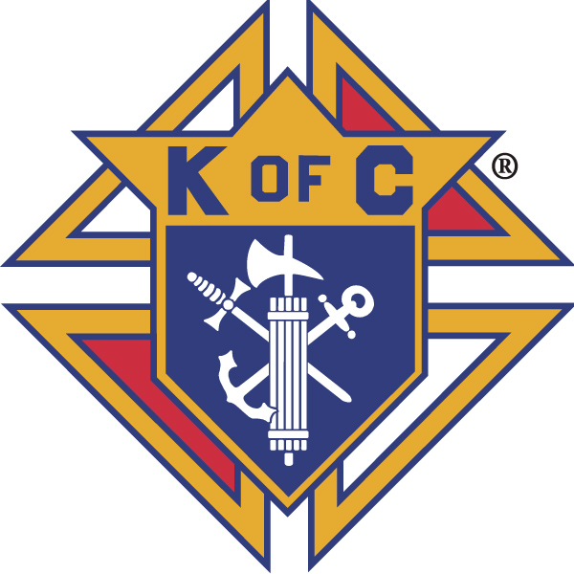
Knights of Columbus

In Service to One, In Service to All
Rev. Robert F. Houlihan, S.J., Council 10937
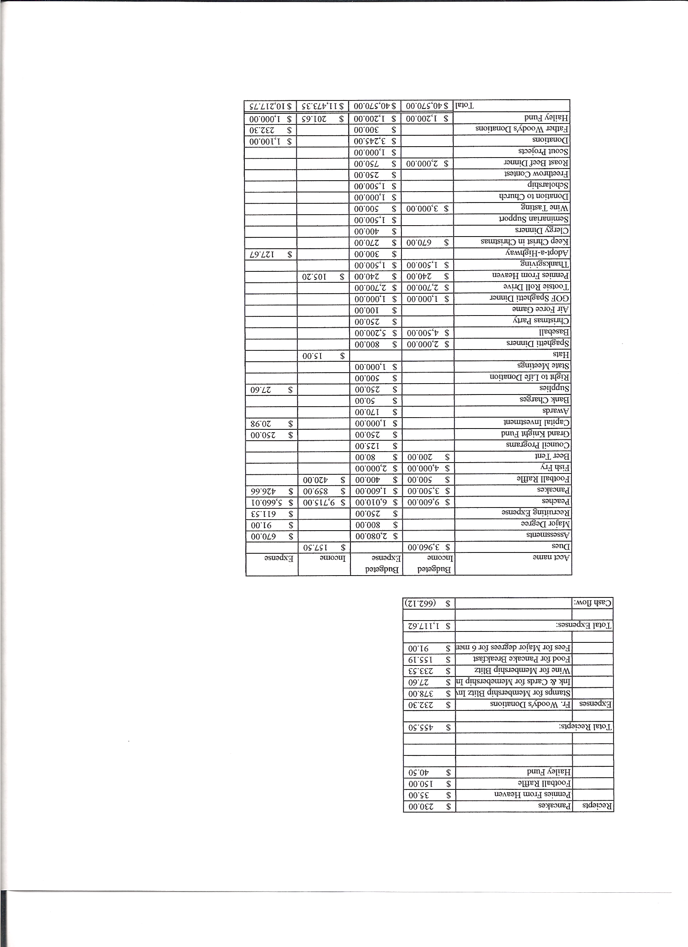
Business Meeting – August 11, 2012
General:
- The Council was called to order at 7:30 AM by First Degree Team Grand Knight, Tom Whyte. Opening Prayer was offered by Tom Whyte.
Applications for membership were read and all candidates were unanimously voted for membership.
Meeting was suspended at this point for first degree exemplification.
Congratulations to Mark Dougherty, Anthony Larosh and Brian Camaglin - our new first degree Knights.

Meeting resumed at 8:31 with call to order by Grand Knight Paul Sciera.
- The role of officers was called and noted as follows (P = Present; A = Absent; E = excused)

Title | Status | Title | Status | Title | Status
Chaplain | E | Financial Secretary | P | Inside Guard | P
Grand Knight | P | Treasurer | P | Outside Guard | A
Dep. Grand Knight | P | Lecturer | P | Trustee 3rd Year | P
Chancellor | P | Advocate | P | Trustee 2nd Year | A
Recorder | P | Warden | P | Trustee 1st Year | A

The July 14, 2012 meeting minutes were approved with corrections changing Colorado Springs to Castle Rock for the location of the district meetings and Janice Vogt’s last name is spelled Vogt not Vogte.

II. Applications for Approval – Roger
None

III. Grand Knight Report – Paul
Pennies from Heaven
Knight of the Month – Alan Brown
Family of the Month – Ron Maser Family
No correspondence.

IV. Chaplain’s Report
No report.
Father Brian is on vacation visiting his family in Atlanta and was not able to attend the meeting. Father Jim has another meeting and could not attend.
Target day for moving to the new rectory is August 28th. Professional movers have been hired for the heavy things but help will be needed for the lighter things. A date will be sent out requesting that help.

V. Treasurer’s Report - Dennis
Bank balance - $ 19,624.64 Available funds - $ 16,072.64

VI. Financial Secretary’s Report – Roger
Report handed out at meeting
Receipts - $ 7,905.98 Expenses - $ 3810.70 Bank balance - $ 19,624.64
VII. Chancellor’s Update – Gary Mayfield
Gary, his dad Bill, and Ron Gerber drove to Grand Junction and back to pick up peaches.
The prayer for vocations was said.

VIII. Committee Reports – Joe Musso
a. Membership – Max Gramly
Max presented the Shining Knight Award to Ed Novak.
The ministry fair will be held August 18 and 19.
Max indicated the need to staff a membership table at all Parish functions to recruit new Knights. At this table, we should have packets explaining what the Knights are about ready to hand out to possible new members. Herb created beautiful posters for display at the table. Knights should be prepared to tell potential members why they joined the Knights and what they get out of it.
Max emphasized that recruitment is only the first part of membership. Retention is the second and that requires some mentoring for the Knights you recruit.
Thus far for this fiscal year, we have three new members. Quota is 13.
Dates for major degrees are listed on the Knight’s state web site.
b. Church Director Report – Ron Reitsch – (Chris Kennedy gave the report in Ron’s absence.)
Beer and Brats will be tonight after the five p.m. mass.
Parish matching funds: An e-mail blast has been sent out to the parish and it’s in the bulletin. Father also announced it last week. Knights should make checks out to Pax Christi with a memo "Knights Matching Gift" If there is a particular thing that you would prefer the money to go to please attach a note with your check.
c. Community Report – Bob Luckner - (Joe Musso gave the report in Bob’s absence.)
The highway cleanup date will be announced.
The Tootsie Roll drive will be Sept. 28 and 29 and Oct. 5 and 6.
d. Council Activity Report – Leonard Leyba - (Joe Musso gave the report in Leonard’s absence.)
The Starke family will host the Council family social hour August 17th.
There are 35 more Football Frenzy tickets left to sell. These tickets help pay for conventions and provide money for charities. Cost is $10.00. See Roger.
e. Family Report – Bill Henson
John Starke will book when he receives a date for the fishing family excursion.
Tim Pimmel has set up the Air Force game for October 6th at 9:30 a.m. There will
be a tailgate party after the game. Info on how to buy your tickets on-line will be coming soon. Thanks to Tim!
f. Right to Life report- Chris Mosley / Mike McGinnis
Prayers and intentions for 40 Days For Life will be sent via e-mail as previously done during the 40 Days For Life campaign.
A Pro-life dinner is on Oct.19th in Colorado Springs. The cost is $20 per person. There are at least four of us attending. If more wish to attend, we might consider carpooling from Pax. Unfortunately, there is a conflict with the state Knights retreat in Sedalia which occurs that same weekend.
g. Youth Report – Dennis Thumann – (Chris Kennedy gave the report in Dennis’s absence.)
This years Relay For Life was Aug.10th and 11th at Cresthill Middle School. Approximately 150 walkers checked in for contributions of $16,000. Thanks to those who cooked and set up.
There will be a poster contest for youth set up at the next beer and brats or the next breakfast.
Council Soccer Challenge will be Sept. 9th. The District Challenge will be Oct.7th. More information will follow.
IX.– Lecturer – Ben Stancati
The Rev. Robert F. Houlihan S.J. Educators Series.
“ Let the Word go forth.” These words spoken by President John F. Kennedy in his first inaugural address continue to inspire us today. In this address, Kennedy quoted scripture and asked for God’s help to face the difficult tasks which lie ahead. Barriers had been broken. Due to prayer, courage and perseverance, a Catholic had been elected president. Kennedy understood that America was founded based on biblical truths that proclaim the dignity of man through basic rights as proclaimed in the Declaration of Independence and our Constitution. Kennedy warned that America will never stand for “the slow undoing of those human rights to which the nation has always been committed.” He also stressed that “the rights of man come not from the generosity of the state but from the hand of God.” The need for religious conviction in our country is as great as it ever has been. In this great oratory the words spoken then still resonate now and will do so into the unforeseeable future.

X. Trustee’s Report -
The August 15th audit is complete and everything is in line. Copies have been sent to Supreme and to State.

VIII. Unfinished Business -
None

IX. New Business
Both regional and state Special Olympics need volunteers. Help is needed with awards, cooking and many other things. Dates and information will come later.

X. 4th Degree Report – Victor
Thanks to all who helped in forming the 4th degree assembly.
There will be a social-business meeting on Aug.16th. Information has been sent via e-mail.

XI. Field Agent Report – Greg Archunde
Greg, who has been a field agent for 5 years, introduced himself and explained changes in the structure of the program causing changes in representation for the Council. Greg said he would be attending as many activities as possible since he is a brother Knight first. He would like to meet with and get to know everyone. His contact number is 720-985-5753. Doug is still our general agent.

XII. District Deputy Report – Mark Solome
No report.
XIII. Good of the Order
Jim DeRose, Shawn Conley Family (Monique, Shawn’s wife)

XIV Chaplain’s Summation – Fr. Brian
Read by Paul Sciera.

XIV. Closing Prayer Read by Joe Musso
MEETING WAS ADJOURNED AT 9:25 am

- minutes recorded and reported by Mike McGinnis

