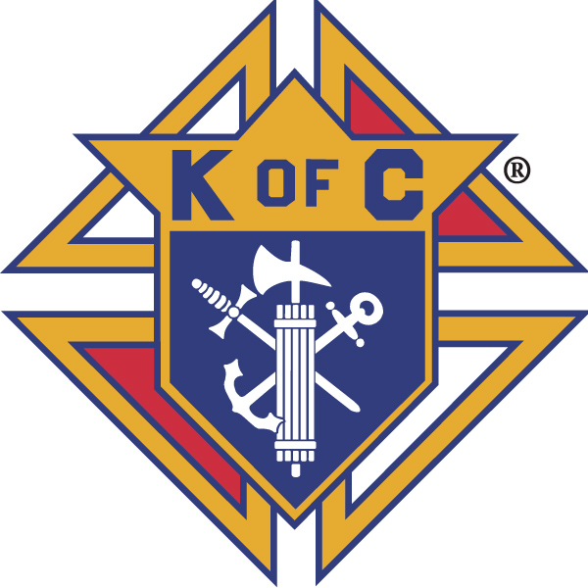
Knights of Columbus

In Service to One, In Service to All
Rev. Robert F. Houlihan, S.J., Council 10937
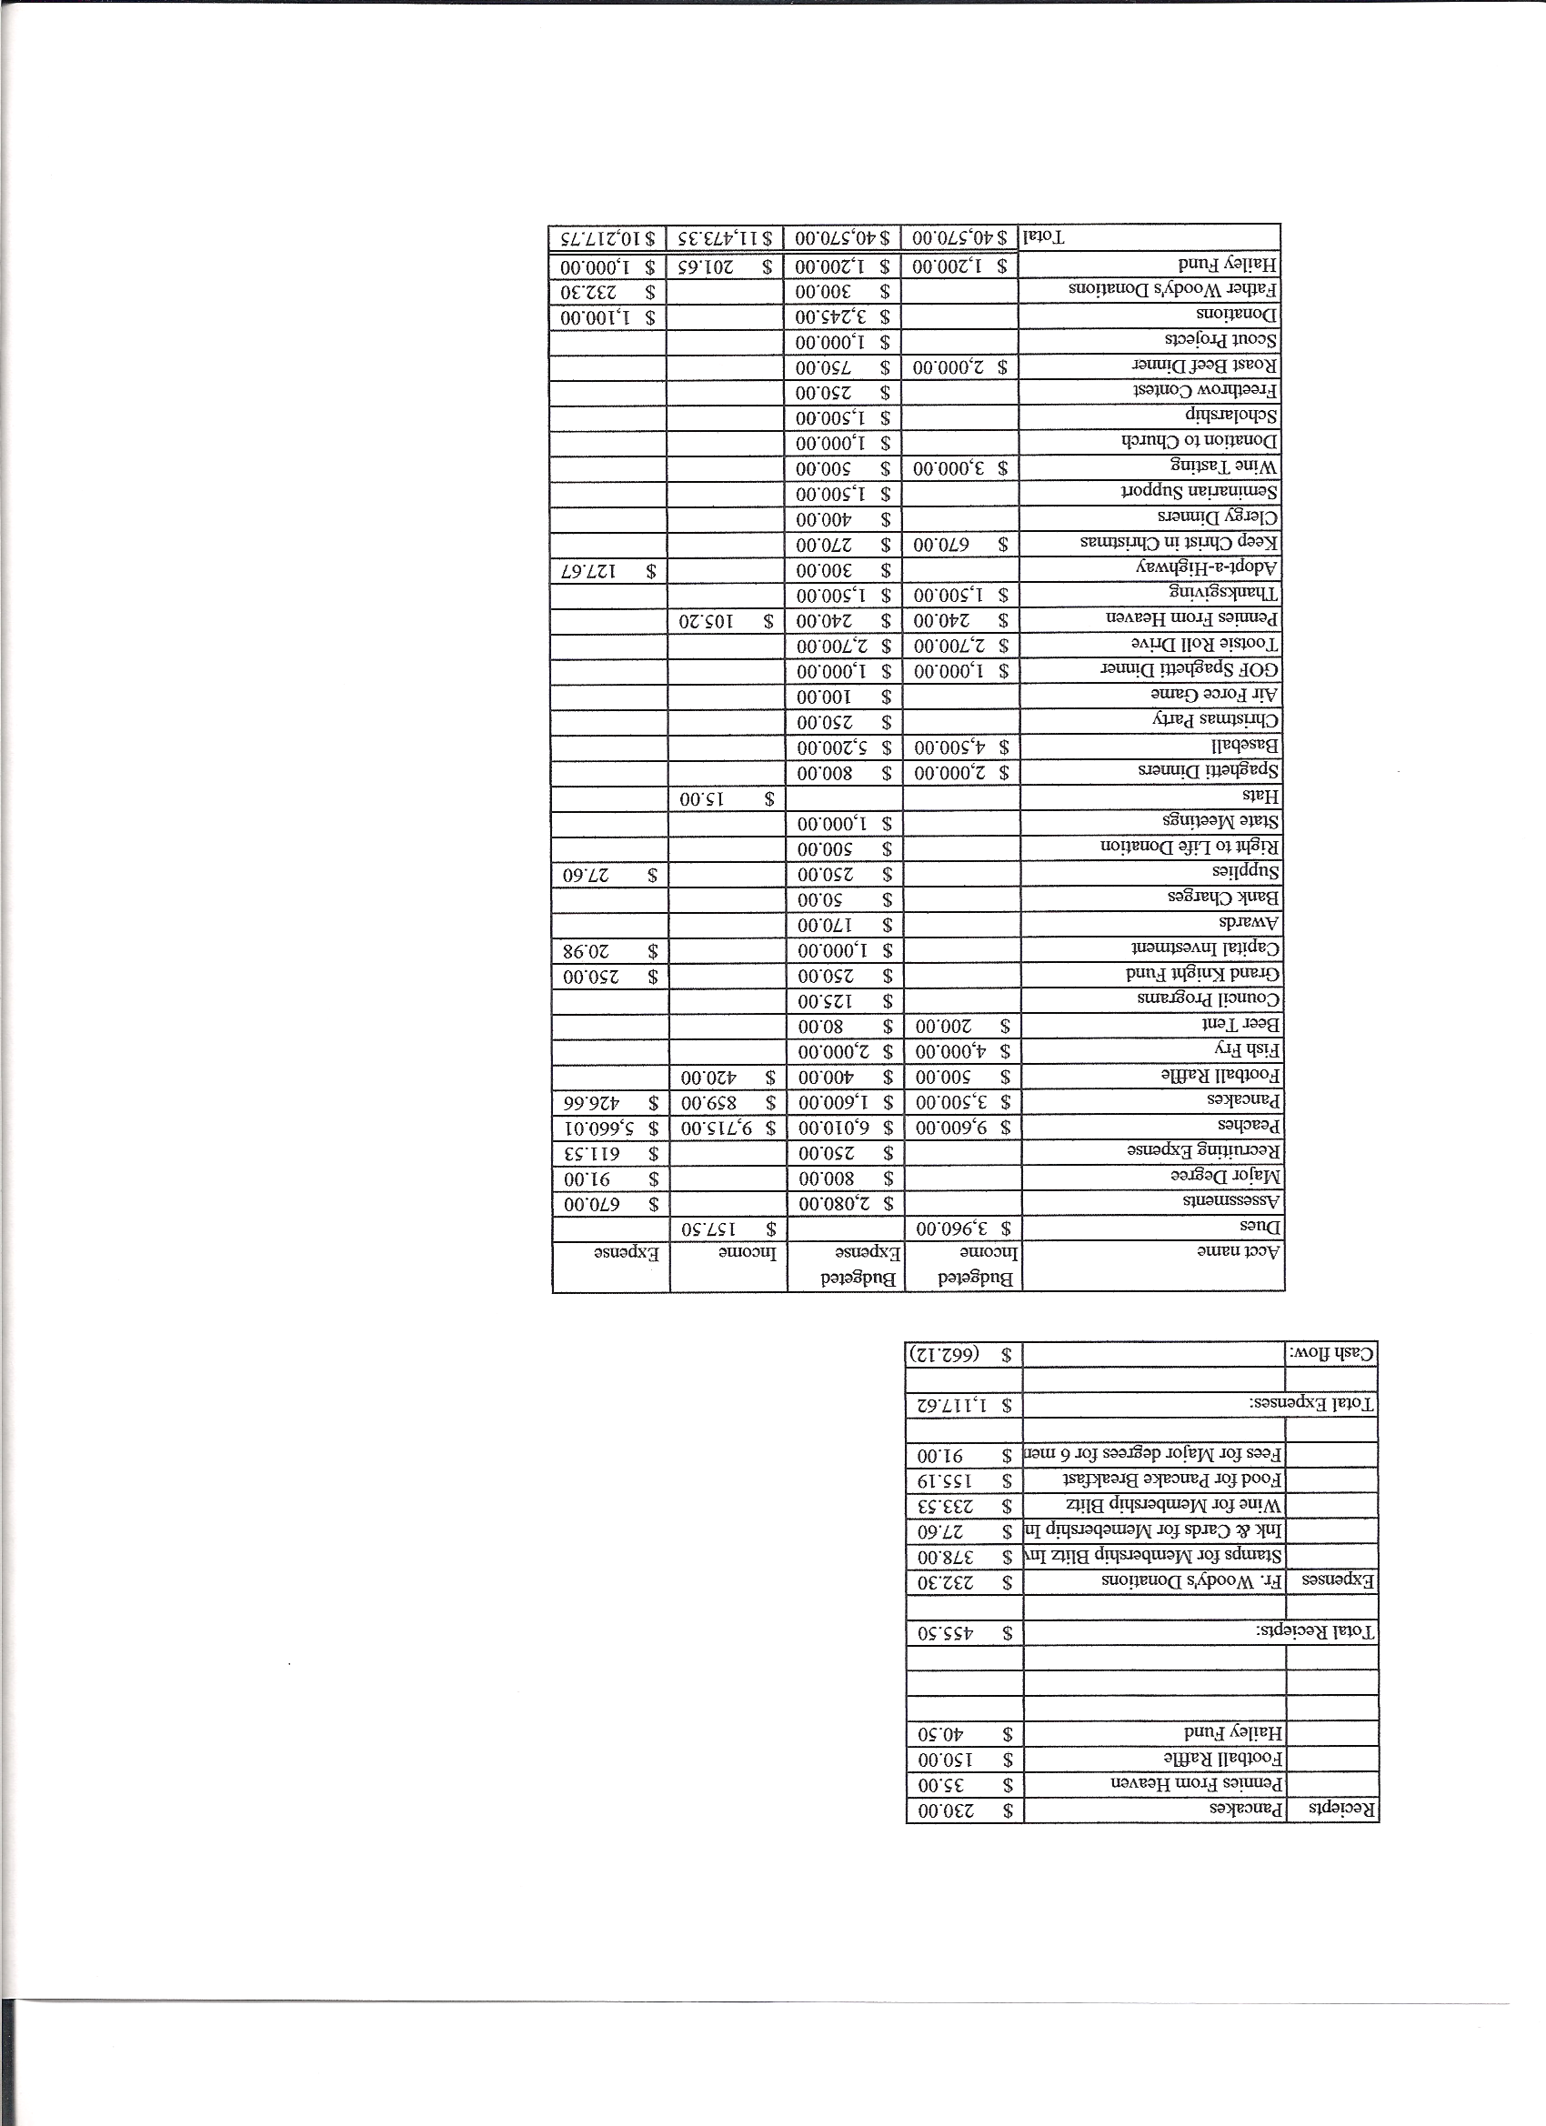
Business Meeting – November 10, 2012

I. General
- The Council was called to order at 8:07 AM by Grand Knight, Paul Sciera.
- Opening Prayer was offered by Joe Musso. The role of officers was called and noted as follows (P = Present; A = Absence; E = excused)

Title | Status | Title | Status | Title | Status
Chaplain | P | Financial Secretary | P | Inside Guard | P
Grand Knight | P | Treasurer | P | Outside Guard | P
Dep. Grand Knight | P | Lecturer | P | Trustee 3rd Year | P
Chancellor | P | Advocate | P | Trustee 2nd Year | P
Recorder | P | Warden | P | Trustee 1st Year | P

The October 13, 2012 meeting minutes were approved as read and published after correction on the spelling of Greg Archunde’s name.

II. Applications for Approval – Roger
None

III. Grand Knight Report – Paul
Pennies from Heaven
Knight of the Month – Bob Luckner
Family of the Month – Alan Brown Family
Donations for pennies from heaven last year were $9364. The monies were donated through Colorado State Charities program to St. Williams Church for a new sidewalk, Sacred Heart Church for assistance, Mother Cabrini Shrine for repairs, Blue Star Moms for retreat, St. Louis Council for refurbishing the house of an incapacitated knight, two suits for priests, and to Colorado Freedom to refurbish a house.
A thank you letter was received from St. Dominic Church for the $1500 we contributed to maintain the “Baby Bus”.
We received a letter of congratulations for making Star Council.

IV. Chaplain’s Report ( Father Jim for Father Brian )
Father Jim expressed some regret at issues against Catholic doctrine that passed in the election. The question is, “What should be done? What are our resources?” The answer is
“ take up your cross and follow Jesus.” Laws and measures do not change where individuals stand. The Year of Faith calls us to recognize that change will happen through evangelization. We need to bring that true liberty obtained from Christ to enrich these laws with an understanding of personal holiness. Patriotism linked to your faith comes in denying one’s self and showing our love for Christ.

V. Treasurer’s Report - Dennis
Report handed out at meeting.
Bank Balance - $13,451.17 Available Funds - $11,479.48

VI. Financial Secretary’s Report – Roger
Report handed out at meeting
Receipts – $6,934.06 Expenses - $3,313.16 Bank Balance - $13,451.17

VII. Chancellor’s Update – Gary Mayfield
Gary sent e-mails inviting seminarians to attend the Christmas party and thanksgiving baskets. He received two responses. Nathan Hinds said he would be here for the baskets and possibly the Christmas party. Peter Morgan, unfortunately, will be leaving the seminary for at least two years for personal reasons.

VIII. Committee Reports – Joe Musso

a. Membership – (Paul Sciera)
The campaign Do Not Be Afraid sent a letter from the vice president of membership informing us that we have met all the requirements for membership. He sent a portrait of blessed Pope John Paul the second to acknowledge our performance. Paul passed the portrait around for all to see. It will be hung at an appropriate place in the building.
Due to travel commitments, Keith will be unable to take over membership duties.
Max is also very busy with outreach projects. Therefore, membership chair will become a join effort.
Paul is in the process of updating the database. He would like to add children and spouses, phone numbers etc. of members. It is possible for members to update their own data by going to council10937.org. Chris Kennedy will send out directions.

b. Church Director Report – Ron Reitsch
The Keep Christ In Christmas sign will be hung the weekend after Thanksgiving.
The reconciliation dinner is December 20th. The Knights will cook dinner for the priests.
Starting this Tuesday, (on Tuesdays only), there will be a 6:30 AM mass.
The Knight’s Christmas Choir will have their first practice on November 29th. Herb Engler’s wife, Vonnie, has volunteered to accompany the choir.
Christmas parking help will be needed, mostly at the Christmas Eve mass.

c. Community Report - ( Joe for Bob )
We need help (8 people at each mass) to sign people up for Thanksgiving baskets after masses. This is the last week for signups. Thus far, we have 115 baskets and $2,875 pledged. There are 128 families involved. Chris Kennedy also needs some help Monday afternoon and Friday before happy hour to pick up food.
Jonathon Feifarek is heading the coat drive which will last until the end of November.
February 9th is Fat Saturday Casino Night and Dance. Please keep the date open as knights usually deal for the games.

d. Council Activity Report – Leonard Leyba
The family social hour will be the Friday before Thanksgiving at Leonard’s house.
The Christmas party is December 14th at Pax Christi
.
e. Family Report – Bill Hensen
Christmas party- Bill will check with either Father Brian or Father Jim to see if one of them can say mass before the dinner. Volunteers are needed to help set up which should be there around 3PM. Paul will check with the Lady Knights to see if they will help. It’s a potluck dinner and Council will provide a turkey and ham. The annual contribution to the Parish will be given during the dinner and we will receive the Marian Icon for display along with district 9.

f. Right to Life report- Chris Mosely / Mike McGinnis
40 Days For Life has concluded. No results at this time.
The Right to Life Dinner at the Broadmoor was attended by Herb and Vonnie Engler and Denise and Mike McGinnis. This fund raiser was for Project Rachel, an organization which helps women through care, love, forgiveness and counseling, to recovery from their abortion experience.
The Alternative Pregnancy Center mobile unit was at Pax October 14th and many parishioners volunteered for various activities at the center. About 20 parishioners toured the bus. Thanks to Marci McGovern who spoke at the 8:30 and 10:30
masses, to Cynthia Kroll, nurse manager, and to Ron Decker who piloted the bus.
g. Youth Report – Dennis Thumann
The free throw contest is January 20th at Rocky Heights gym.
Scholarship awards will take place in February.
We still have no youth minister. Our search continues. Father Jim is meeting with small groups of high school kids.
Dennis attended the canonization of Native American Kateri Takakwitha and Hawaian Marianne Cope. Dennis was impressed by the Knights participation before, during and after the ceremony.

IX. Advocate’s Report –
No Report

X. Auditor -
No report

XI. Lecturer – Ben Stancati
The Rev. Robert F. Houlihan, S.J. Educators Series, number 6.0
Part 2, An Authentic Fruit of Faith, The Second Vatican Council.
From Vatican II, 16 conciliar documents were developed, 4 of which were significant constitutions. It is striking that near unanimous acceptance of these documents was achieved. For over 50 years now topics in these documents have been examined, interpreted and debated under Papal guidance through scholarly process. Both ends of the spectrum (the documents went too far challenging the roots of our faith to they didn’t go nearly far enough) have been examined. This controversy has generated a call for a Vatican III council to wrap up this unfinished business of Church reform. Remember that the Holy Spirit was the guiding force in Vatican II and that Vatican II was a pastoral council, designed to feed souls and was open to all faiths. No new dogma was decreed in the council.

XII. Unfinished Business -
None

XIII. New Business
A resolution to nominate Jon Herskovits and to endorse him for the office of state warden was presented, read and voted on. The motion was unanimously approved.
Chris Kennedy moved that $100 for funding of an accompanist for the Knight’s choir be given to Vonnie Engler who volunteered for the job. The motion was unanimously approved.
Roger Guidici presented a motion to donate $100 to Alternative Pregnancy Center. The motion was seconded by Chris Kennedy, voted on and unanimously approved.
Roger Guidici presented a motion to donate $250 for youth t-shirts. The motion was seconded by Chris Kennedy, voted on and unanimously approved.

XIV. 4th Degree Report – Victor
Corporate Mass will be 10:30 November 18th. All are invited.
The first formal meeting of the fourth degree will be today.

XV. Field Agent Report
No Report

XVI. District Deputy Report – Marc Solome (Report was given by John Lynn who is in the process of transitioning for Marc whose term is up in July.)
Membership for our council is at 4 so far. Insurance has lost 1.

The district free throw contest will be at the new Ave Maria gym on Feb.24th.
The semi-annual audit is due by Feb.15th.
There is a new incentive, (retroactive to July), for the Food For Families Program. For every $500 donated in food or cash to food banks or pantries, $100 will be refunded to council up to a maximum of $500 in a fraternal year.

XVII. Good of the Order
Jim DeRose, Ken Bertrand, Dave Martz

XVIII. Chaplain’s Summation – Fr. Brian
None

XIX. Closing Prayer
Read by Joe Musso

MEETING WAS ADJOURNED AT

9:31 am

- minutes recorded and reported by Mike McGinnis

