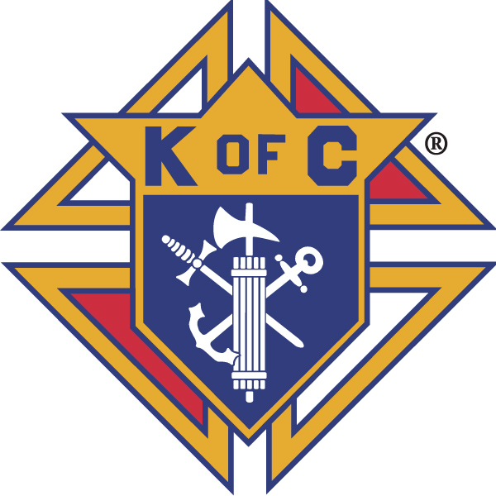
Knights of Columbus

In Service to One, In Service to All
Rev. Robert F. Houlihan, S.J., Council 10937
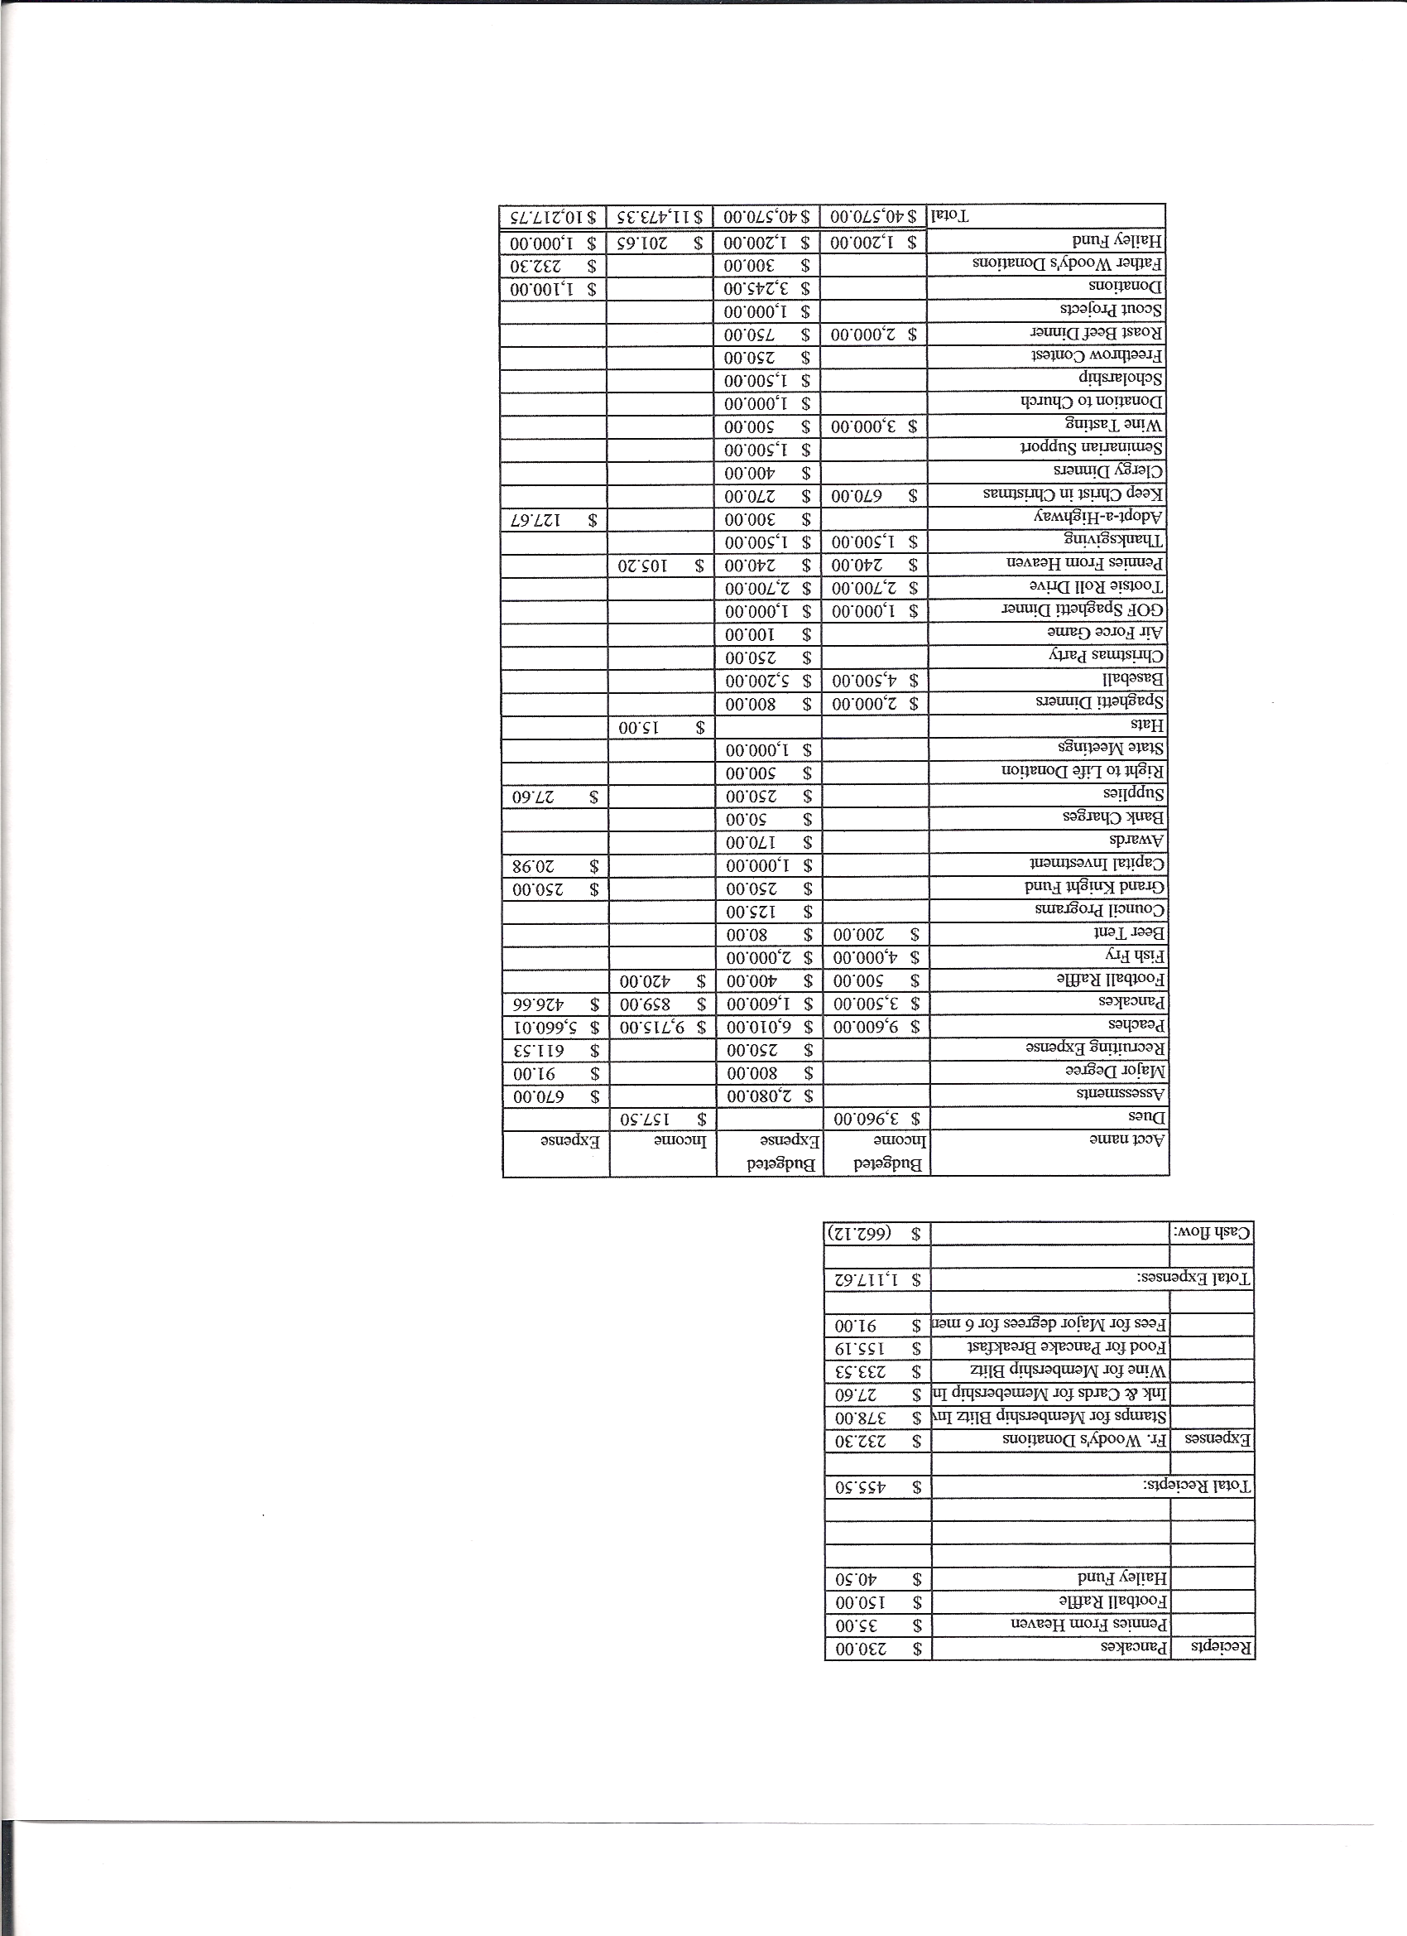
Business Meeting Minutes– December 8, 2012

I. General
- The Council was called to order at 7:40 AM by 1st Degree Team Grand Knight, Tom Whyte. At 7:48 AM the meeting was suspended for the 1st degree exemplification. Congratulations to Clyde (Tony) Mancuso, our new 1st degree Knight. After the 1st degree ceremony, at 8:31AM, Grand Knight Paul Sciera reconvened the regular December meeting.
- Opening Prayer was offered by Joe Musso. The role of officers was called and noted as follows (P = Present; A = Absence; E = excused)

Title | Status | Title | Status | Title | Status
Chaplain | E | Financial Secretary | P | Inside Guard | P
Grand Knight | P | Treasurer | P | Outside Guard | A
Dep. Grand Knight | P | Lecturer | P | Trustee 3rd Year | P
Chancellor | E | Advocate | P | Trustee 2nd Year | A
Recorder | P | Warden | P | Trustee 1st Year | A

The November 2012 meeting minutes were unanimously approved as read and published.

II. Applications for Approval – Roger
none

III. Grand Knight Report – Paul
Pennies from Heaven
Knight of the Month – Chris Kennedy
Family of the Month – John Davis Family
End of the year reports are due to Joe before the end of December. Paul and Joe would like to hand the reports in at the Jan. 5th State meeting. Also, please fill out the volunteer time “ Fraternal Activity” survey and send it to Joe before the end of December.

IV. Chaplain’s Report
none

V. Treasurer’s Report - Dennis
Report handed out at meeting.
Bank Balance - $ 17,429.42 Available Funds - $11,221.30

VI. Financial Secretary’s Report – Roger
Report handed out at meeting
Receipts - $5,784.81 Expenses - $6,192.36 Bank Balance - $17,429.42

VII. Chancellor’s Update – Gary Mayfield (Joe Musso)
Jason Keas is coming for the Christmas dinner.

VIII. Committee Reports – Joe Musso
There is a major degree in Brighton on Jan. 26.
There is a 4th degree in Littleton April 14th.
- Membership –
no report

b. Church Director Report – Ron Reitsch (Paul Sciera)
Reconciliation dinner for the priests is on Dec. 20.
We need parking help for the 4:00 PM Christmas Mass on Christmas Eve. We will start parking people about 2:45 PM. Contact Ron about helping.

c. Community Report - Bob Luckner
Thanksgiving basket drive was a success. 314 baskets went out. $1,000 went to Parker Task Force, $ 750 to Father Woodies. From the Tootsie Roll drive, 30 % went to State Special Olympics, 70 % went to ARC and Special Olympics of Highlands Ranch.

d. Council Activity Report – Leonard Leyba

e. Family Report – Bill Hensen
Everything is ready for the Christmas dinner. The ham and turkeys have been purchased and the cooking crew is ready. The Marian Icon Prayer Service will be held in the Church before the Knight’s Christmas dinner party at 5:30 PM, December 14th. Bring food to share and gifts, ($10), if you are bringing small children. Gifts with the child’s name should be placed in the office for Santa to distribute. Set up will start at 3:30 PM for those helping. Help is needed. An e- mail will go out today.

f. Right to Life report- Chris Mosely / Mike McGinnis
Statistics from 40 Days For Life fall 2012 campaign:
- 821 babies were saved from abortions.
- 6 abortion workers quit their jobs.
- 1 Planned Parenthood Center closed its doors 5 days after the campaign ended.
Since the first 40 Days For Life Campaign:
- There have been 2,210 campaigns in 481 cities.
- There have been 550,000 participants who have joined together to pray and fast.
- 15,500 Church congregations have participated.
- 6,749 lives have been saved from abortion.
- 75 abortion workers have quit their jobs.
- 25 abortion centers have closed.
The next 40 Days For Life campaign is from Feb. 13th, 2013 to March 24th, 2013.

g. Youth Report – Dennis Thumann
Basketball free throw is at Rocky Heights Middle School 1:00 PM on Jan. 20th. E-mails will come.

IX. Advocate’s Report – Dave Petteys
Dave highly recommended the movie “Trafficking of the Innocents”. The movie is on a limited engagement but is presently showing here in town. Dave felt it was excellent, an inspiration of the Holy Spirit.

X. Auditor -
No report

XI. Lecturer – Ben Stancati
no report

XII. Unfinished Business -
none

XIII. New Business
Todd would like to have one mass that is ushered by all knights. He is looking at the 9:00 PM Christmas Eve mass. If you are interested in ushering at that mass, please let Todd know. The Knight’s men’s choir will sing at that mass. Suit and tie should be worn.

XIV. 4th Degree Report – Victor (Roger)
E-mail is out about corporate masses. All are invited. 4th Degrees should come in tuxedos.
Roger will send out information in January about the March dinner at Pappadeaux.
There is a 4th Degree exemplification on April 14th. The six-month waiting period has been removed.
There is an exemplification for priests and deacons on Jan. 16th. Father Jim will be attending.

XV. Field Agent Report
no report

XVI. District Deputy Report – Mark Solome
Mark is excused. Jon Herskovits thanked all for their support in his bid for election to state warden.
The mid-year training meeting is Jan. 5th. The specifics are on training. Breakout meetings will be held for all areas. All are invited to attend. There is a lot to be learned from intermingling with other councils, particularly for those heading up committees. An e-mail from Roger will be sent this week. If you are interested in going, let Roger know. Our council will pay for lunch. We will carpool, leaving at 6:30 AM and be back in time for the 5:00 PM mass. There will be a push from State and Supreme for membership recruiting. Councils are encouraged to bring a person to receive his 1st degree at an exemplification at the meeting. The hope is that every council will bring at least one new recruit to this huge 1st degree exemplification.

XVII. Good of the Order
Jim DeRose, Chris Kennedy Family, Ken Bertrand Carol Barrett, Bob Chubbick.

XVIII. Chaplain’s Summation – Fr. Brian
none

XIX. Closing Prayer
Read by Joe Musso

MEETING WAS ADJOURNED AT

8:45 am

- minutes recorded and reported by Mike McGinnis

