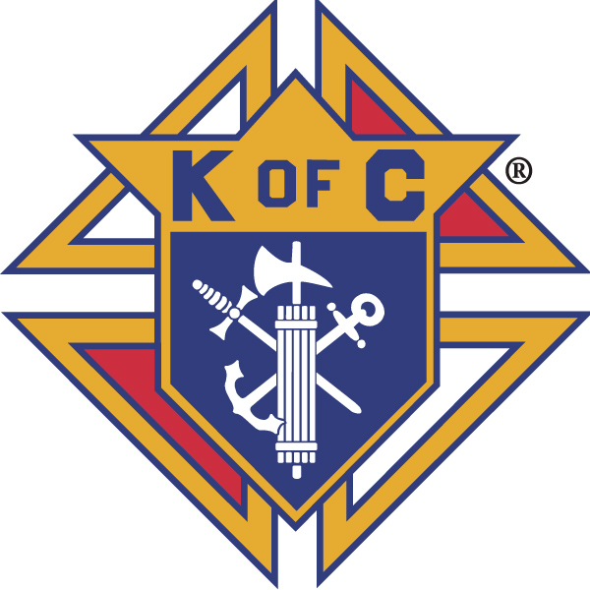
Knights of Columbus
In Service to One, In Service to All
Rev. Robert F. Houlihan, S.J., Council 10937
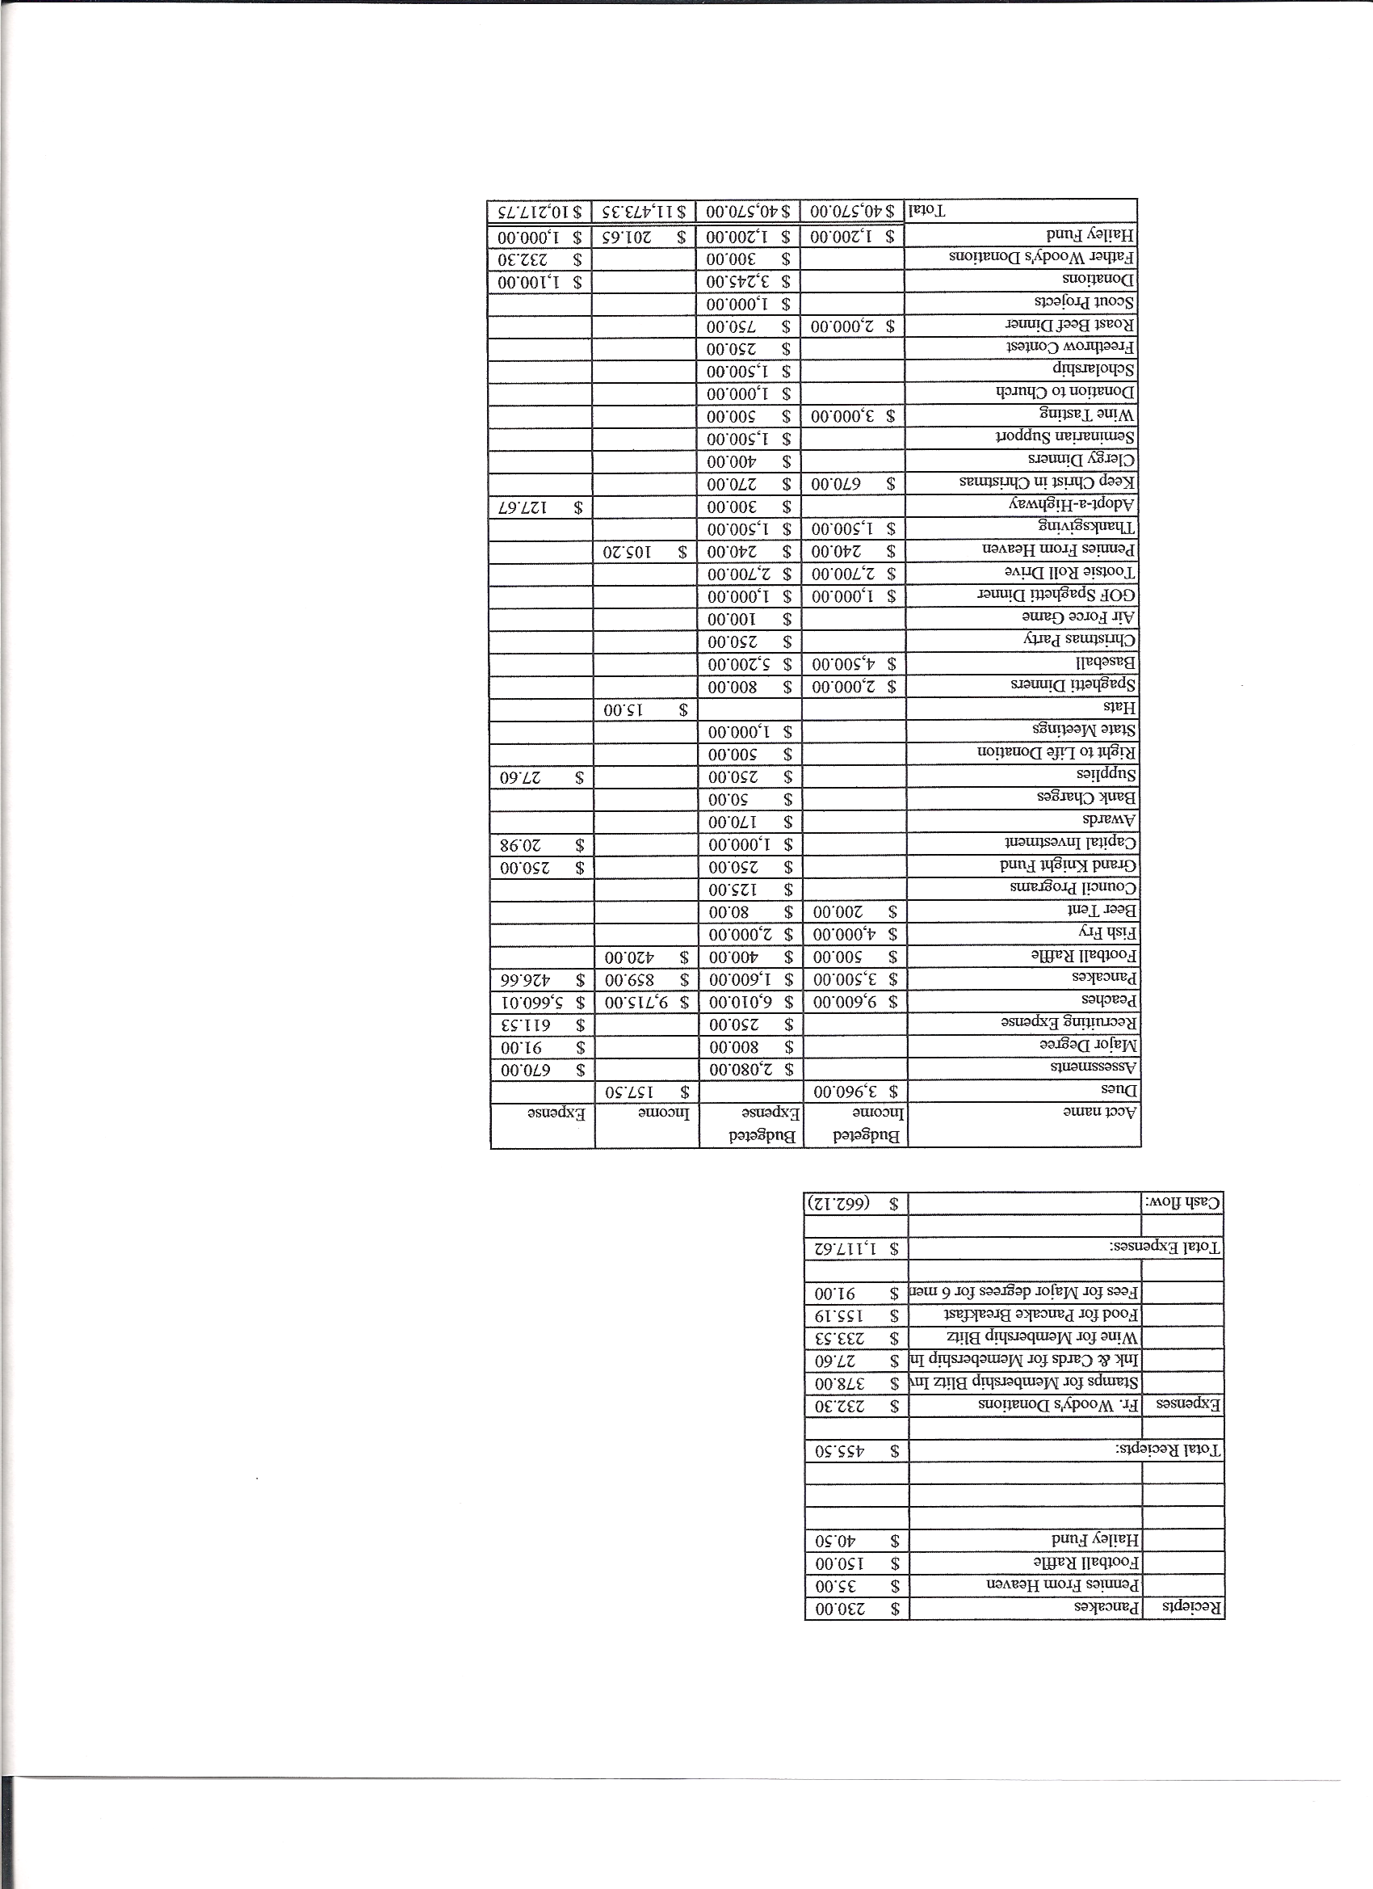
Business Meeting – January 12, 2013

I. General
- The Council was called to order at 8:03 AM by Deputy Grand Knight, Joe Musso.
- Opening Prayer was offered by Gary Mayfield. The role of officers was called and noted as follows (P = Present; A = Absence; E = excused)

Title | Status | Title | Status | Title | Status
Chaplain | P | Financial Secretary | P | Inside Guard | P
Grand Knight | E | Treasurer | P | Outside Guard | A
Dep. Grand Knight | P | Lecturer | P | Trustee 3rd Year | P
Chancellor | P | Advocate | P | Trustee 2nd Year | E
Recorder | P | Warden | P | Trustee 1st Year | A

The December 8, 2012 meeting minutes were approved as read and published.

II. Applications for Approval – Roger
None
Congratulations and welcome to Bill Miller our newest Knight.

III. Grand Knight Report – (Deputy Grand Knight Joe Musso) for Paul Sciera
Pennies from Heaven
Knights of the Month – Father Brian and Father Jim
Family of the Month – Ron Gerber Family
Family of the Year – Since Roger was sick last meeting, Joe presented the Family of the Year award to him.
Correspondence: Received a thank you from a person who received a Thanksgiving Day food basket.
The Knights are sponsoring a wheelchair drive to send children in Afghanistan needed wheelchairs. They are looking for 2000 wheelchairs.
March for Life rallies will be held in several cities including San Francisco,
Washington DC, Toronto, and the Philippines the week of the anniversary of Wade vs Roe.
The agenda for the Knight’s midyear meetings arrived.
Knights who work on Special Olympics are able to satisfy the requirement of participating in 4 Council events for the year if they put in 200 man-hours and raise at least $2000.
There will be a major degree on Jan. 26th in Brighton.

IV. Chaplain’s Report - Father Brian
Christmas was busier than last year. Some of the Knights ushered at the masses. Father would like to have the Knights be more involved in masses on a routine basis.
We need help at wedding and funeral masses (ie. altar servers, ushers, etc.)
Financially at Christmas, we did slightly better than last year.
There will be a Holy Hour at 7:00 PM on January 22, the anniversary of Roe vs Wade. Attendance is encouraged.
Father Brian is very excited about our new youth director, Patrick Meleney. He was very impressed after watching him work with the youth of St. Thomas More.

V. Treasurer’s Report - Dennis
Report handed out at meeting
Bank Balance - $10,966.54 Available Funds - $3,310.14

VI. Financial Secretary’s Report – Roger
Report handed out at meeting
Receipts - $814.90 Expenses - $8,626.06 Bank Balance - $10,966.54
Dues statements for this year will be sent out shortly.
Our Council won $400 on Football Frenzy this year. Finally, a big winner!

VII. Chancellor’s Update – Gary Mayfield (reported by Matt Yeagle)
The Knights will participate in the ordination of Jason Keas on June 1st. Please think about attending.
All the seminarians have received and cashed their checks.

VIII. Committee Reports – Joe Musso (Gary)

a. Membership – Tony Yarosh

We need an additional director of membership.
Now through June, 2013, Supreme is giving $9 per new member as credit toward assessments. This is a great opportunity for the Council to grow in membership and also financially.
New membership is at 6, which is 46% of our quota. We are -1 out of 5 on insurance.
There is a 2nd and 3rd degree in Brighton on Jan. 26, a 2nd degree on Feb. 19th at Ave Maria, and a 4th degree at Light of the World on April 13th.

b. Church Director Report – Ron Reitsch
Thanks to all who helped out during the Christmas celebrations.
2013 has been designated the “Year of Faith”.
Roger needs help selling tickets after Sunday Masses. Please see him before Mass to volunteer.

c. Community Report - Bob Luckner
Lent will soon be here and that means fish fries. Please sign up to help at http.www.mysignup.com/pax_christi_kofc_2012_feb_fish_fry

d. Council Activity Report – Leonard Leyba
The family social will be hosted by Shawn and Monique Conley on Jan. 18th. Please RSVP at 720-935-1735.
More dealers are needed for the Fat Saturday, Feb. 9th celebration. A one man band will play at this event. There will be more gambling tables this year and, hence, more dealers.

e. Family Report – Bill Hensen
There were 104 people at the Christmas party.
A family game night may be planned soon.

f. Right to Life report- Chris Mosely / Mike McGinnis
Tax preparers are needed again this year to help the elderly and needy with their taxes. Volunteers should contact Dave Martz.
There will be an adoration service at 7:00 PM on Jan. 22nd, the 40th anniversary of Roe vs Wade. Please plan to attend and pray for an end to the slaughter of unborn children. Since 1973, there have been over 55,000,000 babies aborted. One in nine women who go to a Panned Parenthood clinic have an abortion, and those clinics perform an abortion in the United States once every 94 seconds.
There are now 7 ultra sound machines in the state. This is good news because they make such a difference (Approximately 90% of mothers who see an ultra sound of their babies will choose life for their unborn child).

g. Youth Report – Dennis Thumann
The free throw contest will be held Jan. 20th from 1:00 to 2:00 PM at Rocky Heights Middle School. Proof of age is required.

h. Newsletter – Herb Engler
Please get articles into Herb.
Suggestions on ways to make the newsletter more widely read and useful are welcomed. Herb’s survey seemed to show that few Knights are actually reading the newsletter. Possibly, a survey monkey with a few questions on how to approve communication was suggested.

IX. Advocate’s Report – Dave Petteys
No Report.

X. Auditors and Trustees – Chris Kennedy
No Report

XI. Lecturer – Ben Stancoti
The Rev. Robert F. Houlihan, S.J. Educators Series, number 1.0, 2013
(From an article by Timothy George, (a Baptist delegate to Synod of Bishops) in Christianity Today, 2013, Jan./Feb. edition.)
The article viewed a major Catholic event, the Vatican Council, through the eyes of Protestants.
Protestant delegates to the Vatican Council made a presentation, critiqued the Church and participated in discussions. While critics have argued that the Catholic Church does not change,
Pope Benedict has contended that change has occurred in the Church and, moreover, is ongoing. This was evident in the 2012 Synod of Bishops in which fraternal, (Protestant), delegates were asked to participate by presentation, written comments, working in small group sessions and helping in the final draft of documents. In his article George stated this was a remarkable degree of openness on the part of the Catholic Church. The focus of the Synod was The New Evangelization for the transmission of the Christian Faith. Three themes evolved from the Synod.
(1) Centrality of the Bible
(a) Need to recognize the transforming power of God’s Word.
(b) Need a collaborative approach in spreading the Word throughout the world.
(c) Need to emphasize reading, studying, translating and obeying the Word of God.
(2) Jesus Christ and His saving grace characterize Christian faith.
(a) A true encounter and relationship with Jesus Christ.
(b) More than just a collection of wise sayings, teachings and codes of morality.
(c) Called for a new evangelization to combat challenges confronting Christians in today’s world.
(3) The importance of religious freedom.

XII. Unfinished Business -
Reports have all been finished and sent.

XIII. New Business

Mullen High School has a fundraiser in which they sell tickets (half price) to Rockies games. Mullen, also, passes out flyers at baseball games on which they offer the opportunity to advertise services or businesses for a price of just $45. Let Tony know if you are interested. He will send an e-mail with information shortly.

XIV. 4th Degree Report – Victor
The Corporate Mass is on Jan.19th at 5:00 PM. All Knights and their families are encouraged to attend.
Certification and regalia training is necessary for fourth degree Knights and will be given by Dave Petteys after he receives his certification.
The March 17th Fourth Degree social brunch will be at Papppadeaux. The cost is $30 per person. Third Degree Knights are invited.

XV. Field Agent Report – Greg Achunde
No Report

XVI District Deputy Report – Mark Solome
There is a District Meeting at Ave Maria Feb. 9th from 9 to 11. This year’s push is on recruitment.

XVII. Good of the Order
Jim DeRose, Ken Bertrand, Keith Haley’s Father,

XVIII. Chaplain’s Summation – Fr. Brian

XIX. Closing Prayer
Fr. Brian

MEETING WAS ADJOURNED AT

9:21 am
- minutes recorded and reported by Mike McGinnis

