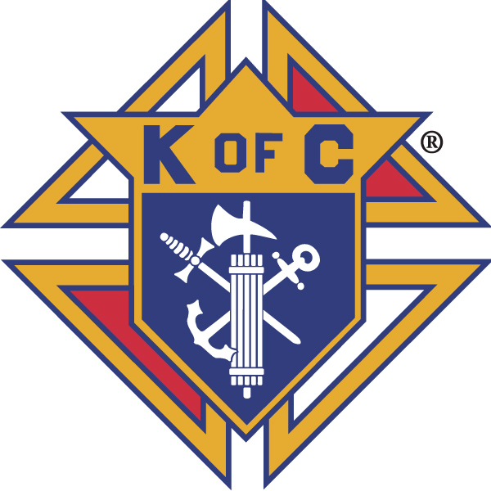
Knights of Columbus

In Service to One, In Service to All
Rev. Robert F. Houlihan, S.J., Council 10937
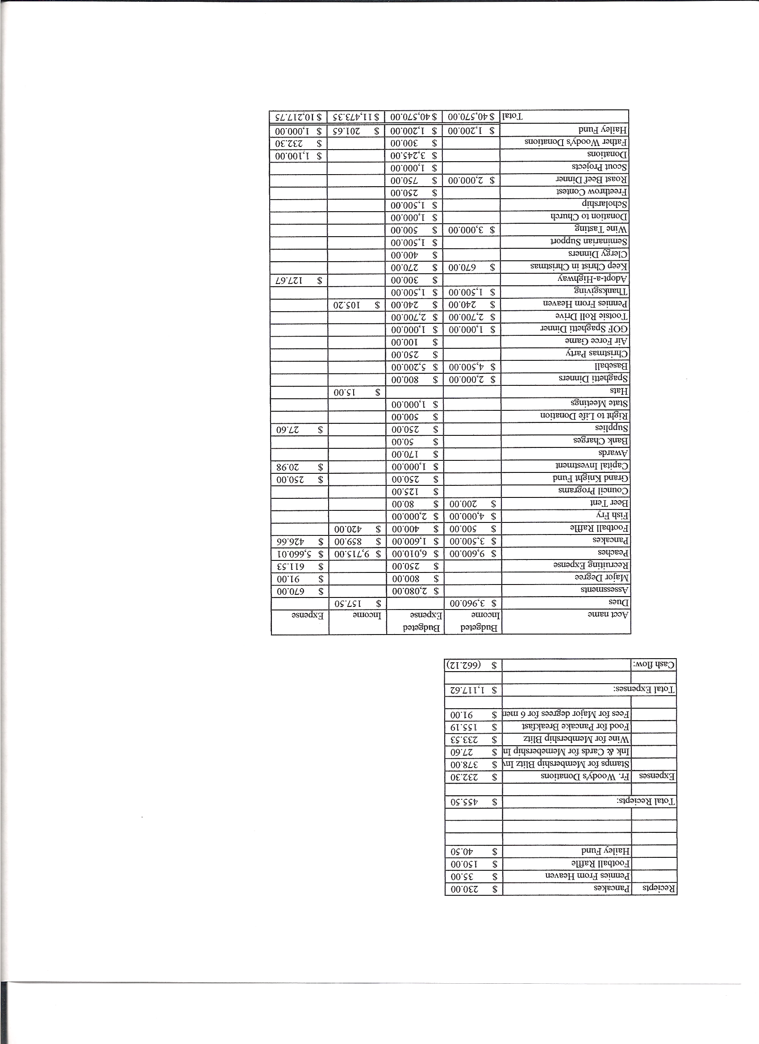
Business Meeting – February 9, 2013

I. General
- The Council was called to order at 7:58 AM by Grand Knight, Paul Sciera.
- Opening Prayer was offered by Joe Musso. The role of officers was called and noted as follows (P = Present; A = Absence; E = excused)

Title | Status | Title | Status | Title | Status
Chaplain | P | Financial Secretary | E | Inside Guard | P
Grand Knight | P | Treasurer | E | Outside Guard | P
Dep. Grand Knight | P | Lecturer | P | Trustee 3rd Year | P
Chancellor | P | Advocate | P | Trustee 2nd Year | E
Recorder | P | Warden | P | Trustee 1st Year | A

The January 12, 2013 meeting minutes were approved as read and published.

II. Applications for Approval – Roger
None

III. Grand Knight Report – Paul
Pennies from Heaven
Knight of the Month – Tony Yarosh
Family of the Month – Jay Calvarese Family
Paul expressed thanks to those who volunteered to help at Casino Night.
Correspondence:
A basket of golf paraphernalia has been donated to Casino Night by the Council. We received a nice letter from fraternal services for that.
There was an Eternal Faith letter about the Year of Faith suggesting activities.

IV. Chaplain’s Report - Father Brian
Pat Meleney, our new youth director, is doing a great job.
Finding a new secretary is taking time. We have been interviewing people outside the parish. We expect to hire someone soon.
Our Haiti connection might need some reevaluating.
Lent is coming up.
Father would like to have more involvement by Knights in the liturgical positions, particularly ushers. Please think about becoming more involved.
A new statue has been donated to the church.

V. Treasurer’s Report - Dennis
Report handed out at meeting.
Bank Balance - $ 6,398.95 Available Funds - $ 4,441.84

VI. Financial Secretary’s Report – Roger
Report handed out at meeting
Receipts - $ 4,240.17 Expenses - $ 3,130.22 Bank Balance - $ 6,398.95

VII. Chancellor’s Update – Gary Mayfield
There is still one check to the seminarians that has not been cashed. Gary will look into it.
Gary pointed out an article featuring Nathan Hines. He passed the article around at the meeting.

VIII. Committee Reports – Joe Musso
The 4th degree social brunch is after the corporate Mass (8:30) on the
17th.
The fish fries offer good recruiting potential for membership. We will have flyers available.
Our Council has contributed over 11,000 volunteer hours this past year.

a. Membership – Tony Yarosh
Supreme is offering a $9 membership credit (per each new member) through June to Councils toward assessments. This is an opportunity to grow membership in our Council and also to improve our finances.
In honor of Father Michael J. McGivney, K of C founder, all councils are urged to conduct membership drives during the weekend of March 16-17. This drive should be followed with an open house and a first degree exemplification.

b. Church Director Report – Ron Reitsch
Patrick Oliver, Pax’s maintenance/custodian, is going to undergo knee surgery. While he is recovering, help will be needed for various projects, especially snow removal. Please consider volunteering.
Help will be needed for the reconciliation dinner for Priests February 26th and also for Easter and Easter parking.

c. Community Report - Bob Luckner
Fish fry events are coming up. Thanks to all who signed up to help February 15th. Please consider signing up for the March 8th fish fry.
40 cans for lent – We are asking Knights and Parishioners to collect 40 cans of food during lent or to give an equivalent cash donation which will be given to the Denver Rescue Mission. A truck will be at Pax on March 23rd to load up the donations and take them to the Denver Rescue Mission. In the meantime help is needed after Sunday Masses to sign up parishioners who want to participate and on the 23rd to collect and load cans and other food donations onto the truck.
Last fall’s Tootsie Roll Drive netted $3500, the most ever. Monies are given to ARC and to Special Olympics.

d. Council Activity Report – Leonard Leyba
Fat Saturday celebration (Casino Night) will substitute for this month’s social hour.

e. Family Report – Bill Hensen
We are considering a family bowling/laser tag day at Brunswick Zone. Details later.
There will be a “funeral event “ on Tuesday, February 12th to explain the funeral preplanning process and the Catholic position on cremation.

f. Right to Life report- Chris Mosley / Mike McGinnis
The Lenten 40 Days For Life campaign is starting February 12th. Daily devotionals will be e-mailed.
Dave Martz explained how the senior tax program (which kicked off February 1st ) is progressing. So far 80 people have already been served. Four Knights from Pax are helping and 8 parishioners (non Knights) from Pax are also helping. There are 2 Knights from other Parishes and a total of 80 to 85 volunteers.

g. Youth Report – Dennis Thumann
The District 9 free throw contest will be held at Ave Maria on February 24th from 2:00 to 4:30 PM.
Applications for the Knight’s scholarship have been sent to all high school seniors who are listed as seniors in the parish office. These applications must be in by the end of February.
Parents of this year’s confirmation class have asked if the Knights would provide hamburgers and hot dogs for their dinner after the 5:00 Mass on April 18th. Help will be needed for grilling. Dennis will send an e-mail with info later.

h. Newsletter – Herb Engler
No report but we wanted Herb to know what a great historical piece the newsletter is and that it is truly appreciated.

IX. Advocate’s Report – Dave Petteys
The Officer’s Best manual is on-line. It changes weekly and Dave has access to it. If you have any questions you can pull up the sight and see the newest info.

X. Auditors and Trustees – Chris Kennedy
The audit has been completed.

XI. Lecturer – Ben Stancoti
The Rev. Robert F. Houlihan, S.J. Educators Series, number 2.0, 2013.
Father Vincent Capodanno received, posthumously, the Congressional Medal of Honor, the highest military honor that our nation can bestow on a military individual. He joined the Navy as a chaplain in 1965 and volunteered to serve with the Marines in Vietnam. Marines gave him the title “Grunt Padre” because of his participation in the field with the Marines on their various missions. On September 4, 1967 he and his unit were caught in an ambush. Although seriously wounded, Fr. Vincent continued to minister to fallen soldiers. He died, after taking 27 bullets, caring for his beloved Marines, administering spiritual aid, spiritual comfort and last rites to the seriously injured. In recognition of his selfless sacrifice, Fr. Vincent was awarded the Congressional Medal of Honor on December 27, 1967.
Thirty years after his death, on May 21, 2006, FR. Vincent Capodanno was publically declared a “Servant of God”, the first step to canonization.
May 11, 2011 the Marine Corps Heritage Foundation honored him through the dedication of the “Sacrifice Window” in the National Museum of the Marine Corps.

XII. Unfinished Business –

Paul addressed concerns about the number and type of e-mails that are being sent through the Knight’s Council e-mail site.
All e-mails must be kept to one of the following topics: Knight’s Business
Church
Members’ Families
Knight’s events
No other topics should be addressed using our Council e-mail.

XIII. New Business
A Memorial Committee needs to be set up according to the new bylaws.
Suggested members for the committee are:
GK – Paul Sciera
FN – Victor Ogunmodede
FS – Roger Guidici
CC – Dave Petteys
FC – Bill Hensen
And Father Brian
Anyone else who would like to join the committee should contact Paul. Guidelines for the committee will be worked out. The committee will meet near the end of the month. A notice of the date will be sent out.
A motion was made to nominate delegates for the convention in April and was seconded and unanimously approved. The following were the delegates nominated:
GK – Paul Sciera
DGK – Joe Musso
FS – Roger Guidici
Advocate – Dave Petteys
Past Grand Knight – Chris Kennedy

XIV. 4th Degree Report – Victor Ogunmodede
The next corporate Mass is February 17th at 8:30.
There will be a meeting of the fourth degree members immediately following this meeting.
The Saint Baldrics Day Parade is March 10th. Please think about participating. All Knights are welcome.

XV. Field Agent Report - Jayme Sanford
Jayme showed an excellent video explaining insurance options and the many ways in which monies from our not-for-profit insurance company helps different organizations of the Church. For example, 1.6 million dollars is donated to the Holy Father to distribute to charities as he sees fit. 300 other charitable organizations are also supported, Special Olympics and Habitat for Humanity among them, totaling 158 million dollars in donations. These donations are made possible through profits made on insurance policies held by Knights. This video and others are on the K of C website. Call Jayme to schedule a visit in which he might be able to help you with a policy that meets your needs.
Jayme also passed out flyers which he suggested that we could use in our membership drive.
Statistic - Knights in the US have donated over 70,000,000 hours of volunteer work.

XVI. District Deputy Report – Mark Solome (Jon Herskovits)
Feb. 19th is a stand alone 2nd degree in Parker. March 19th is a stand alone 3rd degree in Parker.
March 1st - 2nd in Denver is a ‘Living the Catholic Faith” conference. Consider coming as there are some very good speakers giving presentations. Volunteers to work at the membership table would be appreciated.
Jon expressed thanks for the support given by our council in his bid for State Deputy. Jon will be hosting the hospitality suite the State Convention. Help would be appreciated.
Jon wanted Herb to know how much he appreciated the newsletter.

XVII. Good of the Order
Jim DeRose, Keith Haley’s father, Ken Bertrand, Michael Burkett’s father who passed away last week, Monique Conley and the Conley family.

XVIII. Chaplain’s Summation – Fr. Brian
Joe Musso

XIX. Closing Prayer
Read by Joe Musso

MEETING WAS ADJOURNED AT

9:18 am

- minutes recorded and reported by Mike McGinnis

