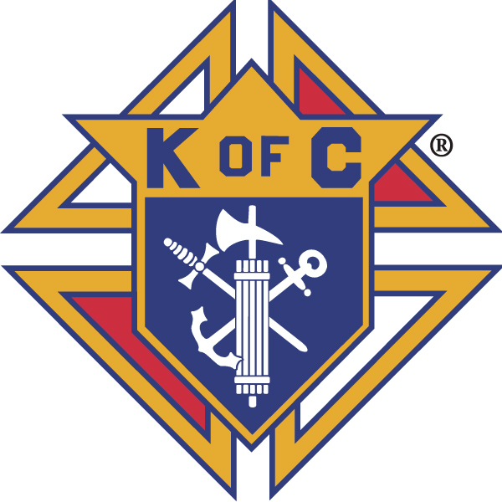
Knights of Columbus

In Service to One, In Service to All
Rev. Robert F. Houlihan, S.J., Council 10937
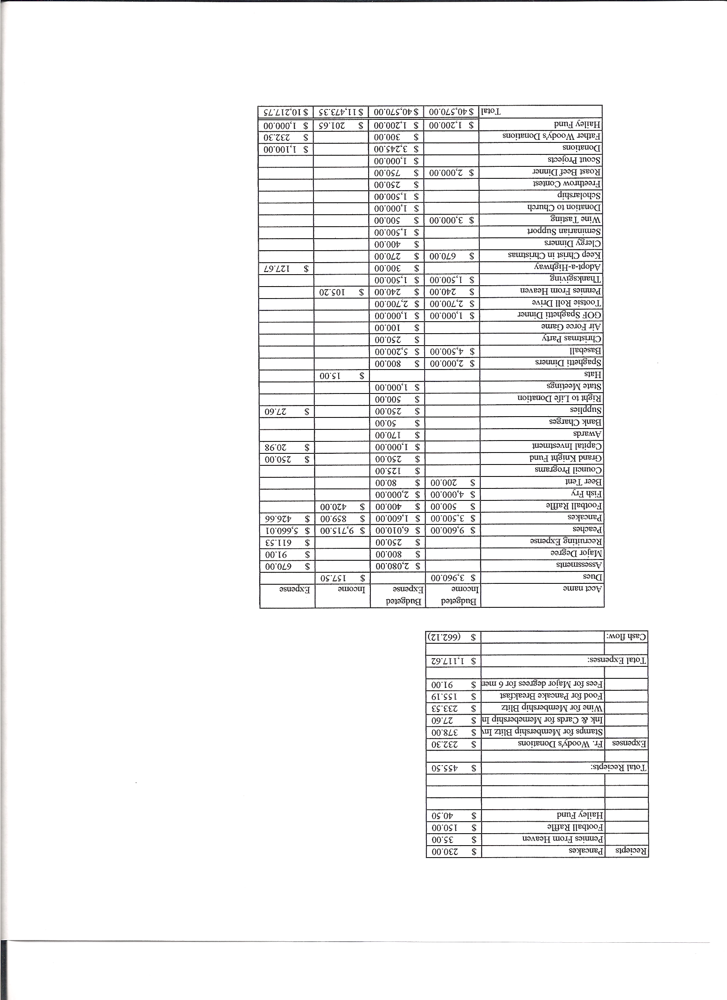
Business Meeting – April 13, 2013

I. General
- The Council was called to order at 8:03 AM by Deputy Grand Knight, Joe Musso.
- Opening Prayer was offered by Gary Mayfield. The role of officers was called and noted as follows (P = Present; A = Absence; E = excused)

Title | Status | Title | Status | Title | Status
Chaplain | P | Financial Secretary | P | Inside Guard | P
Grand Knight | E | Treasurer | P | Outside Guard | A
Dep. Grand Knight | P | Lecturer | P | Trustee 3rd Year | P
Chancellor | P | Advocate | P | Trustee 2nd Year | E
Recorder | P | Warden | P | Trustee 1st Year | A

The March 13, 2013 meeting minutes were approved with correction that the opening prayer was not read by Joe Musso.

II. Applications for Approval – Roger
None

III. Grand Knight Report – Paul (Given by Joe Musso, Deputy Grand Knight)
Pennies from Heaven
Knight of the Month – Todd McCusker
Family of the Month – Mark Daugherty’s Family
Correspondence:
Veterans – Equestrian (Moonfall Ranch) helps veterans with brain injuries, PTSD, etc.
Wheelchair Mission raises money for those in need of wheelchairs.
Rosary rings as an event or fundraiser (Confirmation Class) might be considered.

Knights will be moving to room #1 for meetings. Cleanup of our closet will be next weekend.
Thanks to Gina DeRose who donated a cabinet to the Knights to help with storage in the
new meeting room.

IV. Chaplain’s Report - Father Brian
Priests will be away next week. They will be having a leadership conference at Keystone.
Thanks for all the Easter help. Father would like to have more Knights working the Holy Week services next year. He would also like more Knights involved in Sunday services
such as ushering, lecturing, sacristan and Eucharistic ministries throughout the year.
Our 25th anniversary is coming up. Father has been reading a book called “Rebuilt” which has some interesting ideas about reforming the Parish. He will present these ideas at the next Parish Council meeting.
Father mentioned Father Emil Joseph Kapaun, an Army chaplain in the Korean War who was the new Congressional Medal of Honor winner. The medal was awarded posthumously to his nephew April 11, 2013.

V. Treasurer’s Report - Dennis
Report handed out at meeting.
Bank Balance - $11,617.63 Available Funds - $ 9,716.02
Our CD will be cashed out next month.
Our last fish fry was about 60 people short of expectations. Unfortunately that amounts to about $600 that could have been used for various charities and Church activities.

VI. Financial Secretary’s Report – Roger
Report handed out at meeting.
Receipts - $ 4,528.19 (We will still be receiving some money from Supreme for 40 Cans for Lent activity). Expenses - $ 1,073.50 Bank Balance - $ 11,617.63

VII. Chancellor’s Update – Gary Mayfield (Given by Matt Yeagle)
Several Knights will be going to the ordination of Jason Keas on June 1st. All are welcome.
We received a thank you card from Mark Monstaff thanking us for the $500 check.
All outstanding checks to our seminarians have been cashed and have come back.
Matt recommended the book “Why Catholicism Matters”.
The prayer for vocations was said.

VIII. Committee Reports – Joe Musso (Given by Gary Mayfield)

a. Membership – Tony Yarosh
Membership drive, April 21st – Thanks to all who passed out cards after Masses announcing the membership drive. During the drive Jaime Sanford will be there to talk with people and pass out information on insurance. It is also important that we answer questions and inform Parishioners of what the Knights stand for and all the things we do. Knights are asked to put the names of prospective members on the web site so they may be called and personally invited to attend the drive and join the Council.
Someone is needed to organize monthly trips to the Denver Rescue Mission for lunches one Saturday per month. Go to the web site to schedule.
We are at 46% of our quota for new Knights. (6 new Knights out of the quota of 13.)
Tony passed out an insurance pamphlet, (for Jayme Sanford), which highlights the stability of the Knight’s insurance plan.

b. Church Director Report – Ron Reitsch (Given by Gary)
Help is needed both after today’s meeting and next Saturday, the 20th, to help with the move to room #1. Spring housecleaning of the church is on the 20th.

c. Community Report - Bob Luckner (Given by Gary)
Thanks for helping to make “40 Cans For Lent” a success. There were two vehicles filled with food and $1,038 was collected to buy fresh food.
Highway cleanup will be May 18th. E-mail to follow.
There are some special opportunities coming for Habitat For Humanity beginning May 23rd. Angel Meza will speak at Pax Christi and there will be a signup May 5th.
Love Inc. needs volunteers to help with various ministries.

d. Council Activity Report – Leonard Leyba
The family social this month will be at Ben and Carolyn Stancotti’s home on April 19th.

e. Family Report – Bill Hensen
The spaghetti dinner will be after the 5:00 Mass on May 11th. Volunteers are needed. Gary will get things done early because he must leave early. He could use help. Tickets will cost $10 each for adults. Kids are free.
The Rockies game will be June 28th against the San Francisco Giants. (Information to come).
Other family events are being planned and information will also come later.

f. Right to Life report- Chris Mosley / Mike McGinnis
Dave Martz reported on volunteer tax preparation. They helped 80 people on this past Friday with their taxes. Altogether, through March, 1887 people have been helped with tax preparation.
Also there is a golf tournament coming that supports the children’s and veteran’s programs. See Dave if you would like to signup.
Results of 40 Days For Life lent campaign will be reported next meeting.

g. Youth Report – Dennis Thumann
The Knights will be cooking for the Confirmation class on April 14th after the 5:00 Mass. Hamburgers and hot dogs will be served.
Youth will be having their first “Youth Mass” on June 2nd and the Knights are also cooking hamburgers and hot dogs after that 5:00 Mass.
The scholarship committee has been formed and will be evaluating applications. Keith Haley will be leading the committee and selections should be made soon.
Mission work camps cost participants $650 to go. Half that amount goes to building supplies and costs. This year they will work at an Apache reservation in New Mexico. Participants are attending meetings for six months prior to leaving in preparation for the week. Thirteen youths and four adult supervisors are attending. Many youths are also attending meetings to prepare for a summer retreat. Many also have been attending the 6:00 A.M. Tuesday Mass before going to school. There is also a group of students planning on visiting nursing homes. Congrats to our youth and to those working with them for such great service!

h. Newsletter – Herb Engler
Thanks to those who contribute to the newsletter. Herb is working on several changes. Currently, he is focusing on themes inspired by the principles of the Knights, (charity, unity, fraternity and patriotism) and on the State Convention. Certain activities will be tied into each theme. He also plans to feature a particular Knight each month in a column called, “Who’s Who and Who’s New”. He will be sending personal questionnaires to featured Knights who he will ask that they fill out with information about themselves for the article. Questions are voluntary and skip any you do not feel comfortable answering.

IX. Advocate’s Report – Dave Petteys
No report.

X. Auditors and Trustees – Chris Kennedy
No report.

XI. Lecturer – Ben Stancoti

The Rev. Robert F. Houlihan, S.J. Educators Series, number 4.0, 2013
Knights throughout the world welcome our new pope, Pope Francis I, the former Cardinal Jorge Bergogolio, who has been known as a people’s representative. He has been a humble example for all in his dedication to the suffering, the poor, the destitute, those suffering from violence and for the working class people, advocating for fairness and justice. As a living example he leads a simple life, cooking his own meals, living in a small apartment, and riding public transportation. He lives to reflect the Gospel message, Love one another as He has loved us. Living in Argentina, where extreme and abject poverty exist along side extreme wealth, he challenged the wealthy of Argentina to take account of the poor and to avoid ignoring the obvious plight of those in despair. His simple message, which he manifests through his actions, is to love God completely and to love your neighbor as yourself. He defends right to life and requires that we promote social teachings of the Church. Pope Francis embraces the cross and a life marked by faith, hope and charity. He is a faithful disciple of God whose goals and objectives center in building up the Church. The Pope’s vision should be recognized by Knights in that it contains and exemplifies our own principles of charity, unity and fraternity.

XII. Unfinished Business -
Haiti – Father Brian met with the Haiti group last week. More money will be given for the chapel to help finish it. The school is functioning and kids are fed each day.
Due to the resignation of some key people on the original board, plans for Haiti may need to be reformulated. Also, the priest in Haiti has stated that he has no money for things such as food etc. He is asking for money for these needs.
Council members will be attending the State Convention April 25th to 28th.

XIII. New Business
Sean McMullen, one of our parishioners, has suffered an inflammation of the spinal cord causing paralysis in his legs. The family needs a ramp to allow easier access to the house. The proposal for funds and for help to build the ramp was tabled for consideration next meeting when, hopefully, more information will be available.

XIV. 4th Degree Report – Victor Ogunmodede (Given by Roger)
The social event at Pappadeaux was very enjoyable and went well. Another social event is being planned for the fall.
There will be a 4th degree exemplification on June 2nd in Montrose, Co.
The next corporate Mass is April 21st at the 5:00 Mass.
Jay, Josh and Tony will be attending their 4th degree exemplification today at Light of the World Catholic Church in Littleton.
The 4th degree meetings in May and June will be determining the slate of officers and holding elections.

XV. Field Agent Report
No report.

XVI. District Deputy Report – Mark Solome
No report.

XVII. Good of the Order
Mel Haley (father of Keith Haley), Ken Bertrand, Mel Claytor, Sherri Suddath (Glen Suddeth,s wife), Monique Conley, Jane Lannan (mother-in-law of Max Gramly), Joan Isset (aunt of Dennis Cullen), Jim DeRose

XVIII. Chaplain’s Summation – Fr. Brian
None.

XIX. Closing Prayer
Read by Gary Mayfield

MEETING WAS ADJOURNED AT

9:17 am

- minutes recorded and reported by Mike McGinnis

