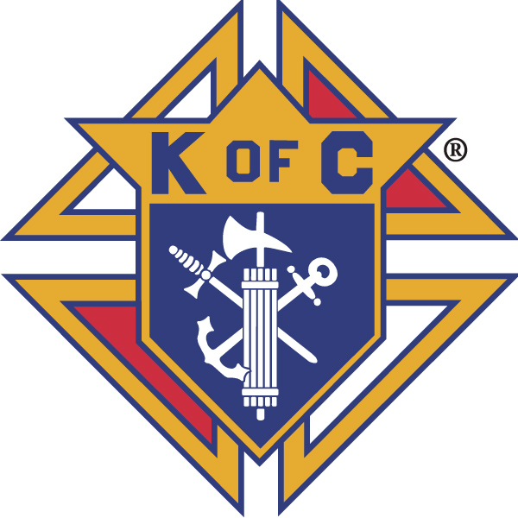
Knights of Columbus

In Service to One, In Service to All
Rev. Robert F. Houlihan, S.J., Council 10937
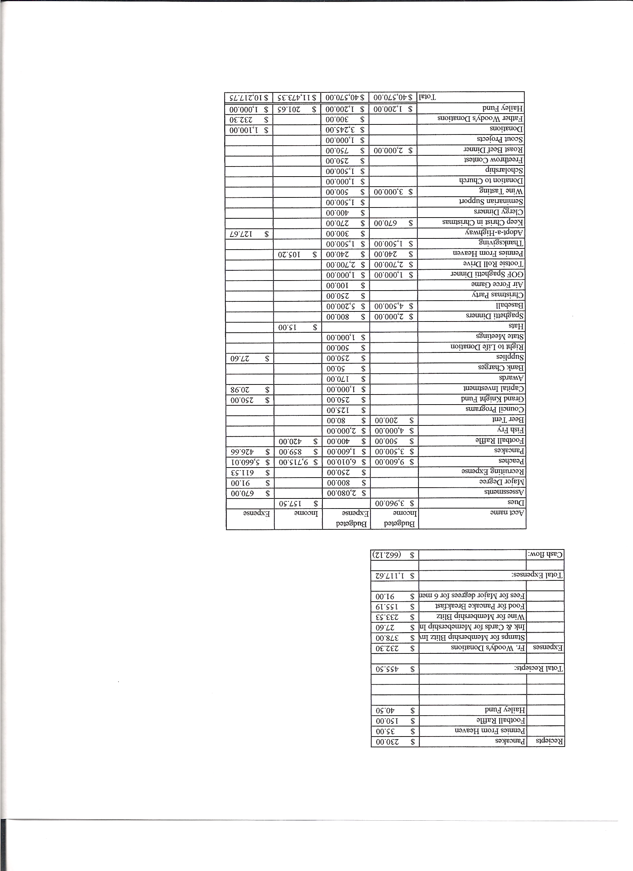
Business Meeting – May 11, 2013

I. General
- The Council was called to order at 7:35 AM by 1st Degree Team Grand Knight, John Hilton. Applications for membership were read and approved unanimously. At 7:45 the meeting was suspended for the 1st degree exemplification. After the 1st degree ceremony, at 8:43 AM, the meeting was reconvened by Grand Knight, Paul Sciera.
- Congratulations to our new 1st degree Knights, Ford Fay, William Ewan, Joseph Cruse Jr., Arthur Myers and Matthew Maranto.
- Opening Prayer was offered by Joe Musso. The role of officers was called and noted as follows (P = Present; A = Absence; E = excused)

Title | Status | Title | Status | Title | Status
Chaplain | P | Financial Secretary | P | Inside Guard | E
Grand Knight | P | Treasurer | P | Outside Guard | A
Dep. Grand Knight | P | Lecturer | E | Trustee 3rd Year | A
Chancellor | P | Advocate | P | Trustee 2nd Year | E
Recorder | P | Warden | P | Trustee 1st Year | P

The April 13, 2013 meeting minutes were approved as read and published.

II. Applications for Approval – Roger
none

III. Grand Knight Report – Paul
Pennies from Heaven
Knight of the Month – Herb Engler
Family of the Month – The Leonard Leyba Family
Correspondence: Charity golf tournament at St. Gabriel’s on Friday August 2nd.
Report on the State Convention. Thanks to those who attended the five major awards ceremonies. Our Council received the top award in the blue division and three others.
Paul asked the new 1st degree knights to introduce themselves and invited them to become involved in the many Knight activities.
Congratulations to Jon Herskovits who was elected State Warden.
Thanks to Paul for his two years of service as Council Grand Knight.

IV. Chaplain’s Report - Father Brian
Father Brian talked about the 25th anniversary celebration carnival, which will be held on June 6th.
Father needs someone to head the Haiti board due to resignations. It has been difficult to communicate with the Pastor of the church there because of language difficulties. We do know they are short of food in the parish. $2700 has been put aside for the floor of their chapel. The school is going well (kids are being fed and taken care of). Please let Father Brian know if you would be interested in working on the Haitian committee.
The Christ Renews His Parish Men’s Retreat did not have enough participants and had to be cancelled. The women’s CHIRP is scheduled for the end of September.
Endow, a women’s program currently in Denver or, possibly, a program on the lives of the saints, is being considered at Pax Christi for women of the Parish. There is a movement in Parish education (from the book Rebuilt) to consider a format involving a theme presentation and small group discussion. A newcomers dinner is being planned which may revolve around that theme. The purpose of the dinner is to welcome new families to the Parish not to push them to join any organizations. Seventy-one families have joined the Parish in the last month. Perhaps the Knights would cook for the dinner?
There will be a Mission Priest coming to the Parish this week.
Remember, the Eucharist is the center of everything.
The Whole World Market needs many volunteers for this year. If not enough people volunteer, the market will be cancelled.
Rumors of transfer of priests at Pax Christi are untrue. Father Brian would like our support.

V. Treasurer’s Report - Dennis
Report handed out at meeting.
Bank Balance - $ 11,025.12 Available Funds - $ 8,878.74

VI. Financial Secretary’s Report – Roger
Report handed out at meeting
Receipts - $ 1,373.50 Expenses - $ 2,210.78 Bank Balance - $ 11,025.12
Thank you Roger for your six years of service as Financial Secretary!

VII. Chancellor’s Update – Gary Mayfield
June 1st will be Jason Keas ordination. All Knights are invited. Car pools will leave Pax Christi about 8:00 for the 9:30 ceremony.
We are looking for new seminarians for our council to sponsor and support. Let our soon to be Chancellor, Matt Yeagle, know if you have ideas. There is a seminarian coming to spend the summer at Pax from New Orleans who might be a possibility for our support.
Meet the Seminarians Night will be in September.
The prayer for vocations was said.
VIII. Committee Reports – Joe Musso

a. Membership – Tony Yarosh
Thanks to all who made poster boards for the membership drive. These posters will be displayed again at the spaghetti dinner.
There will be three candidates for the June 8th 1st degree exemplification.
Tony encouraged new members to ask questions about any committees, activities or anything else they might wish clarified. He also encouraged them to move on to 2nd and 3rd degree Knights.
Max mentioned that new 1st degree Knights should feel free to volunteer to serve on any of the committees or to participate in any of our activities and he encouraged them to sign up via our website. He also reminded us that we need a new membership director.
Thanks to Tony for a job well done organizing the membership drive.

b. Church Director Report – Ron Reitsch
Help is needed for the Church anniversary carnival. The Knights will be cooking brats and manning the beer gardens.
We need a new Church director. If you are interested, please contact Paul.
Thanks to Ron for his service in this position.

c. Community Report - Bob Luckner
The spring highway cleanup will be the morning of May 18th from 9 to 12. We meet at Happy Canyon Road and Hwy 85. We need lots of help. Pizza follows.
Art Myers will coordinate with Father Woody’s. There is a need for clothing (socks, underwear, shirts, pants etc.). $400 is currently budgeted by the Knights for Father Woody’s and the Church tithes $200.

d. Council Activity Report – Leonard Leyba
The May family social is May 17th at Paul Sciera’s home.
Leonard would like to have a second for the social committee.

e. Family Report – Bill Hensen
The spaghetti dinner is Saturday, May 11th after the 5 PM Mass.
The baseball game at the Rockies has been changed to June 29th. Tickets are $12 for the 2 PM game with the Giants.
We may be having a campout at Chatfield Reservoir this summer.
Some hiking trips are in the planning.

f. Right to Life report- Chris Mosley / Mike McGinnis
Mike gave the following results from the Spring 2013 - 40 Days For Life campaign.
261 campaigns
11 countries
83,000 plus participants
250 media reports
5,000 church congregations
787 lives saved
7 abortion workers quit
7 abortion centers closed.
God truly listens to our prayers!!

g. Youth Report – Dennis Thumann
Scholarship winner was Drayton C. Harvey

h. Newsletter – Herb Engler
None

IX. Advocate’s Report – Dave Petteys
A motion to elect officers by acclamation must be agreed upon and recorded in the minutes. Otherwise, according to the rules of order, a secret ballot is necessary.

X. Auditors and Trustees – Chris Kennedy
No report.

XI. Lecturer – Ben Stancoti
None

XII. Unfinished Business -
None

XIII. New Business
The slate of officers and service personal for next year was presented:
Grand Knight – Joe Musso, Deputy Grand Knight – Gary Mayfield, FinancialSecretary – Josh Tracy(will need to be appointed by Supreme), Treasurer – Dennis Cullen, Chancellor – Matt Yeagle, Recorder – Mike McGinnis, Advocate – Dave Petteys, Warden – Tony Yarosh, Inside Guard – Ben Stancati, Outside Guard - Jay Calvarese, 1 Year Trustee – Ron Rietch, 2 Year Trustee – Chris Kennedy, 3 year Trustee – Paul Sciera, Chaplain – Rev. Brian Mohan, Lecturer – Ben Stancati.
Dave Pettys motioned to accept this slate and Chris Kennedy seconded the motion. The slate was voted on and unanimously accepted. The vote for officers will be held at the May meeting.
Roger presented the proposed budget for next year and asked for suggestions. The budget will be published and voted on in the June business meeting.

XIV. 4th Degree Report – Victor Ogunmodede
The Corporate Mass will be May 18th at the 5 PM Mass.
There will be a 4th degree exemplification at St Francis Cabrini (Padre Pio) on June 22nd.
There will be another 4th degree at Our Lady of Loretto later in the summer.
See Roger if you are interested.

XV. Field Agent Report
We need five new insurance members to make quota as a star council.

XVI. District Deputy Report – Mark Solome
No report.

XVII. Good of the Order
Jim DeRose, Ken Bertrand, Mel Claytor, Monique Conley, Sherri Suddeth.

XVIII. Chaplain’s Summation – Fr. Brian

XIX. Closing Prayer
Read by Joe Musso

MEETING WAS ADJOURNED AT

10:15 am

- minutes recorded and reported by Mike McGinnis

