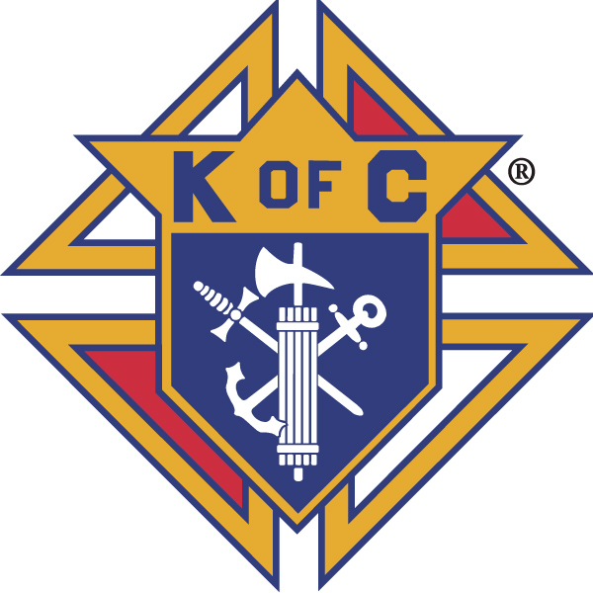
Knights of Columbus

In Service to One, In Service to All
Rev. Robert F. Houlihan, S.J., Council 10937
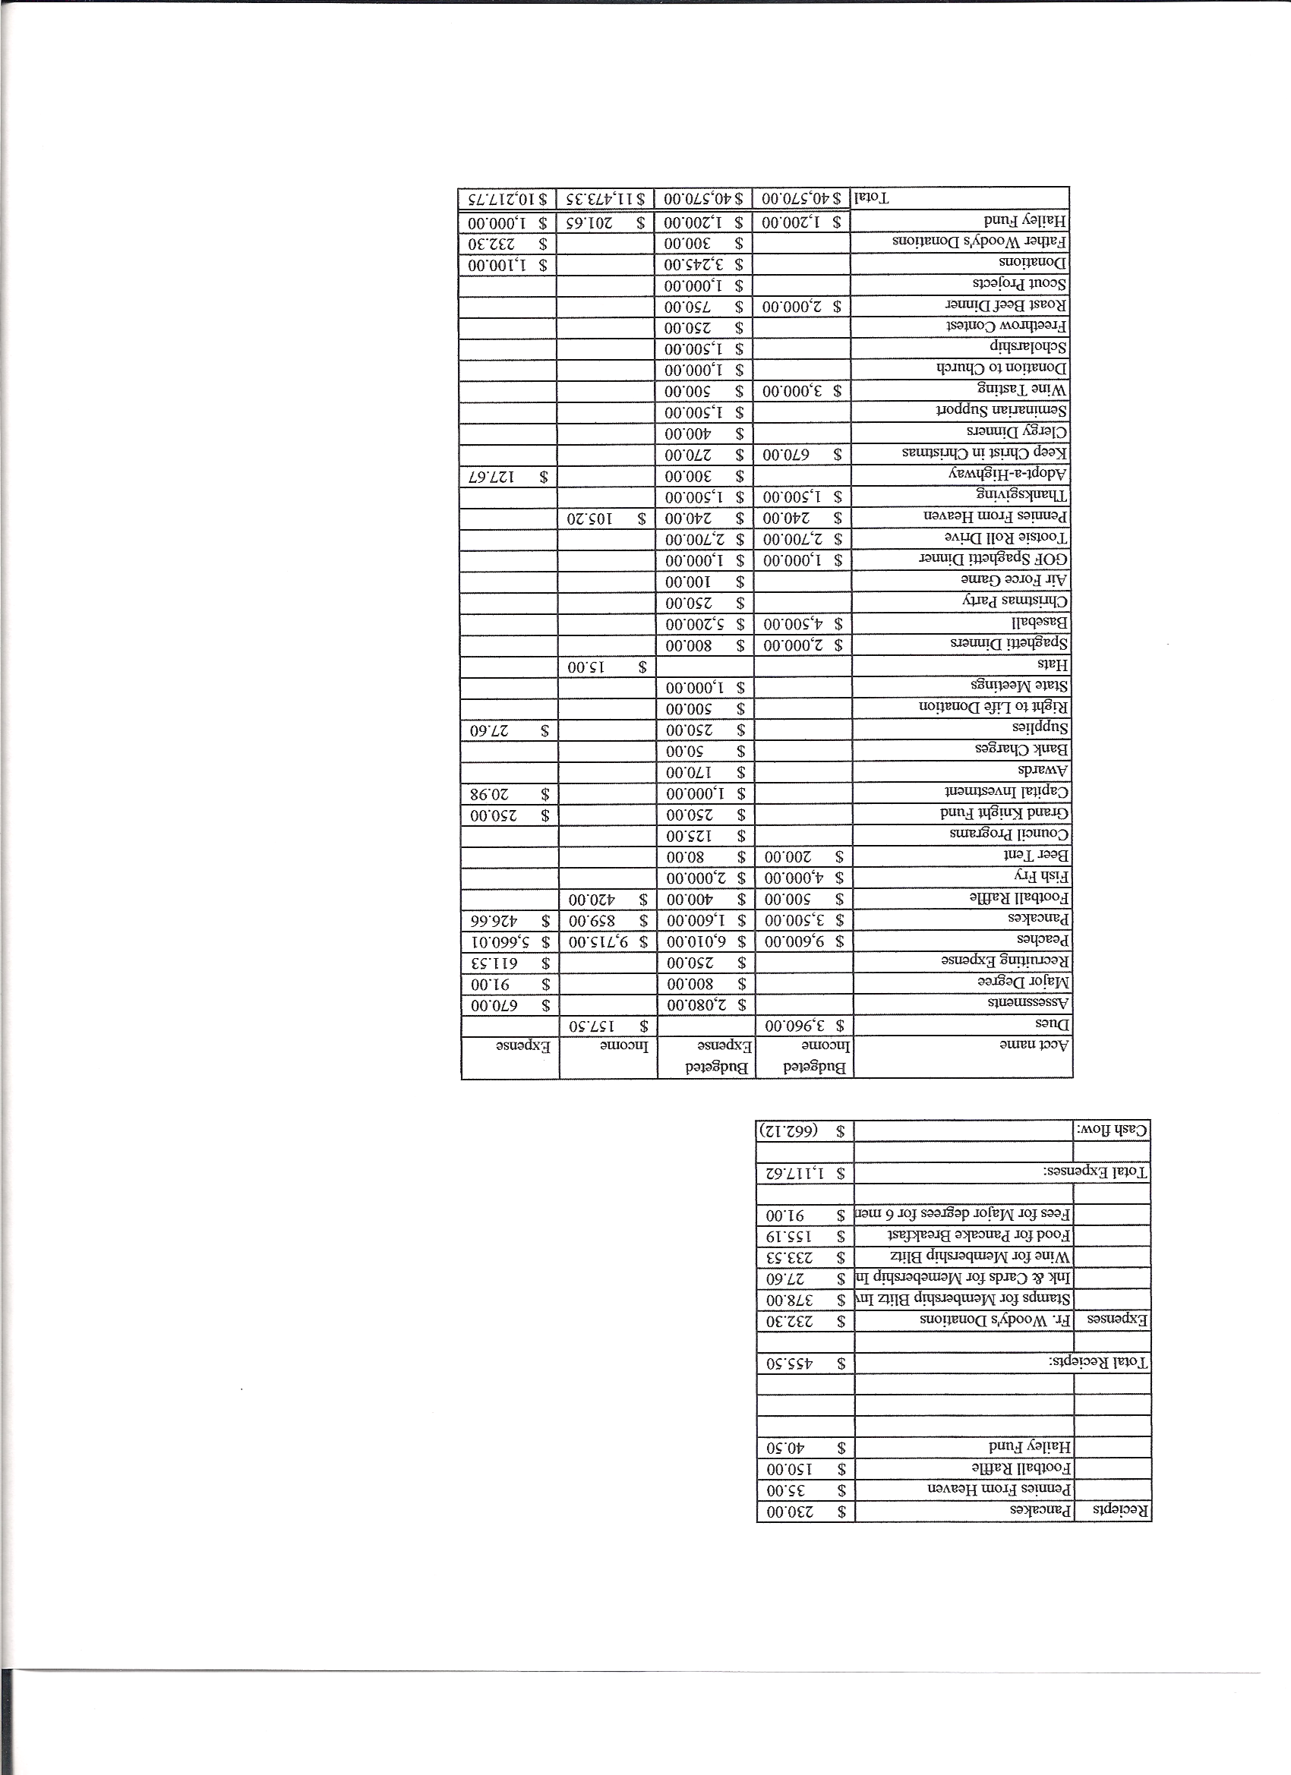
Business Meeting – June 8, 2013

I. General

The Council was called to order at 7:35 AM by 1st Degree Team Grand Knight, Tom Whyte. Applications for membership were read and approved. The meeting was then suspended for the 1st degree exemplification.
- Congratulations to our new 1st degree Knights, Oluivaseum Ogunmodede and Franklin “Pete” Flatten.
- After the 1st degree exemplification, the Council was reconvened by Deputy Grand Knight, Joe Musso.
- The role of officers was called and noted as follows (P = Present; A = Absence; E = excused)

Title | Status | Title | Status | Title | Status
Chaplain | E | Financial Secretary | E | Inside Guard | E
Grand Knight | E | Treasurer | P | Outside Guard | P
Dep. Grand Knight | P | Lecturer | E | Trustee 3rd Year | P
Chancellor | P | Advocate | P | Trustee 2nd Year | E
Recorder | E | Warden | P | Trustee 1st Year | A

The May 11, 2013 business meeting minutes were approved as read and published.

II. Applications for Approval – Roger
none

III. Grand Knight Report – Paul (Joe)
Pennies from Heaven
Knight of the Month – Matt Maranto
Family of the Month – Tim Pimmel Family
Correspondence: Summer Lunch Program in Layfayette for Catholic school children can use help preparing lunches.
There will be a retreat at Sacred Heart Retreat house geared specifically for Knights in October. If interested in attending, you should let them know as these retreats fill up quickly.
The next business meeting will be Wednesday July 10th at 7 PM at Pax Christi.

IV. Chaplain’s Report - Father Brian (Joe Musso)
A newcomers meeting will be held June 22nd. Father Brian would like Knights who would be willing to cook at this dinner.

V. Treasurer’s Report - Dennis
See report handed out at meeting.
All CD’s have now been cashed.

VI. Financial Secretary’s Report – Josh
See report handed out at meeting
The new budget will come out for the new fiscal year at the July meeting.
Roger has resigned as financial secretary after six years of extraordinary service to the Council. Thanks Roger for all you’ve done.
VII. Chancellor’s Update – Gary Mayfield
Matt, who has been Warden, will now become Chancellor.
The ordination for Jason Keas was well attended and a great experience.
We received a thank you card from Nathan Hines expressing appreciation for our support.
The prayer for vocations was said.

VIII. Committee Reports – Joe Musso

a. Membership – Tony Yarosh
Roger will become our membership director. Thanks to Max and Tony for the fantastic jobs they have done.
Membership quota is 13 of 13. Insurance is at minus 2.
Roger needs volunteers to form membership subcommittees. Details were outlined in his previous e-mail.

b. Church Director Report – Jay Calvarese
The June 9th 25th anniversary picnic is tomorrow. Details for food and beer were discussed.

c. Community Report - Bob Luckner (Gary)
The May 18th highway cleanup went well.
Denver Rescue Mission coming up next Saturday. So far we only have 6 volunteers. We need 10 by Tuesday.
Don’t forget the summer clothing drive for Father Woody’s.

d. Council Activity Report – Leonard Leyba
The June family social is on the 14th at Jon Herskovits’ house.

e. Family Report – Bill Hensen (Gary)
Rockies game is June 29th with Faith Day concert following the game.

f. Right to Life report- Chris Mosley / Mike McGinnis
No report.

g. Youth Report – Dennis Thumann
Relay for Life is July 26th and 27th. Dennis will send updates as time goes on. Signups and donations will be online. There will be volunteers in the great hall after masses with information two weeks prior to the event.

h. Newsletter – Herb Engler
No report.

IX. Advocate’s Report – Dave Petteys
Dave explained the role of Advocate to the new members.

X. Auditors and Trustees – Chris Kennedy
No report.

XI. Lecturer – Ben Stancoti
No report.

XII. Unfinished Business -
None.

XIII. New Business
Final checks for the fiscal year are being written. (Fr. Woody’s-$200 along with 1,000 disposable razors, 575 pre-pasted toothbrushes, Oklahoma relief (Supreme) $500, Annual VA contribution-$100, Eagle Scout project-$500).
Nomination of officers – Joe read the slate. No additional nominations were presented. Motion was made to accept the slate as is. The motion was seconded and passed unanimously. A motion was made and seconded and approved unanimously to select officers by verbal acclamation. A motion was then made, seconded and unanimously approved for the slate of officers as read.
The date for installation of officers is yet to be determined.

XIV. 4th Degree Report – Victor Ogunmodede (Chris)
4th degree Knights should come out for the July 4th parade wearing full regalia if possible.
There will be a quick meeting for the 4th degree members following the business meeting to approve a candidate Roy, the new seminarian, for exemplification to the fourth degree.

XV. Field Agent Report
Knights of Columbus insurance (nonprofit agency) has broken a record in their gifts to charity, contributing over 158 million dollars to Catholic Charities all over the world.
We need two more insurance members to make star council. A new Knight can open an annuity for as little as $100.

XVI. District Deputy Report – Mark Solome
No report

XVII. Good of the Order
Jim DeRose, Ken Bertrand, Mel Claytor, Monique Conley, Sherri Suddarth.

XVIII. Chaplain’s Summation – Fr. Brian
Read by Max Gramly.

XIX. Closing Prayer
Read by Gary Mayfield.

MEETING WAS ADJOURNED AT

9:03 am

- minutes recorded and reported by Max Gramly and Mike McGinnis

