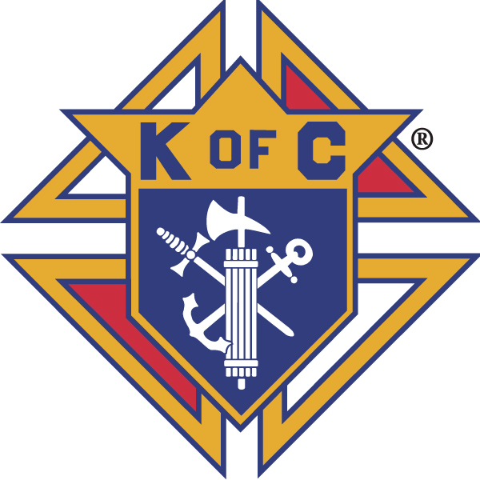
Knights of Columbus

In Service to One, In Service to All
Rev. Robert F. Houlihan, S.J., Council 10937
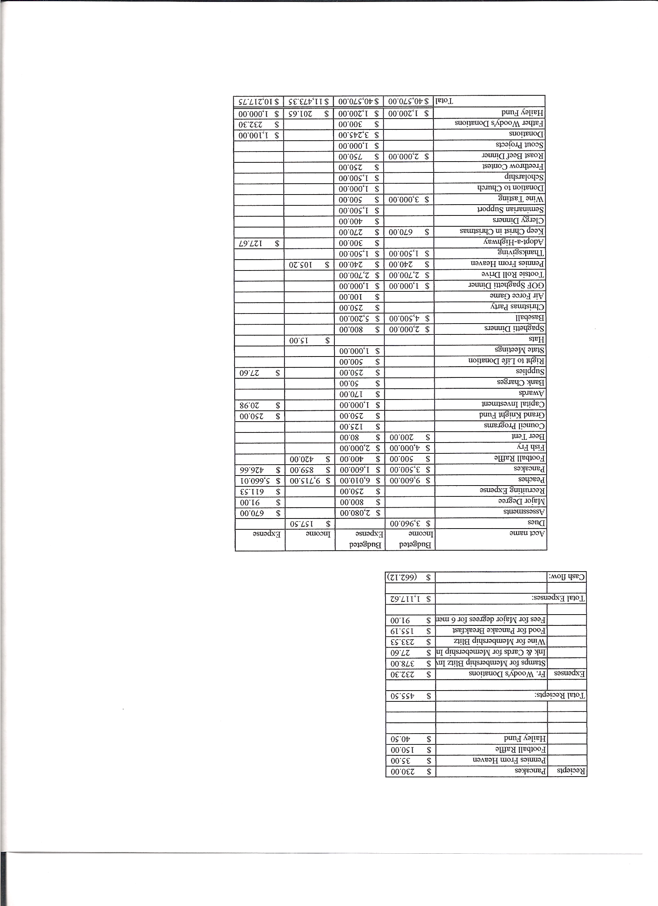
Business Meeting – July 10, 2013

I. General
- The Council was called to order at 7:01 PM by Grand Knight, Joe Musso.
- Opening Prayer was offered by Gary Mayfield. The role of officers was called and noted as follows (P = Present; A = Absence; E = excused)

Title | Status | Title | Status | Title | Status
Chaplain | P | Financial Secretary | P | Inside Guard | P
Grand Knight | P | Treasurer | E | Outside Guard | P
Dep. Grand Knight | P | Lecturer | P | Trustee 3rd Year | P
Chancellor | E | Advocate | P | Trustee 2nd Year | E
Recorder | P | Warden | P | Trustee 1st Year | P

The May 11, 2013 business meeting minutes were approved as read and published.

II. Applications for Approval – Roger
Irvin Guzman (transfer dependent on dues check)
Another possible transfer and a first degree candidate for the August 1st degree exemplification.

III. Grand Knight Report – Joe
Pennies from Heaven
Knight of the Month – Ford Fay
Family of the Month – Josh Tracy Family
Correspondence: Thank You Notes: Supreme for the Tulsa Tornado Relief Fund,
FR. Woody's
VA Hospital for our donation.
The Sacred Heart Retreat House will be hosting a retreat for Knights the weekend of Oct. 18 – 20th.
Joe addressed the meeting for the first time as Grand Knight. He talked about why he became a Knight, how inspired he is by the organization and the interesting and untiring efforts put forth by our Brother Knights.

IV. Chaplain’s Report - Father Brian
Father mentioned that we should keep the kids leaving for New Mexico in our prayers.
The Newcomers Dinner was very successful with 65 people attending. Father spoke about the Knights at the dinner.
We are looking for Parish Council members.
There will be some changes coming in the Church:
Sliding glass doors
New crucifix
Gold tabernacle
More statues and more traditional stations of the cross.
There will also be some staining and painting done in some areas.
The religious education program will change to Growing in Faith Together.

V. Treasurer’s Report - Dennis

Bank Balance - $ 12,651.75 Available Funds - $ 9,490.71
VI. Financial Secretary’s Report – Josh

Receipts - $ 2,387.60 Expenses - $ 3,006.95 Bank Balance - $ 12,651.75

VII. Chancellor’s Update – Matt Yeagle (Gary)
Roylan Reuo-Miraburt will be our new seminarian.
Mark Langstaff may not be in as seminarian.

VIII. Committee Reports – Matt Yeagle(Gary)

a. Membership – Roger Guidici
There will be a 2nd and 3rd degree exemplification at Queen of Peace on July 20th.

b. Church Director Report – Jay Calvarese
Beer ‘n Brats on July 13th. Bottled water will be added as another beverage.
We are getting crews together to handle donuts. Our next donut day is July 14th.

c. Community Report - Bob Luckner
There is an American Legion golf tournament on July 12th. Can we get a foursome to represent Pax Christi?
We took several carloads of clothing to Father Woody’s. There is a need for backpacks and socks.

d. Council Activity Report – Leonard Leyba
The next family social is July 19th. We need a host.
We will start selling peaches this weekend. Check after masses to see if help might be needed selling tickets. Peaches will be picked up August 23rd and distributed the 24th and 25th. The cost in $40 per case and $21 per half case.
We will have 250 cases to sell.

e. Family Report – Bill Hensen
This years Air Force game will be November 2nd against Army.
We are thinking of possibly doing a dinosaur walk.

f. Right to Life report- Chris Mosley / Mike McGinnis
The next 40 Days For Life will be from Sept. 25th to Nov. 3rd.
The Texas House approved HB2, a bill that protects unborn children capable of feeling pain.
The Alternatives Pregnancy Center will be displaying their mobile unit here at Pax in October. We made our annual $500 contribution to the center.
We are able to borrow crosses representing the millions of unborn children who are victims of abortion to display during October, the Respect Life month.
Every Friday Mass is offered in front of the Planned Parenthood facility in Colorado Springs. There are also Respect for Life prayer services every Saturday (sometimes Mass) at the 38th street PP in east Denver. All are invited and encouraged to attend any of these services.

g. Youth Report – Dennis Thumann
Relay for Life is July 26th-27th. (Youth will speak at masses encouraging parishioners to sign up two weeks prior to the walk.) About 55 participants have signed up from Pax. Dennis would like to see over a 100.
Letters are being sent to scholarship recipients.
Four adults and thirteen kids will make the trip to the reservation in New Mexico.
Bible study at Starbucks has attracted many of the high school students. Flag football games have also been successful. Our core group is the same but we expect growth. Also, these activities require chaperones so volunteers would be appreciated.

h. Newsletter – Herb Engler
Herb’s goal is to make the K of C more visible to the parish and community. He plans to have a “blurp” in the bulletin each weekend for nine weeks or so, in a question and answer format, explaining what Knights are all about.
Herb is also working on a second project regarding the history of Council 10937.
Herb reminded program directors that the deadline for bulletin announcements for the following weekend is Monday by 10:00 AM.
Herb has posted documents as well as pictures on the “cloud”. You may access them in the following way:
(1) Open: skydrive.com
(2) Under the Microsoft Account type: council10937@outlook.com
(3) Type: Fratern1ty# in the password box. (the F is caps)
(4) Click: sign in.
(5) Click: pictures.

IX. Advocate’s Report – Dave Petteys
No report.

X. Auditors and Trustees – Chris Kennedy
No report.

XI. Lecturer – Ben Stancoti
Report postponed until next meeting.

XII. Unfinished Business -
The installation of officers will be after the 5:00 Mass on August 3rd.

XIII. New Business
Ron Reitsch wanted to know if there would be any interest in forming a softball team. If you are interested, contact Ron.
Roger presented a resolution that deacons and active seminarians not be charged K of C membership dues. The resolution was seconded and will be voted on at the August business meeting.

XIV. 4th Degree Report – Victor Ogunmodede (Chris Kennedy)
The next Corporate Mass is July 21st at the 5:00 PM Mass.

XV. Field Agent Report
No report.

XVI. District Deputy Report – Mark Solome
No report.

XVII. Good of the Order
Jim DeRose, Mel Claytor, Monique Conley, Council 11370(Our Lady of the Pines- Black Forest fire), Arlene Bena, Ken Bertrand.

XVIII. Chaplain’s Summation – Fr. Brian

XIX. Closing Prayer
Read by Gary Mayfield.

MEETING WAS ADJOURNED AT

8:10 PM

- minutes recorded and reported by Mike McGinnis

