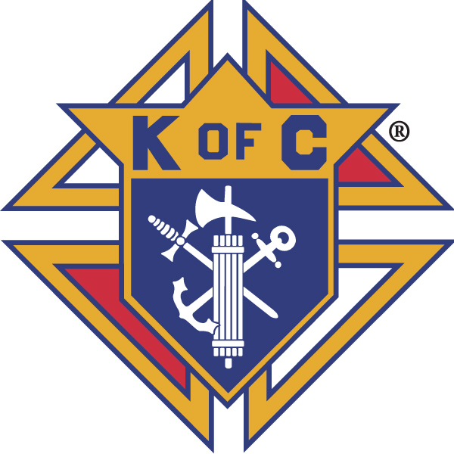
Knights of Columbus

In Service to One, In Service to All
Rev. Robert F. Houlihan, S.J., Council 10937
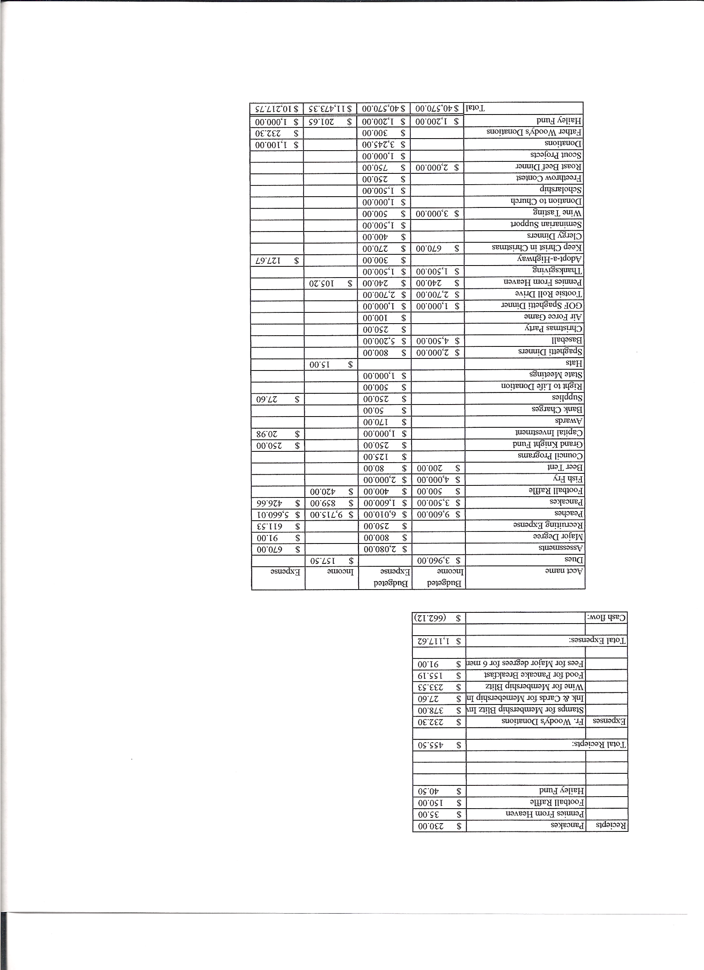
Business Meeting – September 14, 2013

I. General
- The Council was called to order at 8:05 AM by Grand Knight, Joe Musso.
- Opening Prayer was offered by Gary Mayfield. The role of officers was called and noted as follows (P = Present; A = Absence; E = excused)

Title | Status | Title | Status | Title | Status
Chaplain | P | Financial Secretary | P | Inside Guard | P
Grand Knight | P | Treasurer | P | Outside Guard | P
Dep. Grand Knight | P | Lecturer | P | Trustee 3rd Year | P
Chancellor | P | Advocate | P | Trustee 2nd Year | P
Recorder | P | Warden | P | Trustee 1st Year | E

The August 10, 2013 business-meeting minutes were approved as read and published.

II. Applications for Approval – Roger
None

III. Grand Knight Report – Joe
Joe passed around a certificate acknowledging membership in the Colorado State Perpetual Memorial Society for Josh Tracy. The certificate will be presented to Josh’s parents, Marilyn and Tim Tracy.
Joe mentioned that two of our Knights, Chris Kennedy and Jay Calvarese, were also the last two stewards of the month at Pax Christi.
Pennies from Heaven
Knight of the Month – Joe Regnery
Family of the Month – Gary Mayfield Family
Correspondence: Tootsie Roll memo from Bob Luckner
Steak and Smoke dinner – St. Thomas More Council, 9/14
Life Network
Josh Tracy condolences and information on duties of financial secretary from Supreme
Fall Festival-Pig Roast from KofC Council 13981, Sacred Heart Church, 9/28
The Red Cross is asking for help as second responders in the northern part of our state.
(All correspondence in its entirety may be read at the end of the minutes.)

IV. Chaplain’s Report - Father Brian
Thanks to those who made the beer and brats so successful Sept. 8th.
The youth group is coming along well. Patrick is doing a good job. 46 kids attended Sunday night’s meeting. A lot of youth are attending the 5:00 mass. New music for the youth is being implemented for the celebration at the 5:00 mass, which will include guitars.
The marriage enrichment program is next weekend. This is meant for couples who wish to enrich their marriages, not those whose marriage is troubled.
Father Brian will be attending a stewardship conference in Dallas on September 22.
Haiti: The chapel is not yet finished. The school has 60 students, a teacher and an aide. We sent $6700 to help pay for these and books. 12 kids are supported by members of the Parish here at Pax Christi for only $100 per year. There is better communication, now between Pax Christi and the new priest, who has taken over the parish in Haiti. We no longer have a Haiti board here at Pax Christi and we will evaluate whether our relationship with the parish in Haiti should continue, or if it is better to choose another need in which to place our efforts and financial assistance for the poor.
Thanks to Jay for the great job he does providing Sunday donuts. Father would like other ministries in the Church to also be involved in providing and serving the donuts.
Thanks to Nereus for providing the antenna during the beer and brats to allow all to watch the Notre Dame-Michigan football game.
Remember our highlight for each week should always be the Mass and the Eucharist.

V. Treasurer’s Report - Dennis
Report handed out at meeting.
Bank Balance - $ 16,962.49 Available Funds - $ 9,198.28

VI. Financial Secretary’s Report – Roger
Report handed out at meeting
Receipts - $ 10,512.73 Expenses - $ 8,879.77 Bank Balance - $ 16,962.49
The difference between the treasure’s report and the financial secretary’s report is because of how the Haley Fund is financed.
We are about $20 ahead of budget on peaches for the year.
We have sold 32 out of 50 of the football frenzy tickets. 18 more need to be sold. Football Frenzy is a fundraiser for state charities of which our Council gets $2 of each $10 toward expenses for state convention etc.
Donuts are doing well financially. Breakfasts are not. There used to be about 100 people having breakfast now it’s down to about 40 to 50, and we used to sell 200 plus breakfast burritos, we are now down to about 100. This directly affects the amount of money we have to contribute for donations.

VII. Chancellor’s Update – Matt Yeagle
There has not been much communication from our seminarians. Father keas reported that he went on a mission to Japan. More from his communication was in the newsletter.
There was a great article in the May Columbia magazine talking about the vocation of fatherhood. It really puts fatherhood in perspective. I highly recommend reading the article.
The prayer To Know My Vocation was said.

VIII. Committee Reports – Gary Mayfield
Gary gave special thanks to Roger for the tremendous amount of work he has done on the peach drive.

a. Membership – Roger Guidici
There are currently two new insurance members and one new 1st degree member.
There will be membership drives in October and March.

b. Church Director Report – Jay Calvarese
Thanks to Jay for disposing of Fish Fry Oil. The person who took the 50 gallons of fish fry oil was able to convert it to 40 gallons of bio-diesel oil. He will continue to accept the oil in the future.
Nine Donuts Sundays already.
The last beer and brats was very successful. Our best this year! Incredible side dishes!

c. Community Report - Bob Luckner
Air Force football is Sept. 21st against Wyoming. This is an evening game (8:15 PM). Contact Tim Pimmel for more info.
Tootsie Roll Drive: Please consider volunteering your time at King Soopers from Sept.26 thru Oct. 12. More information is listed in correspondence at the end of the minutes. For times and places, signup at:

http://www2.mysignup.com/cgi-bin/view.cgi?datafile=2013_pax_christi_kofc_tootsie_roll_charity_fund_raiser

d. Council Activity Report – Leonard Leyba
Family social for September 20 – Melissa and Keith Haley
Thanks to Melissa & Keith Haley for volunteering to host our September Family Social Hour. Message from Keith:
(We have shuffleboard, darts, foosball and a large screen HDTV downstairs in the basement. Nobody will get bored)
Start time will be 6:00 PM, Friday Sept 20th.
The address is 2816 Windridge Circle, Highlands Ranch, Co., 80126
Pancake breakfast is Sunday, Sept. 22nd.

e. Family Report – Bill Hensen
The spaghetti dinner is Oct. 12th. We will go with donations to help with costs this year. Altar servers and their families will again be recognized at the dinner.
The family hike to Devil’s Head was successful and lots of fun.

f. Right to Life report- Chris Mosley / Mike McGinnis Activities for October Respect Life Month:
Respect for Life Crosses will be delivered to us by Bob Dalton from St. Thomas More Parish. I will consult with Patrick to see if the youth will help with this project.
40 Days for Life starts Sept. 25th and runs through Nov. 3rd.
Alternates Pregnancy Center will bring their mobile unit and a representative will speak at masses October13th.
30th Anniversary Life Network Life Matters Gala will be held Oct. 4th in Colorado Springs. (Information is in correspondence section at the end of the minutes.)
The Bishop’s Respect Life dinner is October 25th at the Broadmoor.
g. Youth Report – Dennis Thumann
Soccer Challenge will be Sept 22nd at Rocky Heights Middle School from 1 to 2pm. Kids ages 8 to 14 may participate.

h. Newsletter – Herb Engler
Program Directors are to send Bulletin Announcements to Joann in the office by 10AM Monday.
Cloud Pic
1. Open skydrive.com
2. Under the Microsoft Account, type council10937@outlook.com
3. Type Fratern1ty# in the password box (note: this is case sensitive - only the F is caps)
4. Click Sigh in
5. Click pictures.
Newsletter theme for October is respect life. Articles are most welcome.
There will be short articles in the bulletin for the next three weeks on 40 Days For Life Campaign, what it is, how to participate etc.
Herb mentioned the brochure about the Knights and also the membership brochure. He suggested brochures be placed out at various functions for parishioners to take.
In the next bulletin, there will be an insert explaining how the Knights make money and how the monies are spent.

IX. Advocate’s Report – Dave Petteys
There are six pages of rules regarding social communication promoting Knights Of Columbus. For activities involving our youth, in particular, (to comply with the Children’s Online Privacy Act), parental permission must be obtained and the nature of the activity must be disclosed to parents. Make sure to save copies of permission and any correspondence with parents.

X. Auditors and Trustees – Chris Kennedy
No report

XI. Lecturer – Ben Stancoti
The Rev Robert F. Houlihan, S.J. Educators Series, number 6.0
Father Colby’s Absolution; A New Brotherhood of Battle via a Shared Moment of Faith
Taken from an article by William Burton Kurtz, which appeared in I-5 Publishing 2013 Commemorative Issue; “Gettysburg: 150th Anniversary”
With the shelling of Fort Sumter in April 1861, Civil War came to America. Across the Northern United States, ethnic Catholics, and in particular Irish Catholics, answered the call. While many Catholic priests served as chaplains in the Union Army during the war, one historical notable was a Father William Corby. At the start of hostilities Father Corby was a member of the Congregation of the Holy Cross at Notre Dame, South Bend Indiana. Upon entering the chaplaincy corps, Father Corby was assigned to the famous Irish Brigade of the 88th New York Infantry Regiment. As causalities mounted, Father Corby and his fellow Catholic chaplains made concerted efforts to serve the spiritual needs of the Catholic Union soldiers both in individual units and hospitals. Nevertheless, Corby was catapulted to historical prominence at the Battle of Gettysburg, which took place from the 1st to the 3rd of July 1863. On the second day of the battle, the Irish Brigade was ordered to take a position in the center of the Union line. Just before moving into position, Father Corby asked the unit to halt so he could administer general absolution to the men of the brigade. This selfless demonstrative act of faith was so moving that even the Protestant solders took part. “The Absolution,” as it is now known, would become one of the most historically famous and religious inspiring moments of the Civil War. In 1864, the bishop ordered Father Corby back to Notre Dame where he would serve twice as president. And through the years, until his death in 1897, Father Corby was very active in Civil War veteran affairs. In 1910, friends and supporters of Father Corby’s memory had a statue erected in his honor on the Gettysburg battlefield. It depicts him standing on a rock doing what he knew how to do best, which was tending to the spiritual needs of his fellow man.

XII. Unfinished Business -

Roger withdrew the following resolution (below) which he introduced in the August 10th business meeting. He will consider reintroduction at a later meeting.

Resolution for Membership Dues

Whereas, The Knights of Columbus and the Rev. Robert F Houlihan, S.J., Council 10937 wish to encourage young men to join the Knights while still in school;

Whereas, Attending school does not provided individuals with much opportunity to earn money and the cost of schooling is high;

Whereas, It is not in the best interest of the Knights of Columbus or the Rev. Robert F Houlihan, S.J., Council 10937 to have financial costs of remaining a Knight deter any young man from remaining a member of the council;

Be it resolved, that annual dues for members 26 and younger shall be $12 per year.

XIII. New Business
We would like to get a Monday Night Football get-together at Pax. We could sell the “square pool” where half the money would go to the winner and half for the Council, (possibly $5 per square). This would be a great family activity.
Bill Hensen opened discussion about possibly having bingo as a fundraiser. The discussion that followed concluded that because of license necessity, use of building space, and intensive work involved, bingo is probably not feasible. Other fund raising ideas, such as sponsoring a golf tournament, were thrown out for thought for future activities.

XIV. 4th Degree Report – Victor Ogunmodede (Chris Kennedy)
Corporate masses will now be quarterly.
Fourth degree Knights finished setting up playground equipment for our preschool.
Fourth degree meeting following the business meeting today
There is a procession in Colo. Springs which will march from Corpus Christi Church to the Cathedral tomorrow.

XV. Field Agent Report - Jayme Sanford
none

XVI. District Deputy Report – John Lynn
none

XVII. Good of the Order - Jim and Gina DeRose, Monique Conley and the Conley family, Sherri Suddarth and Glenn, Josh Tracy family

XVIII. Chaplain’s Summation – Fr. Brian

XIX. Closing Prayer
Read by Gary Mayfield.

MEETING WAS ADJOURNED AT

9:05 am

- minutes recorded and reported by Mike McGinnis

----- Correspondence -----

From: Robert Luckner <Bob_Luckner@yahoo.com>
To: "kofc10937@yahoogroups.com" <kofc10937@yahoogroups.com>
Sent: Thursday, September 12, 2013 9:46 PM
Subject: [KofC10937] 2013 KofC Tootsie Roll Drive
Brother Knights,

This Email is to kick off the volunteer sign-ups for the 2013 Tootsie Roll Drive to help those with Special Disabilities.

Last year, we collected $3500 for Special Olympics and ARC and we're hoping to achieve similar success this year.

This year, since we were unable to reserve Saturdays due to increased competition for time at King Soopers, we have reserved a variety of dates/times from 9/26 to 10/12 for King Soopers locations at Highlands Ranch Parkway, MacArthur Ranch, and Castle Pines.

Please consider donating your time to this very important annual Knights event by clicking on the link below and signing up for a few different charity dates.

http://www2.mysignup.com/cgi-bin/view.cgi?datafile=2013_pax_christi_kofc_tootsie_roll_charity_fund_raiser

Thanks for all that you do to support the Pax Christi community!

Bob Luckner
C - 303-809-5942

