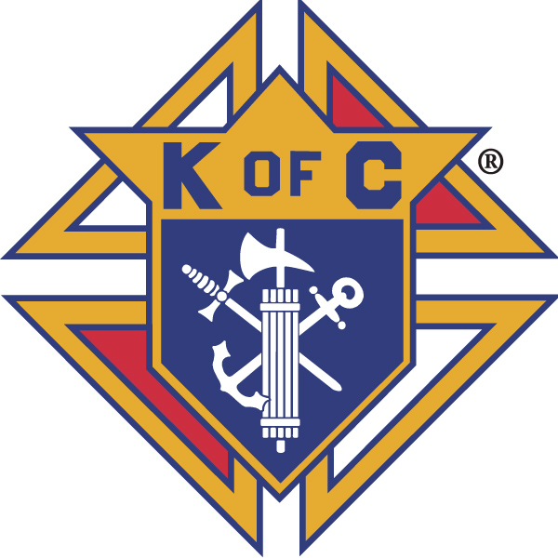
Knights of Columbus

In Service to One, In Service to All
Rev. Robert F. Houlihan, S.J., Council 10937
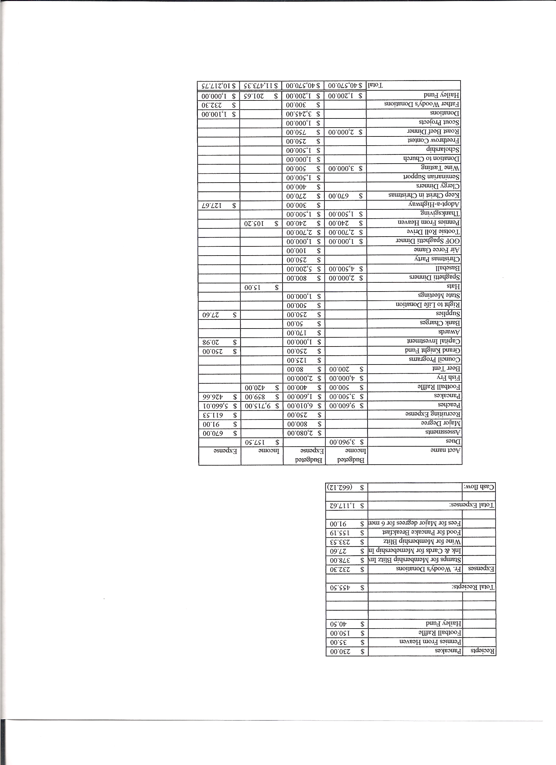
Business Meeting – October 12, 2013

I. General
- The Council was called to order at 7:58 AM by Grand Knight, Joe Musso.
- Opening Prayer was offered by Gary Mayfield. The role of officers was called and noted as follows (P = Present; A = Absence; E = excused)

Title | Status | Title | Status | Title | Status
Chaplain | P | Financial Secretary | P | Inside Guard | P
Grand Knight | P | Treasurer | E | Outside Guard | P
Dep. Grand Knight | P | Lecturer | P | Trustee 3rd Year | E
Chancellor | P | Advocate | E | Trustee 2nd Year | P
Recorder | P | Warden | P | Trustee 1st Year | P

The September 14, 2013 business -meeting minutes were approved as read and published.

II. Applications for Approval – Roger
Ron Hallam
Ervin Guzman

The candidates were unanimously approved.

III. Grand Knight Report – Joe
Pennies from Heaven
Knight of the Month – Jay Cavarese
Family of the Month – Sean Sweeney Family

Joe announced that Dennis Thumann will be our new Financial Secretary.
Help will be needed to move Gina DeRose to her new condo on Oct. 26th.
October is the month of the Holy Rosary. There was a Rosary at St. Mary Cathedral October 11th at which Josh Tracy was honored.
Happy birthday wishes were expressed for Fr. Brian.
Supreme with help from the Bronco wives is sponsoring coats for Colorado flood victims.
“The Knights of Columbus will distribute new winter coats to children in Denver on Tuesday, Oct. 15. Members of the Denver Broncos family - including players, coaching staff, their spouses and children - will assist the Knights in their effort.”
Correspondence:
A thank you letter from Alternative Pregnancy Center.
A letter from CSU indicating that they had received $500 KofC scholarship money for Erica Thomasson who is attending CSU.
A letter from Joan House encouraging Knights to join Stephen Ministries.
A letter from St. Mary Cathedral KofC inviting our council to attend the Rosary Oct.11th.
Copies of the correspondence are at the end of the minutes. (You may have to click on the page if it is blank.)

IV. Chaplain’s Report - Father Brian (Fr. Jim)
Central to patriotism is accountability. Three levels must be considered:
(1) Government, (2) fraternities and local organizations, and (3) families.
Moral formation of the people is the job of the Church and that formation begins within the family, which is the primary level of accountability. Politics is the realm of opinion. Government was meant to be accountable to the people. Democracy will fail if good morals are not formed. For a stable civic society to function, the state must be held accountable. The common good is foremost. We need to know what standards we must have and through local governments promote these standards. Intelligent men and women, formed in morality and well versed in politics, must hold politicians accountable to uphold the God given rights so proclaimed in our Constitution. The state relies on the people whose families have built character and value through high moral expectations and well-defined goals. Various fraternities such as the Knights of Columbus, The Elks Clubs, the Shriners are examples of organizations where men of similar values band together to keep each other accountable and build high standards which they have formed through the influence of their religious affiliations. Men must assert themselves to make sure, locally, that government officials are accountable in maintaining these values and standards promoted by the people and solidified through the family. Strong marriages where husband and wife strive to make each other better is the primary structure formatting values and morals which are then promoted locally through fraternities and organizations composed of men and women holding similar morals and values which are then passed on to local and national government, a government of the people, by the people, for the people. Good government begins with the first level of accountability found in the family, moves from there to fraternity and local groups and finally to government. No upper level of accountability can be allowed to usurp any function of a lower level such as the structure of marriage, the primary level of accountability.

V. Treasurer’s Report – Dennis (Roger)
Report handed out at meeting.
Bank Balance - $ 12,263.04 Available Funds - $ 10,076.25

VI. Financial Secretary’s Report – Roger
Report handed out at meeting
Receipts - $ 1,360.12 Expenses - $ 419.20 Bank Balance - $ 12,263.04

VII. Chancellor’s Update – Matt Yeagle
Mark Longstaff has left the seminary so we need to pick another candidate to sponsor. It is crucial that we build stronger relationships with those whom we sponsor in the seminary. Part of the sponsorship should include an interview with whoever is nominated. There are presently three candidates from Colorado Springs whom we could consider for sponsorship.

VIII. Committee Reports – Gary Mayfield

a. Membership – Roger Guidici
Speakers are needed this weekend after each Mass to invite Parishioners to attend our membership drive.
Please volunteer after each Mass to signup Thanksgiving basket donations. This is also an opportunity to invite people to join the Knights.

b. Church Director Report – Jay Calvarese
The Lady Knights will serve the donuts this weekend.
Help will be needed for the reconciliation dinner December 19th.

c. Community Report - Bob Luckner
Bob thanked everyone for the great work done on the Tootsie Roll drive.
Bob talked about the Thanksgiving Basket drive and related a very touching story about the roll they played in the life of a young single mother. Please volunteer for a few minutes after each Mass for the next few weeks to help sign people up for Thanksgiving baskets.
Adopt a Highway cleanup will be held October 19th. Volunteers are needed.
Help is still needed for the Denver Rescue Mission on October 19th.

d. Council Activity Report – Leonard Leyba
The family social for October will be after the 1st degree exemplification on October 18th in the great hall.
A pancake breakfast is scheduled for October 27th. Help is needed.

e. Family Report – Bill Hensen
The spaghetti dinner is tonight. Four to six volunteers are still needed.
There will be a potluck dinner prior to the Bronco-Patriot’s game on November 24th. All are invited to enjoy dinner and watch the game together in the great hall.
Our Christmas dinner will be held Friday, December 13th.

f. Right to Life report- Chris Mosley / Mike McGinnis
Thanks to those who helped place the crosses in front of the Church.
Please continue to pray the daily 40 days For Life devotionals for the success of the fall campaign. Many lives have already been saved. Also, if possible, consider praying outside an abortion center during the campaign.
Alternatives Pregnancy Center will be here Sunday to inform Parishioners about their services and to allow people to tour the “baby bus”.

g. Youth Report – Dennis Thumann
Dennis discussed the importance of adoption and the preciousness of adoptive children as another aspect of respect life month.
The soccer kickoff had many volunteers but only one participant who was only nine years old and, hence, was not eligible for district completion.
Preparation for determining next year’s scholarship recipients needs to begin.
The basketball shootout will be in January.
Dennis is resigning as youth director (after 7 years) and will become our financial secretary. Tim Pimmel will be the new youth director.
Dennis thanked all who helped him with youth activities and especially Ben Stancati who volunteered for every youth activity during Dennis’s directorship.

h. Newsletter – Herb Engler
No report.

IX. Advocate’s Report – Dave Petteys
No report.

X. Auditors and Trustees – Chris Kennedy
No report.

XI. Lecturer – Ben Stancoti
The Immigration Reform Question, by Most Rev. Michael J. Sheridan
Taken from the“The BISHOP’S Voice” section of the August 2013 edition of “The Colorado Catholic Herald,” the Diocese of Colorado Springs newspaper
“For the Lord, your God, is the….. Lord of Lords, the Great God, mighty and awesome, who has no favorites, accepts no bribes, who executes justice for the orphan and widow, and befriends the alien, feeding and clothing him. So you, too, must befriend the alien, for you were once aliens yourselves in the land of Egypt.” (Dt 10:17-19)
In his monthly editorial Bishop Sheridan argued that no one issue is more polarizing for Americans, Catholics included, then the issue of comprehensive immigration reform. In the milieu of rancor and overheated arguments, what everyone has forgotten is that that issue is about real people, made in the image and likeness of God. People like us with hopes, dreams, families, and the desire to have peace and security. Bishop Sheridan contends that there is a place for the Church in this secular debate, and a decade of neglect concerning the problem now compels the Church to act. In 2003, bishops from both Mexico and the US collaborated on a joint letter entitled Strangers No Longer: Together on the Journey of Hope. In the letter the bishops have enunciated five principles that will help guide the Church as she navigates these stormy waters. Bishop Sheridan points out that it is important for all, but particularly people of faith, to remember them and take the following to heart: that all people have the right to find opportunities in their own homeland, and to live a full life in dignity; that people have the right to migrate to support themselves and their families, when work disappears in their country of origin people should have the right to seek employment elsewhere; that countries have the right to control their borders; that refugees and asylum seekers should be afforded protection without incarceration, this applies specifically to people fleeing wars and persecution; and that the human dignity and human rights of undocumented migrants should be respected. The bishop ended his editorial with a clarion call for the Catholic faithful to make their voices heard, reminding us that Jesus’s family were refugees too. And not to forget that our salvation is bound up with fulfilling the call of the Lord, which means taking care of the least of our brethren.

XII. Unfinished Business -
None.

XIII. New Business
The men’s choir will again sing Christmas Eve. $100 needs to be set-aside for the accompanist.

Coats For Kids - As mentioned under the Grand Knight’s report, Supreme asked if they could send 1000 coats for flood victims in northern Colorado. The Denver Broncos found out about the coats and asked to be involved. 25 families from Greeley will help distribute the coats along with the Knights and Broncos wives. They will go to people in towns in northern Colorado that were affected by the flood.

The following resolution was proposed, discussed and unanimously approved.
Resolution:
That $500 plus 50% of the profits from our spaghetti dinner be donated to Colorado Flood Relief on behalf of Council 10937.

XIV. 4th Degree Report – Chris Kennedy
The next corporate Mass is tomorrow. Knights and their families should sit together. Fourth degree Knights, please wear tuxes. We will go to breakfast after Mass.
Chris will talk about helping out at the Special Olympics coming November 9th. Six to eight people will be needed twice during the day. Chris will talk more about this as the event approaches.

XV. Field Agent Report - Jayme Sanford
No report.

XVI. District Deputy Report – John Lynn
No report.

XVII. Good of the Order
Jim DeRose, Monique Conley and Conley family, Sherri Suddarth, Dennis and Michelle Cullen, Roger Muller, Abby Thumann, Loren Hansen, and Bridgid Mosely.

XVIII. Chaplain’s Summation – Fr. Brian (Gary)

XIX. Closing Prayer
Read by Gary Mayfield.

MEETING WAS ADJOURNED AT

9:05 am

- minutes recorded and reported by Mike McGinnis

----- Correspondence -----

