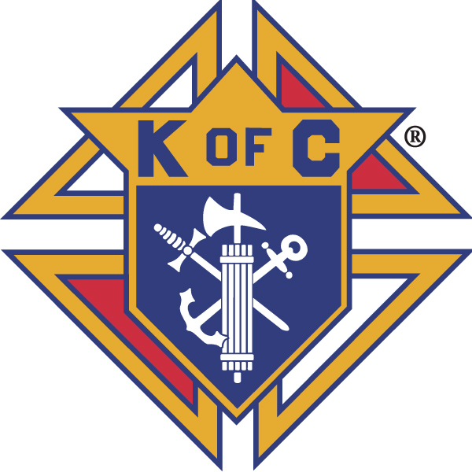
Knights of Columbus

In Service to One, In Service to All
Rev. Robert F. Houlihan, S.J., Council 10937
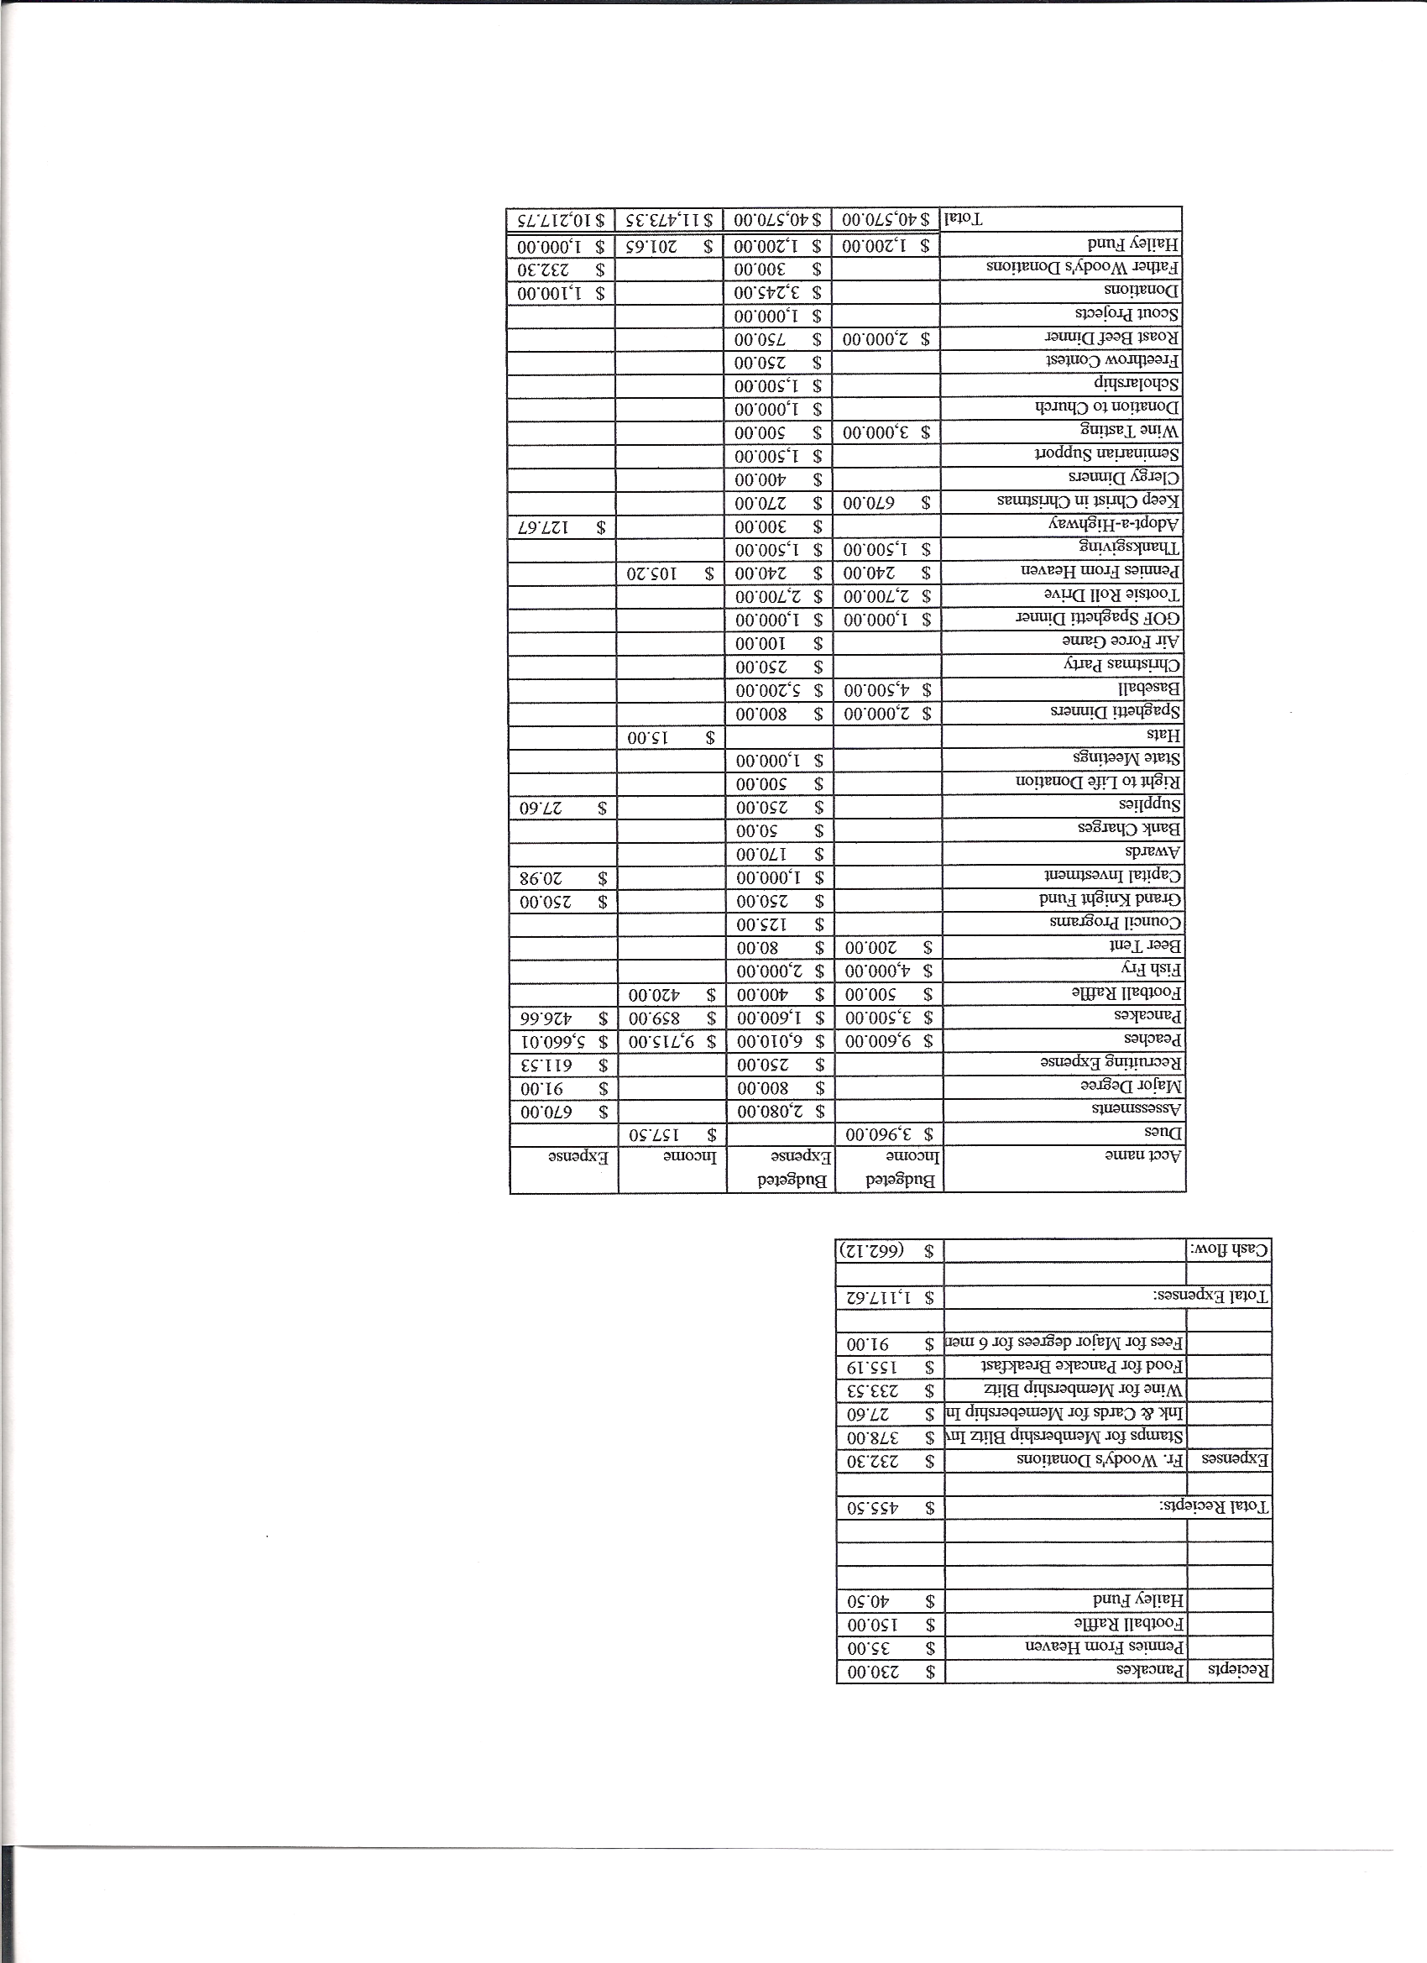
Business Meeting – November 9, 2013

I. General
- The Council was called to order at 7:58 AM by Grand Knight, Joe Musso.
- Opening Prayer was offered by Matt Yeagle. The role of officers was called and noted as follows (P = Present; A = Absence; E = excused)

Title | Status | Title | Status | Title | Status
Chaplain | P | Financial Secretary | P | Inside Guard | P
Grand Knight | P | Treasurer | E | Outside Guard | P
Dep. Grand Knight | E | Lecturer | P | Trustee 3rd Year | P
Chancellor | P | Advocate | A | Trustee 2nd Year | P
Recorder | P | Warden | P | Trustee 1st Year | E

The October 12, 2013 meeting minutes were approved as read and published.

II. Applications for Approval – Roger
Dan Donaldson (transfer) - Approved unanimously
Dale Shubering (transfer) - Approved unanimously

III. Grand Knight Report – Joe
Pennies from Heaven – A separate hat, in addition to our regular Pennies from Heaven box, was earmarked for socks to be purchased by Art for Father Woody’s.
Knight of the Month – Barney Meyer
Family of the Month – Bob Luckner Family
Correspondence: Charitable Giving Accountability Standards (Knights of Columbus)
Guidelines for participating in the Ultrasound Initiative (Knights of Columbus)
Letter from the Global Wheelchair Mission
Letter confirming the appointment of Dennis Thumann as Financial Secretary
Letter concerning the “Pennies From Heaven” program detailing what charities and the amounts they received from the program.
The January 11, 2014 business meeting has been changed to Thursday, January 9, 2014 at 7PM because the State midyear meeting was scheduled for Jan.11th.
Bob Luckner was chosen Steward of the Month at Pax Christi. – Congratulations Bob.
Joe recognized veterans in our council and thanked them for their service. Father Brian said he will give a special blessing for veterans at the Sunday Masses.
Joe, on behalf of Gina DeRose, thanked everyone who helped make her move a success.
Supreme extended the coats for flood victims with another donation of 1000 coats.

IV. Chaplain’s Report - Father Brian
Father expressed thanks to people who attended Mass. He emphasized that the Mass and the Eucharist is the source and summit of our spiritual lives.
One hundred people have signed up for the newcomers’ dinner this month.
Our Sunday collections have been averaging around $21,000. It takes $28,000 to pay the bills. 46% of our registered Parish members give no financial help to the Parish. Father will soon be speaking about stewardship and the need to give at Sunday masses.
Father Brian will be traveling to Haiti soon to meet with the priest there and evaluate our involvement.

V. Treasurer’s Report - Dennis
Report handed out at meeting.
Bank Balance - $ 16,511.57 Available Funds - $ 14,128.83

VI. Financial Secretary’s Report – Dennis
Report handed out at meeting
Receipts - $ 7,082.32 Expenses - $ 2,832.70 Bank Balance - $ 16,512.66

VII. Chancellor’s Update – Matt Yeagle
Justin Nelson, whom our Council is considering sponsoring, has been invited to the Christmas party. He is currently studying with Roy in New Orleans.
Peter Srsich, from the Diocese of Denver, may be a new candidate for our council to consider sponsoring next year.
The web site Future Priests.com is a source of information concerning seminarians.

VIII. Committee Reports – Gary Mayfield

a. Membership – Roger Guidici
Council 10937 currently stands at three new members.
There will be a 1st degree exemplification December 14, 2013. We expect to have two or three participants in this exemplification
The Thanksgiving basket campaign provides an excellent opportunity for recruitment and we expect some additional candidates for the 1st degree.

b. Church Director Report – Jay Calvarese
Donut will be served at the following Sunday Masses: 11/10, 11/17, 11/24, 12/1, 12/15, 12/22, and 12/29. There will not be donuts 12/8.
The Christmas party will be on December 13th.
The reconciliation dinner will be 12/19. Help is needed.

c. Community Report - Bob Luckner
Bob reported that Tootsie Roll donations were distributed to Rocky Mountain Special Olympics and to ARC.
Volunteers are needed after each weekend Mass to encourage donations for Thanksgiving baskets. 300 baskets have currently been pledged. We need at least 400. Assembly of baskets will be Saturday morning, Nov. 23, at 8:00 AM at Pax Christi. Knights should be at the Church at 7:30 AM. There have been many comments that this is the “coolest” event in the Church.

d. Council Activity Report – Leonard Leyba
The family social this month is Nov. 15th at Roger’s house.
There will be a pancake breakfast Dec. 8th.

e. Family Report – Bill Hensen
There will be a potluck dinner at Pax Christi on Nov. 24th at which we will watch the Denver Broncos annihilate the New England Patriots. We’ll watch the game on our new 60 inch TV set. A pool will be available at $5 per square for those lucky people who like winning money. All are invited to attend this fun event to root the Broncos on.
The spaghetti dinner is scheduled for February 1st.

f. Right to Life report - Mike McGinnis
Please contact our Senators and Representatives to ask their support for two pro- life bills being introduced in Congress.
The Abortion Insurance Full Disclosure Act HB 3279 introduced by Rep Chris Smith (R-NJ)
Pain Capable Unborn Child Protection Act introduced by Sen. Lindsey Graham (R-SC)
Thanks to those who helped place the crosses on the lawn outside the Church.
Herb and Vonnie Engler, Chris and Michelle Kennedy, Mike and Denise McGinnis and Father Brian and Father Jim attended the Bishop’s Respect Life Dinner at the Broadmoor. There were excellent and moving speakers including David Bereit who is the 40 Days For Life director. After the dinner approximately 100 people gathered for a candle light vigil for the unborn.
Thanks to all who participated in the fall 40 Days For Life campaign.

g. Youth Report – Tim Pimmel
Tim is planning a change in direction for the youth. He will coordinate with Patrick on some possible fund raising activities (babysitting, for example) to support such organizations as the pre-school, the Boy Scouts and Girl Scouts, possibly a Marriage Enrichment Family Dinner and working with the Mom’s group in the recruitment of youth.
The basketball free throw contest will be held in January.
The scholarship committee is being formed.

h. Newsletter – Herb Engler
There was no newsletter last month due to Herb’s eye injury. Herb will attempt to publish one for December.
Program directors remember to submit articles and announcements for the bulletin to Joann by 10:00 AM on Monday.

IX. Advocate’s Report – Dave Petteys
No report.

X. Auditors and Trustees – Chris Kennedy
No report.

XI. Lecturer – Ben Stancoti
Matt Moranto spoke about the Boy Scouts. He presented a brief history and talked about religious awards that are given by Boy Scouts and Girl Scouts. He passed out the pamphlet “Duty to God” which answers many questions about scouting and how to start a religious program within the Boy Scouts of America. Bishop Sheridan recognizes Scouts the 2nd or 3rd Sunday of advent.

XII. Unfinished Business
None.

XIII. New Business
None.

XIV. 4th Degree Report – Chris Kennedy
The bowling Special Olympics is today at Belleview Lanes. Participation in awards by 4th degree knights, (regalia if possible), is needed this afternoon from 2:00 to 3:30.
The end of the Year of Faith Mass will be Nov. 24th at the Broadmoor Hotel. Knights in regalia are urged to participate. Tickets are needed in advance. See Chris.

XV. Field Agent Report – Mike Masto
Mike was introduced and pledged active participation in the Council. He would like to contact all members as soon as possible. He can be contacted at: michael.masto@kofc.org or at 303-727-0373.

XVI. District Deputy Report – John Lynn
Membership for our Council is 3 and insurance is at 40% (2 out of 5).
The District free throw is scheduled for February.
Reports need to be filed by the Feb.1st so you need to be working on them.
The icon will be here for the Christmas party.
The State website talks about flood relief and where it will go.
John presented the 2012 Shining Knight award to the Council.

XVII. Good of the Order
Jim DeRose, Sherri Suddarth, , Father Brad Noonan, Bridget Mosely, Loren Hansen, Michelle Cullen and Joe Snearline Family (Typhoon Haiyan), Herb Engler (eye).

XVIII. Chaplain’s Summation – Fr. Brian
None.

XIX. Closing Prayer
Read by Matt Yeagle.

MEETING WAS ADJOURNED AT

9:22 am

- minutes recorded and reported by Mike McGinnis

----- Correspondence -----

