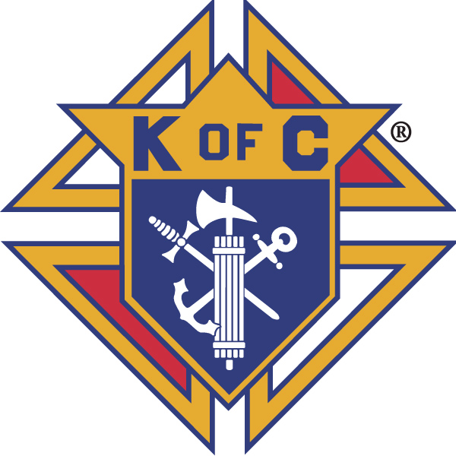
Knights of Columbus

In Service to One, In Service to All
Rev. Robert F. Houlihan, S.J., Council 10937
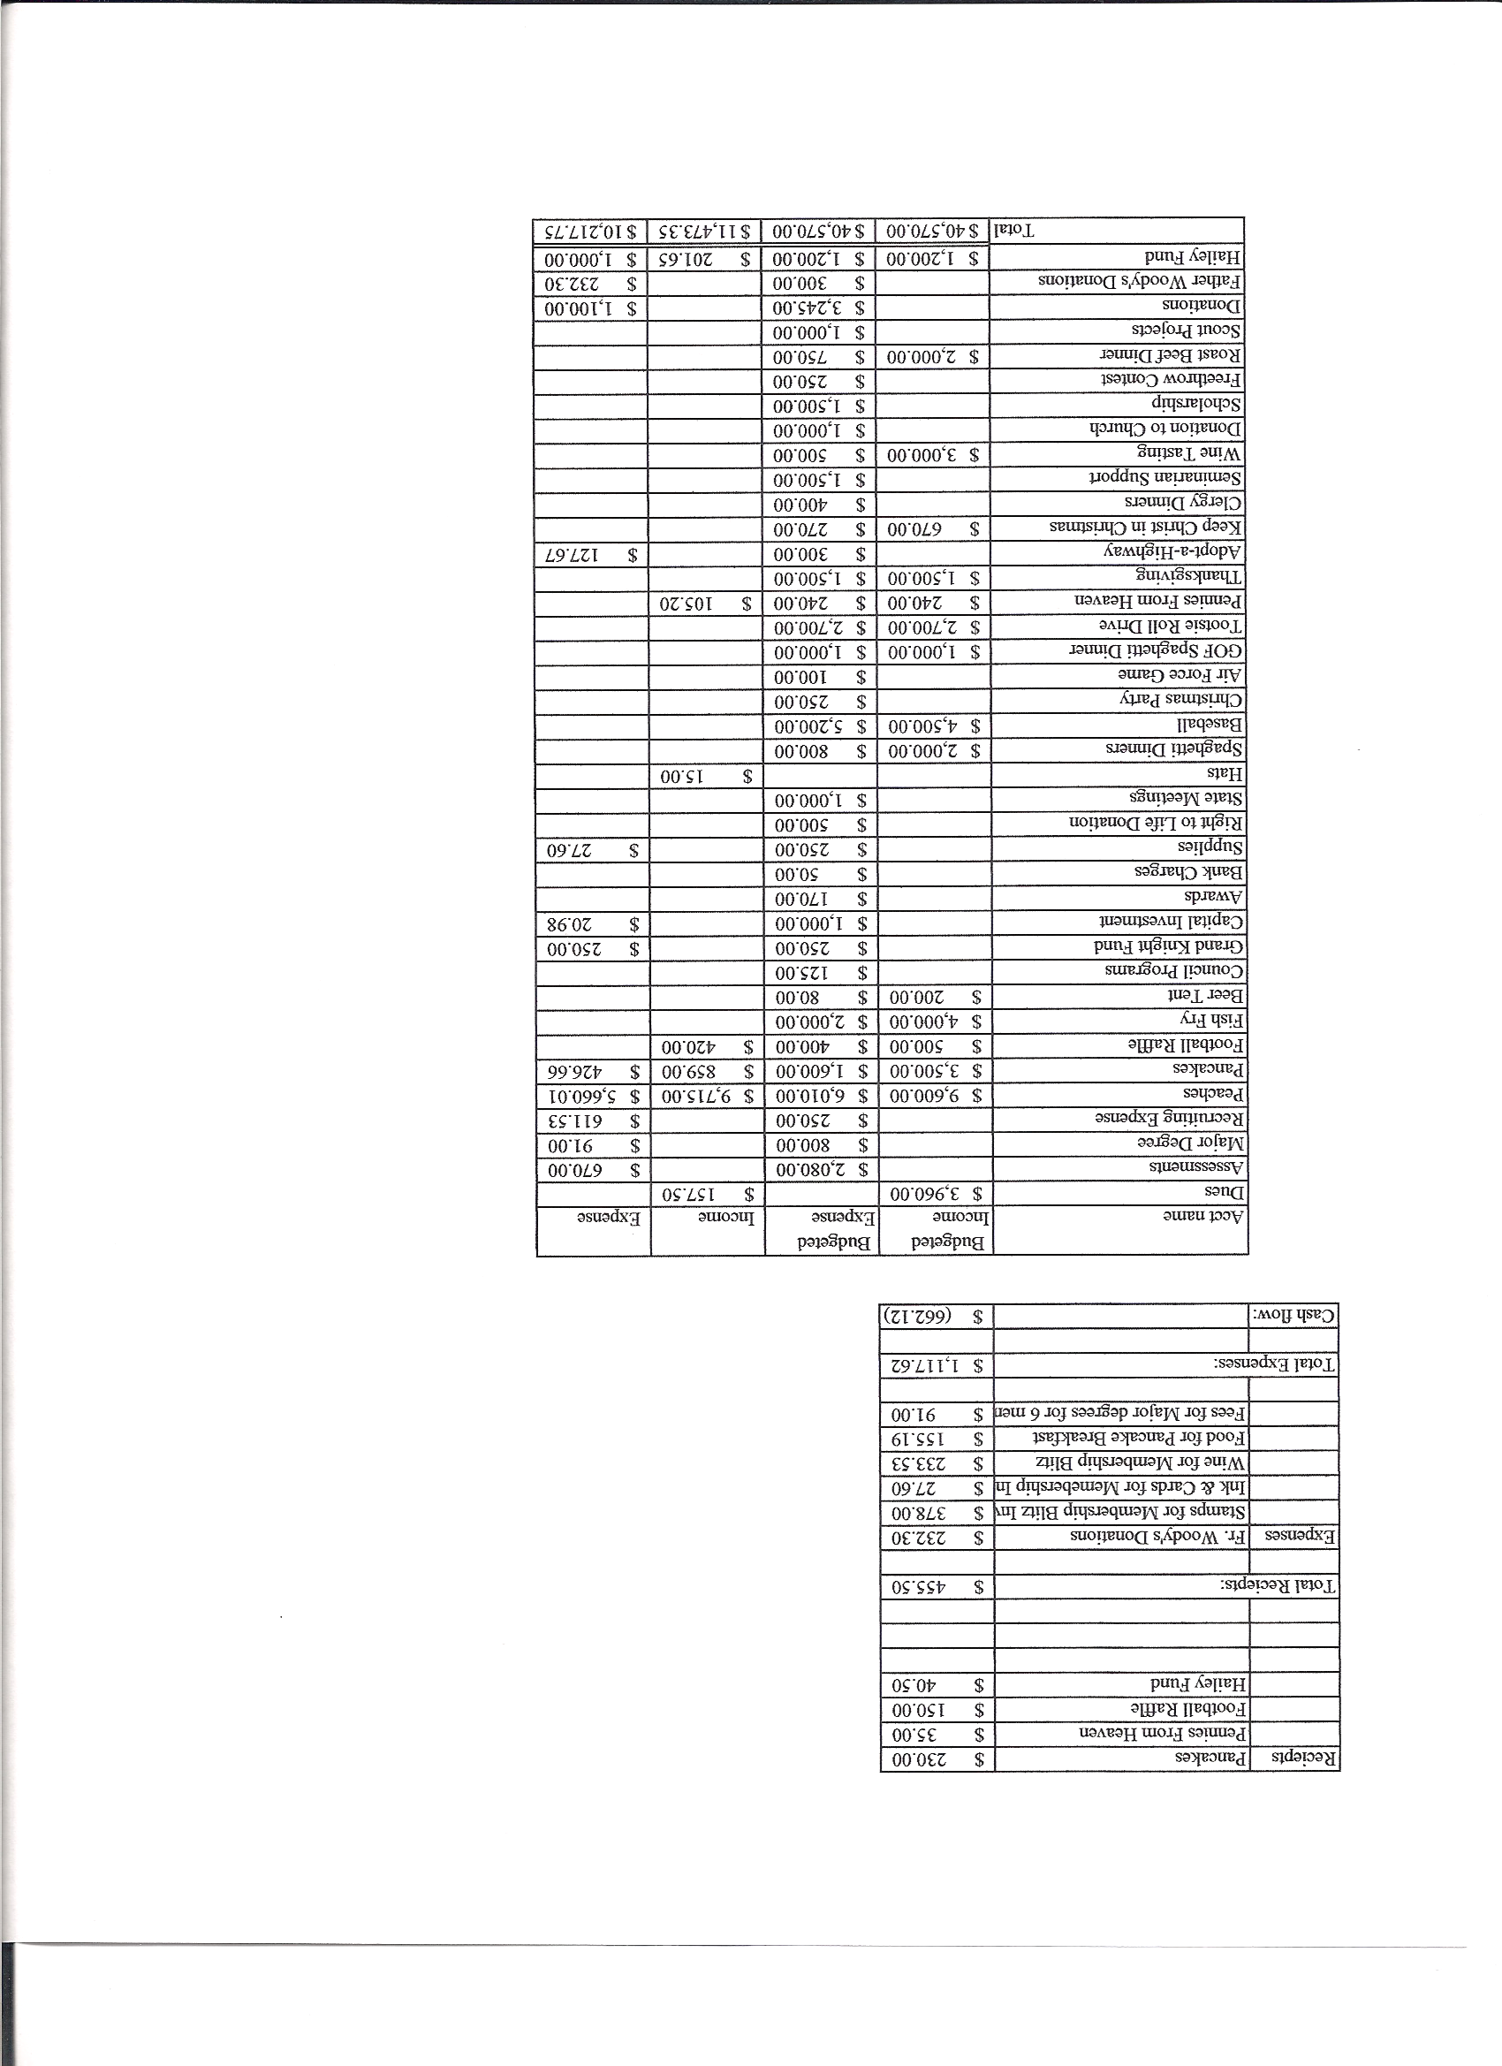
Business Meeting – July 14, 2012

I. General
- The Council was called to order at 8:08 AM by Grand Knight, Paul Sciera.
- Opening Prayer was offered by Joe Musso. The role of officers was called and noted as follows (P = Present; A = Absence; E = excused)

Title | Status | Title | Status | Title | Status
Chaplain | P | Financial Secretary | P | Inside Guard | P
Grand Knight | P | Treasurer | P | Outside Guard | P
Dep. Grand Knight | P | Lecturer | P | Trustee 3rd Year | P
Chancellor | P | Advocate | P | Trustee 2nd Year | E
Recorder | P | Warden | P | Trustee 1st Year | E

The June 9, 2012 meeting minutes were approved as read and published.

II. Applications for Approval – Roger
None

III. Grand Knight Report – Paul
Pennies from Heaven
Knight of the Month – Barney Meyer
Family of the Month – Roger Giudici Family
Correspondence – There is a special retreat for the Knights October19 thru October 21at the Jesuit Retreat House in Sedalia.
- There will be a celebration for our new Archbishop. All Knights are asked to help by picking clergy up at the airport etc., if possible.
- Thank you letters were received from Alternatives Pregnancy Center, Department of Veteran Affairs, Special Olympics and Father Woody.
Tonight is Beer and Brats night. Thanks to the Knights who contributed to the purchase of the new grill.
Help is needed to put up awards and also to clean up the kitchen.

IV. Chaplain’s Report
The new Rectory should be done by the third week in August. Father requests donations for furnishings etc. Possibly a registry for donations could be established.
Father Jim will be here about the first of August. He will need a place to stay until the Rectory is ready.
Deacon Tim has left to serve at St. Francis of Assisi in Castle Rock.
We are still looking for a youth director. Interviews are currently taking place.
Father Brian expressed thanks for his home Mass kit.
Bishop Sheridan e-mailed Father Brian that he will be at the 20th year celebration on the 28th of July and will celebrate Mass.
Father will have surgery soon and would like prayers.

V. Treasurer’s Report - Dennis
Lady Knights - $ 188.66 Available funds - $ 12,024.02 Hailey Funds - $949.55

VI. Financial Secretary’s Report – Roger
Report handed out at meeting
Receipts - $ 2,500.31 Expenses - $ 3,866.31 Bank balance - $ 14,819.72

VII. Chancellor’s Update – Gary Mayfield
Jason Keas and Peter Morgan have both been invited to tonight’s beer and brats. Neither will be able to attend.
Sunday is the Cathedral Walk For Vocations. Participants will walk from the Cathedral to Corpus Christi church.
Meet the Seminarians Night followup - There were 49 kids in attendance and 22 adults.
The prayer for vocations was said.

VIII. Committee Reports – Joe Musso

a. Membership – Max Gramly
There will be a staff membership table at the ministry fair. We need a team to man the table.
Our Council posted 225% of our insurance quota this last fiscal year.
Dates for different degree exemplifications can be found on the Knight’s web site.

b. Church Director Report – Ron Reitsch
Report given by Chris Kennedy – Chris talked with Father about a “wish list” for both the Church and the rectory financed through the matching fund.
The Rosary Walk is complete. Signs have been placed after each decade of the rosary. Father asked whether something could be done to make it easier to get there. Chris said he would check out possibilities.
Chris again reminded all that beer and brats is tonight after the 5:00 o’clock Mass.

c. Community Report – Bob Luckner
Report given by Joe Musso – Tootsie Roll drive dates have been determined. They are September 28 and 29 and October 5 and 6.
Highway cleanup will be coming soon. Date will be announced.

d. Council Activity Report – Leonard Leyba
There will be no family social this month because of the 20th anniversary celebration, July 28. Installation of officers will occur that night.
The Knights need volunteers to help at the Knight’s table during the ministry fair, August 18th and 19th.

e. Family Report – Bill Hensen
Bill is our new family director. He was introduced by Joe Musso and welcomed by all.
Bill plans to continue the agenda as it now stands.
f. Right to Life report- Chris Mosely / Mike McGinnis
40 Days For Life begins its fall campaign September 26 and will run through November 4.
On July 18th, the U.S. House Judicial Committee will vote to ban abortions in Washington DC after 20 weeks. Please contact your representative to encourage support for this essential right to life legislation.
Janice Vogte from the Alternative Pregnancy Center in Denver may speak about the type of work performed at the center and may bring the mobile unit over to Pax Christi sometime in the fall. I will work with her to find a date and time.
g. Youth Report – Dennis Thumann
This years Relay for Life will be August 10th and 11th at Cresthill Middle School. Cooking help is needed. You can sign up online.
The Soccer Challenge is September 9th and will be held at Rock Canyon High School soccer field.
July 19th is movie night for the youth group. Approximately 60 youth will be attending.
Youth director interviews are continuing.
John Kennedy, who was the lead for the scholarship committee, has transferred to another council. Hence, we need a volunteer to take the lead. If interested, let Dennis know.
July 23rd will be a desert night for those who supported the work camp at the Navajo reservation in Monument Utah. Before and after pictures of buildings the youth worked on will be shown.
IX.– Lecturer – Ben Stancati
The Rev. Robert F. Houlihan, S.J. Educators Series
Ben spoke about the Vatican Diplomatic Corp, its work and the various activities in which the Corps is engaged. Its mission is to wage a war of peace across the globe. The Corps is charged with protecting religious freedom, the dignity of human life, access to health care for all people, educational opportunities, relief services and human rights. The Corps defends serious moral issues and promotes the ideals of justice, peace and solidarity and works to eliminate poverty, hunger and disease in our world. The Vatican Diplomatic Corps has relations with 178 countries and is one of the best informed and influential diplomatic networks in the world.

X. Trustee’s Report – Quorum is not present to do the audit today. It will be done before August 15. The date will be announced.

VIII. Unfinished Business -
The motion from June 9 regarding matching funds was brought up for discussion. Roger offered an amendment that there be two groups for matching: (1) The Knights and (2) the parish. The motion was seconded by Chris Kennedy. Discussion followed and the vote for the amendment was unanimous.

The amended motion reads as follows: “I move that there be the creation of a fund in the value of $5,000 for the purpose of financing identified improvements to the parish, including both improvements to the worship place and the furnishing of the rectory. The fund shall be a matching fund against the greater of funds collected by members of the Knights or by members of the Parish.”

Discussion followed and the motion was unanimously approved. Guidelines will be established.

The budget for this fiscal year was presented, discussed, voted on and unanimously approved.

IX. New Business
Two requests for amounts of $500 each were made by Roger.
The first is for the expenses incurred by our anniversary dinner. We are charging only $20 per family and there are approximately 50 guests who are not covered by that $20.
The second is seed money to start our new assembly. The money will help to get started and to pay for jewels.
The motions to authorize $500 for each were made by Roger, seconded and voted in unanimously.

X. 4th Degree Report – Roger
Victor talked about installation of officers for the new assembly. The installation will be done in the church. He also invited all third degree Knights to become members of the assembly by becoming 4th degree.

XI. Field Agent Report
Our new field agent is Greg Archunde. He was not present at the meeting.

XII. District Deputy Report – Mark Solome
The district meeting will be Saturday in Colorado Springs. All are invited to attend.

Football Frenzy tickets are on sale. Mark said he would pay for coffee and donuts at our business meeting if we sold our quota of tickets.

Father Brian asked about discerning whether candidates for Knighthood are in full communion with the Church and, thus, a Practical Catholic. Marc said that only a priest can determine that. Father will make out a list of questions that should be asked to each potential candidate. Based on his answers that candidate may be referred to Father for Practical Catholic determination.

XIII. Good of the Order
Jim DeRose, John Starke, Dennis Cullen

XIV Chaplain’s Summation – Fr. Brian
Father Jim will say his first Mass at Pax Christi August 4th. Please welcome him and introduce yourself as a Knight. Father Jim will need a place to stay for three weeks until the rectory is complete.

XIV. Closing Prayer
Read by Joe Musso

MEETING WAS ADJOURNED AT

10:39 am

- minutes recorded and reported by Mike McGinnis

