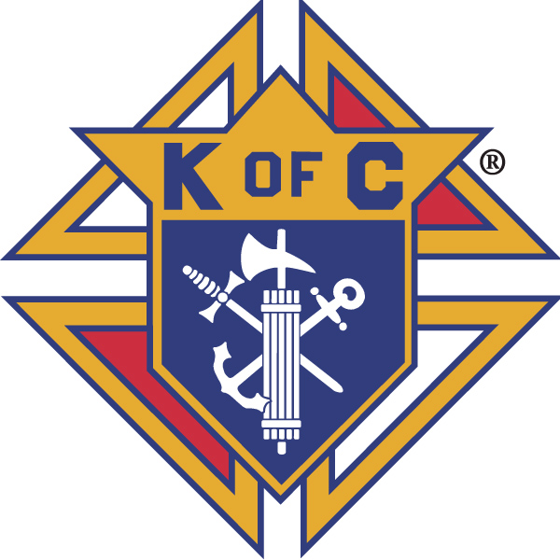
Knights of Columbus

In Service to One, In Service to All
Rev. Robert F. Houlihan, S.J., Council 10937
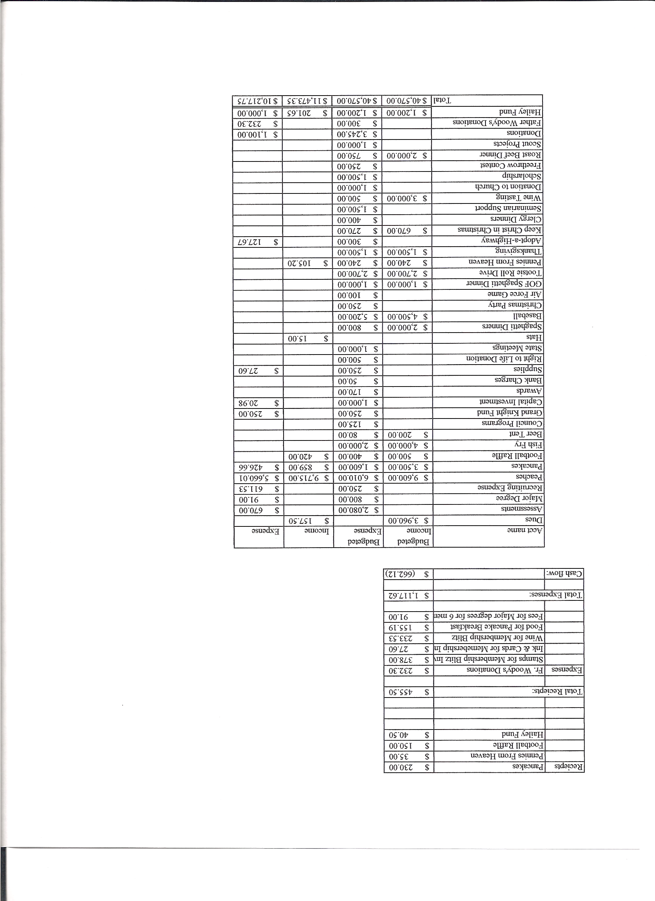
Business Meeting – October 13, 2012

I. General
- The Council was called to order at 7:59 AM by Deputy Grand Knight, Joe Musso.
- Opening Prayer was offered by Gary Mayfield. The role of officers was called and noted as follows (P = Present; A = Absence; E = excused)

Title | Status | Title | Status | Title | Status
Chaplain | P | Financial Secretary | P | Inside Guard | P
Grand Knight | E | Treasurer | P | Outside Guard | A
Dep. Grand Knight | P | Lecturer | P | Trustee 3rd Year | P
Chancellor | P | Advocate | P | Trustee 2nd Year | P
Recorder | P | Warden | E | Trustee 1st Year | A

The September 8, 2012 meeting minutes were approved as read and published.

II. Applications for Approval – Roger
New member – Scott Parrill
Transfer – Brennon Mendus
Both applicants were unanimously approved.

Currently we have six 100 forms submitted.

III. Grand Knight Report – Joe (for Paul)
Pennies from Heaven
Knight of the Month – Max Gramly
Family of the Month – Tony Yarosh

IV. Chaplain’s Report
Father Brian said he is feeling much better and that the experience made him realize how precious health is.
October is Respect for Life month. The Presidential debate was disappointing in that neither vice presidential candidate stood up for life in all cases including rape and incest.
Father will move into the new rectory this week.
The Knights wished Father happy birthday in song.

V. Treasurer’s Report - Dennis
Report handed out at meeting
Bank balance - $ 9,129.01 Available funds - $ 7,757.08

VI. Financial Secretary’s Report – Roger
Report handed out at meeting
Receipts - $ 0 Expenses - $ 0 Bank balance - $ 9,129.01

VII. Chancellor’s Update – Gary Mayfield
We have new seminarian, Nathan Hinos.

VIII. Committee Reports – Joe Musso

a. Membership – Keith Haley
There will be a membership push at the spaghetti dinner.

b. Church Director Report – Ron Reitsch
Information concerning the events for November and December will be coming soon.
Patrick will be on vacation the last two weeks of the month and, in the event of snow, the parish may need help with snow removal while he is gone.
December 14 is the reconciliation dinner. We will need Knights to help.
Carpet cleaning will be done in the great hall after the 10:30 breakfast probably on October 28th. Father Brian will confirm this date.

c. Community Report – Bob Luckner
The Tootsie Roll drive for people with intellectual disabilities netted $3,171.47. Gary noted that young people were extremely generous.
We will be signing up parishioners for Thanksgiving baskets starting Sunday after all masses. Knights please sign up to help. Christmas cards will also be on sale after each mass.
The highway cleanup September 15th was a very successful.

d. Council Activity Report – Leonard Leyba
The family social will be October 19th starting at 6:00 PM. It will be in conjunction with a first degree ceremony.

e. Family Report – Bill Hensen
The council fishing trip was a good time and a great success. Thanks to John Starke for all his efforts.
The Air Force game was very cold. Preference would be not to have such an early
kickoff in the future.
The spaghetti dinner is tonight.
The Christmas party and also a family game night are coming up. Information on these later.

f. Right to Life report- Chris Mosely / Mike McGinnis
The Alternative Pregnancy mobile unit will be here October 14th. Mary McGovern will speak briefly about the center after the 8:30 and 10:30 masses. The Knights are providing donuts and proceeds will be donated to the center.
Knights are participating once again in the fall 40 Days For Life campaign. There have already been many successes in saved lives. Knights and their families are encouraged to attend and participate in prayer at the Planned Parenthood facility in Colorado Springs.
The Bishop’s respect for life dinner will be held October 19th at the Broadmore Hotel in Colorado Springs. McGinnises and Englers are planning to attend.
We are all encouraged to participate in the Rosary Novena for Life and Liberty.

g. Youth Report – Dennis Thumann (no report)
Father Brian reported that he has not yet found a youth director but he does have a possibility.

IX.– Lecturer – Ben Stancati
The Robert F. Houlihan, S.J. Educators Series, number 5.0
“The Year of Faith” (10/11/12 – 11/24/13) called by Pope Benedict XVI marks the 20th anniversary of the publication of the Catechism of the Catholic Church and also the 50th anniversary of the Second Vatican Council. This month in Rome the Synod of Bishops will meet in order to focus Christian Doctrine on both implementation and development of the work started in Vatican II. Vatican II was only the second council convened since the 1500’s and was truly a historical event. It was a continuation of an intense process of spiritual and pastoral renewal in the Church. It gave the Church a renewed awareness of mystery and mission, obedience to the word of God, and a goal to more effectively present the word of God, to more effectively serve the masses and to work for unity of Christian religions. The goals and objectives of Vatican II have been influential on Popes presiding since and their magisterial teachings reflect that.
Next month’s session will focus on the teaching of Vatican II and on the Catechism.

X. Trustee’s Report -
No report

VIII. Unfinished Business -
None

IX. New Business
Ben Stancati urged formation and participation in a men’s Christmas Choir which would perform at the 9:00 Christmas Eve mass. Interested men will meet in the chapel starting November 29th at 7:00 PM for rehearsal for four consecutive weeks. Joe will send out an e-mail.
Keep Christ in Christmas cards will be sold from existing inventory this year.

X. 4th Degree Report – Victor Ogunmodede (report by Chris Kennedy)
Corporate Mass will be October 21st at 8:30 AM. Breakfast will follow for those interested.
Tootsie Roll drive will also take place after the masses.
We are trying to find a room for the Assembly meeting.
Monstrance is ready. Adoration services need to be scheduled.

XI. Field Agent Report – Greg Achunde
No report

XII. District Deputy Report – Mark Solome
Mark presented Herb Engler the State Knight of the Month award.
We are four out of thirteen of our quota for membership. At present we have 0 for 5 of our insurance goal for this fiscal year. We are waiting for two insurances to clear.
The RSVP program donates funds for personal expenses for seminarians and religious sisters and brothers. 2628 councils donated more than 3 million dollars for these personal expenses.

Make sure to get out and vote. Knights as an organization can legally only speak on issues, not candidates.

There will be a 3rd degree on December 6th.

XIII. Good of the Order
Jim DeRose, Ron Knowels. (Ron was hit by a truck and is in serious condition.)

XIV Chaplain’s Summation – Fr. Brian

XIV. Closing Prayer
Read by Gary Mayfield.

MEETING WAS ADJOURNED AT

9:12 am

- minutes recorded and reported by Mike McGinnis

