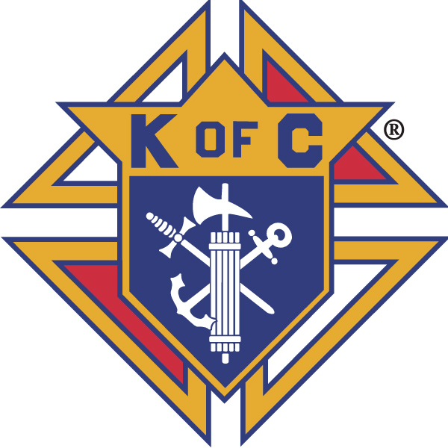
Knights of Columbus

In Service to One, In Service to All
Rev. Robert F. Houlihan, S.J., Council 10937
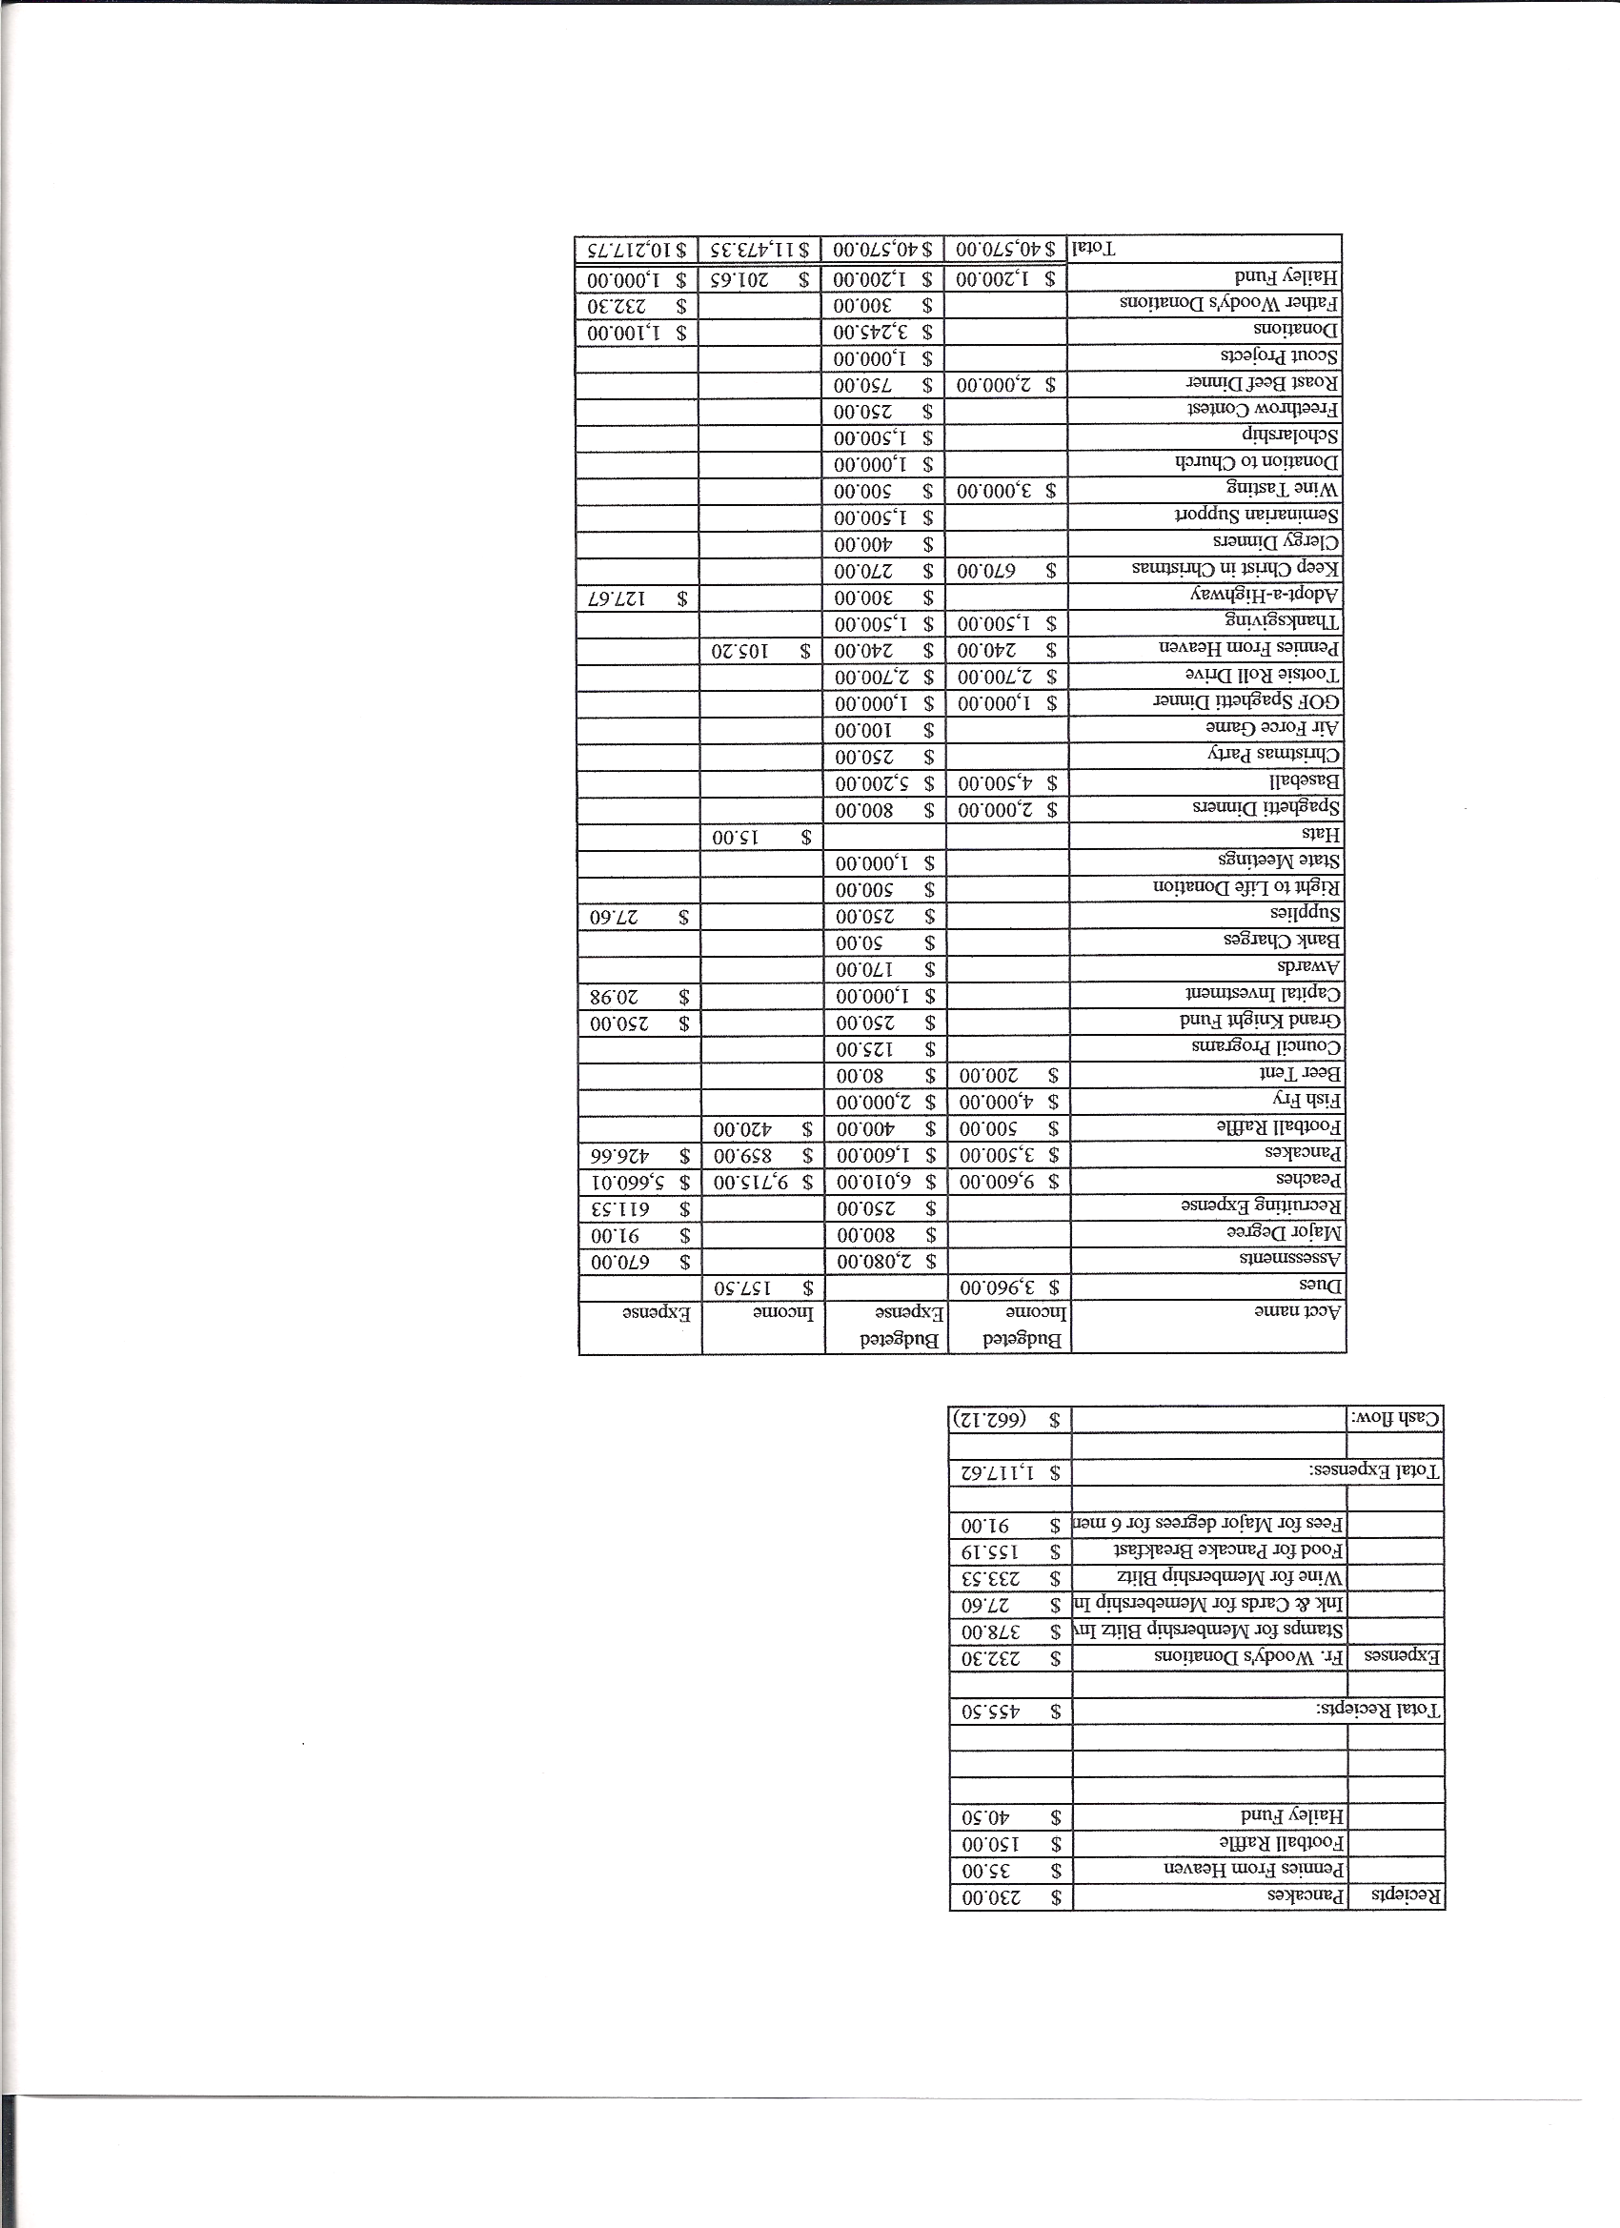
Business Meeting – July 10,2014

I. General
- The Council was called to order at 7:06 PM by Grand Knight, Joe Musso.
- Opening Prayer was offered by Gary Mayfield. The role of officers was called and noted as follows (P = Present; A = Absence; E = excused)

Title | Status | Title | Status | Title | Status
Chaplain | E | Financial Secretary | P | Inside Guard | E
Grand Knight | P | Treasurer | P | Outside Guard | P
Dep. Grand Knight | P | Lecturer | E | Trustee 3rd Year | E
Chancellor | P | Advocate | P | Trustee 2nd Year | E
Recorder | P | Warden | P | Trustee 1st Year | E

The June 14,2014 business meeting minutes were approved as read and published.

II. Applications for Approval – Roger

III. Grand Knight Report – Joe
Pennies from Heaven
Knight of the Month –
Family of the Month –
Correspondence:

IV. Chaplain’s Report - Father Jim

V. Treasurer’s Report – Dennis Cullen
Report handed out at meeting.
Bank Balance - $ Available Funds - $

VI. Financial Secretary’s Report – Dennis Thumann
Report handed out at meeting
Receipts - $ Expenses - $ Bank Balance - $

VII. Chancellor’s Update – Matt Yeagle

VIII. Committee Reports – Gary Mayfield

a. Membership – Roger Guidici/Brennan Mendus

b. Church Director Report – Jay Calvarese

c. Community Report - Bob Luckner

d. Council Activity Report – Nereus Lobo/Paul Sciera

e. Family Report – Bill Hensen

f. Right to Life report - Mike McGinnis

g. Youth Report – Tim Pimmel/Ben Stancati

h. Newsletter – Chris Kennedy

IX. Advocate’s Report – Dave Petteys

X. Auditors and Trustees – Chris Kennedy

XI. Lecturer – Ben Stancati (Alan Brown)
The Rev. Robert F. Houlihan S.J. Educator Series
“Fathers and Chaplains of World War I”
Discussed at the July Knights of Columbus Council 10937 meeting on 7/10/14 by Alan Brown
When I talked with Ben Stancati about a subject for this month’s lecture series, he suggested that I research chaplains and priests from World War 1 to coincide with the 100th year anniversary. The First World War, was a global war centered in Europe that began on 28 July 1914 and lasted until 11 November 1918. More than 9 million combatants were killed; a casualty rate exacerbated by the belligerents' technological and industrial sophistication, and tactical stalemate. It was one of the deadliest conflicts in history, paving the way for major political changes, including revolutions in many of the nations involved.
From a source named “They Gave Their Today”, http://www.theygavetheirtoday.com/army-chaplains-ww1.html , there were many British chaplains that were killed in the war. From a quote from John Maxwell Edmunds in 1916, “When you go Home, tell them of us and say, for your Tomorrow, we gave our Today”. I chose 4 British chaplains including to give you a feel for the bravery and heroism of these men:
- The Rev Frederick William AINLEY, who was a reverend chaplain 4th class (equivalent to a Captain) and curate of St. Paul’s Church in England. Father Ainley was interested in being a missionary in China but his dreams were altered by the advent of WW1. Father Ainley contracted sotted fever (today called Typhoid) which caused him to lay prostrate and be affected both mentally and physically. Father Ainley passed away on October 13, 1915.
- The Rev Thomas Leo BAINES was a reverend chaplain 4th class attached to 152nd Brigade, Royal Field Artillery and died May 31, 1918 at the age of 31. Father Baines became an early casualty of a new wartime danger – aerial bombardment. Germans hit his base at Aire Casualty Clearing Station, near St Omer.
- The Rev Frank Harrison EDINGER was a reverend chaplain 4th class and died at sea on the hospital ship Glenart Castle on 26 February 1918. He was 33. The story of this war crime is that SS Glenart Castle was torpedoed at 03.47 hours by the German Uboat UC56. Although painted white with several Red Cross’s prominently displayed and fully lit including a prominent green band painted all around the ship indicating her status, Wilhelm Kiesewetter the submarine commander totally ignored all rules of war and engagement. The Glenart Castle was 10 miles west of Lundy Island in the Bristol Channel heading for Brest to pick up wounded troops. 153 died, only 38 survived.
- The Rev William Joseph FINN was also a reverend chaplain 4th class and died while administering last rights to dying soldiers on V beach (and all over Gallipoli) on April 15, 1915. Father Finn was the first padre of war to be killed having ignored an order not to go ashore with the troops. He is reputed to have said, 'The priest's place is beside the dying soldier; I must go'. Due to being wounded in both arms and chest, In order for Father Finn to give absolution he had to hold up an injured right arm with his left. While he was blessing one of the men in this fashion, there was a shrapnel burst above him which blew part of his skull away.
Some information from http://www.tfp.org/tfp-home/focus-on-history/catholic-army-chaplains-americas-forgotten-heroes.html regarding American chaplains included:
- Father John B. DeValles would become known as the “Angel of the Trenches.” This was due to his charity in deliberately entering “No Man’s Land” to look for wounded and dying soldiers; Allied or German. Father DeValles’ selfless charity would lead to early death from health problems connected to the war at age forty-one.
- Father Francis Patrick Duffy was also a legend and known for his chaplaincy to the 69th “Fighting Irish” New York National Guard in World War I. Today, while not well known, a statue of Father Duffy can be found in the middle of Times Square.
- Father William R. Bonniwell, O.P. Dominican Priest was on Utube video from 1984 when he was 96 years old and recounting the stories of the first world war. Father Bonniwell said that he rarely saw the enemy and at night, it was the duty of the chaplain to provide the last rights to dying German soldiers close to the Allied lines or bring the wounded soldiers back to the medics to get them needed care and aid. For the most part, German soldiers from the trenches would mostly respect the chaplains and held their fire, but there were some instances were the chaplains were shot while administering the sacraments to fellow German soldiers.
For a fitting conclusion, I utilized a very moving quote regarding World War and the Catholic Church from Dr. Alan Clifford, pastor of the Norridge reformed church. Dr. Clifford said: “I wish to address you on the subject of Remembrance. Who are we remembering, what are we to remember and why? We should remember the huge sacrifices made by men and women during the world wars. We should wear our poppies with honor, supporting today’s troops and their families in their brave service to our nation.”

XII. Unfinished Business -

XIII. New Business

XIV. 4th Degree Report – Chris Kennedy

XV. Field Agent Report –

XVI. District Deputy Report – John Lynn

XVII. Good of the Order

XVIII. Chaplain’s Summation – Fr. Brian

XIX. Closing Prayer
Read by Gary Mayfield.

MEETING WAS ADJOURNED AT

am

- minutes recorded and reported by Mike McGinnis

----- Correspondence -----

