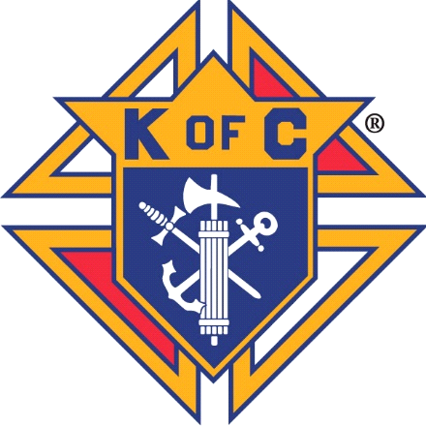Knights of Columbus

Rev. Robert J Houlihan, SJ, Council 10937

Agenda for July 2021 Planning Meeting

* **Grand Knights Report**

Recruiting for Deputy Grand Knight and Treasurer

July Business Meeting – Saturday July 10th, Great Hall, Rosary or Mass 7:30am, meeting 8am to 9am

Thank you for your service to Parish, Community and Council. Prayers for all affected by Coronavirus. Please let us know of any distressed or sick Knight or Family member.

## COUNCIL OFFICERS – 2021/2022 -



|  |  |  |  |  |  |  |
| --- | --- | --- | --- | --- | --- | --- |
| **GRAND KNIGHT** | **DEPUTY**  **GRAND KNIGHT** | **CHANCELLOR** | **RECORDER** | **TREASURER** | **FINANCIAL SECRETARY** | **WARDEN** |
| **Leonard Martinez** | **Who would help?** | **Dan Donaldson** | **Ben Stancati** | **Who would help?** | **Ryan Fesker** | **Darren Lombardi** |
| **INSIDE GUARD** | **OUTSIDE GUARD** | **1ST TRUSTEE** | **2ND TRUSTEE** | **3RD TRUSTEE** | **LECTURER** | **ADVOCATE** |
| **John Alfeld** | **Paul Sciera** | **Gary Mayfield** | **William Hensen** | **Michael Burkett** | **Alan Brown** | **James Egan** |

**Chaplain – Father Andrej**

**Knight of the Month -**

**Family of the Month -**

**Financial Secretary’s Report** - Ryan Fesker.

Prepare to closeout fiscal year ending June 30th

**Treasurer’s Report** – Matt Bahnemann

**Program Directors:** Ken Balcerzak

**Membership** chair: *Joe Regnery*

KofC.org/Joinus

**Family:** Co- Directors- Brennen Mendus and Jason Curl

Burritos – July 25th

Beer and Brats on Saturday July 31st

**Community**: *Richard Cooke*:

4th of July parade – Faithful Navigator Paul Sciera

Need painters for 3 offices at Pax Christi, Projected dates: July 9th, 10th, 11th

Peach sales, Requesting Capt. For each weekend Masses: July 10th & 11th, July 17th & 18th, July 24th & 25th, July 31st & Aug. 1st. Distribution Aug. 14th.

Prepare for Tootsie Roll Drive to contact at Murdoch’s and King Soopers

**Faith**: *Alan Brown* -

Decide on Silver Rose coming to Pax between Diocese of Colorado Springs, July 26 - Aug 8

**Life**: *Mike McGinnis* -

**Good of the Order** Art Myers 2/6; Jennifer Sciera (Healing) 5/8; Mom and Dad Mayfield 2/13; Mindy Martz 2/13 (Dave and Kathy’s daughter); Terry Neuhalfen 2/13; Jay Calvarese 2/13; Phil Sheridan (healing Brother in-law to Mike McGinnis) 3/13; Dave Ellgen (healing Joe Musso Brother in-law) 4/10;  George Alberts (healing) 4/10; Joe Regnery’s Mom and Dad (healing) 4/10; Leonard Martinez (full recovery of knee) 4/10; Dave Petty’s (healing) 4/10; Lucas Donaldson (healing 4/28; Ron and Deanne Gerber (healing) 4/28; Seminarians/future Sister (Will Dwayer, Matthew Kane, Kolbe Kirst, Catherine Logan), Soul of Jan Duntz 3/13; Soul of Doug Dick (Brother-in Law Steve Froseth) 4/10; Soul of Mike Midkiff 4/28; Soul of Kathy Myers; Soul of Tom Morrisey; and all those in our hearts that need our prayers.