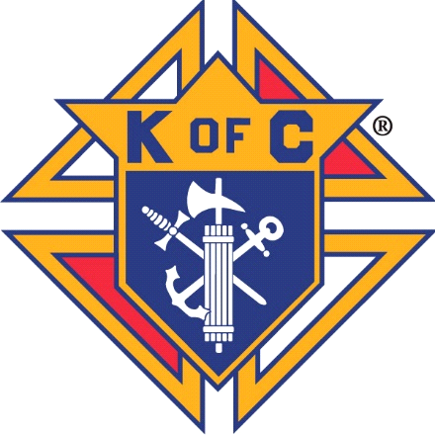Knights of Columbus

Rev. Robert J Houlihan, SJ, Council 10937

Agenda for August 2021 Planning Meeting Wednesday, July 27th 6:30pm Leonard Martinez’s house

* **Grand Knights Report**

Recruiting for Deputy Grand Knight

August Business Meeting – Saturday August 7th, Great Hall, Rosary at 7:30am meeting 8am to 9am

Thank you for Volunteer Ushers for Cathy Myers’ funeral

Thank you for Scholarship funds going to 4 deserving students to continue their education

Special thank you to Brennan Mendus, Ben Stancati, Jim Egan and our newest Knight, Greg de Rosario for taking Friday afternoon and Saturday afternoon to paint 3 offices at church

Thank you to our Officers, Directors, and Brother Knights and your families for a most productive July. We cheerfully work to increase our Faith, touch hundreds with our Programs, and attract new members

Thank you for your service to Parish, Community and Council. Prayers for all affected by Coronavirus. Please let us know of any distressed or sick Knight or Family member.

## COUNCIL OFFICERS – 2021/2022 -



|  |  |  |  |  |  |  |
| --- | --- | --- | --- | --- | --- | --- |
| **GRAND KNIGHT** | **DEPUTY**  **GRAND KNIGHT** | **CHANCELLOR** | **RECORDER** | **TREASURER** | **FINANCIAL SECRETARY** | **WARDEN** |
| **Leonard Martinez** | **Who would help?** | **Dan Donaldson** | **Ben Stancati** | **Jason Curl** | **Ryan Fesker** | **Darren Lombardi** |
| **INSIDE GUARD** | **OUTSIDE GUARD** | **1ST TRUSTEE** | **2ND TRUSTEE** | **3RD TRUSTEE** | **LECTURER** | **ADVOCATE** |
| **John Alfeld** | **Paul Sciera** | **Gary Mayfield** | **William Hensen** | **Michael Burkett** | **Alan Brown** | **James Egan** |

**Chaplain – Father Andrej**

**Knight of the Month - Brennan Mendus**

**Family of the Month -**

**Financial Secretary’s Report** - Ryan Fesker.

**Treasurer’s Report** – Jason Curl

**Program Directors:** Ken Balcerzak

**Membership** chair: *Joe Regnery*

KofC.org/Joinus

New on-line Knight Shawn Menagh and Greg de Rosario

**Family:** Co- Directors- Brennen Mendus and Jason Curl

Beer and brats on Saturday July 31st

Breakfast Burritos coffee on Sunday July 25th and August 22nd

Parrish Picnic after Saturday mass August 28th

**Community**: *Richard Cooke*:

Ongoing Peach sales, which supports our college scholarships

Prepare for Tootsie Roll Drive to set up contacts at Murdoch’s and King Soopers

**Faith**: *Alan Brown* -

Vigano Letters – Struggle between good and evil

Congratulations to scholarship winner Gabriel Rivera

Silver Rose coming to Pax Christi has been cancelled this year due to scheduling

**Life**: *Mike McGinnis*

**Good of the Order:** Art Myers 2/6; Jennifer Sciera (Healing) 5/8; Mom and Dad Mayfield 2/13; Mindy Martz 2/13 (Dave and Kathy’s daughter); Terry Neuhalfen 2/13; Jay Calvarese 2/13; Phil Sheridan (healing Brother in-law to Mike McGinnis) 3/13; Dave Ellgen (healing Joe Musso Brother in-law) 4/10;  George Alberts (healing) 4/10; Joe Regnery’s Mom and Dad (healing) 4/10; Dave Petty’s (healing) 4/10; Lucas Donaldson (healing 4/28; Ron and Deanne Gerber (healing) 4/28; Seminarians/future Sister (Will Dwayer, Matthew Kane, Kolbe Kirst, Catherine Logan), Soul of Jan Duntz 3/13; Soul of Doug Dick (Brother-in Law Steve Froseth) 4/10; Soul of Mike Midkiff 4/28; Soul of Kathy Myers; Soul of Tom Morrisey; and all those in our hearts that need our prayers.