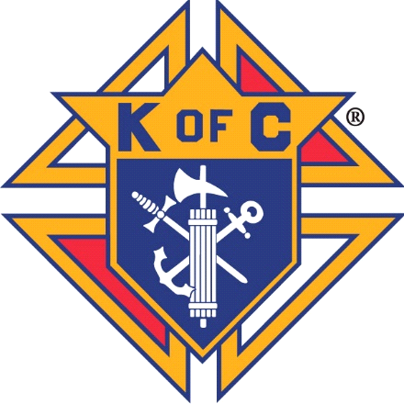Knights of Columbus

Rev. Robert J Houlihan, SJ, Council 10937

Agenda for September 2021 Planning Meeting Tuesday, August 31st 6:30pm Leonard Martinez’s house

* **Grand Knights Report**

Recruiting for Deputy Grand Knight

September Business Meeting – Saturday September 11th, Great Hall, Rosary at 7:30am meeting 8am to 9am

Truly thank you to our Officers, Directors, and Brother Knights who worked extensively before and after each weekend mass selling, logging in and collecting money for the peaches we sold. A SPECIAL THANK YOU to fellow Knight RICHARD COOKE, who took on the task of communicating between the peach orchard, Grand Knight and all others involved to close this project to a great finish.

Thank you to Brennan Mendus and his breakfast team for another great Breakfast Burrito event on August 22nd.

## COUNCIL OFFICERS – 2021/2022 -



|  |  |  |  |  |  |  |
| --- | --- | --- | --- | --- | --- | --- |
| **GRAND KNIGHT** | **DEPUTY**  **GRAND KNIGHT** | **CHANCELLOR** | **RECORDER** | **TREASURER** | **FINANCIAL SECRETARY** | **WARDEN** |
| **Leonard Martinez** |  | **Dan Donaldson** | **Ben Stancati** | **Jason Curl** | **Ryan Fesker** | **Darren Lombardi** |
| **INSIDE GUARD** | **OUTSIDE GUARD** | **1ST TRUSTEE** | **2ND TRUSTEE** | **3RD TRUSTEE** | **LECTURER** | **ADVOCATE** |
| **John Alfeld** | **Paul Sciera** | **Gary Mayfield** | **William Hensen** | **Michael Burkett** | **Alan Brown** | **James Egan** |

**Chaplain – Father Andrej**

**Knight of the Month -**

**Family of the Month -**

**Financial Secretary’s Report** - Ryan Fesker.

**Treasurer’s Report** – Jason Curl

**Program Directors:**

**Membership** chair: *Joe Regnery*

KofC.org/Joinus

**Family:** Director- Brennen Mendus

Burritos and coffee on Sunday September 26th

**Community**: *Richard Cooke*:

Knights of Columbus Golf Tournament October 1st 8am Links Golf Course, Highlands Ranch – Steve Froseth

Prepare for Tootsie Roll Drive to contact at Murdoch’s

Knights of Columbus 2021 Football Czar September 1st thru October 12th – Dave Martz

NEW cleanup church project: consider church wide volunteer project for late Sept. or Oct. proposed dates: Sept. 25th, Oct. 9th or Oct. 16th from 8am to noon. Event would look a lot like previous cleanup events. Church would provide materials, we provide tools, gloves, misc. small tools. Need quick answer as they want to advertise all month of Sept.

Proposed Spaghetti Dinner – Bill Hensen Only Sept Sat. available is the 25th; just the day before our Breakfast Burritos on the 26th. Alternative dates: Oct 2nd or 23rd – Note Halloween party might be on that Oct 23rd Saturday.

**Faith**: *Alan Brown* -

Funeral Mass for Art Myers 4th degree - Thursday September 9th at 11am

Risen program

**Life**: *Mike McGinnis* -

Baby Bottles - September 25th

**Good of the Order** Prayer intentions for Eileen Love, mother of Brennan Love, Jennifer Sciera (Healing) 5/8; Mom and Dad Mayfield 2/13; Terry Neuhalfen 2/13; Jay Calvarese 2/13; Phil Sheridan (healing Brother in-law to Mike McGinnis) 3/13; Dave Ellgen (healing Joe Musso Brother in-law) 4/10;  George Alberts (healing) 4/10; Joe Regnery’s Mom and Dad (healing) 4/10; Dave Petty’s (healing) 4/10; Lucas Donaldson (healing 4/28; Ron and Deanne Gerber (healing) 4/28; Seminarians/future Sister (Will Dwayer, Matthew Kane, Kolbe Kirst, Catherine Logan), Soul of Jan Duntz 3/13; Soul of Doug Dick (Brother-in Law Steve Froseth) 4/10; Soul of Mike Midkiff 4/28; Soul of Art Myers; Soul of Tom Morrisey; and all those in our hearts that need our prayers.