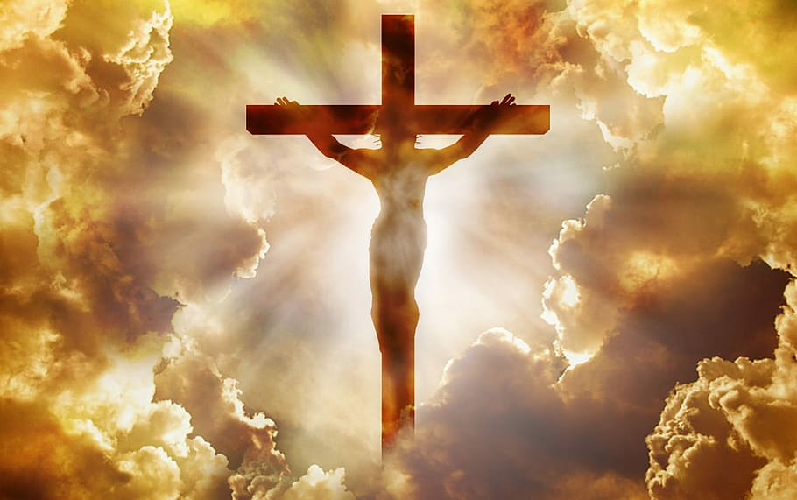

**SAVE THE DATE**

**Regnum Christi**

**Men’s Spiritual Exercises**

**Silent Retreat**

**Led by Father Dean Stasell LC**

**October 20-23, 2022**

**Mother Cabrini Shrine, Golden, CO**

**Retreat fee $350 Non-Refundable Deposit $100**

***Daily Mass, Confession, Adoration, Guided Meditations, and Spiritual Guidance***

For more information and to make your reservation contact

John vega

[Johnvega7734@gmail.com](mailto:Johnvega7734@gmail.com) 303-870-2767